Programming for geographical inquiry K–10

Activity booklet

Contents
Standards/Descriptors 3
Geographical inquiry process
Activity 1: The ‘process’ step in a geographical inquiry 4
Activity 2: Mapping quiz 5
Activity 3: Local fieldwork sites 7
Activity 4: Using ABS statistics 8
Activity 5: GIS maps and tools 9
Activity 6: Visual representations 10
Inquiry design
Course deliverable: A programmed geographical inquiry 11
Wrap up
Reflection 12

Standards/Descriptors
The table outlines how the course content addresses the Standards/Descriptors
Standard/Descriptor | Course content addressing the Standard/Descriptor
Standard 2: Know the content and how to teach it  Descriptor 2.2.2 Organise content into coherent, well-sequenced learning and teaching programs. | Participants will engage in the Geography K–10 Syllabus to design a geographical inquiry containing a sequence of teaching and learning activities for one geography content area, with a focus on the geographical inquiry process.
Standard 3: Plan and implement effective teaching and learning  Descriptor 3.3.2 Select and use relevant teaching strategies to develop knowledge, skills, problem solving and critical and creative thinking. | Participants will examine the geographical inquiry process, tools and skills. They will program teaching and learning strategies that explicitly develop students’ knowledge and skills in acquiring, processing and communicating geographical information which embed higher order thinking, problem solving and critical and creative thinking.
Standard 6: Engage in professional learning  Descriptor 6.4.2 Undertake professional learning programs designed to address identified student learning needs. | Participants will:  - engage with geographical skills, concepts and tools  - plan geography teaching and learning activities for a diversity of student needs in a programmed geographical inquiry as the course deliverable.

Activity 1: The ‘process’ step in a geographical inquiry

Geographical inquiry process, Process
The geographical inquiry process involves questioning, acquiring, processing, communicating and responding to geographical data and information.
Processing geographical information includes:
- evaluating data and information for usefulness, reliability and bias
- representing data and information, e.g maps, graphs, tables, graphic organisers
- interpreting data and information for geographical relationships, patterns, trends
- analysing findings and results
- drawing conclusions.
1. Why is the ‘process’ step in a geographical inquiry necessary?

2. Why can’t students move straight from collecting information and data to communicating it?

Activity 2: Mapping quiz (optional) Geographical tools
Geographers use a variety of types of maps to acquire, represent and communicate geographical information.
1. What types of maps are these and what is an example of use?
Map images | Type and example of use for each
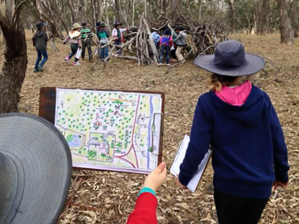
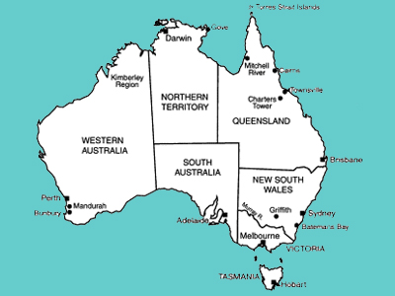
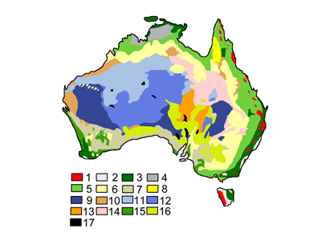
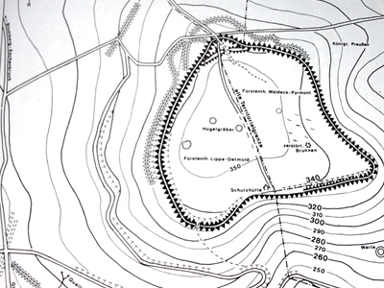
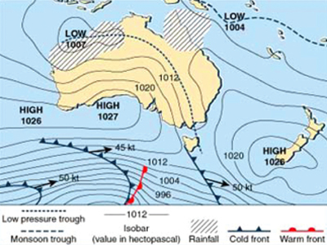
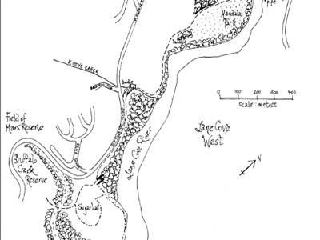

2. Every good map should have:
B
O
L
T
S
Activity 3: Local fieldwork sites (optional)
Geographical tools
Fieldwork is integral to the study of geography. Fieldwork involves taking students outside the classroom to observe, measure, collect and record geographical information.
1. Identify a fieldwork activity for your school grounds

2. Identify a local area for fieldwork that is walking distance of the school

3. Identify your closest DoE Environmental Education Centre or fieldwork provider

Activity 4: Using ABS statistics (optional)
Geographical tools
Statistics are used by geographers to collate, organise and summarise geographical data and information. Geographers analyse statistics for patterns, relationships and trends.
1. Examine the data for your region using the Find data for your region button on the Australian Bureau of Statistics (ABS) site. Note some interesting statistics.

2. How could you use this information with your students?

Activity 5: GIS maps and tools (optional)
Geographical tools
A GIS is a system for storing, managing, analysing and portraying spatial data.
Explore one or more of the GIS maps and tools and explain how one of the tools could be used by your students in a geographical inquiry.
Examples of GIS maps and tools:
- Google Earth
- Google Maps
- Google My Maps
- Google Tour Builder
- Google Street View
- Scribble Maps
- SIX Maps (includes 1943 aerial photography of greater Sydney)
- SpatialGenie (includes colonial maps of Sydney and other Australian information)
- National Geographic MapMaker Interactive
- Eyes on the Forest (Sumatra’s forests, wildlife and climate 1985 to the present)
1. What GIS mapping tool/s did you explore?

2. Explain at least one way a feature of one of the tools could be used by your students in a geographical inquiry.

Activity 6: Visual representations (optional)
Geographical tools
For each step of the geographical inquiry process identify a visual representation your students could use and explain how your students would use it.
1a. A visual representation for acquiring geographical information is:

1b. Students could use it by:

2a. A visual representation for processing geographical information is:

2b. Students could use it by:

3a. A visual representation for communicating geographical information is:

3b. Students could use it by:

Course deliverable

A programmed geographical inquiry for one geography content area
The indicative time for the course deliverable is 100 minutes.
The Inquiry design tab will guide you in programming a geographical inquiry. Each activity contributes to the completion of the course deliverable.

Geography teaching and learning frameworks
The Geography K–10 teaching and learning frameworks may be of considerable assistance in creating your implementation plan. Participants are encouraged to refer to the relevant framework(s) when completing the first four steps of the process.

Program builder
- Access the geographical inquiry template and sign-in using your DoE login.
- Work directly into the geographical inquiry template in Program builder (or use an alternative template).

Alternative template
Your geographical inquiry does not have to be created in Program builder. You may prefer to use a school based programming proforma or save and type over a geography teaching and learning frameworks document.

Geographical inquiry design process:
- Select focus area and content heading
- Select outcomes, content and key inquiry questions
- Decide on a case study and write a geographical question
- List concepts, skills and tools
- Consider assessment strategies
- Plan teaching and learning strategies
- Adjust content, process, product or learning environment
- Plan evaluation and reflection strategies.
Share your completed geographical inquiry with your colleagues and supervisor as an exported Word document for feedback.

Reflection

Reflect on your learning
Congratulations! You have completed the online course Programming for geographical inquiry K–10.
In this course, we have explored the Geography K–10 Syllabus. Particular attention was given to programming using the geographical inquiry process as a framework and embedding geographical tools into the teaching and learning activities. The course deliverable involved programming a geographical inquiry for one content area.
- What aspect(s) of the course seemed most important to you?

- What did you learn?

- What will you do differently as a result of completing this course?

