Using the *NSW Literacy Continuum K-10*

Participant activity booklet

Contents Page

Using the *NSW Literacy continuum K-10* 2

Course completion checklist 2

Introduction 3

Standards/Descriptors 4

**Literacy:** Defining literacy 5

Activity 1a Purposes for literacy 5

**Literacy:** Defining literacy 6

Activity 1b Modes of communic*a*tion 6

**Literacy:** Literacy in syllabuses 7

Activity 2 Literacy in the syllabuses 7

**Literacy as a continuum:** A continuum of learning 8

Activity 3 The literacy continuum K-10 in the progression of learning 8

**Literacy as a continuum:** *NSW Literacy continuum K-10* 10

Activity 4 Overview of the *NSW Literacy continuum K-10* 10

**Literacy as a continuum:** *NSW Literacy continuum K-10* 11

Activity 5 Building literacy strength – close study 11

**Literacy continuum in practice:** Teachers applications 13

Activity 6 Continuum close-up (Reading) 13

Course Deliverable 16

One page response 16

Reflections 17

Reflect on your learning 17

# Using the *NSW Literacy continuum K-10*

## Course completion checklist

**Teacher name** ______________________________________________________________________

**School** __________________________________________________ ☐ I am an early career teacher

### Pre-course checklist

[*MyPL@Edu*](http://www.det.nsw.edu.au/docprs/welcome.do)(<http://www.det.nsw.edu.au/docprs/welcome.do>) registration

Consultation with school Professional Learning Committee / Principal

### Deliverables checklist

All sections of the Activity book completed, as below.

🞏 **Literacy**: Defining literacy

* Purposes for literacy – Activity 1a
* Modes of communication – Activity 1b

🞏 **Literacy**: Literacy in syllabuses – Activity 2

🞏 **Literacy as a continuum:**

* A continuum of learning - Activity 3
* *NSW Literacy continuum K-10* Overview – Activity 4
* K-10 Building literacy strength – Activity 5

🞏 **Literacy continuum in practice**: Teacher applications

* Continuum close-up – Reading
* Annotated literacy demands of text - Activity 6

🞏 **Course deliverable: Mini-lesson plan (Part A) and evaluation (Part B).**

### Post-course checklist

Collegial collaboration – actively engaged in discussion and collaboration with teaching colleagues, facilitators and supervisors during the course.

Both print and online versions of the NSW Literacy continuums were used throughout the course.

[*My PL@Edu*](http://www.det.nsw.edu.au/docprs/welcome.do) evaluation must be completed for successful accreditation.

### Supervisor sign off

I certify that _______________________________ has completed the above requirements for the [*Insert course name]* course.

Signed: ___________________________________ Date: _____________

Position: _____________________________________________________________________________

# Introduction

Throughout this course, you will develop and apply your knowledge of both the *NSW Literacy continuum K-10* and NSW BOSTES syllabuses to plan, use and evaluate learning activities. The course deliverable will demonstrate your understanding of how to explicitly teach selected skills in *Reading texts* to access stage appropriate curriculum content.

All activities in the Activity booklet should be completed in order for the principal or supervisor to sign off for your accreditation.

As a follow-up to this course, we suggest literacy leaders use the **[Literacy matrix](https://detwww.det.nsw.edu.au/literacy-and-numeracy-support/literacy/resources" \o "https://detwww.det.nsw.edu.au/literacy-and-numeracy-support/literacy/resources)** (<https://detwww.det.nsw.edu.au/literacy-and-numeracy-support/literacy/resources>) as a survey to identify the school’s understanding and use of the[*NSW Literacy continuum K-10*](http://www.literacy-continuum.det.nsw.edu.au/Matrix), (<http://www.literacy-continuum.det.nsw.edu.au/Matrix>) and to provide guidance for the continued successful use of the continuum.

Literacy leaders can work with staff, students and the community to consider ways to move to the next level of engagement with the continuum.

# Standards/Descriptors

The table outlines how the course content addresses the Standards/Descriptors

| **Standard/Descriptor** | **Course content addressing the Standard/Descriptor** |
| --- | --- |
| **Standard 1: Know students and how they learn**  **Descriptor 1.5.2** Develop teaching activities that incorporate differentiated strategies to meet the specific learning needs of students across the full range of abilities. | Participants will apply knowledge of how students learn, their own students’ needs and the NSW Literacy continuum K-10 to develop and trial a teaching idea, as a strategy, lesson, a series of lessons or a unit of learning. |
| **Standard 2: Know the content and how to teach it**  **Descriptor 2.5.2** Apply knowledge and understanding of effective teaching strategies to support students’ literacy and numeracy achievement. | Participants will apply knowledge of the purpose, structure and content of the NSW Literacy continuum K-10 to syllabus content and text-based activities. |
| **Standard 3: Plan and implement effective teaching and learning**  **Descriptor 3.2.2** Plan and implement well-structured learning and teaching programs or lesson sequences that engage students and promote learning. | Participants will plan, use and review a learning and teaching program which utilises teacher literacy and syllabus knowledge and understandings, and contextualises literacy learning. |
| **Standard 6: Engage in professional learning**  **Descriptor 6.3.2** Contribute to collegial discussions and apply constructive feedback from colleagues to improve professional knowledge and practice. | Participants will:   * engage in discussion, activities, reflection and key questions designed to strengthen understanding of how the NSW Literacy continuum K-10 can be used to guide teaching and learning based on the needs of students * complete the course deliverable, applying up to date knowledge and practice to improve student learning. |

# **Literacy:** Defining literacy

## Activity 1a Purposes for literacy

### (Indicative time for Activities 1a and 1b is 40 minutes)

Literacy is the ability to understand and evaluate meaning through reading and writing, listening and speaking, viewing and representing.

Policy statement 1.1.1 NSW Literacy K–12 Policy, 2007

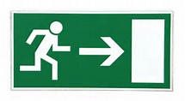

Icon: Collaboration Use the exit sign image to consider the following questions. Discuss these with a colleague and record your thinking:

1. Why does literacy require the ability to both understand and evaluate meaning?

_________________________________________________________________________

_________________________________________________________________________

1. Can there be understanding of meaning without some level of evaluation?

_________________________________________________________________________

_________________________________________________________________________

1. Is it possible for a literate person to be able to evaluate meaning without understanding?

_________________________________________________________________________

_________________________________________________________________________

1. Use knowledge of your own literacy learning, and think of examples from your teaching experience to explore these ideas.

_________________________________________________________________________

_________________________________________________________________________

# **Literacy:** Defining literacy

## Activity 1b Modes of communication

Students use a variety of the six modes of communication in every subject. However, each subject requires students to use these modes in different ways.

Consider what each of these modes of communication looks like in your subject.

Icon: Collaboration Record your responses to the following:

1. What modes of communication are used most frequently in your subject?

_________________________________________________________________________

_________________________________________________________________________

1. Make a list of the texts, processes and technologies which your students use to access syllabus content:

_________________________________________________________________________

_________________________________________________________________________

1. Make a list of the texts, processes and technologies your subject requires students to use in order to represent what they know and can do:

_________________________________________________________________________

_________________________________________________________________________

# **Literacy:** Literacy in syllabuses

## Activity 2 Literacy in the syllabuses

### (Indicative time 40 minutes)

### Record your discussion and reflection on the following questions:

1. What are the implications for your teaching for the different ways in which literacy is used in syllabus documents?

_________________________________________________________________________

_________________________________________________________________________

_________________________________________________________________________

________________________________________________________________

1. What preparation do you need to do to ensure your students are using literacy in the most appropriate way in at least one KLA?

_________________________________________________________________________

_________________________________________________________________________

_________________________________________________________________________

________________________________________________________________

# **Literacy as a continuum:** A continuum of learning

## Activity 3 The literacy continuum K-10 in the progression of learning

### (Indicative time 30 minutes)

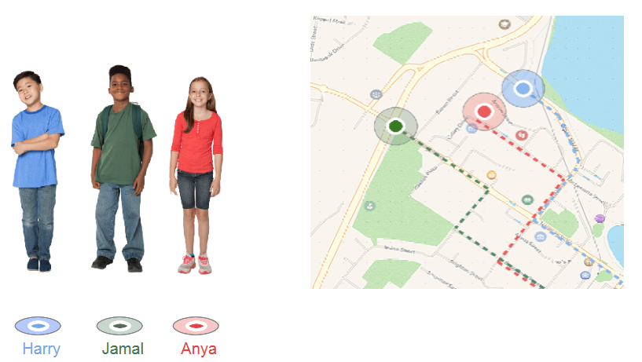

Our Stage 3 learners, Harry, Jamal and Anya, have taken quite different paths as they develop their literacy skills.

1. What are some of the factors that can impact on early literacy development?

_________________________________________________________________________

_________________________________________________________________________

_________________________________________________________________________

1. Suggest some of the factors that may impact on the progress of each of these students:

_________________________________________________________________________

_________________________________________________________________________

_________________________________________________________________________

1. Consider what may have caused the ‘change of direction’ for Anya in Stage 3?

_________________________________________________________________________

_________________________________________________________________________

_________________________________________________________________________

1. Jamal seems to have taken a very direct route in his literacy development in Stage 3. What could be a reason for this?

_________________________________________________________________________

_________________________________________________________________________

_________________________________________________________________________

1. Consider a key incident that impacted on your own literacy progress. What triggered this key event, and why was it significant? How could this knowledge assist you when you work with students in literacy in your subject?

_________________________________________________________________________

_________________________________________________________________________

_________________________________________________________________________

# **Literacy as a continuum:** *NSW Literacy continuum K-10*

## Activity 4 Overview of the *NSW Literacy continuum K-10*

### (Indicative time 30 minutes)

icon:reading Read the *Overview of the NSW Literacy continuum K-10* . https://detwww.det.nsw.edu.au/literacy-and-numeracy-support/literacy/resources

[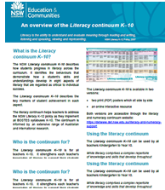](https://detwww.det.nsw.edu.au/literacy-and-numeracy-support/literacy/resources)

Icon: Collaboration Consider the content, using the following questions as a guide:

1. Why do you think there is there a need for a literacy continuum K-10?

_________________________________________________________________________

_________________________________________________________________________

_________________________________________________________________________

1. In what ways are these eight particular aspects critical to literacy development?

_________________________________________________________________________

_________________________________________________________________________

_________________________________________________________________________

For more information about the aspects of literacy included in the *NSW Literacy continuum K-10*, refer to the [Introduction to Quality Literacy Teaching](https://detwww.det.nsw.edu.au/literacy-and-numeracy-support/literacy/resources), (<https://detwww.det.nsw.edu.au/literacy-and-numeracy-support/literacy/resources>) pages 7-10.

Links to the national and international research that informs the *NSW Literacy continuum K-10* are on pages 34 and 35 in this document.

# **Literacy as a continuum:** *NSW Literacy continuum K-10*

## Activity 5 Building literacy strength – close study

### (Indicative time 30 minutes)

By the end of Stage 3, our three students are making progress in all critical aspects of the *NSW Literacy continuum K-10*.

Focus on one of the students for closer consideration.

1. What are this student’s literacy strengths?

________________________________________________________________

________________________________________________________________

________________________________________________________________

________________________________________________________________

1. What is the area of greatest concern?

________________________________________________________________

________________________________________________________________

________________________________________________________________

________________________________________________________________

1. Suggest ways that you could use the student’s literacy strengths to build their less successful aspect.

________________________________________________________________

________________________________________________________________

________________________________________________________________

________________________________________________________________

EXAMPLE: Anya is not working at an appropriate level in *Aspects of writing*. The reciprocal nature of reading and writing will help develop her skills.

Anya has strengths in *Reading texts,* so she could be involved in analysing and critically reflecting on the effectiveness of several texts, including her own.

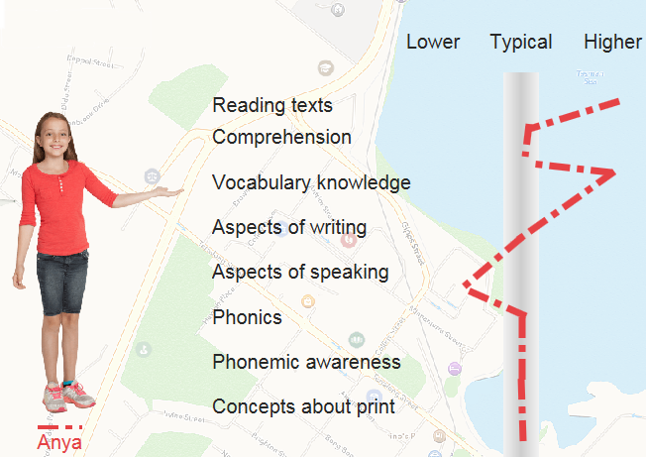

Anya could work with other students to identify successful elements in effective texts. She could then be supported to work on incorporating these elements into her own writing. The process can be repeated, with a different focus as demanded by syllabus content and text requirements.

## **Literacy continuum in practice:** Teachers applications

## Activity 6 Continuum close-up (Reading)

### (Indicative time 20 minutes)

The critical aspect of literacy, Reading texts is described in the continuum:

Reading texts involves recognising words automatically, reading in a phrased and fluent way and navigating texts to create meaning.

icon:reading These are the three significant strategies we use as we read texts:

* recognising words *automatically*
* reading in a phrased and fluent way
* navigating texts in order ‘to create meaning’.

The strategies work together so the reader understands and can use what they read.

The description of *Reading Texts* in the Literacy continuum is the same from Kindergarten to Year 10, but it has different meanings for readers at varying stages of development.

**For early readers:**

* *recognising words automatically* - high frequency words necessary for meaning, and learned early, such as *the*, *and*, *I*
* *phrased and fluent* - grouping words to read sentences such as “*Dad and I went* *to the park*,” with its direct relationship to the reader’s experiences; introducing grammatical structures and text organisation to inform future reading and making meaning
* *navigating texts* - using one-to-one correspondence, relating words and accompanying pictures, and using environmental print.

**For developed readers:**

* *automatically* - identifying subject specific vocabulary rapidly; having a wide vocabulary to draw on to read complex texts and meet tasks
* *phrased and fluent* - looking ahead for ‘chunks’ of words to maintain meaning; modifying the pace of reading accordingly
* *navigating texts* - using text features - headings, sub-headings, diagrams, images and captions, references, quotes - to understand their relationships in a text

Effective teachers are aware of the literacy demands of the age and Stage appropriate texts students are required to read.

Icon: Collaboration With a colleague, consider the demands of the text in Examples 1 and 2. They have been annotated to demonstrate the features of texts that the teacher has identified. The teacher is then ready to assist the student, in case meaning is interrupted.

### Example 1- literacy demands of literature

The sample text is:
Friday had never been in the archive room before. There were filing cabinets along one wall, two tall rows of bookcases housing a very impressive collection of leather-bound books, and along the far wall a row of glass display cases. Everything looked perfectly neat and ordered, as though no-one had ever come in here, which Friday suspected was the case. School was boring enough in the present – archival records of the school from decades earlier took boringness to a new level.
Friday Barnes,  by R.A. Spratt 
Examples of literacy demands are as follows. 
Unfamiliar setting is 'archive room'
Challenging and unusual vocabulary is 'very impressive collection of leather-bound books'
Understanding that descriptive language creats meaning in a literary text is 'Everything looked perfectly neat and ordered, as though no-one had ever come in here'
Use of topic knowledge and context to read is 'archival records of the school from decades.'
An example of understanding the reading path of a literacy text is 'took boringness to a new level.'


**Cluster 10 Reading texts** – Reads short novels with minimal illustration, unfamiliar content, settings and characters and challenging and unusual vocabulary.

### Example 2 – literacy demands of information text

The sample text is
Dr Fiona Wood is a leading Australian plastic surgeon. She has developed a product called ReCell, which is an aerosol spray that spreads skin cells over a wound. ReCell is an important invention for the treatment of burns.
Burns are serious injuries because they can damage large areas of skin. The burns need to be covered quickly to reduce infections and encourage growth of new cells for healing. This also helps patients feel better and reduces the amount of scar tissue that forms on the burnt skin.
Spray-on skin cells, p. 12 ESSA, NSW 

Features of the text are as followis
Applying technical vocabulary and content knowledge 'plastic surgeon', 'aerosol spray', 'of scar tissue'.

Monitoring and self-correcting by following the topic words through this complex text, 'Dr Fiona Woods', 'treatment of burns', 'new cells for healing', 'helps patients feel better'.

An exmple of selecting a suitable reading path to engage with new content is 'Burns are serious injuries because...'.

**Cluster 14 Reading texts –** Reads a wide range of increasingly complex subject texts for sustained periods.

# Course Deliverable

## One page response

### (Indicative time 90 minutes)

### Part A

1. Choose a text or part of a text that you will be using in your next unit of work. This might be a scientific report, a historical source, a poem or a mathematical problem.
2. Identify the literacy challenges in the text and annotate an example. Don’t attempt to annotate every detail; use the previous examples as a guide.
3. Use the literacy continuum to identify the cluster where *MOST* of your students are working.
4. Determine the marker/s you are targeting.
5. **Locate a teaching idea from the interactive continuum that addresses an identified student need. Trial and modify this idea for your context.**
6. Write a lesson plan or an outline of a series of lessons that you will implement to teach the literacy skills that you have identified. Ensure that the plan includes strategies and evidence of learning.

### Part B

Write an evaluation of the lesson that you have planned and delivered. Include the following information in your response.

* Class and Subject
* Time frame e.g. 1 period or 50 minutes
* Target cluster or marker/s
* Curriculum content goal
* Teaching and learning strategies
* Evidence of learning
* Evaluation (200-250 words)

# Reflections

## Reflect on your learning

Congratulations! You have completed the online course, Using the NSW Literacy continuum K-10.

You now have even more resources to assist you to plan for the delivery of superior learning for your students.

In this course we have explored broad understandings of learning as a continuum. We have seen how each syllabus has its own literacy requirements, and investigated the ways the NSW Literacy continuum K-10 supports our teaching to ensure the student is at the centre of learning.

As you prepare for the final submission, consider the following:

* What were some of the things you did that were important for you?

_________________________________________________________________________________________________________________________________________________________________________________________________________________________________

* What did you learn?

_________________________________________________________________________________________________________________________________________________________________________________________________________________________________

* What will you do differently as a result of completing this course?

_________________________________________________________________________________________________________________________________________________________________________________________________________________________________