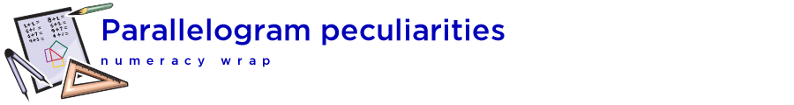

## Teaching notes

This numeracy wrap addresses the following syllabus outcomes from NSW Mathematics K-10 Syllabus 2012, © NSW Education Standards Authority, NSW:

MA5.3-1WM uses and interprets formal definitions and generalisations when explaining solutions and/or conjectures

MA5.3-3WM uses deductive reasoning in presenting arguments and formal proofs

MA5.3-16MG proves triangles are similar, and uses formal geometric reasoning to establish properties of triangles and quadrilaterals

Students will:

* Apply logical reasoning, including the use of congruence and similarity, to proofs and numerical exercises involving plane shapes
* prove and apply theorems and properties related to triangles and quadrilaterals:
  + the sum of the interior angles of a triangle is 180º
  + the opposite angles of a parallelogram are equal
  + the opposite sides of a parallelogram are equal
  + the diagonals of a parallelogram bisect each other
  + the diagonals of a rhombus bisect each other at right angles
* Examine measurements of a parallelogram to deduce its invariant properties

|  |  |
| --- | --- |
|  | It may be helpful to define some terms such as bisect and diagonal so that students can express their observations using correct mathematical language. |

|  |  |
| --- | --- |
|  | The applet that the students create shows that a parallelogram consists of two congruent triangles. This is the basis for the mathematical proof of several quadrilateral properties. The class could discuss how the concepts in the applet could be formalised into a proof. |

|  |  |
| --- | --- |
|  | [The Geometer’s Warehouse](https://app.education.nsw.gov.au/rap/resource/access/cb02edfa-eb1d-43e7-b913-08e55cdb3435/1) comprises 70 dynamic html worksheets, each exploring a different outcome in Stage 4 and Stage 5 geometry. A unique characteristic of the resource is that when screen figures are dragged, angle and length measurements are updated automatically, allowing students to recognise and explore invariant properties. |