Compliance update 2018
The early learning unit aims to make keeping up with preschool compliance easier and to ensure that all department preschools are providing safe environments that support children’s learning and wellbeing. Legislative requirements underpin quality early childhood educational programs and are a key component of the National Quality framework. The following is a list of commonly targeted areas that the regulatory authority is monitoring during both compliance visits and assessment and rating. These are all requirements under the National Education and Care Services Law or Regulations.

Medical conditions – regulation 90
Children with identified medical conditions such as a child at risk of anaphylaxis, asthma and diabetes must have 3 individual plans:
- An individual action/medical plan
- A risk minimisation plan
- A communication plan
The communication plan is a focus of authorised officers. It should be part of the preschool’s medical conditions procedures and must outline:
- How staff members and volunteers are informed about the medical conditions policy and the medical management and risk minimisation plans for each child; and,
- The procedures for a child’s parent to communicate to staff any changes to the medical management and risk minimisation plans for the child.
Preschools must be able to show how they document communication from families about a child’s individual health care needs e.g. a change in the child’s condition, modification to the medical plan or change to medication. Contact your P-2 Initiatives Officer or the Early Learning Unit if you require further advice about this.

Emergency and evacuation procedures – regulation 97
Each preschool should have emergency procedures that are specific to that preschool. This includes a floor plan of the preschool (rather than the whole school) with the emergency exits, assembly places, fire extinguishers and ‘you are here’ spots clearly marked. The floor plan and procedure must be prominently displayed next to all exits, making sure they are not obscured by blinds or curtains.
This will help all staff in the event of an emergency, including casuals who are less familiar with the school’s emergency procedures. The school should aim to mitigate risk of emergency that may begin in the preschool and include this in their emergency risk minimisation plan e.g. fire starting in the kitchen, a lockdown situation starting in the preschool.

Risk minimisation/management plans – national law: section 167
It is advised that risk minimisation/management plans be developed for foreseeable potential risks at the preschool. Some considerations include sun safety/shade, falling tree branches and outings to the school. Provision of adequate shadeis an area that preschools often overlook..

Principal’s role – regulations 118 and 150; national law: section 161
In accordance with the ‘Agreements for departmental preschools under the Education and Care Services National Regulations’, the principal still holds the role of nominated supervisor, educational leader and responsible person in charge. The principal may delegate responsibility for the tasks e.g. a teacher or preschool supervisor may be responsible for leading the educational program and practice. However, principals still retain the legal responsibility. All school staff should be able to articulate these processes.
If the principal is off the school site or absent, the next in charge or whoever is acting in the principal role automatically assumes these three positions. The approved provider template should only be changed to show the relieving principal if the principal is on extended leave. The template is not required to be changed e.g. the photo of the principal does not need to be changed every time the principal leaves the school premises.

Qualifications – regulations 126, 136, 145-147
In accordance with the National Regulations and the agreed position of the department and the regulatory authority, preschools must keep the qualifications of the permanent, regular and casual preschool staff on the preschool premises. This does not include the principal whose qualifications are held centrally. You may be asked to provide evidence of qualifications for school staff who cover short breaks such as lunch.
Qualifications include: WWCC records (verified), tertiary qualifications, first aid, anaphylaxis and asthma management, child protection and NESA teacher accreditation documentation.

SLSO/AEO qualifications – regulation 126
The minimum qualification requirement for educators working in all early childhood services, including department preschools, is at Certificate III level. To be permanently employed in a department preschool SLSOs/AEOs must hold or be actively working towards a Certificate III in Children’s Services or Certificate III in Early Childhood Education and Care.
Casual and temporary staff who hold a Certificate III in Education Support can also work in the preschool. Your preschool may also have a long term support officer that was employed full-time prior to 2014 with the Certificate III in Education Support qualification. All three qualifications are ACECQA approved.
Breaks, absences and leave of SLSOs/AEOs must be covered by another Certificate III trained educator who holds one of the three approved qualifications above. An untrained educator who works in the school must not cover breaks, as this breaches the law and regulations.

First aid qualifications – regulation 136
Early Learning advises that the first aid officer and/or at least one other full time preschool staff member holds the ‘HLTAID004 – Provide emergency first aid response in an education and care setting’ qualification. This will cover the asthma, anaphylaxis and first aid requirement of regulation 136.
In accordance with regulation 136 (2) the person/s who holds this qualification must be in attendance at the school site and immediately available in an emergency.
The following department mandatory training is ACECQA approved.
- Anaphylaxis e-learning (this only meets the anaphylaxis part of regulation 136)
- HLTAID003 Provide first aid (Mandatory for first aid officers. This only meets the first aid part of regulation 136)
The following department mandatory training is not ACECQA approved.
- E-Emergency care (Mandatory online training for all staff every 3 years)
- HLTAID001 CPR (this qualification does not meet any part of regulation 136)

WWCC qualifications – regulation 147
All department employees must have their WWCC verified by the principal before they can work at the school. Permanent and regular staff working in the preschool should have their WWCC letter and a print out of verification from their ESS portal on the preschool premises.
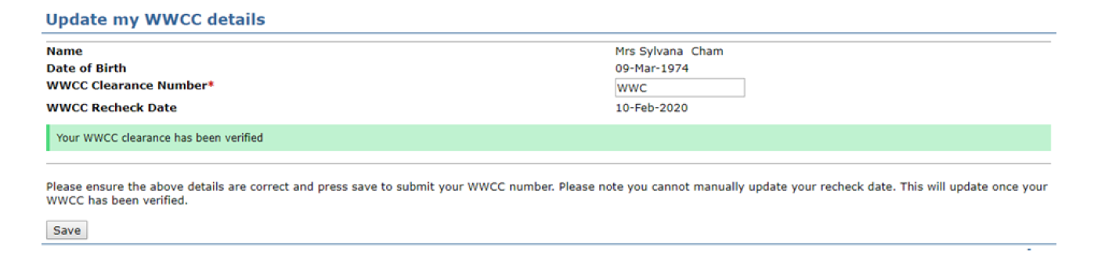If the preschool has a lot of staff covering breaks, the principal can show the authorised officer their verifications using ECPC.

Child protection – regulation 84; national law: section 162A
Child protection, including training, procedures and reporting, falls under regulation 168 – ‘Providing a child safe environment’. Early learning advises that preschools should make reference to child protection in their localised procedures. This could highlight the mandatory training that all staff do annually. The department’s Child Protection Awareness Training for all new department staff and the annual Mandatory Child Protection Training 2018 meets the requirements of the regulation 84 – awareness of the child protection law. Child protection should be a regular discussion item on team meetings to ensure educators understand their responsibilities and have an opportunity to raise any concerns.
The department’s ‘Child Protection Policy: Responding to and reporting students at risk of harm’ and ‘Child Protection Guidelines’ should also be referred to and covers this part of regulation 168. A link to this policy and the associated guidelines is on our preschool website.

