Formulae and Equations – Assessment task

Year 11 Mathematics Standard – Algebra
Assessment type: Year 11 Standard Algebra – Assignment
Stage 6
This document references the Mathematics Standard Stage 6 Syllabus © 2017 NSW Education Standards Authority (NESA) for and on behalf of the Crown in right of the State of New South Wales.
Due Date:

Outcomes
A student:
- uses algebraic and graphical techniques to compare alternative solutions to contextual problems MS11-1
- makes predictions about everyday situations based on simple mathematical models MS11-6
- uses appropriate technology to investigate, organise and interpret information in a range of contexts MS11-9
- justifies a response to a given problem using appropriate mathematical terminology and/or calculations MS11-10

Learning across the curriculum

General capabilities
Critical and creative thinking
Information and communication technology capability

Other areas of learning
Work and enterprise

Assignment

Part A: Blood Alcohol
Blood Alcohol Content (BAC) is the measure of alcohol concentration in the bloodstream. It is measured in grams of alcohol per 100 millilitres of blood. A BAC of 0.02 means that there are 0.02 grams (20 milligrams) of alcohol in every 100 millilitres of blood.

Part 1 - Scenario
Jenny and her husband went to a BBQ. She had two glasses of white wine and he had three mid strength beers. They both believe they are okay to drive home. What other factors would influence their BAC and thus their ability to drive home? Give as much detail as possible

Part 2 - Calculating BAC
Use the correct formula to find the BAC for the following situations.

BAC - Blood Alcohol content
N - Number of standard drinks consumed
H- Hours drinking
M- Mass in kilograms

Open up Resource 1 - BAC Random Number Generator. You will have a unique set of values for to substitute in for N, H and M. Copy the values into the table below. Fill in the first 2 columns with the name and sex (5 male and 5 female) of 10 fictional people. Calculate the BAC.

Name | Sex | N | H | M | Working | BAC

Part 3 - Hours to wait before driving
In New South Wales there are three blood alcohol limits: 0, 0.02 and 0.05.
Research these limits by either visiting a licensing centre or online and list the drivers which each limit applies to.

0 BAC | 0.02 BAC | 0.05 BAC
The limits of 0 and 0.02 are so low that it means you really can’t afford to have anything to drink if you plan to drive. Trying to calculate when you would be ‘safe’ to drive is a difficult process and it is recommended that if you are in doubt then just don’t drive. You cannot use any calculation technique as an excuse if you return a positive roadside test including the one below.
A formula that is sometimes used to decide when it is safe to drive is:
- Number of hours, you always round this up to the nearest hour.
Using your calculation of BAC from table in Part 2, how many hours would each of the people need to wait before driving if they stopped drinking straight away.

Part 4 - Investigating BAC - Changing one variable
Everyone on the list goes on a diet and loses 10 kg. What happens to BAC? How much does it change? Is it the same for everyone?

Part B: Other formulae
Administering medicine is one area that using a formulae is not only important but could be life threatening.

Part 1 - Children’s Panadol
Look at the packaging image for recommended dose of paracetamol below.
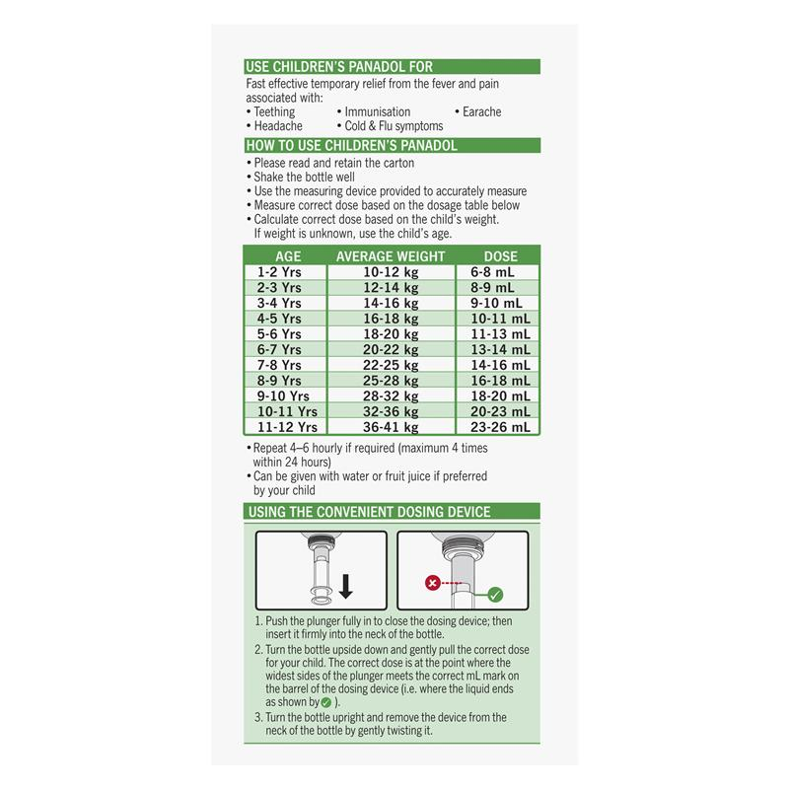
- Panadol claims to be effective in the temporary relief of fever and pain associated with of the following (circle)

snake bite
cold and flu
teething
burns
headache
sprains
immunisation

- What do you think is more important, the child’s age or weight? Justify
- What is the recommended dosage for a child aged 3 years old who is 15kg?
- How far apart can you give the child another dose?
- How many (maximum) doses can you give the child in a 24 hour period?

Part 2. Calculating BMI
Open up Resource 2 - BMI Random Number Generator. Below is a BMI chart which is sometimes used by health professional to find your BMI. Use the chart at Nutrition Australia to determine their BMI. http://www.nutritionaustralia.org/sites/default/files/imagecache/product_full/Aim%20for%20a%20Healthy%20Weight%20Poster_1.JPG

Part 3: How tall will you be?
As soon as a baby is born people make comments about how big they are, how tall they will be and so on. Lots of people, including paediatricians and researchers have tried to create a formula to predict a child’s adult height, weight, shoe size and many other factors. In this part of the assignment you will research some of the most popular and most bizarre then write a few paragraphs explaining the method, the inventor, and you might want to include a formula or online calculator with some examples. Choose two of the following (or alternatives) and compare (they are hundreds of different calculators on the internet and they usually make different predictions. Maybe you can find out how tall you were at 1 year old and see how close to your height it predicts?
- Khamis-Roche method
- Grays method predictor
- Shoe size predictor
- Genetic height theory
- Environment height theory
- Kinesiology

