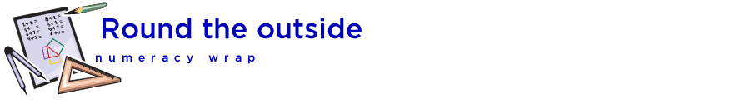

## Teaching notes

This numeracy wrap addresses the following syllabus outcomes from NSW K-10 Mathematics Syllabus 2012, © NSW Education Standards Authority, NSW:

**Measurement and Geometry**

**MA3-9MG** selects and uses the appropriate unit and device to measure lengths and distances, calculates perimeters, and converts between units of length

Students will:

• calculate perimeters of common two-dimensional shapes, including squares and rectangles

• select and use the appropriate unit and measuring device to measure lengths and distances

• make different shapes from given perimeters

|  |  |
| --- | --- |
|  | Students will use the Shodor interactive to generate random squares and rectangles of a given area and find the perimeter of each one. They should begin by setting up a table in Excel or a note-taking program to keep track of the height, width, area and perimeter of each shape. Once students have filled in a few rows, ask them about patterns, and guide them towards the formula for perimeter of a square and rectangle. |
|  | Students will be looking for pictures of things that are best measured with different tools. Make sure to ask students if they know of other tools they could use to measure distance. Students can use presentation software to group tools and things together. |
|  | 1. Students can use the PhET interactive to construct shapes, compare them, or test themselves to build shapes of a particular area or perimeter. |