Stage 2 Geography and Visual Arts – Sustainability and Sydney Metro
Revesby Public School is a community-based metropolitan school situated 30 kilometres south-west of the centre of Sydney. The school is in a residential area in close proximity to both Revesby railway station and the M5 South West Motorway. The school has an enrolment of 332 students with 78 per cent of the population coming from language backgrounds other than English. The school has 12 mainstream classes (K-6) and three support classes for students with disabilities (mild intellectual disability [IM], moderate intellectual disability [IO] and autism).

Sustainability and Sydney Metro
Stage 2 (3 composite classes) – duration 10 weeks (3 lessons per week)

Unit context
This unit was written by Athanasia Radic, Joan Henry, Christina George and Louise Tate of Revesby Public School.
It was created, trialled and peer reviewed as part of a professional development program in inquiry-based learning for primary and secondary school teachers. The professional development courses were part of a pilot partnership between the NSW Government’s Sydney Metro transport agency and Western Sydney University. Facilitated by Western Sydney University’s Education Knowledge Network, the professional development program aimed to develop teacher expertise in inquiry-based learning using a real-life example of a major infrastructure project in delivery stage.
The unit is aligned to NSW Education Standards Authority (NESA) syllabuses specifically the Geography K-10 Syllabus (2015) and Creative Arts K-6 Syllabus (2006) and the Australian Curriculum.
Sydney Metro is Australia’s biggest public transport project.

Syllabus outcomes and cross-curriculum priorities
Geography | Sustainability | Visual Arts
GE2-2 describes the ways people, places and environments interact  GE2-3 examines differing perceptions about the management of places and environments | Designing action for sustainability requires an evaluation of past practices, the assessment of scientific and technological developments, balanced judgments based on projected future economic, social and environmental impacts. | VAS2.2: uses the forms to suggest the qualities of subject matter  - investigate various construction techniques and spatial arrangements suited to the interpretation of selected subject matter in sculpture and in other three-dimensional work including installations and ceramics.  VAS2.4: identifies connections between subject matter in artworks and what they refer to, and appreciates the use of particular techniques  - identifies resemblances between subject matter in artworks and the features of things as they exist in the world, recognising similarities and differences in how things are represented in the artworks  - expresses opinions about how well subject matter that is represented in particular forms refers to the world, and appreciates the skills involved to achieve these effects  - to talk and writes about the meaning of artworks in terms of how subject matter realistically represents things in the world.

Sydney Metro Stage 2, Term 3 – Sustainability
Four quality questions
Intellectual quality  Where are the students now? | Significance  Why does the learning matter? | Deep understanding  What do we want our students to learn? | Explicit quality criteria  How will we know the students get there?
The students in Stage 2 have a limited understanding of Sydney Metro. Based on pre-assessment data almost 100% of students have very little understanding of sustainability and this will need to be a focus in English to build background knowledge.  Through English lessons the students will immerse in content knowledge about the Sydney Metro and sustainability. This will become their focus in reading and writing.  Our students are engaged learners who seek a challenge and are highly motivated. | Sydney Metro is part of the students’ future lives. It is a real world connection that will impact their ability to move around Sydney with the estimated finish date of 2019 for stage 1 and 2024 for stage 2. By this time, the cohort of Stage 2 students who piloted this unit will be approximately 14 years old. It is highly likely that they will use the Sydney Metro from the Bankstown Station as a form of travel.  We need to teach our students the importance of making sustainable decisions for the benefit of future generations.  The general capabilities of the NSW syllabus identify the following areas that will be a focus of our project:  - sustainability  - information and communication technology capability. | Geography – sustainability  We want our students to have a deep understanding of how Sydney Metro designers have taken measures to minimise their impact on the environment. We want them to apply this knowledge of sustainability to creatively design and create a sustainable train station of the future.  Creativity  We want our students to become creative thinkers who take risks in their learning and have the ability to generate new ideas. Through this project we will be focusing on the student’s creative resolution. This is teaching the students how to use the design thinking process and feedback to think creatively to redesign and improve their train stations. | Teachers will use formative assessment strategies to assess students against the explicit learning intention and success criteria throughout each part of the project.  Individually: Students will be pre and post assessed using a ‘Know, want-to-know, learnt’ (KWL) chart. This will assess student understanding across a range of content, including:  - heritage  - energy and carbon  - demolition, waste and recycling  - biodiversity (plants)  - climate change (air quality)  - water use and efficiency  - noise pollution.  Students will be assessed against a success criteria with a focus on:  - creativity resolution  - KWL chart assessing knowledge of sustainability  - sustainable train station  - presentation of learning using the design thinking process.

Driving Questions
How can we as architects design a sustainable train station of the future?

Focus questions
- What is sustainability?
- How and what measures has Sydney Metro taken to minimise the impact on the environment?
Project calendar and key steps
Week | Method of inquiry  Design thinking process | Lesson 1 | Lesson 2 | Lesson 3
1 | Introduction | Pre assessment  KWL chart | Introduction to project and building background knowledge  Video introducing Sydney Metro such as ‘Sydney Metro: Fast Tracking the Future education program an introduction for primary school students’ (Transport for NSW, 2019) (4 minutes 1 second)  Video: Sydney Metro project update (advanced). See Australia's Biggest Public Transport Project | Sydney Metro for the latest video. | Building background knowledge  Why are we doing the project? (Purpose)
2–3 | Define the challenge | Building background knowledge Why is Sydney Metro important?  - To reduce traffic congestion  - Growing population  - New suburbs  Share the driving question: How can we as architects design a sustainable train station of the future? | Building background knowledge – Why is Sydney Metro (or the metro) important?  - Easy access to the city  - Provide more work  - Decrease noise pollution  - To save and conserve energy and carbon in our environment  - To save money | Building background knowledge – What is ‘sustainability’?  - Heritage  - Energy and carbon  - Demolition waste and recycling  - Biodiversity (plants)  - Climate change (air quality)  - Water use and efficiency  - Noise pollution
4–5 | Brainstorm ideas  Improve/redesign | Stage 3 Joeys Cup winners present their sustainable city.  Choose teams  Introduce the assessment success criteria  Introduce the design thinking model PBL Consulting 2016) as a process that can guide inquiry. | In teams, brainstorm how you are going to make your train station sustainable. Outline at least 5 elements of sustainability you will include. Use the design thinking process poster and the brainstorm scaffold on page 22 of this document.  Provide an example or two if needed. | Plan/design  Review your ideas from the brainstorm session. Pick the best ones and sketch out some preliminary designs.  Assessment  Assess students against the success criteria - creativity.  - What resources will be needed?  - How will they source them?  - Refer to success criteria.

Week | Method of inquiry  Design thinking process | Lesson 1 and 2 | Lesson 3
6 | Improve/redesign  Plan  Create train station | Gallery walk  Students provide feedback to improve the ideas generated in their brainstorm from the previous lesson.  Refer to the brainstorm scaffold on page 22 of this document. Develop and communicate a gallery walk feedback protocol (for example. feedback needs to be kind, specific and helpful Ron Berger) and conduct a gallery walk. See the NSW Department of Education’s ‘How do I use a gallery walk’ for ideas.  Students undertake a gallery walk and use the peer feedback to improve their design.  Refer to success criteria. | Use the SCAMPER model to improve plans from the previous lesson. Cards to support this activity may be found on pages 18-21 of this document.  Assessment  Assess students against the success criteria – creativity  Use the gallery walk feedback protocols. This time students give each other feedback using two stars and a wish.

Week | Method of inquiry  Design thinking process | Lesson 1 | Lesson 2 and 3
7 | Improve/redesign | Improve design using student feedback from previous lesson.  Assessment:  - Assess students against the success criteria – creativity. | Put final touches on train stations.  Assessment:  - Assess students against the success criteria – sustainable train station.

Week | Method of inquiry  Design thinking process | Lesson 1, 2 and 3
8 | Create presentation | Refer to the success criteria. If you have access to technology, students can be encouraged to use a range of digital presentation tools including  - Google Slides  - Microsoft PowerPoint  - Apple Keynote or others.

Week | Method of inquiry  Design thinking process | Lesson 1 | Lesson 2 | Lesson 3
9 | Speeches | Catch up | Speeches and presentations  Assessment:  - Assess students against the success criteria. | Speeches and presentations  Assessment:  - Assess students against the success criteria.
10 | Share and design | Speeches and presentations  Assessment:  - Assess students against the success criteria. | Exhibition in the hall and invite the community | Post assessment:  Using the KWL chart, and the post assessment sheet on page 20-22 of this document, assess students against the success criteria – KWL.

Stage 2 Sydney Metro success criteria
Criteria | Presentation
Creativity | - We have used the design thinking process to redesign and improve our train station.  - We have used peer feedback to redesign and improve our train station design.  - We have used the SCAMPER model to improve our design.
KWL (knowledge of sustainability) | I have explained my understanding of sustainability on the KWL chart including:  - heritage  - energy and carbon  - demolition waste and recycling  - biodiversity (plants)  - climate change (air quality)  - water use and efficiency  - noise pollution.
Sustainability train station | - We have used all recycled materials to make our train station.  - We have at least 5 elements of sustainability in our train station.  - Our model is strong and can stand on its own.  - Our model looks appealing and interesting.  - We have a labelled sketch of our design including the elements of sustainability.  - We have included resources used in our labelled sketch.
Presentation | Our presentation includes:  - what we did at each stage of the design thinking process  - a definition of 'sustainability', in our own words  - information on the measures that were taken to minimise the impact of Sydney Metro on the environment, in our own words  - relevant and informative images/photos

Teaching and learning sequence
Week | Resources | Teaching and learning sequence
Weeks 1-3 | KWL Chart  Video links  Journals  (Optional) Information and communication technologies (ICT) for students to record their initial inquiries | Learning intention  We are learning about:  - sustainability  - elements of sustainability  - the connection between elements of sustainability and Sydney Metro.  Success criteria  To be successful we will:  - ask questions and understand how to use the marking criteria to achieve success  - understand the design thinking process.  Inquiry questions  - What is sustainability?  - What are elements of sustainability?  - What elements of sustainability have considered by Sydney Metro?
Weeks 4-5 | Joeys Cup  Pictures of Joeys Cup 2017 Challenge  STEM roles resource on page 15 of this document.  Sticky notes  Design thinking process poster  Poster Plan/design proforma on page 13 of this document. 1 per group printed on A3 paper.  1 folder per group to organise their resources  1 copy of the marking criteria per group for folders. | Learning intention  We are learning about:  - our Sydney Metro project and how we will be assessed  - the design thinking process.  Success criteria  To be successful we will:  - ask questions and understand how to use the marking criteria to achieve success  - understand the design thinking process.  Inquiry questions  - What is sustainability?  - What are elements of sustainability?  - What elements of sustainability have considered by Sydney Metro?  Share the Joeys Cup winning design and trophy. Discuss the Joeys Cup challenge and share pictures of the day  Choosing teams: Do not reveal to the students that you will be using this information to choose the teams.  Discuss STEM roles and ask students to choose two that best describe them. Roles include challenge captain, materials master, testing coordinator, chief architect and rapid reporter. Students put their names on two sticky notes and place them against STEM roles on posters around the room. The teacher takes this information and their knowledge of the students to create strong teams.  Introduce the assessment success criteria  Explain to the students that this is what success looks like and it is how the teachers will be assessing them.  Introduce the design thinking model as a process of inquiry  Explain to the students that we will be using this process throughout each stage of the project. Display the design thinking poster.  Learning intention  We are learning about:  - plan our train station design.  Success criteria  To be successful we will:  - work as a team to sketch a train station design with 5 elements of sustainability  Explain to the students that we are in the planning phase of the design thinking process.  Display the design thinking process poster (PBL Consulting, 2016) on interactive whiteboard.  Remind the students about the criteria for marking the train station. Display this on interactive whiteboard.  Using the plan/design proforma, in project teams the students sketch a draft of their train station designs. They outline what elements of sustainability they will address, what resources they will need and how they will get those resources.
6 | Sticky notes  Gallery Walk instructions on page 15 of this document | Learning intention  We are learning about:  - get feedback to improve our design use a gallery walk to give each other feedback.
7-8 | Recycled materials  Design thinking process poster  STEM roles poster  (Optional) Computers, laptops, iPads  or other ICT resources  Stationery | Learning intention  We are learning about:  - make the train station using our design from the previous week  - give feedback to each group.  Success criteria  To be successful we will:  - modify design model using feedback from our peers  - refer to the design thinking process.  Students build their design over the next two weeks. Remind students of their roles and responsibilities.
9 | (Optional) Computers, laptops, iPads or other ICT resources  Success criteria on page 7 of this document  Design thinking process poster  Journals | Learning intention  We are learning about:  - complete our model of a train station  - present our project.  Success criteria  To be successful we will:  - work collaboratively to present our model and presentation  - refer to the criteria to ensure all questions are answered  - address the elements of sustainability used in the project  - define what is sustainability  - use evidence and photos in our presentation.
10 | (Optional) Computers, laptops, iPads or other ICT resources  (Optional) The school hall as presentation space | Learning intention  We are learning about:  - present our model and presentation to the community  - (optional) use a digital presentation software, for example Google Slides, PowerPoint or Keynote.  Success criteria  To be successful we will:  - present to the community and explain our projects  - address the elements used on our model  - show how we have linked the ideas for our design to the measures taken by Sydney Metro when they designed the Metro.

KWL chart
K  What I know or think I know | W  What I want to know | L  What I learnt

Plan/design
Team members:
Sketch your design (include your 5 elements of sustainability)
What resources will be needed?
Where will you get your resources from?

Gallery walk
Set-up  Hang posters and distribute sticky notes. | 5 minutes
Gallery walk and feedback  Silently record feedback on posters using sticky notes with reflections starting with ‘I like’ and ‘I wonder’.  Give at least one ‘I like’ and one ‘I wonder’ per poster. | 20 minutes
Reflection  Reflect on the feedback to revise and improve your work. | 5 minutes
TOTAL | 30 minutes

STEM roles
Challenge leader | Organiser of resources | Builder | Tester | Reporter
- Communicate the team’s decisions.  - Encourage and support team members to do their job.  - Record information on the lab sheet on behalf of the team. | - Organise and gather the team’s resources.  - Research and communicate the best way to use the resources to the team.  - Help other team members  - use resources correctly.  - Request resources if necessary. | - Coordinate building as needed.  - Decide which ideas to build.  - Suggest when a test might be needed for the challenge.  - Make sure the team is building in a safe way.  - Ask for help building if needed.  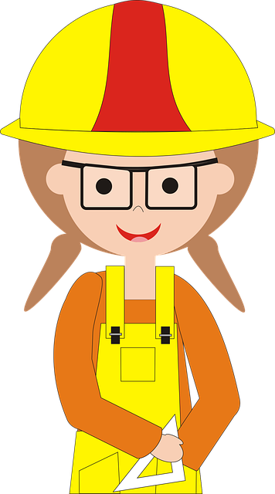 | - Decide when ideas need to be tested.  - Create and coordinate tests of the team’s ideas.  - Determine when the team is successful in the challenge.  - Ask for additional time to test if needed. | - Share the team’s ideas.  - Explain the team’s solution.  - Describe any challenges the team encounters.  - Answer any questions from others about the challenge
Images Left to right: Mohamed Hassan from Pixabay, Mohamed Hassan from Pixabay, Alejandra Jimenez from Pixabay, OpenClipart-Vectors from Pixabay.
All images on this page are free to use according to the Pixabay License

S
Substitute
A
Adapt
C
Combine
M
Magnify / Modify / Minimise
by lowrieedwards03. Downloaded from https://www.tes.com/teaching-resource/scamper-cards-11778439
Substitue
- Can I replace or change any parts?
- Can the rules be changed?
- How can I change the materials or processes?
- What would happen if I swapped A to B?
- What can I substitute to make an improvement?
Adapt
- What other products / processes are similar to our problem?
- What can we change to adapt them to our problem?
- What part of the product can I change?
- What could I copy, borrow or steal
Combine
- What materials, features, processes, products or components can we combine?
- Can I combine or merge it with other objects?
- What idea or parts can be combined?
- Where can I build synergy?
Magnify / Modify / Minimise
- How can I modify the process in some way?
- What can be exaggerated or overstated?
- What can be magnified or made larger?
- What can be duplicated? Can I make multiple copies?
- Can I add extra features or somehow add value?

by lowrieedwards03. Downloaded from https://www.tes.com/teaching-resource/scamper-cards-11778439
P
Put to other uses
E
Eliminate
R
Rearrange or Revert
by lowrieedwards03. Downloaded from https://www.tes.com/teaching-resource/scamper-cards-11778439
Put to other uses
- What else can this be used for?
- Are there any possible uses if it’s modified?
- How could someone else use this?
- Are there other ways to use this in its current
shape/form?
Eliminate
- What can I substitute to make an improvement?
- How can I simplify this?
- What feature can I take away?
- Can I compact the product or make it smaller?
- What non-essential or unnecessary?
Rearrange or Revert
- Can I interchange components?
- Are there other patterns, layouts or sequences that can be used?
- What if I try doing the exact opposite of what I originally intended?
by lowrieedwards03. Downloaded from https://www.tes.com/teaching-resource/scamper-cards-11778439

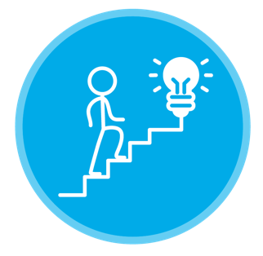

How will your train station be sustainable?
What will you include in your model?
Sustainability consideration 1: | Sustainability consideration 2:
Resources needed: | Resources needed:

Sustainability consideration 3: | Sustainability consideration 4:
Resources needed: | Resources needed:

Sustainability consideration 5

Resources needed:

What is sustainability?
How can we help sustain our environment?

How have humans impacted the environment?

What were the 5 elements of sustainability addressed by your design and why were they used?

Sustainability element 1:

Sustainability element 2:

Sustainability element 3:

Sustainability element 4

Sustainability element 5:

How have you linked your ideas for your design to the measures taken
by Sydney Metro when they designed the Metro?

YouTube resources for sustainability project
Sustainability | ‘What is sustainability?’ (MacomiKids, 2013) (2 minutes 53 seconds)  https://youtu.be/gTamnlXbgqc
Sustainable energy | ‘Renewable energy’ (Stephen Berger, 2016) (4 minutes 52 seconds)  https://youtu.be/1sI_ot8qoXE  ‘Different sources of energy, using energy responsibly. Educational video for kids’ (KidsEduc , 2014) (18 minutes 40 seconds)  https://youtu.be/wMOpMka6PJI  ‘Renewable energy explained in 2 ½ minutes’ (Dane Bliss Design, 2015) (2 minutes 40 seconds)  https://youtu.be/KEeH4EniM3E
Carbon sustainability | ‘Explaining carbon neutrality’ (ACCIONA, 2016) (2 minutes 25 seconds)  https://youtu.be/9pPsso2acew
Noise pollution | ‘What is noise pollution?’ (Cine Kids, 2014) (1 minute 15 seconds) https://youtu.be/O1-W7gz6Znk
Air quality | ‘Air pollution for kids’ (It’s AumSum Time, 2015) (4 minutes 57 seconds) https://youtu.be/sAKyhfxxr7s
Biodiversity and sustainability | ‘Why is biodiversity so important?’ (Ted-Ed, 2015) (4 minutes 18 seconds) https://youtu.be/GK_vRtHJZu4  ‘Sustainability and biodiversity’ (Erin Mitchell, 2013) (9 minutes and 18 seconds) https://youtu.be/JUCOycwy-fY
Water pollution | ‘Water pollution for kids’ (It’s AumSum Time) (2 minutes 47 seconds) https://youtu.be/93BqLewm3bA  ‘Animated lesson to learn about water pollution’ (Turtlediary, 2012) (3 minutes 1 second)  https://youtu.be/y1ObvXZDQNs
Heritage | ‘Modern infrastructure development and heritage restoration working together in Jaipur, India’ (Livable Cities, 2017) (6 minutes 53 seconds) https://youtu.be/eVfyEkxT2zM
Energy | ‘Energy: The Dr. Bincos Show’ (Peekaboo Kids, 2015) (4 minutes 13 seconds) https://youtu.be/Q0LBegPWzrg  ‘What is energy? Lesson for Kids’ (25SDA, 2013) (1 minute 14 seconds) https://youtu.be/wyVF6R9e6xE
Climate change | ‘Climate change: Crash course kids #41.2’ (Crash Course Kids, 2016) (3 minutes 40 seconds)  https://youtu.be/SzcGTd8qWTg

Photos from the unit and work samples

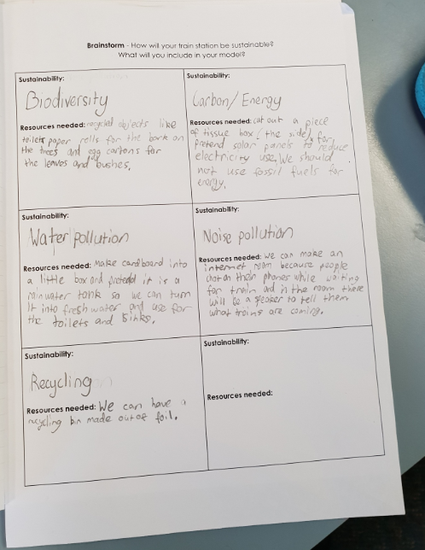
Brainstorming
In groups, students worked together to define the elements of sustainability and how they could consider it in their designs. They had to plan what resources were needed to design their sustainable model
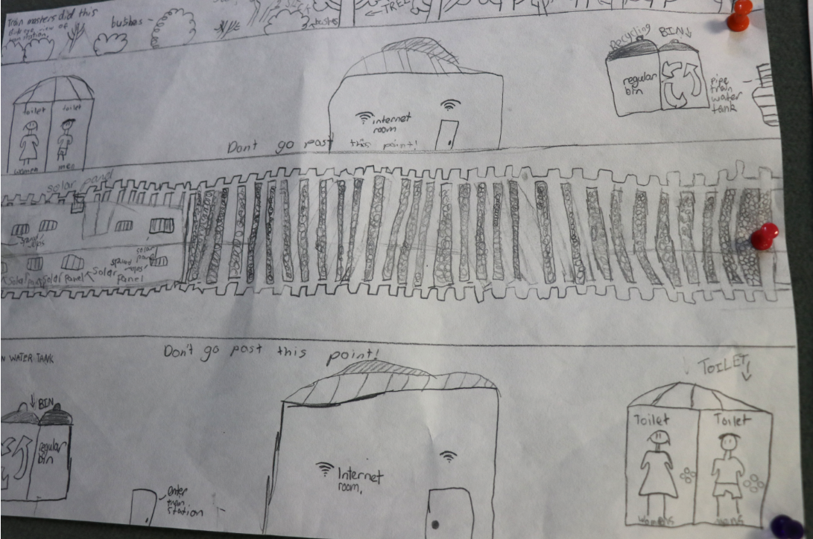
Plan/design
Students worked in small groups sketching their sustainable train station. They had to use 5 out of the 7 elements of sustainability in their plan.
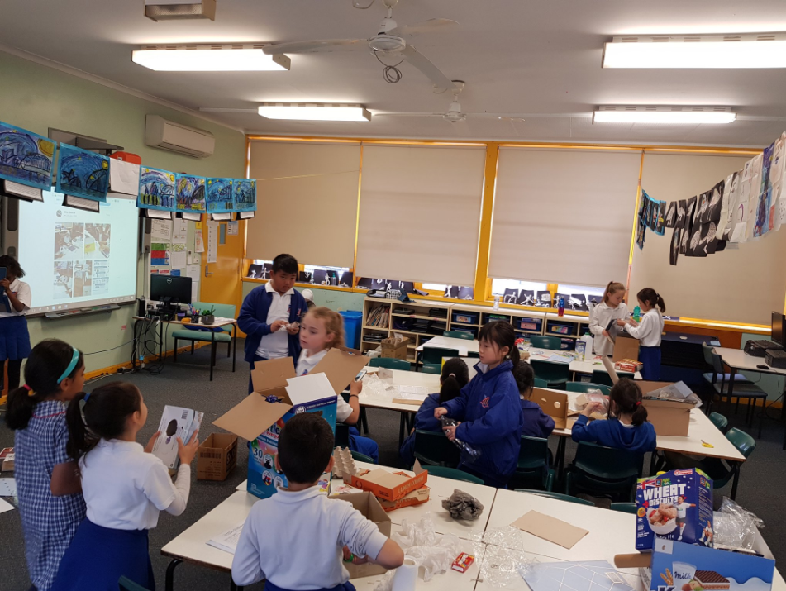
Create/develop
Students brought in recycled materials as this was one of the requirements. They started constructing their sustainable train station.

Photos from the unit and work samples
Students working collaboratively to complete their projects.
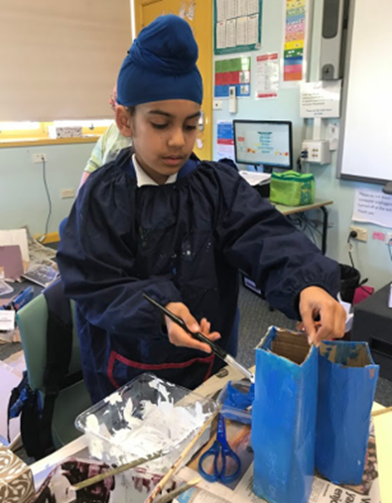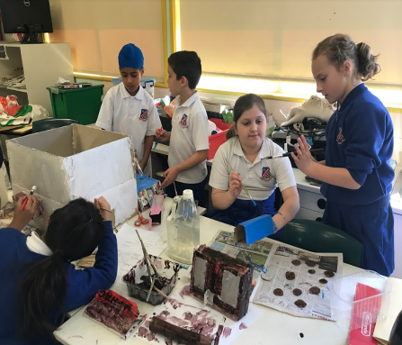

Teacher reflection on the unit and inquiry-based practices

What worked well?
- Using the expertise of staff members on the project such as IL and librarian who were previously trained in Project Based Learning.
- Working collaboratively with stage teachers during and after hours to ensure all teachers had a deep knowledge and understanding of the content and skills to be taught.
- Making students accountable and having authentic experiences.
- Gallery walks where students learnt to appreciate critiques from their peers- this enabled them to use feedback to improve their design.
- Involving community through our celebration of the project where students presented their model and PowerPoint displays to parents, teachers, peers and other community members.
- Continual reflection and evaluation of lessons by students and teachers was powerful as it allowed continuous success throughout the unit of work.

What were our challenges?
- Time - Teachers needed to stay back after hours to design our inquiry-based unit of work. Extra stage meetings were needed.
- One of our stage teachers was absent due to illness which affected the planning and teaching of the project to his class.
- A few students had difficulty understanding their roles and responsibilities

Copyright
© State of New South Wales (Department of Education), 2019
The copyright material in this publication is subject to the Copyright Act 1968 (Cth), and is owned by the NSW Department of Education or, where indicated, by a party other than the NSW Department of Education. Copyright material which is owned by the NSW Department of Education is licensed under a Creative Commons Attribution 4.0 International (CC BY 4.0) licence.
This licence allows you to:
- share – copy and redistribute the material in any medium or format
- adapt – remix, transform and build upon the material for any purpose, even commercially.
Attribution should be given to:
© State of New South Wales (Department of Education), 2019.
Material in this publication not available under a Creative Commons licence includes:
- the Department of Education logo, other logos and trademark-protected material
- material owned by a third party that has been reproduced with permission. Permission will need to be obtained from the third party to re-use this material.
If this publication contains your work and you have an objection to such content, please contact legal@det.nsw.edu.au.

Links to third-party websites
If you use the links provided in this publication to access a third party’s website, you acknowledge that the terms of use, including licence terms set out on the third party’s website apply to the use which may be made of the materials on that third party’s website or where permitted by the Copyright Act 1968 (Cth).
The department accepts no responsibility for content on third-party websites.

https://youtu.be/JisOoSjIzv4
https://www.sydneymetro.info/
https://docs.wixstatic.com/ugd/bff196_cbc590e97c8343d6ac74ea8c1f5561a2.pdf
More information on gallery walks can be found on the NSW Department of Education website at https://education.nsw.gov.au/teaching-and-learning/school-learning-environments-and-change/future-focused-learning-and-teaching/Future-focused-resources/gallery-walks2#How2
SCAMPER is a series of questions designed by Bob Eberle to promote fluency at the ideate phase of the design thinking process.
Two stars and a wish’ is a strategy to support students to evaluate peers. Students identify two positive aspects of the work of a peer and then convey a wish about what the peer might do next time in order to improve an aspect of their work.
The Joeys cup is a fun, innovative and educational program offered by our high school partners at Sir Joseph Banks High School, offering the opportunity for feeder primary schools to compete in a design challenge, assisted by student mentors and teachers from Sir Joseph Banks High School. When this unit was undertaken, the topic for the Joey’s Cup. https://sirjosephb-h.schools.nsw.gov.au/news/2017/6/joeys-cup1.html

