Boogie Woogie Woogie Woogie Boogie (S2-S3)
Vocal Ease More

Songs we love to sing – how do patterns make music?
- Watch a short video overview by the composer (0:36)
- Watch a short video overview of the teaching points (0:51)
- Listen and follow the music score (3:00)
- Listen to the full performance (2:58)
- Listen to the backing track (2:58)
- Access the lyric sheet (pdf)

Background to Boogie Woogie Woogie Woogie Boogie
Boogie Woogie Woogie Woogie Boogie uses a boogie woogie shuffle feel to introduce the sounds of different instruments. Boogie woogie is a genre of music that became popular in the 1920’s and was mainly associated with dancing. It was developed in African American communities in the 1870’s in the United States.
The Boogie woogie style and this piece, the Boogie Woogie Woogie Woogie Boogie, are based on the 12-bar blues. This features chords I (1), IV (4) and V (5) in a pattern of:
Bar | 1 | 2 | 3 | 4 | 5 | 6 | 7 | 8 | 9 | 10 | 11 | 12
Chord | I | I | I | I | IV | IV | I | I | V | IV | I | I
Note in C | C | C | C | C | F | F | C | C | G | F | C | C
The 12-bar blues is also the foundation of the dance known as the jive. The jive features simple and reusable steps that transfer easily across boogie woogie samples of music and that lend themselves to further experimentation.
Listen to examples of boogie woogie piano players such as Fats Domino (2:25), Ray Charles (2:00), Fats Waller (3:08), John Lee Hooker (3:33) and Winifred Atwell (2:07) to introduce the Boogie Woogie Woogie Woogie Boogie.
In this piece however, band instruments such as the guitar (12:50), bass guitar, drums, piano and saxophone are used additionally to the voice. Listen to the instrumental sounds.
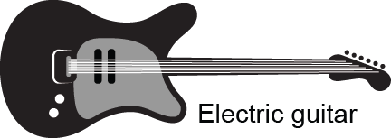
Rhythm guitar sample (0:19) and lead guitar sample (0:08)
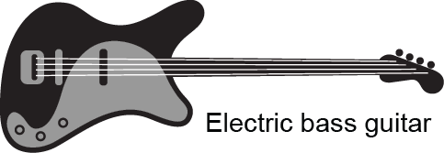
Double bass sample (0:13)
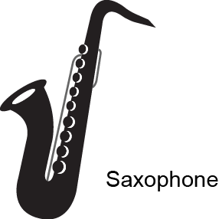
Tenor saxophone sample (0:13)
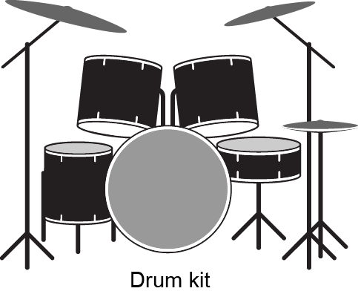
Drum sample (0:11)
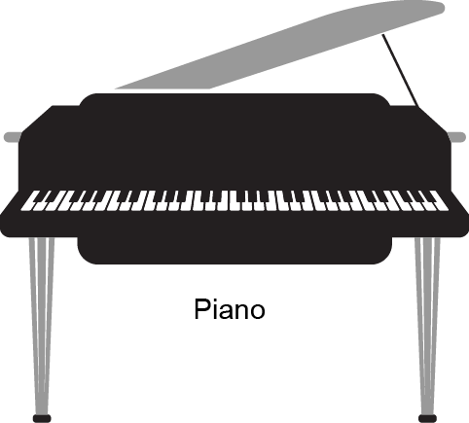
Piano sample (0:20)

Quick start menu
- Listen to the Boogie Woogie Woogie Woogie Boogie and keep the beat. Add movement to help identify the different sections of the music. Learn to dance a jive. Build up to singing the full version of the song. Perform if you wish.
- Learn about the instruments used in this song and the boogie woogie style.
- Learn to dance the jive.
- Explore chords I, IV, V (in this case C, F, G) and add instruments to represent the different sections.
- Improvise different rhythms and notes within the chords of the 12-bar blues.

Key to icons

Concepts of music
Duration
Pitch
Dynamics
Tone colour
Structure

Learning experiences
Performing
Organising sound/composition
Listen
© Outcomes and other elements of the syllabus used in this document are copyright Creative Arts K-6 Syllabus (NESA)

Learning across the curriculum
General capabilities | Other learning across the curriculum areas
Critical and creative thinking  Information and communication technology capability  Intercultural understanding  Literacy  Numeracy  Personal and social capability | Difference and diversity

Get familiar

Outcomes and purpose

MUS2.1
MUS2.2
MUS3.1
MUS3.2
To learn about the boogie woogie style.
To sing a song for fun.
To keep the beat.
To use movement and dance to reinforce musical concepts.

Learning experiences | Activities S2-3 | Concepts of music | Watch the lesson
Context – with the words displayed listen to the song. Reflect upon what style of music the song is and how we know? Discuss and explore the instruments used the saxophone, guitar, bass and drums. Focus on the lyrics and discuss their meaning.
Discuss the boogie woogie as a musical style. Explore some YouTube clips of famous musicians of this style such as Fats Domino, Fats Waller.
Compare their music to this example of the Boogie Woogie Woogie Woogie Boogie by focusing on instruments, lyrics, overall feel and so on.
Keep the beat – with words displayed, keep the beat whilst listening to the recording of the full song. Try this a few times with a variety of methods for beat keeping including movement (such as stepping), clapping or other body percussion (such as clicking or patsching).
Practice singing the song through using the words. Dramatise the words to reinforce the meaning.
 | Investigate the music – listen to the song and discuss the changes in the way the music sounds. Discuss how in the boogie woogie style of music there are constant changes in the chords but the chords are always on the same notes.  Allocate a different set of body percussion movements to each chord. For example, patsch for chord I, clap for IV and shoulders for V. Try this with the full recording of the song to reinforce the chord structure. |  | 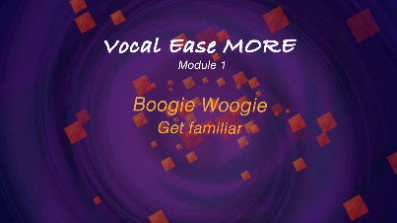  (1:46)
 | Move – using the words as stimulus, students could improvise movements to match the song. Practice whilst singing the words. This will reinforce the lyrics.  Learn the simple steps of this modified version of the Jive as a dance form. Start slowly and when comfortable add these steps to the song.  Once firmly established, teach the students the full basic jive steps. Add these to the song as appropriate. |  | 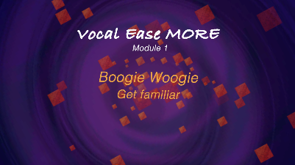  (1:29)  (1:30)
 | Perform – sing with the complete recording of the song. Add movement at a level appropriate for the students.

Spice it up

Outcomes and purpose
MUS2.1
MUS2.2
MUS2.3
MUS2.4
MUS3.1
MUS3.2
MUS3.3
MUS3.4
Explore the 12-bar blues chord structure.
Learn about chord accompaniments.
Use these chords to assist in creating new versions of the song.

Learning experiences | Activities S2-3 | Concepts of music | Watch the lesson
 | Keep the beat – revise the song by singing and keeping the beat using some form of body percussion or movement. Repeat one of the activities previously completed.
 | Accompaniment – repeat the chord activity above, changing body percussion to match the chords of the music. Using three different types of non-melodic percussion, play the beat for each of the three chords as they occur in the music. For example, tambourines for chord I, triangles of chord IV and maracas for chord V.  Using melodic percussion, ukuleles, boomwhackers or recorders, play on the beat of each chord as it occurs. Depending on your resources, divide into three groups to play just one chord or alternatively play the chord note of each – C, F or G.  You may also choose to use the recording of the 12-bar blues (2:34) which includes 8 cycles for the students to play along with. |  | 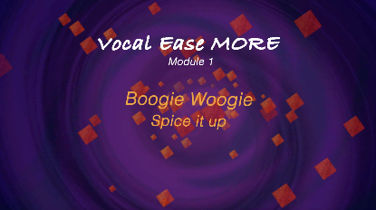  (1:45)
Experiment – using these chord notes as the basis, the students can experiment with different rhythms on the note for each chord. Again, group the students according to your resources. If melodic instruments are unavailable, use different non-melodic instruments for each chord and improvise different rhythms on each in turn.
During the sections ‘Let’s hear some…’ rest and listen or move. Alternatively use this as a brief chance to swap instruments or notes.
You can also use this track without instruments (2:59) to substitute your own instrument in. For example, 'Let's hear some triangles' or 'Let's hear some claves' and so on.
 | Experiment some more – explore and play the notes of each chord. Remembering that a chord is made up of the 1st note, the 3rd note and the 5th note of the scale above it. Link it directly to mathematics.  C = CEG  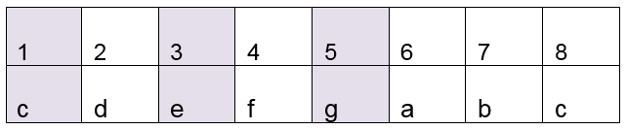  F = FAC  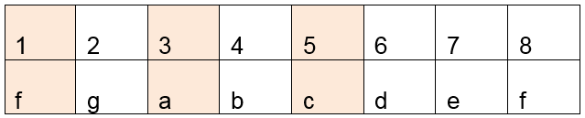  G = GBD  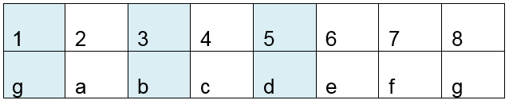 |  | 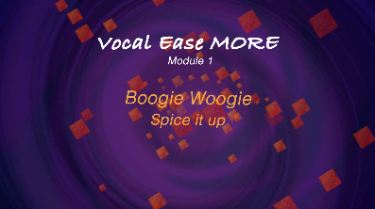  (1:36)
Experiment even more – start with the students in three groups. When it is time for their chord, have them improvise using the notes of their chord. Any of the notes of this chord will work in that section.
Explore the practiced methods of improvising by starting as a class, then in pairs, then individually.
Depending upon your resources, students may continue with just the notes of one chord as allocated and swap to different groups, or could try all three chords. This will require substantial preparation but will open the door to a great deal of improvisation activities with these chord patterns.
 | Perform – use your instrumental and movement accompaniments to enhance singing with the complete recording of the song or with the backing track.

Make it up

Outcomes and purpose

MUS2.1
MUS2.2
MUS2.3
MUS2.4
MUS3.1
MUS3.2
MUS3.3
MUS3.4
Improvise using call and response.
Investigate syncopation or playing off the beat.

Learning experiences | Activities S2-3 | Concepts of music
 | Call and response – using the backing track, change to different instruments during the call section. For example, ‘Let’s hear some triangles’ the triangles then respond with an improvised rhythm, then ‘Let’s hear some boomwhackers’ and the boomwhackers respond and so on.
 | Improvise together – as a class, explore different rhythms that can be clapped to accompany the whole song as an ostinato. For example,
 | Improvise in pairs – with a partner the students can think, pair, share a rhythmic ostinato. Sit in a circle. As a whole class, have each pair give their rhythmic ostinato. Depending on the size of the class, start with 8 beats each pair.
Improvise alone – repeat the above steps but this time the students individually provide their ostinato.
If the students are struggling with using all these rhythms, encourage them to just keep to the offbeat that is just clap on beats 2 and 4. For example,
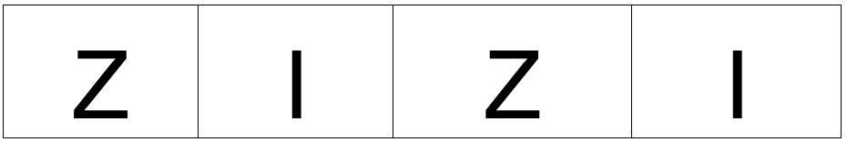
Extend it – write your own version of the Boogie Woogie Woogie Woogie Boogie. Do this by changing the existing lyrics and adapting them to a class theme or student created texts. Use either the same melody or create your own to suit the backing track provided.
Arrange it with instruments, ostinatos, movement or dance as your desire. Perform and record it.

Where to from here?

Purpose
- Use the 12-bar blues as a way of extending improvisation and other organising sound activities.
- Sing more songs from a variety of historical periods.
- Explore the relationship between music and dance.

Activities S2-3
- Explore jazz and blues music to sing to dance with.
- Dance the jive to a variety of boogie woogie music.
- Change the words to the Boogie Woogie Woogie Woogie Boogie to make your own version.
- Use the 12-bar blues as a means to compose a variety of music, including using student composed texts.
- Research a variety of songs that are fun just to sing. These songs can be on a variety of topics and to suit class themes, student or teacher choice.

- What are scale and chords and why do we have them? Are they universal around the world? What would music sound like without them? What is atonal music?
- Why did the 12-bar blues start and what is its role in music? Explore the patterns and notes in each key. Investigate the number of beats and arrays of notes within patterns. Tune bottles to the 12-bar blues in C (C, F, G).
- What is the circle of 5ths? How does it relate to music and what is its relationship to mathematics?
- Create instruments that can be used in the 12 bar blues or in the boogie woogie style. These might include a carrot saxophone/clarinet (3:00) or making guitars (2:24). Explore their shapes, requirements, measurements. Why are these created this way, and can they be altered?
- Science and Technology - use technology to record, enhance or change the song or to make a new one.
- Creative Arts – Visual Arts: investigate the blues and how this relates to visual art. Explore famous artists who used a lot of blue such as Matisee and Van Gogh. Examine the meanings of colours. Create artworks which reflect emotions, by selecting a colour to match that emotion. Dance: explore the jive in other contexts and with other pieces. Experiment with dancing to a variety of jazz and blues pieces and styles.
- English – examine the lyrics of this song. What do they mean? What is the role of rhyme and repetition in this song and other examples of this style of composition? Create your own lyrics to incorporate into this song or to create a new one.
- HSIE – History: explore the history of the boogie woogie style. What is the social story of America in the years 1920-1945. What was happening in Australia at this time? Geography: where is America? Investigate its states. Can you find any other folk tales from other countries that you could use in a song?
- PD/H/PE – discuss interacting with others, conflict resolution, sensitivity to others, interpersonal relationships, social and emotional growth and development, friendships, personal and family identity. Problem solve and discuss strategies and actions for dealing with difficult situations.

