# **Early intervention and Kindergarten – DoE specialist support services for students with disability**

## **Early intervention specialist support**

### There are five specialist support provisions for children who meet the DoE criteria for disability prior to school, **two** of which are via an Access Request.

* **Early Intervention Support Class (EI):** via an Access Request. There are a limited number of classes for children who meet the DoE criteria for disability from the age of three to school entry. Children attend for 2.5 hour sessions, two to three days a week. Class sizes range from five to eight children depending on the support needs of the children in the class. <https://education.nsw.gov.au/teaching-and-learning/curriculum/early-learning/early-intervention>
* **Early Intervention Resource Support:** via an Access Request. For children who meet the DoE criteria for disability from the age of three to school entry. The early intervention teacher travels to the child care centre or preschool to provide regular support on a weekly or fortnightly basis. Early intervention teachers work in partnership with parents and carers and other support agencies to plan personalised learning and support, based on individual interests and personal care, health, social and wellbeing needs
* **Itinerant Support Teacher Hearing**: this support is available to children and families from birth. Assistant Principals Hearing and Vision conduct appraisal and make a recommendation for support. If only a sensory provision is required, an access request is not needed and the Assistant Principal Hearing and Vision can instigate the quick sensory application process.
* **Itinerant Support Teacher Vision**: this support is available to children and families from birth. Assistant Principals Hearing and Vision conduct appraisal and make a recommendation for support. If only a sensory provision is required, an access request is not needed and the Assistant Principal Hearing and Vision can instigate the quick sensory application process.
* **Transition Support Teacher Early Intervention:** A limited number of Transition Support teachers support children with disability or significant support needs and their families and teachers prior to school and in transition to preschool or kindergarten in a NSW public school. Access to a Transition Support Teacher Early Intervention is not by access request but via referral from local schools or local early childhood education services, early intervention services, health or therapy services. See <https://education.nsw.gov.au/teaching-and-learning/curriculum/early-learning/early-intervention>

## **Specialist support for school aged students with significant disability**

* See the following link on the Disability, learning and support homepage at: <https://education.nsw.gov.au/teaching-and-learning/disability-learning-and-support/programs-and-services>

## **Creating an Access Request for an early intervention specialist support service**

## **Responsibility for the Access Request for an early intervention class or resource**

## Access to early intervention classes and resource support is through an access request and the placement panel process. The Access Request and disability confirmation is managed and submitted by the local public school on behalf of the family where the student is new to DoE.

## **Early Intervention Access request set up page**

* The Access Request Author is responsible for ensuring that the child does not already have an SRN by completing a ‘Deep Search’ of ERN.
* On the Access Request set up screen choose the 4th check box ‘Summary profile EI (Early Intervention class and/or resource)

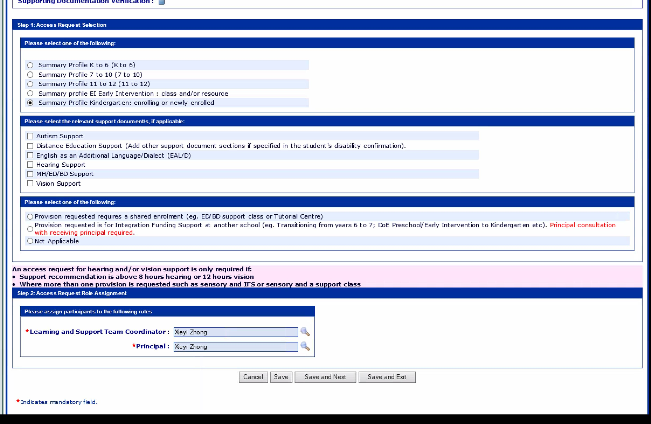

* Choose when the provision is required for.

The provision required is often for the following year, but may be immediate or the following term depending on when the Access Request is submitted.

## **Provision requested section**

* The provision requested page is completed by the Access Request Learning and Support Coordinator
* Early intervention provisions: choose 1 or 2 or 3 priorities as appropriate with the first priority being the parents preferred choice
  + Early Intervention Support Class (EI)
  + Early Intervention Resource:
  + Itinerant Support Teacher Hearing (access request only required if more than one provision is being requested e.g. ISTH + IFS, or ISTH + support class)
  + Itinerant Support Teacher Vision (access request only required if more than one provision is being requested e.g. ISTH + IFS, or ISTH + support class)
* A student can be supported in a class ‘OR’ with a resource. Vison and hearing support is not mutually exclusive. As an example a child could be supported in a class ‘AND’ with sensory support.

|  |
| --- |
|  |

## **Responsibility for the Kindergarten Access Request**

# **Kindergarten Access Request for a student who will be new to DoE**

The family’s local public school completes the Access Request for a student starting Kindergarten who has not been in any DoE specialist support program prior to school. It is important to do a ‘Deep Search’ in ERN to ensure there is not a previous Access Request and/ or SRN.

## **Kindergarten Access Request for a student currently attending a DOE preschool**

When a child is enrolled in attendance at a NSW Department of Education preschool the Access Request is completed by the staff at that school. The student is already enrolled in attendance at the school as a census enrolment so the school creates an Access Request for a student ‘currently registered at the school.’

## **Kindergarten Access Request for a student currently in an Early Intervention class**

When a child is enrolled in attendance in an Early Intervention support class the Access Request is completed by the staff at that school. The student is already enrolled in attendance at the school so the school creates an Access Request for a student ‘currently registered at the school’.

Where the student is enrolled in a department preschool and an early intervention class the setting that has the census enrolment is responsible for the Access Request. With agreement, staff from both settings are able to be added to Access Request roles after the census school principal adds them in the school’s AMU (Access Management Utility) as an ‘Access Request participant’.

## **Kindergarten Access Request for a student currently receiving Early Intervention Resource Support**

When a child is supported through the early intervention resource program the Access Request is normally created through the child’s local school. The child will already have an SRN as this would have been created for the child to access resource support. **It is critical that another SRN is not created.** **See following section for further guidance.**

With agreement, the Early Intervention teacher is able to be added to Access Request roles by the local school after the principal adds them in the school’s AMU (Access Management Utility) as an ‘Access Request participant’.

## **Kindergarten Access Request for a student currently receiving Itinerant Support Teacher Early Intervention**

When a child is supported with an Itinerant Support Teacher Early intervention, the Access Request for Kindergarten is normally created through the child’s local school. I**t is critical that another SRN is not created so a deep search in ERN is required to check**. **See following section for further guidance.**

With agreement the Itinerant Support Teacher is able to be added to the Access Request roles by the local school after the principal adds them in the school’s AMU (Access Management Utility) as an ‘Access Request participant’.

## **Checking that the student does not already have an SRN**

In ERN the Access Request Author should always do a ‘Deep Search’ to ensure the child does not already have an SRN.

* When a student is new to the government school system and they do not already have an SRN you can ‘Create a new student and a new access request’ which automatically creates a new SRN. The status in this situation is ‘pre-enrolled’ with a status of registered or applied to enrol. You will notice that the child’s scholastic year is ‘Special’.
* If a student already has an SRN create a registration at your school for the student with a starting date of the following year as an example. Make sure you include their current SRN in their details. The registration form must be completed to the end of page 14 so the enrolment status is ‘Applied to Enrol (Risk-Assessed)’.

As soon as the student’s enrolment status is “Enrolled Risk Assessed” an Access Request for a student ‘*currently registered at the school’ can be created.* See the Access Request User guide for schools section 5 for further information.<https://education.nsw.gov.au/help/platoapps/media/documents/ern/qrgs/AccessRequest-Userguide-for-schools-October2018.pdf>

# **Creating a new Access Request for Kindergarten**

A new Access Request is required for Kindergarten.

If they are not as yet at school use the 5th check box in the following screen shot: “Summary profile Kindergarten: enrolling or newly enrolled”.

New screen shot needed

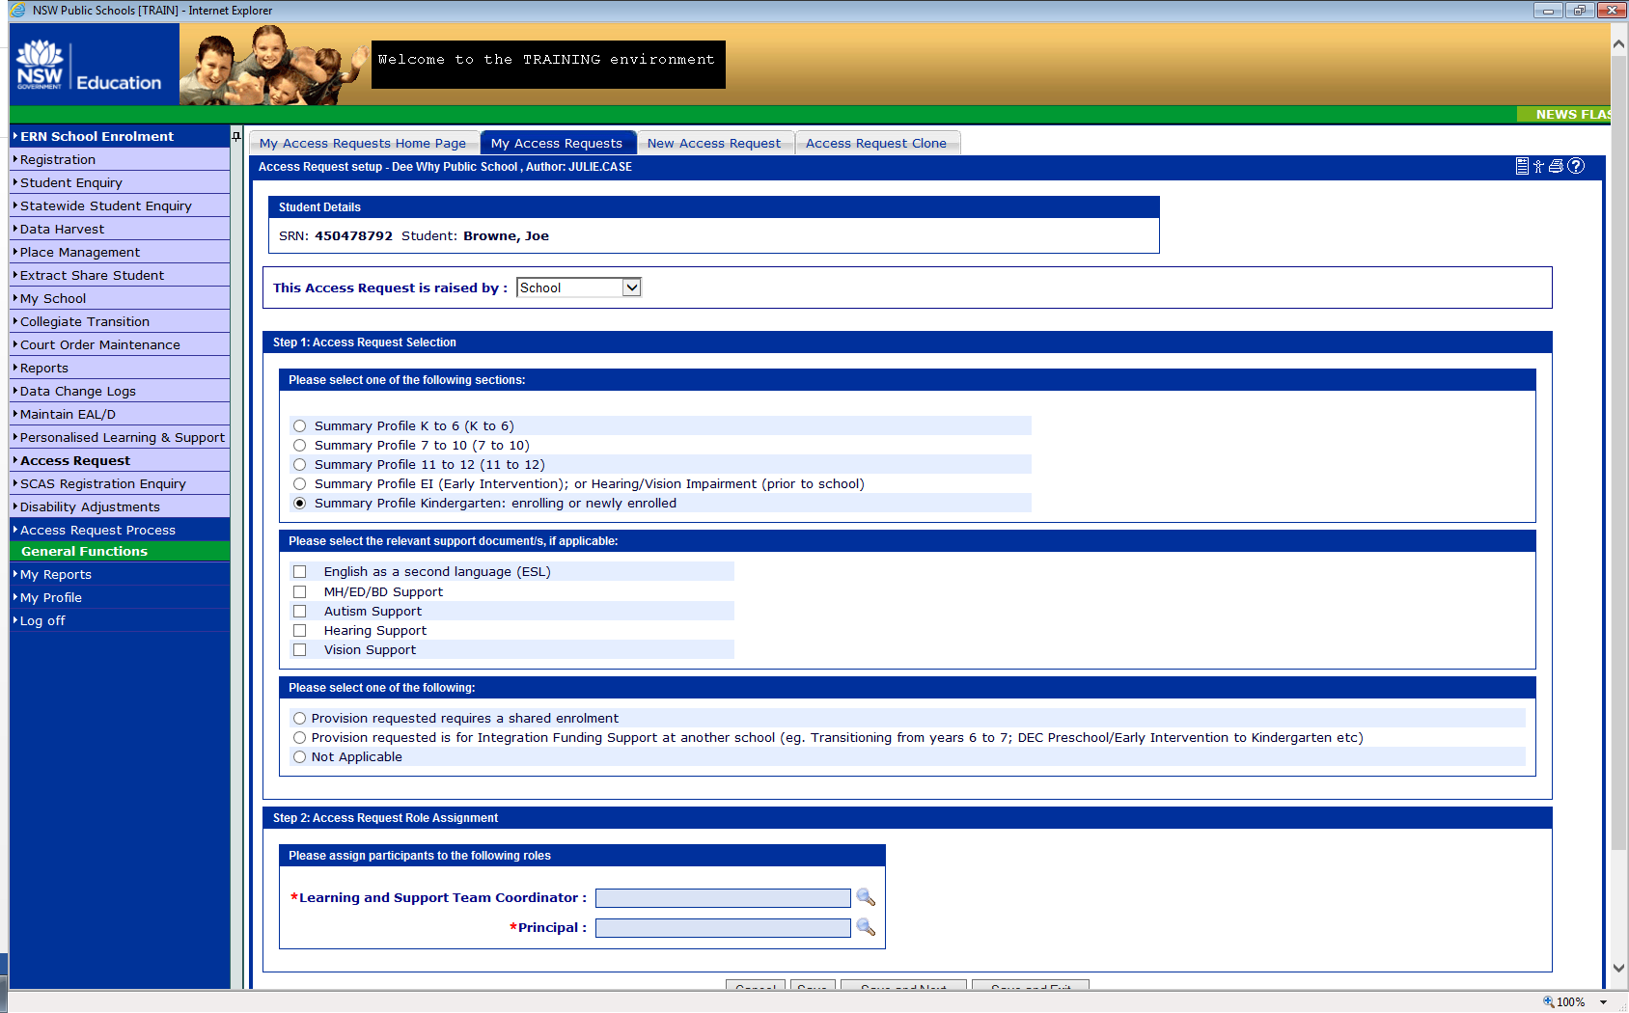

## **Why is a new Access Request required for Kindergarten**

A new Access Request is required for Kindergarten as the child’s needs and abilities change rapidly from 3 to 5 years of age. There are significant differences in the information collected for an early intervention and new Kindergarten Access Request application.

If an Early Intervention Access Request is cloned the set up page must be changed and there is a chance of technical error. The developers of Access Request recommend that it is best to create a new Access Request for the Kindergarten application due to the differences in many of the sections between the two applications.

The screen shots below demonstrate the differences in the summary profile pages for Early intervention and for Kindergarten – enrolling or newly enrolled.

**See below the summary profile page Early Intervention:**

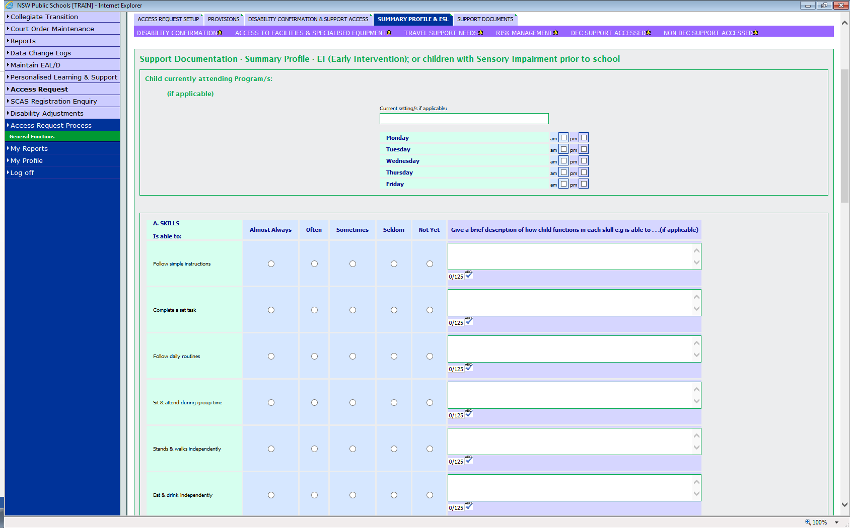

**See below the summary profile page for Kindergarten:**

