Engagement and accomplishment
Duration: 30 minutes

Purpose of the task
Knowing and using personal strengths enhances our self-belief and engagement with activities and life in general. If we know what our strengths are we can use them to get through tough times as well as work towards accomplishing great success.

Course outcomes
1.3 Build positive thinking, self-belief and a sense of empowerment to take action to promote meaningful futures for self and others.

What do we want students to know, understand or be able to do?
- Develop their own definitions and understandings of engagement and accomplishment.
- Reflect on their own accomplishments.
- Identify their strengths and relate to how they can use these for future accomplishment.

Required resources and materials for preparation
Student activities are set around:
- small group
- individual activities
- online
- offline
Equipment required:
- paddle pop sticks (1 per student)
- glass jar (to place sticks in)
- laptop/Tablet/Phone
- online access to
  - Viacharacter
  - Bite Back website
- Y chart worksheet

Suggested content
Learning context | Content
Mental health and wellbeing  Focus: Developing self-efficacy and mental fitness | Building resilience  - recognising achievements and successes  Positive wellbeing  - engagement and mindfulness  - establishing meaning and purpose for life  - accomplishment
Independence  Focus: Building self-concepts and independence | Self-management  - using mind-sets for motivation and achievement, e.g. growth mind-set  - responsibility for self and actions

Teaching notes

Creating a safe and supportive learning environment
There are a number of strategies that can be used to create a supportive learning environment which enables students to feel safe to learn and ask questions. They include:
- making students aware at the beginning of Life Ready sessions that disclosing personal information that indicates they may be at risk of harm will be reported to the school principal in all instances. This includes personal disclosures related to instances of abuse, drug use, neglect or sexual activity under the legal age of consent.
- being aware that some parts of Life Ready can be confronting and sensitive for some students.
- enabling students to withdraw if they find issues personally confronting to protect them from making harmful disclosures. Equally, it is important to be prepared for issues that arise as a result of a student making a public disclosure in the classroom.
More information on creating a safe and supportive learning environment can be found on the Life Ready website.

Evaluating resources before use
Preview and evaluate all strategies, resources and teaching and learning approaches in full before use with students to determine suitability for student learning needs, stage of development and local school context. Consider the age, maturity, cultural background, sexuality, gender, sex, health and other characteristics of students in your care. Apply professional judgements to all strategies, teaching and learning approaches and resources including audio visual materials (e.g. videos, media clips and YouTube), interactive web-based content (e.g. games, quizzes and websites) and texts.
Use the resource review flowchart to decide about the suitability of teaching and learning resources.
Materials should be reviewed in full and endorsed by the school principal before use in NSW government schools.

Communication with parents and caregivers
Some aspects of Life Ready may be viewed as sensitive or controversial, such as learning about abuse, child protection, drugs, respectful relationships, sexual health, sexuality and violence. Inform parents and carers, prior to the occasion, of the specific details of the Life Ready program, so that parents and caregivers have time to exercise their rights of withdrawing their child from a particular session. In this regard, a parents or caregiver’s wish must be respected.
Establishing how parents and caregivers will be informed about programs and involved in consultation is a school-based decision. Where parents and caregivers indicate they wish to withdraw their child from a program it is useful to negotiate which parts of the Life Ready program they are concerned about. A sample information letter is available on the Life Ready website.

Learning experiences

Mindfulness
- Guide students through the Mindfulness 102 session as a whole group
- Students complete the Mindfulness Quiz on the BiteBack website: biteback.org.au/mental-fitness/mindfulness
- In pairs, students reflect on the question: How could mindfulness relate to achievement?

What is engagement?
- As a whole group, brainstorm the meaning of the term engagement.
Teacher tip: fairness jar activity
To encourage open group discussion and invite all students to have an equal chance of sharing their opinion through this brainstorm, use the paddle pop stick strategy. Record students’ names on a paddle pop stick each and place in a jar. Through the discussion remove a student’s name from the jar and invite them to share their idea.

What is achievement/ accomplishment?
- Invite students in pairs or small groups to identify their personal meaning of achievement and accomplishment. Share an example of a personal achievement or accomplishment to support their meaning.
- As a whole group, discuss personal and group meanings of achievement and accomplishment. Were there differences within the group regarding definition or meaning or achievement and accomplishment?
- Additional questions to encourage group discussion include:
  - list popular personalities and significant others who have displayed achievement/accomplishment in their chosen field.
  - what does achievement/accomplishment look like? Feel like? Sound like for this person? Students complete the Y chart activity sheet

Knowing your strengths
- Students identify their strengths using the ‘Identifying strengths, skills and strategies’ Life Ready activity
Teacher note: This is also an opportune moment to remind students of where to get help for themselves or a friend at school and out of school time

Y Chart
What does accomplishment…
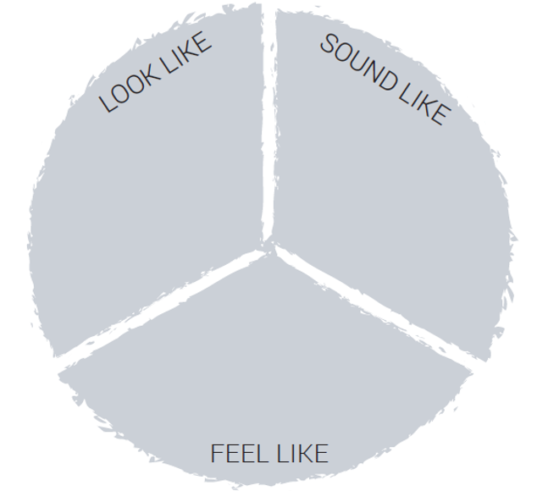
Complete the questions below
Describe a time when you felt achievement/accomplishment.

What can you learn from failure?

How can you increase the number of times you achieve?

