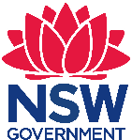 Stage 4 Geography, Science and Mathematics – Human landscapes – Inquiry-based learning through Sydney Metro
Mosman High School is a comprehensive, coeducational secondary school of approximately 1100 students with an outstanding reputation for academic achievement and success in the creative and performing arts. The school is conveniently located on Sydney's lower North Shore, in the business and shopping district of Mosman – a harbourside suburb just 5 kilometres from the heart of Sydney, near Balmoral Beach and the famous Taronga Park Zoo, with easy access to bus and ferries. The school has a high community profile and is proud of the very active involvement of its parents and the community

Human landscapes: Inquiry-based learning through Sydney Metro
Stage 4 – duration 10 weeks

Unit context
This unit was written by Catharina Simmonds of Mosman High School. It was created, trialled and peer reviewed as part of professional development in inquiry-based learning for primary and secondary school teachers. The professional development courses were part of a pilot partnership between the NSW Government’s Sydney Metro transport agency and Western Sydney University. Facilitated by Western Sydney University’s Education Knowledge Network, the professional development program aimed to develop teacher expertise in inquiry-based learning using a real-life example of a major infrastructure project in delivery stage.
The unit is aligned to © NSW Education Standards Authority (NESA) syllabuses specifically the Geography K-10 Syllabus 2015, Mathematics K-10 Syllabus (2012) and Science 7-10 Syllabus (2018).
The Year 7 Academic Enrichment program includes three hours a fortnight and is a separate to core curriculum subjects. The unit was run in the fourth term in two classes where students had already spent three terms developing their ability to research, problem solve, work collaboratively, reflect and provide peer review. Mosman High School staff have been professionally developed in the process of visible learning as well as having received training in the process of GERRIC (Gifted Education Research, Resource and Information Centre); therefore learning intentions, success criteria and differentiation according to novice, developing and expert level students are central to the teaching program.
Sydney Metro is Australia's biggest public transport project.

Mosman High School Program – Stage 4 (Year 7)

Subject – Academic enrichment
Students explore the complex relationship between people and urban and natural landscapes, and the ways in which individuals and communities both shape and are shaped by their environments. Students question and problem-solve collaboratively in order to design a metro train station for Mosman. Students will investigate existing pieces of architecture that represent the community before working collaboratively together to prototype and present their design for a proposed metro station in Mosman.

Big question
If landscape is a reflection of us as individuals, what are others seeing?

Differentiated questions
Novice | Developing | Expert
Differentiated question: Why are urban landscapes not all the same?  By the end a novice student will:  - present a design that demonstrates an understanding of the local Mosman community. | Differentiated question: How do urban landscapes reflect those that live within them?  By the end a developing student will:  - present a design that demonstrates an increased understanding about the complexities of Mosman’s community. | Differentiated question: To what extent do our social structures reflect the way we plan our urban infrastructure?  By the end an expert student will:  - present a design that demonstrates an understanding of the ways in which urban infrastructure reflects social structures, using the Mosman local area as one example

Values in action
Resilience, connection and innovation are the qualities that shape effective global citizens and 21st century learners
(Mosman High School, School Management Plan 2017 goals 1-3)

Key assessments strategies

Assessment for learning
Inquiry-based project: Students drive their own learning and assess their development through SMART(ER) goals.

Assessment as learning
Student inquiry journal: Each lesson students ask questions and respond to questions monitoring their learning on a lesson by lesson basis.

Assessment of learning
Student collaborative presentation: Sydney Metro has decided to put together a team to meet the rising demands of public transport on Military Road. Your team will be responsible for designing the metro station for Mosman and presenting your proposal to a panel of judges and audience.

Formative assessment and peer review
Students will be provided with formative verbal and written feedback from peers through a mock presentation.

Summative assessment
Students’ peer review, self-reflection and teacher feedback all contribute to students’ final summative assessment task.

Key capabilities
- Literacy – Students develop and apply conventions of syntax, spelling, punctuation and grammar for specific purposes and effect.
- Numeracy – Students use numeracy skills in their interpretation of spatial and statistical information for analysis and application.
- Information Communication Technology – Students develop skills in reading, viewing and responding to digital and multimodal texts, and utilise different forms of media to convey meaning and ideas.
- Critical and creative thinking – Students learn to generate and evaluate knowledge, clarify concepts and ideas, seek possibilities, consider alternatives and solve problems. Students think broadly and deeply using skills including reason, logic, resourcefulness, imagination and innovation.
- Personal and social capability – Students are provided with opportunities to develop personal and social capability through independent and collaborative research, reflective practices, and peer review.
- Ethical understanding – Students are provided with opportunities to develop greater empathy for others through questioning and exploring values, and attitudes.
- Intercultural understanding – Students come to understand how personal, group and national identities are shaped, and the variable and changing nature of culture.

Syllabus (Standards 1, 2)

Objectives
Academic extension aims to develop students’ capacity for conceptual learning with a particular focus on critical and creative thinking as well as make cross-curricular connections. Additionally, Academic Extension aims to encourage dispositions including inquisitiveness, reasonableness, intellectual flexibility, persistence, open and fair mindedness, and a readiness to try new ways of doing things and considering alternatives.
Cross Curricular Objectives adapted from the Australian National Curriculum General Capabilities
- Students develop critical and creative thinking as they learn to generate and evaluate knowledge, clarify concepts and ideas, seek possibilities, consider alternatives and solve problems.
- Students develop increasingly sophisticated understanding of the processes for encountering problems, unfamiliar information and new ideas.
- Students respond to the challenges of the 21st century in creative, innovative, enterprising and adaptable ways with confidence and skills.

Geography Stage 4 Concepts
- Place: ‘the significance of places and what they are like’, for example: factors influencing people’s perceptions of places; the special significance place has to some people; the effect of global trade, transport, information and communication technologies on places across the world.
- Environment: ‘the significance of the environment in human life, and the important interrelationships between humans and the environment’, for example: processes that form and transform landscapes and landforms across the world; the aesthetic, cultural, spiritual and economic value of environments to people; the effect of human activities on natural and human environments.
- Sustainability: ‘the capacity of the environment to continue to support our lives and the lives of other living creatures into the future’, for example: pressures on the Earth’s water resources and landscapes; the need to manage environments for a long-term future; sustainable management approaches.

Science Stage 4 Objectives
- Students develop an appreciation of the contribution of science to finding solutions to personal, social and global issues relevant to their lives now and in the future.
- Students develop a willingness to use evidence and reason to engage with and respond to scientific and technological ideas as informed, reflective citizens.

Maths Stage 4 Objectives
- Students develop their understanding and fluency in mathematics through inquiry, exploring and connecting mathematical concepts, choosing and applying problem-solving skills and mathematical techniques, communication and reasoning.

Module: Academic Extension: Human Landscapes

Stage 4 Geography – NSW Syllabus
- GE 4-5 discusses management of places and their environments for sustainability
- GE 4-7 acquires and processes geographical information by selecting and using geographical tools for inquiry

Stage 4 Geography – Australian Curriculum
- Develop geographically significant questions and plan an inquiry, using appropriate geographical methodologies and concepts (ACHGS047, ACHGS055)
- Apply geographical concepts to draw conclusions based on the analysis of data and information collected (ACHGS052, ACHG060)
- Present findings, arguments and ideas in a range of communication forms selected to suit a particular audience and purpose; using geographical terminology and digital technologies as appropriate (ACHGS053, ACHGS061)
Skills
- Field work: observing, measuring, collecting and recording data, developing and conducting surveys and interviews
- Spatial technologies: virtual maps, satellite images, global positioning systems (GPS), geographic information systems (GIS)

Critical and Creative Thinking learning continuum
General capabilities creative and critical thinking learning continuum
Inquiring – identifying, exploring and organising information and ideas (Level 5)
- pose questions to probe assumptions and investigate complex issues
- clarify information and ideas from texts or images when exploring challenging issues
- critically analyse information and evidence according to criteria such as validity and relevance
Generating ideas, possibilities and actions (Level 5)
- draw parallels between known and new ideas to create new ways of achieving goals
- generate alternatives and innovative solutions, and adapt ideas, including when information is limited or conflicted
- predict possibilities, and identify and test consequences when seeking solutions and putting ideas into action
Analysing, synthesising and evaluating reasoning and procedures (Level 5)
- identify gaps in reasoning and missing elements in information
- differentiate the components of a designed course of action and tolerate ambiguities when drawing conclusions
- explain intentions and justify ideas, methods and courses of action, and account for expected and unexpected outcomes against criteria they have identified

Stage 4 Science – NSW Syllabus
- SC4-2VA A student shows a willingness to engage in finding solutions to science-related personal, social, and global issues, including shaping sustainable futures
- SC4-3VA demonstrates confidence in making reasoned, evidence-based decisions about the current and future use of technology, including ethical considerations

Stage 4 Mathematics – NSW Syllabus
- MA4-2WM applies appropriate mathematical techniques to solve problems
- MA4-19SP collects, represents and interprets single sets of data, using appropriate numerical displays
- MA4-21P represents probabilities of simple and compound events

Meeting the needs of the 21st century learner in literacy and numeracy and addressing the needs of students with learning difficulties
Duration of unit | Resources | Assessment overview | Quality teaching | Registration of date competed and signature
10 weeks | Human landscapes student information pack  Inquiry-based learning and metacognition  - Bloom’s taxonomy  - Doran’s SMART goals  Sydney Metro  - Seven Network, ‘World’s Best Metro: Go Deep Under Sydney, 1 hour news special. 20161  - NSW Government, Sydney Metro, Construction Stations and Sites www.sydneymetro.info  - Chatswood to Sydenham Environmental Impact Statement, Sydney Metro  - Chatswood to Sydenham Environmental Impact Statement Summary May−June 2016  ICT (Optional)  - A digital classroom, for example Google Classroom or Seesaw  - Online collaboration tools, such as Office365, G Suite or Apple Productivity suite.  - Online maps  - Survey creators such as Google Forms or Survey Monkey  - 3D Modelling and design software, including SimCity, Minecraft, SketchUp, or Floor Plan Creator  - A Website creator, for example Wix, Weebly or Google Sites | Summative Assessment  Sydney Metro has decided to put together a team to meet the rising demands of public transport on Military Road. Your team will be responsible for designing the metro station for Mosman and you will need to present your proposal to a panel of judges. In your team, you will need to consider the station design and location and one of the following:  - engineering and construction  - safety and accessibility  - environment and sustainability  - new technologies.  Successful designs will consider the people and landscape in the local area and demonstrate an awareness of the values held by the local community. Presentations should include technologies such as film, design simulations, and/or interactive technologies. | - Intellectual quality  - Relevance  - Inquiry-based learning  - Collaborative teaching  - Critical and creative thinking  - Problematic knowledge  - Higher order thinking

Week | Teaching and learning experience  (Standards 2,3,4 and 5) | Evidence of understanding of success criteria and learning intention  (Standards 3, 4 and 5) | Quality teaching | Date completed/ Signature
Week 1 | Introduction to inquiry-based learning and qualitative and quantitative research  Learning intentions: Students to develop their meta-cognitive understanding of the purpose and appearance of inquiry-based learning as well as develop their questioning skills through Bloom’s Taxonomy.  Success criteria  - I can define what inquiry-based learning looks like in the classroom.  - I can use a quantitative and qualitative method of research.  - I can evaluate the effectiveness of the research methods in relation to the purpose of my project.  Activities  - Students read about inquiry-based learning and answer questions using the pre-test on page 17.  - Students explore the different levels of Bloom’s Taxonomy and develop their abilities to answer questions using the pre-test on page 18.  - Students complete a pre-test using their understanding of Bloom’s Taxonomy and inquiry-based learning to ask and respond to their own questions. Teachers may choose to model/scaffold questions depending on their learners. See a student pre-test work sample on page 29 of this document. | Pre-test: Students complete the following two activities for teacher to assess their ability to answer questions and direct their own learning.  - Watch the ‘Designing Sydney Metro stations’ video (3 minutes 34 seconds). Write down question corresponding to each level of Bloom’s taxonomy relevant to the video.  - Answer and complete three of the activities and questions you have created.  Formative feedback: Teacher provides verbal/written feedback on student’s choice of verbs and their questions.  - [N] Student questions use verbs from Bloom’s taxonomy.  - [D] Student questions increase in complexity.  - [E] Students questions are increasingly conceptual.  Student goal setting: Students set SMART goals in order to assess their own learning throughout the unit assessing.  - [N] Goal is broad and relevant to the subject.  - [D] Goal is specific with strategies to attain.  - [E] Goal considers evidence of achievement. | 5.1 Assess student learning  2.5 Literacy and Numeracy Strategies  5.2 Provide feedback to students on their learning  3.1 Establish challenging learning goals
Week 2 | Human landscapes: Asking questions about what we see  Learning intentions: Students develop conceptual understanding of how architecture connects to community and culture through an exploration of significant landmarks and pieces of architecture.  Success criteria  - I can ask novice, developing and expert style questions  - I can connect pieces of architecture to community  Activities: Students view pieces of architecture that are unique and have cultural significance to their communities.  - View: For each piece of architecture fill in the grids.  - Discuss: Which example of architecture in the slides do you like the most and why?  - Question: Write a novice, developing, and expert style question for the piece of architecture you are most interested in. Choose one of these questions and answer the question.  - Describe: What do train and or metro stations look like usually? Is there anything beautiful about these places?  - Assess: Students respond to differentiated questions considering images of Moscow Metro Station (200 words). Give students the resource sheets on pages 19-20 of this document to assist them with these activities. See student work sample of page 31-32 of this document.  Self-directed learning: Students view Seven Network, ‘World’s Best Metro: Go Deep Under Sydney’ and explore sydneymetro.info. Students are to ask questions in the design portfolios, seek the solutions and then share their responses with the class and within their groups. | Modelling/scaffolding: Teacher may choose to provide model paragraph samples or scaffold paragraph structure.  Informal feedback: Students read their novice, developing and expert questions and teacher provides verbal feedback to the class on ‘where to go next.’  Differentiation: Respond to one of the following questions considering the images of the Moscow Metro Station:  - [N] In your opinion are Sydney Metro stations or the Moscow Metro Station more appealing? Why do you think this way?  - [D] How is the aesthetic of the Moscow Metro a reflection of the people of Moscow when it was being built?  - [E] To what extent is Moscow’s culture at time of construction reflected in the way they have planned their urban infrastructure?  Formative feedback: Teacher to provide verbal/written feedback to students on their written task:  - [N] Describe the visual appearance of the Moscow Metro Station.  - [D] Describe and discuss the context and culture of Russian people during the time of construction.  - [E] Evaluate the aesthetic of the Moscow Metro Station with specific references to events, people, and values | 2.2 Content selection and organisation  4.1 Support student participation  1.5 Differentiate teaching to meet the specific learning needs of students across the full range of abilities  5.2 Provide feedback to students on their learning
Week 3 | Student driven questioning and research  Learning intentions: For students to develop their understanding of qualitative and quantitative types of research in order for them to choose and pursue different methods of collecting research for their project.  Success criteria  - I can identify different qualitative and quantitative research methods.  - I can assess the relevance of these methods to my own project.  - I can design and implement these methods in my community.  Activities: Students explore three different methods of quantitative and qualitative methods and assess the best research strategies for their learning.  - Types: Find three different types of qualitative/quantitative method types that can be conducted.  - Assess: Which of these methods are best suited to your group’s project and why?  - Plan: Brainstorm the type of questions that you will be asking that match your chosen method of research. Who will you questioning? How will you collect and assess the information?  - Design and implement: Design your final research product. Make sure you show your teacher your final product before taking it out into the Mosman community.  See qualitative and quantitative research resource sheets of pages 21-22 and a student work sample on page 30 of this document. | Modelling: Teacher may choose to provide sample model of survey or questions for students.  Formative feedback: Teacher provides verbal/written feedback into students’ choice of qualitative and quantitative research as well as their questions.  - [N] Student’s questions use verbs from Bloom’s taxonomy and methods are relevant to project.  - [D] Student’s questions are increasingly complex and have assessed the relevance of questions to their project.  - [E] Student’s questions are increasingly conceptual in nature and research approach has evaluated the questions and methods that best reflect their project.  Student research and evaluation of research: Teacher to collect evidence of student research and evaluation of their research.  - [N] What did you learn about the people of Mosman through your research?  - [D] How has your research reshaped or galvanised your understanding of the people of Mosman?  - [E] To what extent will your research impact the design of your Mosman metro station? | 5.2 Provide feedback to students on their learning  7.4 Engage with professional teaching networks and broader communities
Weeks 4-8 | Student research, drafting and creating  Learning intentions: To develop students’ skills in questioning, collaboration and research through inquiry-based learning.  Success criteria  - My questions are more complex and conceptual with each lesson.  - I set myself tasks and goals for each lesson and share my findings with my group.  Activities  - Students negotiate their groups with teacher, allocate a specific role within the group on page 23, and select their additional area of interest.  - Students drive their own learning throughout the unit by planning, asking questions, researching, and reflecting upon their learning through the process of creating a design portfolio.  The Human landscapes student information pack on pages 15-28 of this document supports students do this | Assessment as learning: Teacher to monitor student’s design portfolio and provide feedback on ‘where to next?’  Expert: Students collaboratively create questions for an interview person working on the Sydney Metro rail station.  Peer review and formative assessment: Students complete peer review and self-reflection on a mock presentation where they receive written and verbal feedback according to the same criteria as the summative assessment task.  Smart(er) goals: Students evaluate and rewrite their goals from Week 1 setting a new goal for Week 8 based off the feedback provided | 4.2 Manage classroom activities  7.4 Engage with professional teaching networks and broader communities  5.2 Provide feedback to students on their learning  3.1 Establish challenging learning goals
Weeks 9-10 | Student presentation and peer review  Learning intentions: Students demonstrate their learning through engaging and interactive presentations.  Success criteria  - The metro station design reflects the people of Mosman community.  - Student’s presentation shows at least two methods of primary research.  - The metro station proposal considers station design and location and one of the following:  - engineering and construction  - safety and accessibility  - environment and sustainability  - new technologies.  Activities  Students present their final designs and considerations to a panel of teachers and students. The panel uses the marking criteria and feedback resource on page 27.  Students then assess their own work collaboratively using the self-reflection grid on page 28 and provide individual reflection on their learning.  Student work samples of part of their final design presentation can be found on pages 34-40 of this document. | Summative feedback  Groups are provided written feedback on areas of success and areas in need of improvement by a panel of teachers and students.  - Students demonstrate a sophisticated understanding of the people of Mosman and the interconnection between landscapes and communities.  - Students demonstrate a sophisticated ability to research through questioning, quantitative, and qualitative research methods.  - Students demonstrate a sophisticated ability to present their ideas clearly through a range of presentation methods including technology  Additionally, groups provide each other feedback on their abilities to:  - research using qualitative and quantitative methods  - work collaboratively in relation to allocated roles  - ask questions and work in an inquiry-based classroom  Finally, students self-reflect on their own learning assessing themselves against all the above criteria. | 5.1 Assess student learning  5.2 Provide feedback to students on their learning  5.3 Make consistent and comparable judgements  5.5 Report on student achievement  3.6 Evaluate and improve teaching programs

Variation and feedback – Standard 6
Students were excited and engaged by the project as well as the process of inquiry itself as this allowed students opportunities to connect with the community in authentic ways – taking their learning outside of the classroom as well as providing autonomy and self-direction in relation to the learning. Students benefited significantly from the feedback of mentors from Sydney Metro who specialised in students’ areas of interest; however this could be substituted with feedback from community members or teacher experts within the school. As Mosman is a bring-your-own-device (BYOD) school and all students in the class had access to technology, students were able to self-select technologies that suited their strengths and abilities, many students teaching themselves the skills necessary for design. Students also directed their own research, based on their choices in qualitative and quantitative methods as well as student directed questioning. However, the unit can be adjusted so that students create designs by hand and are provided with a resource booklet for their learning. In the implementation of this unit in other school contexts, there is scope to further embed Mathematics or Geography skills and expand learning opportunities through excursions and site studies. The structure of the lessons can also be adapted to other design projects beyond the scope of a metro station. In schools where this unit is an introduction to project-based and inquiry-based learning, students might need further modelling and explicit instructions around the presentation of tasks; however student choice and self-questioning should remain at the core of the unit.
New strategy: Use of external experts as mentors for students as well as the design and implementation of inquiry-based learning using Sydney Metro as a basis for student engagement.
Consequences: Students were highly engaged and motivated throughout the learning process as a consequence of learning being authentic and focused on interactions with the community. Student qualitative and quantitative research methods required students to survey and interview members of the Mosman community, and this included students taking the initiative to interview the Mosman Mayor and the people of Mosman for their project. Students drove their own learning by asking questions and choosing their own area of interest for their project, and this led to students to seek feedback and guidance from experts outside the classroom including technology and applies studies (TAS) and mathematic teachers. Students additionally interviewed and were mentored by engineers, an environmental specialist, and a construction manager from Sydney Metro who came into the school and this provided students with an opportunity to extend and test their ideas.
Literacy: Students were provided with explicit feedback on their literacy in written paragraphs including their paragraph structures and ability to use topic sentences and link to the question. Additionally, students were provided with explicit feedback on their verb choices, with a specific focus on questions.
Numeracy: Students needed to analyse data collected from surveys in the community, which involved reading graphs, percentages and statistics. Students also needed to consider area and space for the location of their metro stations. Some groups also considered time and ratios, questioning the community on the speed and frequency of metro to inform their designs.
Differentiation: Although an academic class, students were still provided with differentiated questions (novice, developing, and expert) to self-select from. Due to the open-ended nature of the project, students’ ability to self-select roles as well as choose an area of interest all students were therefore provided with an opportunity to showcase their strengths within the collaborative presentations. With a mixed ability class the necessity for modelling and scaffolding of tasks (including the selection of resources) would be more significant. Students also negotiated their groups based on student interests and student ability (novice, developing and expert from GERRIC); however I did not find that the novice groups needed more scaffolding or additional support beyond what was provided to all students within the context of the classroom with the novice group being amongst the most successful.
Assessment: Groups presented their station designs through a range of technologies that were self-selected including Minecraft, SketchUp, and Floor Plan design as well as creating PowerPoint presentations and websites to showcase their designs. Student presentations connected their research within the community to features of their designs and discussed the process of design-making along with the presentation of their actual designs. In the future, emphasising the interactive element of student designs will engage students with the presentation process further, as many students were interested in asking questions and comparing their final products. Additionally, students could have presented their designs back to the community for feedback upon presentation to further increase feelings of significance.

Human landscapes student information pack

Inquiry-based learning
If landscape is a reflection of us as individuals, what are others seeing?

Unit overview
Students explore the complex relationship between people and urban and natural landscapes and the ways in which individuals and communities both shape and are shaped by their environments. Working in collaboration with Sydney Metro and the Western Sydney University, students use inquiry-based learning to question and problem solve collaboratively in order to design a metro train station for Mosman. Students will question existing pieces of architecture that represent the community before working collaboratively to ask questions and complete research on their selected site in Mosman to design their own Mosman Metro Station.

Learning intention
To develop students’ skills in questioning, collaboration and research through inquiry based learning.

Success criteria
- Metro station design reflects the people of Mosman community
- Student presentation shows at least two methods of primary research
- Metro station proposal considers station design and location AND one of the following:
  - engineering and construction
  - safety and accessibility
  - environment and sustainability
  - new technologies

Instructions
- In your groups you will need to complete research of Sydney Metro and design a series of questions to answer based on Bloom’s Taxonomy and Gifted Education Research, Resource and Information Centre (GERRIC) questioning.
- Your group must then choose two primary forms of research to complete in the Mosman Community in order to gain an understanding of the needs of your client.
- After you have completed your primary and secondary forms of research you will need to choose a location for your metro station and start the design process.
- As well as your station design and location your group will need to select one other area to ask questions in and consider (engineering and construction, safety and accessibility, environment and sustainability and new technologies).
- Present your completed design to a panel of judges and audience using at least one interactive form of communication.

Term outline
Human landscapes schedule – Term 4
Week | Tuesday | Wednesday | Thursday
Week 1 | What is inquiry based learning? Bloom’s Taxonomy and Asking Questions. |  | Architecture as Human Landscapes: Asking questions about what we see.
Week 2 |  | Introduction to Sydney Metro: Asking questions about what we see.
Week 3 | Introduction to Sydney Metro: Asking questions about what we see. |  | Research Strategies
Week 4 |  | Research Strategies
Week 5 | Questioning, Designing,  and Researching |  | Questioning, Designing,  and Researching
Week 6 |  | Questioning, Designing,  and Researching
Week 7 | Questioning, Designing, and Researching |  | Questioning, Designing, and Researching
Week 8 |  | Presentation
Week 9 | Presentation |  | Presentation
Week 10 |  | Presentation

Inquiry-based learning pre-test
Inquiry-based learning is a broad pedagogical approach which has enjoyed widespread support by educators and education systems over the past decade. Inquiry can be defined as ‘seeking for truth, information or knowledge/understanding’ and is used in all facets and phases of life. Specific processes of inquiry have become central to knowledge building or truth seeking in a range of different ways.
Characteristics
- Equal emphasis on content and process (reflecting, collaborating, analysing etc.).
- Genuine curiosity, wonderment and questioning (by teachers and students) are central.
- Student ‘voice’ is evident. Elements of the curriculum/learning are negotiated and student questions are taken seriously and addressed.
- Prior knowledge is ascertained and built upon. Formative assessment and subsequent planning is essential.
- Significant concepts and essential questions are identified which unify knowledge and understandings.
- Students are actively involved in constructing understandings through hands-on experiences, research, processing and communicating their understandings in various ways.
- Learning takes place in a social context. Students learn from each other, together with others, and from those outside of the classroom context.
- There is an assumption that understandings are temporal and are constantly reviewed and refined on the basis of new learning and questions – therefore inquiry is ‘recursive’ in nature.
- Reflection, metacognition and depth of thought are valued and planned for.
- Assessment is ongoing and clear criteria link performances or products to rigorous curriculum goals.
- Learning leads to action – informing and sharing with others, implementing change, advocacy or taking up further questions or learning.
Discuss
[N] What is inquiry based learning?
[D] What do you think inquiry based learning looks like in the classroom?
[D] How can we implement inquiry based learning into the classroom?
[E] How effective do you think inquiry based learning is to your development as a student?
Write
- Describe the type of student who would succeed during inquiry-based learning (150 words)

Bloom’s taxonomy pre-test

Learning intention
For students to develop their questioning skills and understanding of the cognitive requirements of the questions that they write using Bloom’s taxonomy.

Activity 1
Bloom’s taxonomy was created by Benjamin Bloom in 1956. It is a method of classifying the complexity of tasks starting with knowledge and moving up to evaluation and creation.
- Why are some questions or activities harder than others?
- Have a look at the groups of verbs that match up with the different levels of Bloom’s taxonomy. Do you agree with where they are placed? Why or why not?
- Brainstorm/share some of the questions that you can ask or have been asked in the past.
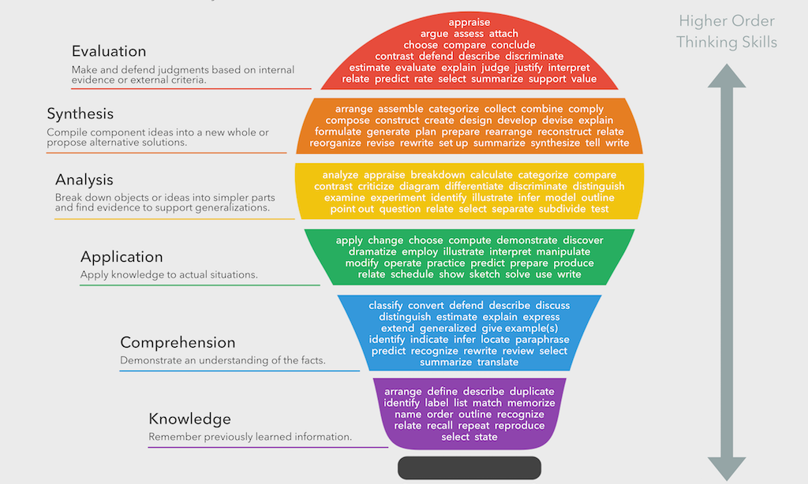
Bloom’s Taxonomy verbs by Fracus Learning. Licensed under the Creative Commons Attribution-Share Alike 4.0 International

Activity 2
Bloom’s taxonomy and Sydney Metro stations
- Watch the Designing Sydney Metro stations video. Write down an activity or question from each of the colours from Bloom’s taxonomy relevant to the video.
- Now answer and complete three of the activities and questions that you have created. Remember: inquiry-based learning means that you drive your own learning through questions. (Evaluation example: What is the value of Sydney Metro stations for local communities?)

Human landscapes
Asking questions about what we see

Learning intention
Students develop conceptual understanding of how architecture connects to community and culture through an exploration of significant landmarks and pieces of architecture.

Activities
- View: For each piece of architecture fill in the below grid.
Name and place | Description | Unique features | Your opinion
- Discuss: Which example of architecture in the slides do you like the most and why?
- Question: Write a novice, developing, and expert style question for the piece of architecture you are most interested in. Choose one of these questions and answer the question.
- Describe: What do train and or metro stations looks like usually? Is there anything beautiful about these places?

- Assess: Respond to one of the following questions considering the images of Moscow Metro Station (200 words paragraph structure):
  - [N] In your opinion are Sydney train stations or the Moscow Metro station more appealing? Why do you think this way?
  - [D] How is the aesthetic of the Moscow Metro a reflection of the people of Moscow when it was being built?
  - [E] To what extent is Moscow’s culture at time of construction reflected in the way they have planned their urban infrastructure?
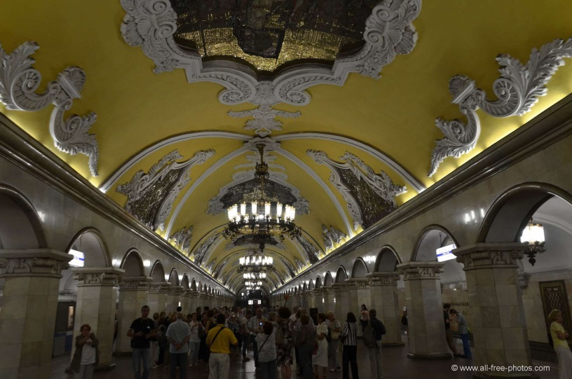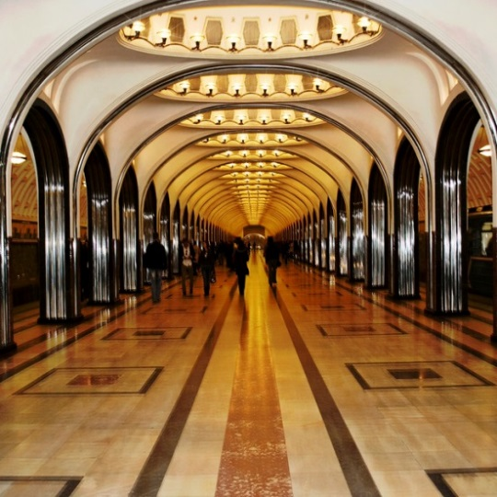
Photo by all-free-photos.com. CC by SA 2.5 Photo by Cat Girl 007. CC by 2.0

Research

Learning intention
For students to develop their understanding of qualitative and quantitative types of research in order for them to choose and pursue different methods of collecting research for their project.

Qualitative research
Definition
A type of market research that aims to find out people’s opinions and feelings rather than information that can easily be shown in numbers. Additional Resource: Qualitative Data Methods: A Data Collector’s Guide
Types: Find three different types of qualitative method types that can be conducted.

Assess: Which of these methods are best suited to your group’s project and why?

Plan: Brainstorm the type of questions that you will be asking that match your chosen method of research. Who will you be questioning? How will you collect and assess the information?
Example: “How often do you catch public transport?”
Design and implement: Design your final research product. Make sure you show your teacher your final product before taking it out into the Mosman community.

Qualitative research
Definition
Quantitative research is used to quantify the problem by way of generating numerical data or data that can be transformed into usable statistics. Additional Resource: Qualitative Methods
Types: Find three different types of quantitative method types that can be conducted.

Assess: Which of these methods are best suited to your group’s project and why?

Plan: Brainstorm the type of questions that you will be asking that match your chosen method of research. Who will you questioning? How will you collect and assess the information?
Example: What does Mosman mean to you?”
Design and implement: Design your final research product. Make sure you show your teacher your final product before taking it out into the Mosman community.

Design groups and roles

Learning Intention
Students develop their collaborative learning skills and the significance of roles and task allocation.
Instructions
- Negotiate your groups with your teacher. You may choose one individual to work with in a pair and then the teacher will join you with another pair.
- Within your groups negotiate the role of each individual and then see your teacher to add your groups and roles to the grid below.
  - Project manager: Manages the team, coordinates creation of plan, and ensures actions are completed on time.
  - Research manager: Responsible for the allocation of research and the assessment of research.
  - Creative design manager: Responsible for the creative vision and design presentation to the panel of judges.
  - Project administration manager: Responsible for quality documentation, editing, and finalising the concept.
- Spend some time creating a task and priorities list for your role. Share this with your group.
Group | Roles

Design portfolio

Learning journal (generic)
Date: | Week:

Questions I need to answer this lesson | What I want to achieve by the end of the lesson

Steps to achieving my goals | What I want to achieve next lesson

What I achieved this lesson/learnt/researched

Reflection on my learning

Human landscapes assessment
Sydney Metro has decided to put together a team to meet the rising demands of public transport on Military Road. Your team will be responsible for designing the metro station for Mosman and you will need to present your proposal to a panel of judges. In your team, you will need to consider the station design and location and one of the following:
- Engineering and construction
- Safety and accessibility
- Environment and sustainability
- New technologies
Successful designs will reflect the people, landscape and values of Mosman and presentations should include technologies such as film, design simulations, and/or interactive technologies.
Success criteria
- Metro station design reflects the people of Mosman community
- Student presentation shows at least two methods of primary research
- Metro station proposal considers station design and location and one of the following:
  - Engineering and construction
  - Safety and accessibility
  - Environment and sustainability
  - New technologies
Roles
- Project Manager: Manages the team, coordinates creation of plan, and ensures actions are completed on time.
- Research Manager: Responsible for the allocation of research and the assessment of research.
- Creative Design Manager: Responsible for the creative vision and design presentation to the panel of judges.
- Project Administration Manager: Responsible for quality documentation, editing, and finalising the concept.
Marking criteria
Criteria | Grade
- Students demonstrate a sophisticated understanding of the people of Mosman and the interconnection between landscapes and communities.  - Students demonstrate a sophisticated ability to research through questioning, quantitative, and qualitative research methods.  - Students demonstrate a sophisticated ability to present their ideas clearly through a range of presentation methods including technology. | A
- Students demonstrate a strong understanding of the people of Mosman and the interconnection between landscapes and communities.  - Students demonstrate a strong ability to research through questioning, quantitative, and qualitative research methods.  - Students demonstrate a strong ability to present their ideas clearly through a range of presentation methods including technology. | B
- Students demonstrate a sound understanding of the people of Mosman and the interconnection between landscapes and communities.  - Students demonstrate a sound ability to research through questioning, quantitative, and qualitative research methods.  - Students demonstrate a sound ability to present their ideas clearly through a range of presentation methods including technology. | C
- Students demonstrate some understanding of the people of Mosman and the interconnection between landscapes and communities.  - Students demonstrate some ability to research through questioning, quantitative, and qualitative research methods.  - Students demonstrate some ability to present their ideas clearly through a range of presentation methods including technology. | D
- Students demonstrate a limited understanding of the people of Mosman and the interconnection between landscapes and communities.  - Students demonstrate a limited ability to research through questioning, quantitative, and qualitative research methods.  - Students demonstrate a limited ability to present their ideas clearly through a range of presentation methods including technology. | E
Teacher comment:

Marking criteria and feedback
Presenter’s names:
Panel feedback grid: As a panel provide feedback to student presenters.
Success criteria | A | B | C | D | E
Students demonstrate a sophisticated understanding of the people of Mosman and the interconnection between landscapes and communities.
Students demonstrate a sophisticated ability to research through questioning, quantitative, and qualitative research methods.
Students demonstrate a sophisticated ability to present their ideas clearly through a range of presentation methods including technology.

Areas of success | Areas in need of improvement
Peer feedback grid: As a group assess your progress throughout the unit together as a team.
Success criteria | A | B | C | D | E
Ability to research using qualitative and quantitative methods
Ability to work collaboratively in relation to allocated roles
Ability to ask questions and work in an inquiry based classroom

Areas of success | Areas in need of improvement

Self-reflection grid
Name :
Have a look at the success criteria for each section and the feedback that you have been provided throughout the unit and peer review. Assess where you are and where you need to go next.
Marking criteria | A | B | C | D | E
Students demonstrate a sophisticated understanding of the people of Mosman and the interconnection between landscapes and communities.
Students demonstrate a sophisticated ability to research through questioning, quantitative, and qualitative research methods.
Students demonstrate a sophisticated ability to present their ideas clearly through a range of presentation methods including technology.
Ability to research using qualitative and quantitative methods.
Ability to work collaboratively in relation to allocated roles.
Ability to ask questions and work in an inquiry based classroom.

Areas of success | Areas in need of improvement

What I need to do next? | Steps to achieve this
Self reflection
At the end of the unit, write a reflection on some of the things you learnt and enjoyed. How do you think the unit could have been more interesting? What were some things you wanted to learn about but did not have time?

Bloom’s taxonomy
Pre-test

Learning intention
For students to develop their questioning skills and understanding of the cognitive requirements of the questions that they write using Bloom’s taxonomy.

Activity: Bloom’s taxonomy and Sydney Metro
- Watch the ‘Designing Sydney Metro Stations’ video. Write down an activity or question from each of the colours from Bloom’s taxonomy relevant to the video.
- Now answer and complete three of the activities and questions that you have created.
Remember: ‘Inquiry-based learning’ means that you drive your own learning through questions.

Student sample
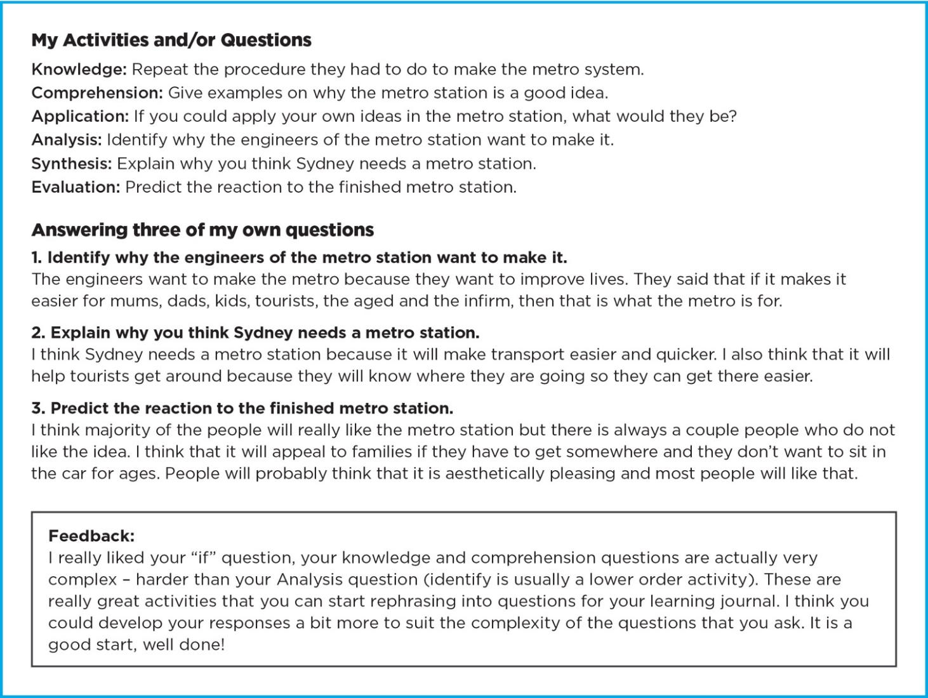

Introduction to inquiry-based learning and qualitative and quantitative research

Learning intentions
For students to develop their metacognitive understanding of the purpose and appearance of inquiry-based learning as well as develop their questioning skills through Bloom’s Taxonomy.

Success criteria
- I can define what inquiry-based learning looks like in the classroom
- I can use a quantitative and qualitative method of research
- I can evaluate the effectiveness of the research methods in relation to the purpose of my project

Student work sample 1: Research methodology
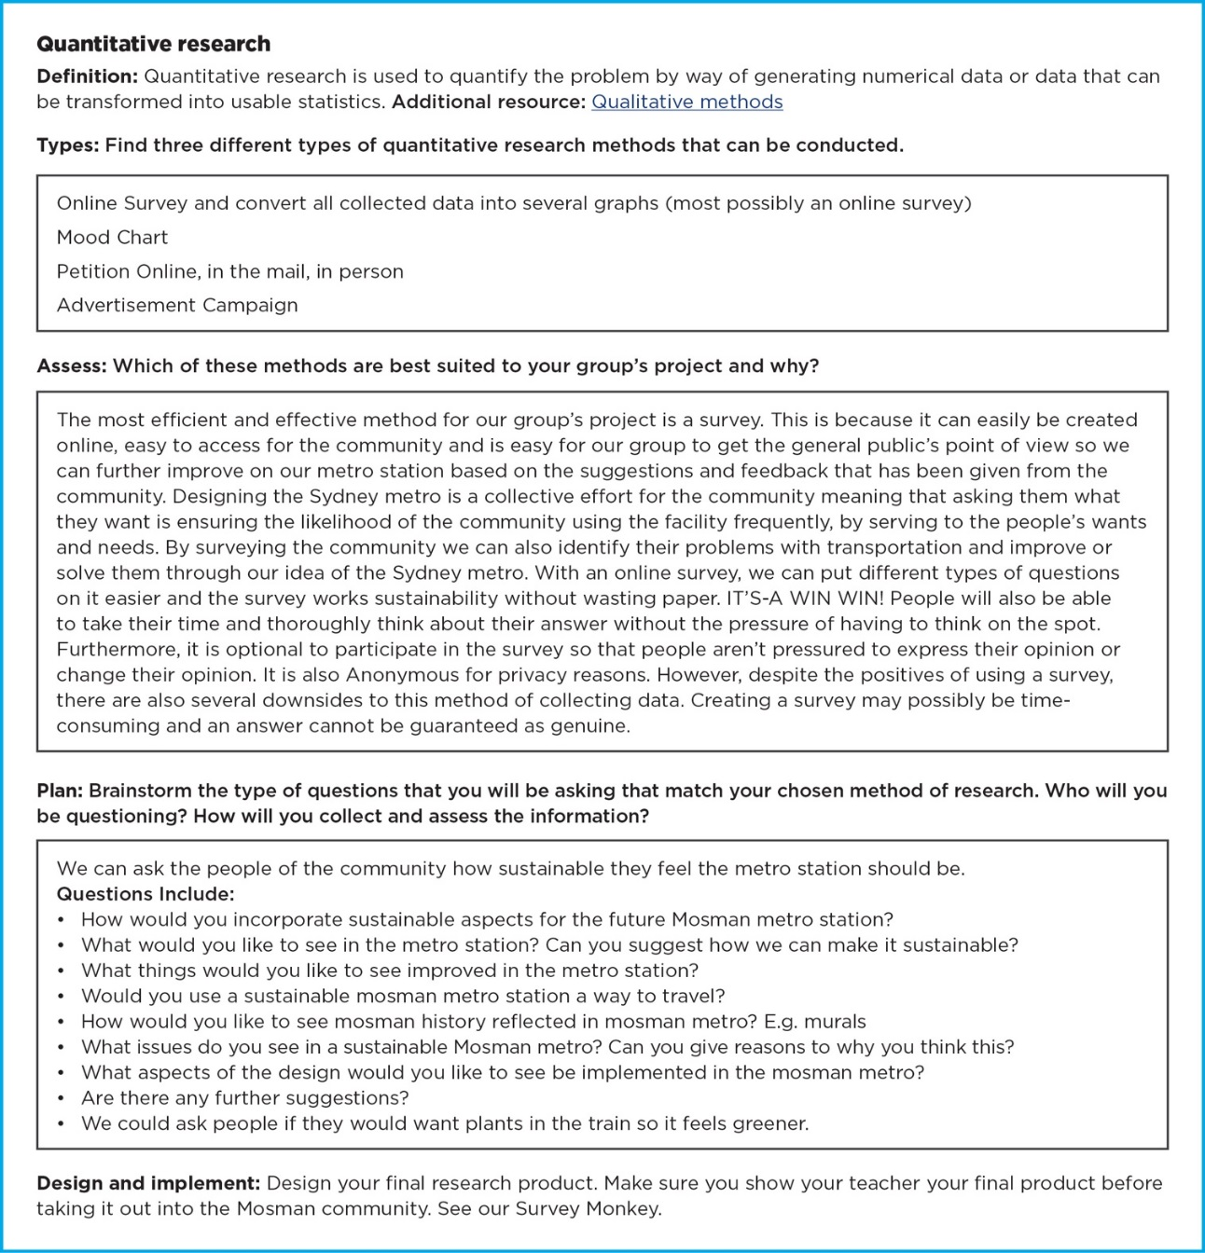

Student analysis of design
Assess: Respond to one of the following questions considering the images of Moscow Metro Station (200 words)
[N] In your opinion are Sydney train stations or the Moscow Train Station more appealing? Why do you think this way?
[D] Assess the aesthetic of the station and the extent to which is it a reflection of the people of Moscow.
[E] To what extent is Moscow’s culture reflected in the way they have planned their urban infrastructure?

Student work sample 1: Extension question
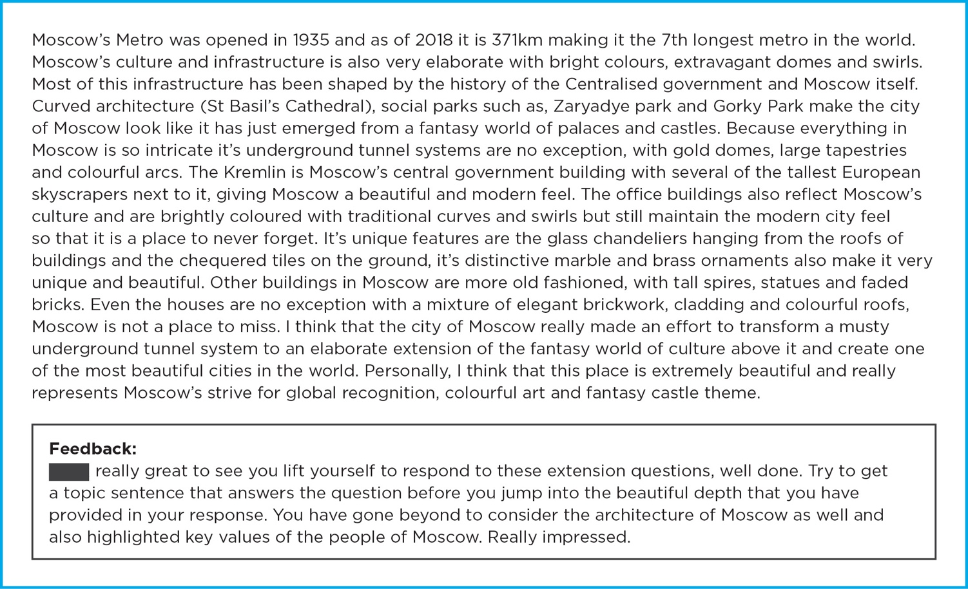

Student work sample 2: Developing question
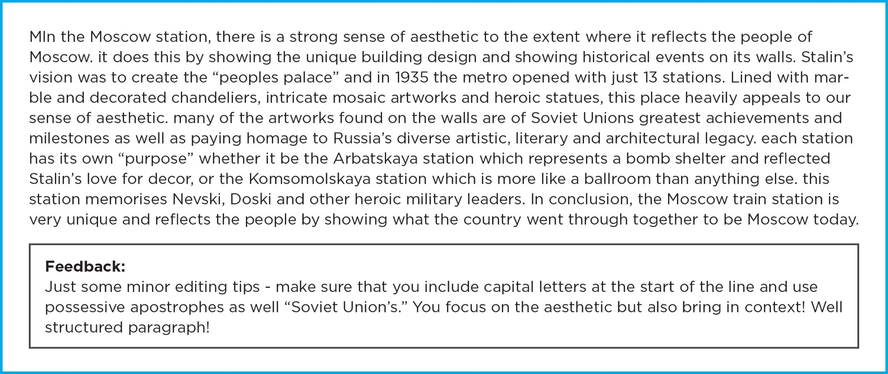

Student sample 3: Novice question
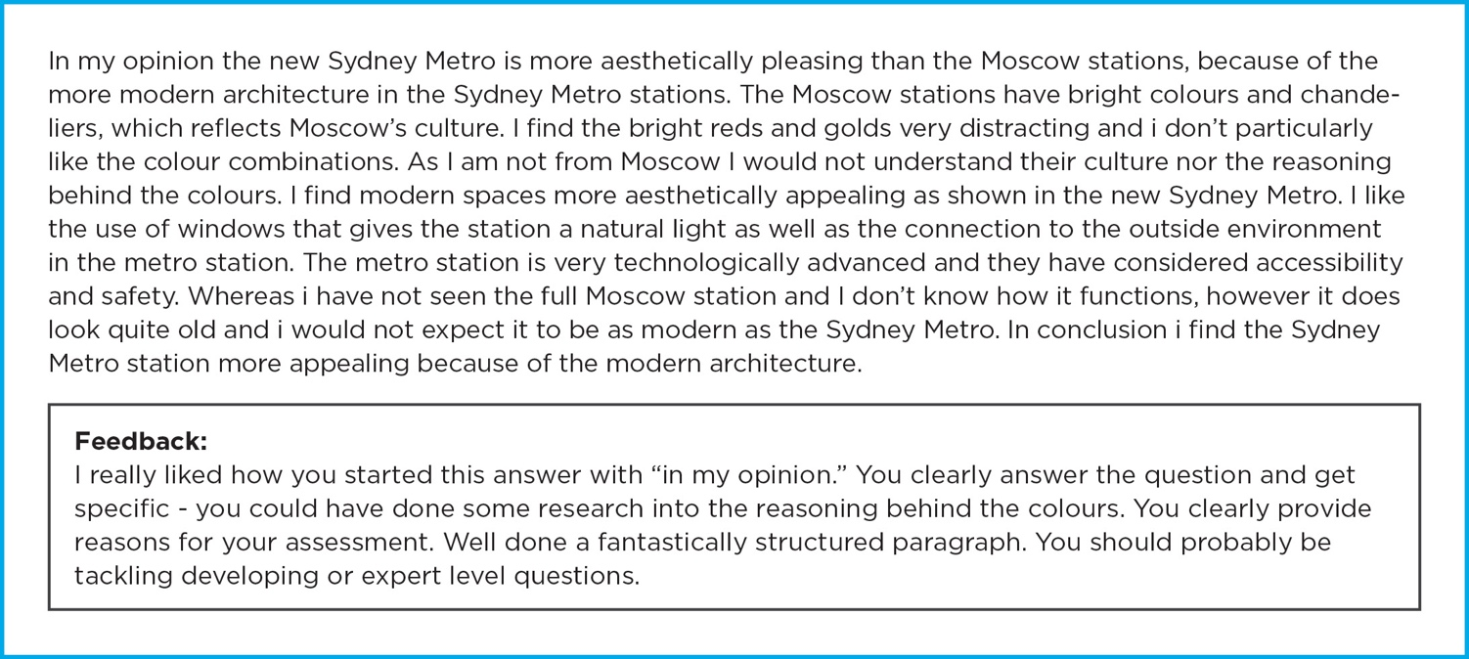

Student sample of a design portfolio
Student research, drafting and creating

Learning intentions
To develop students' skills in questioning, collaboration and research through inquiry-based learning.

Success criteria
- My questions are more complex and conceptual with each lesson.
- I set myself tasks and goals for each lesson and share my findings with my group.

Group 1: Design portfolio sample
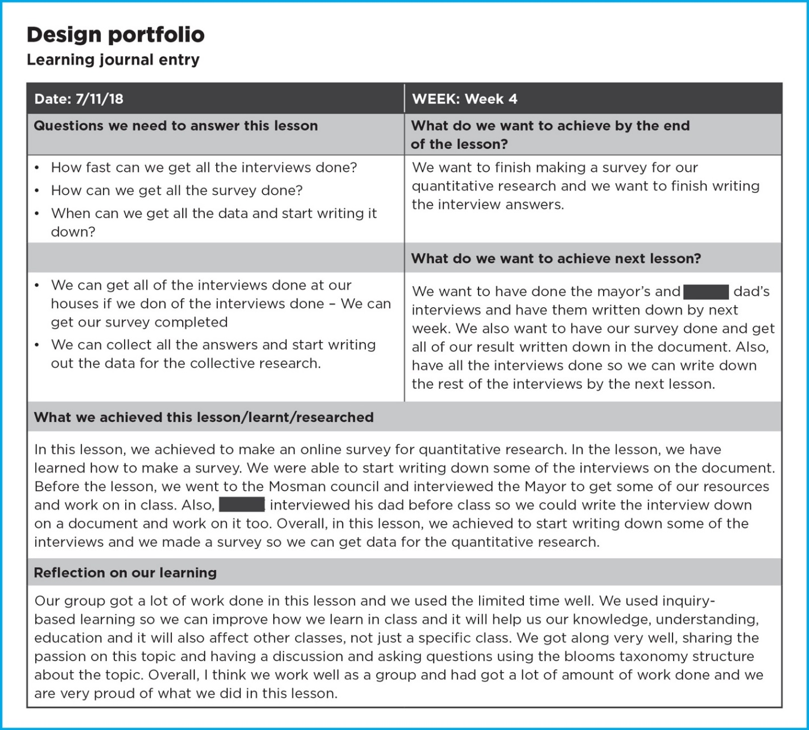

Final design presentation group 1
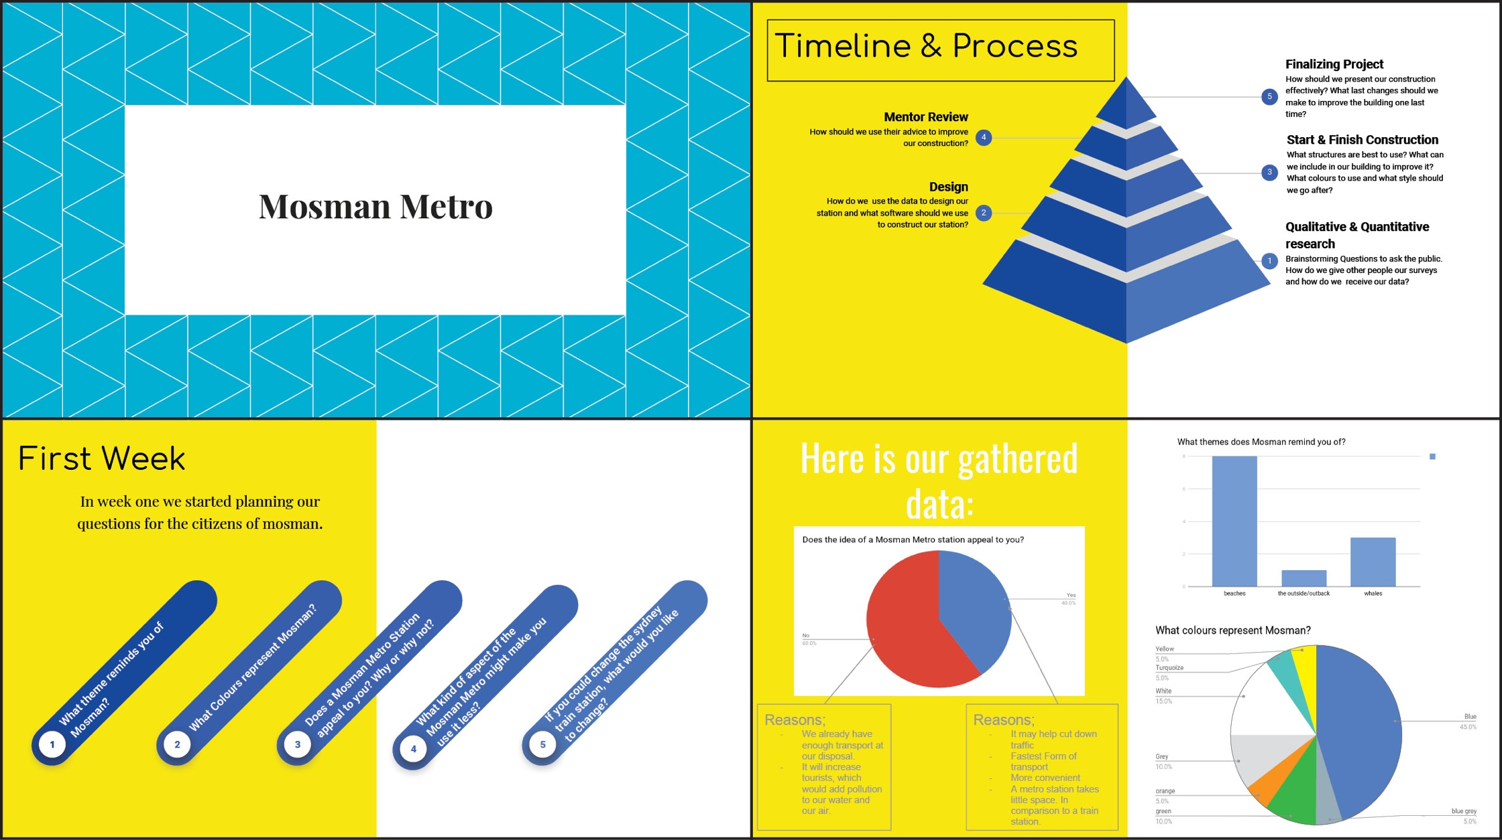

Final design presentation group 1 (continued)
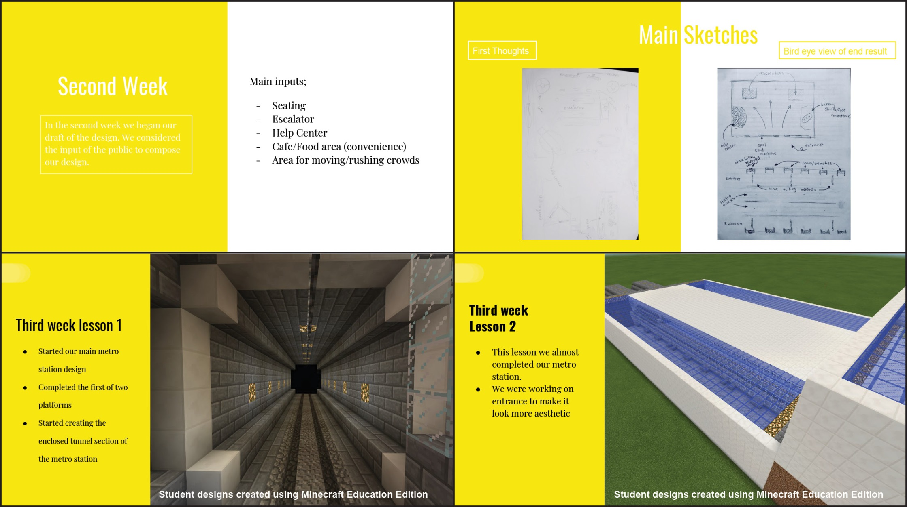

Final design presentation group 1 (continued)
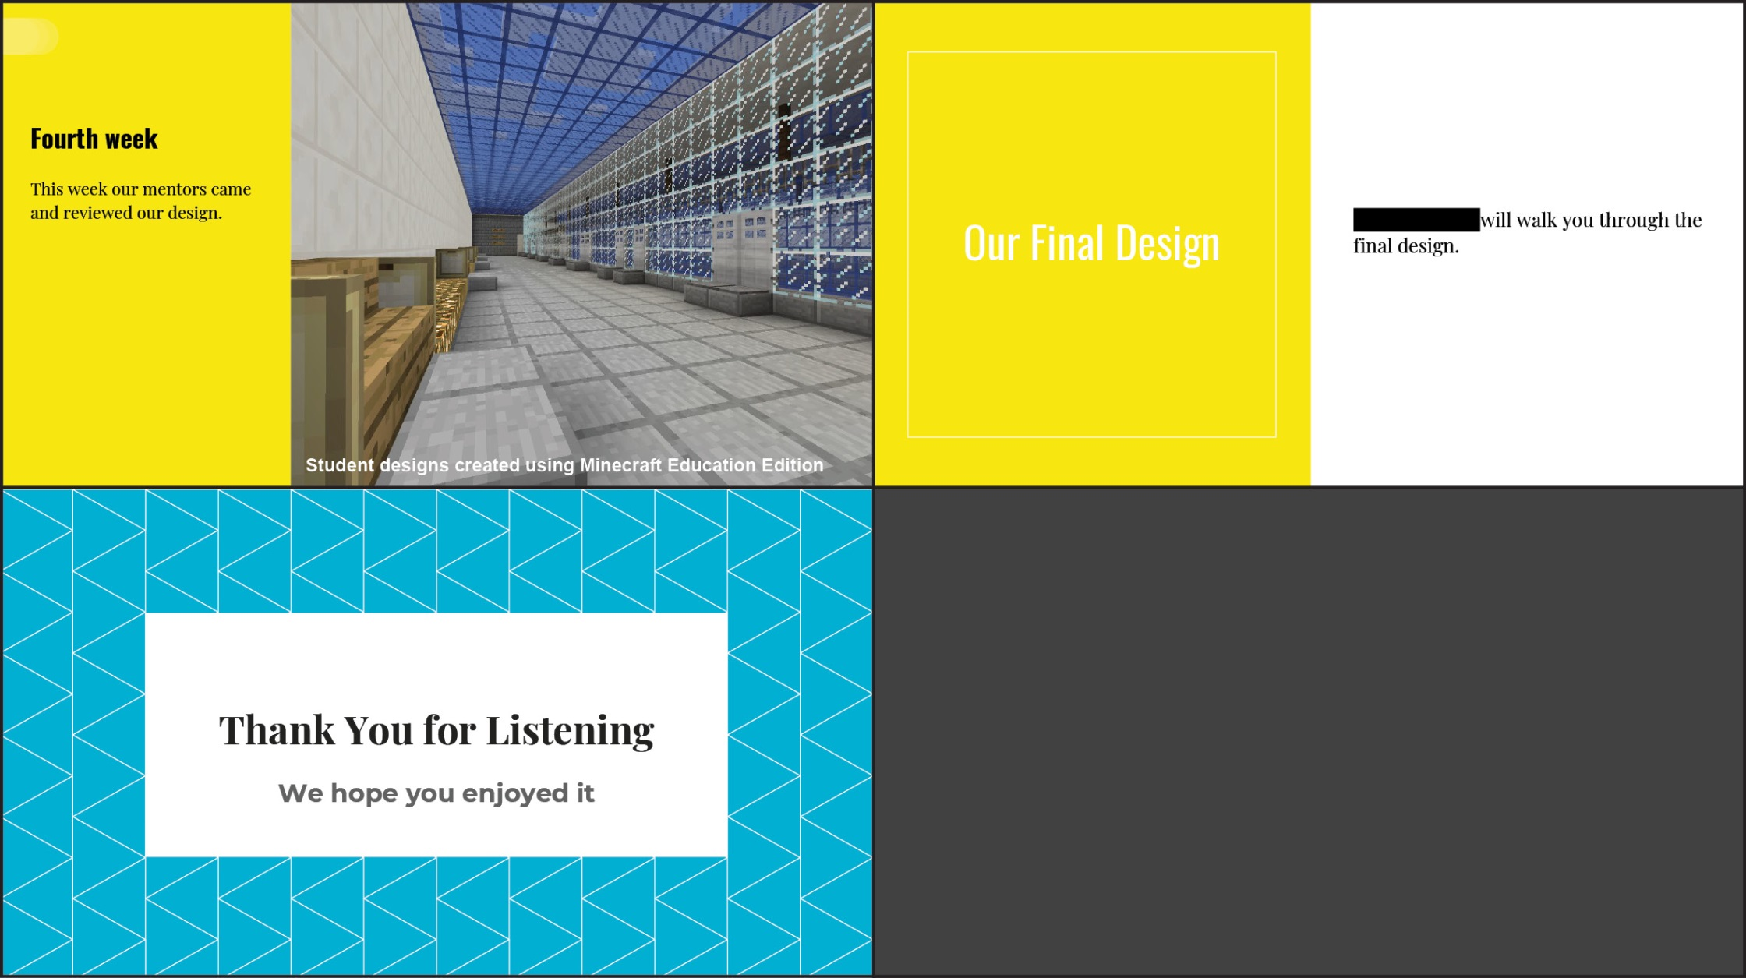

Final design presentation group 2
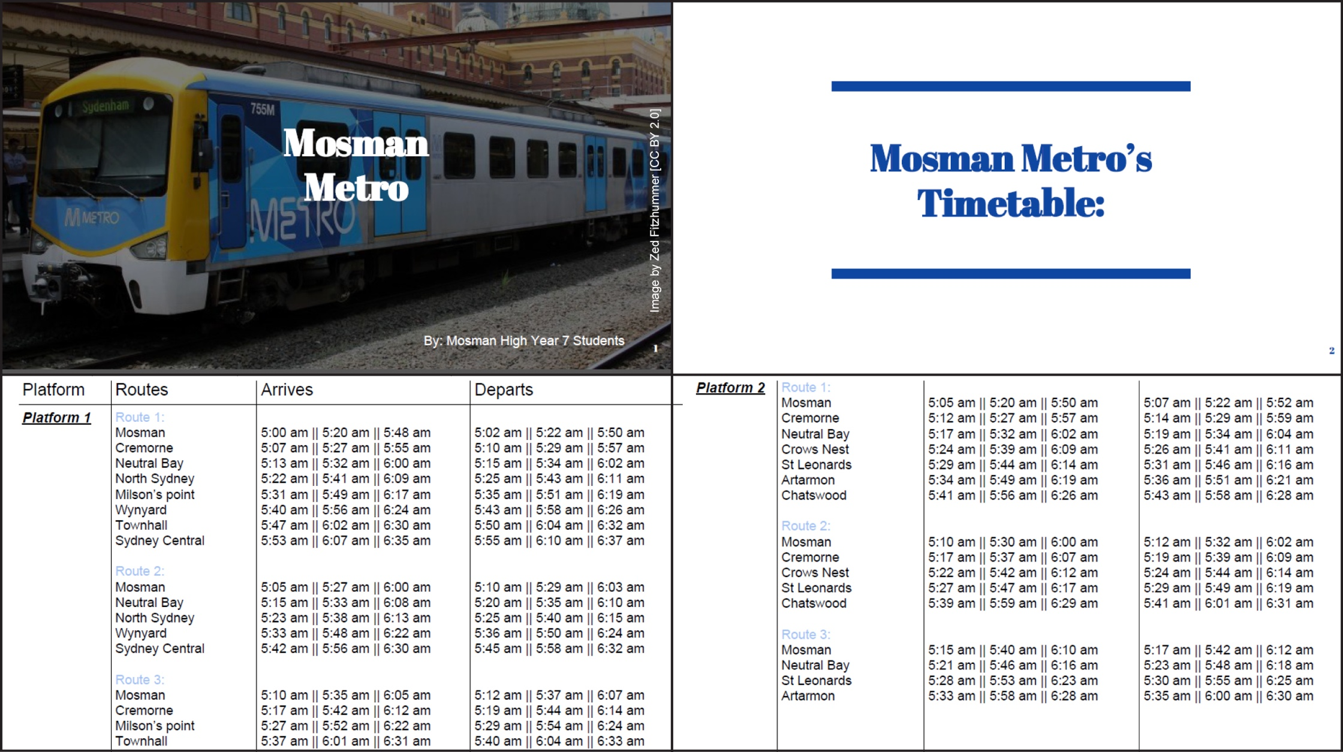

Final design presentation group 2 (continued)
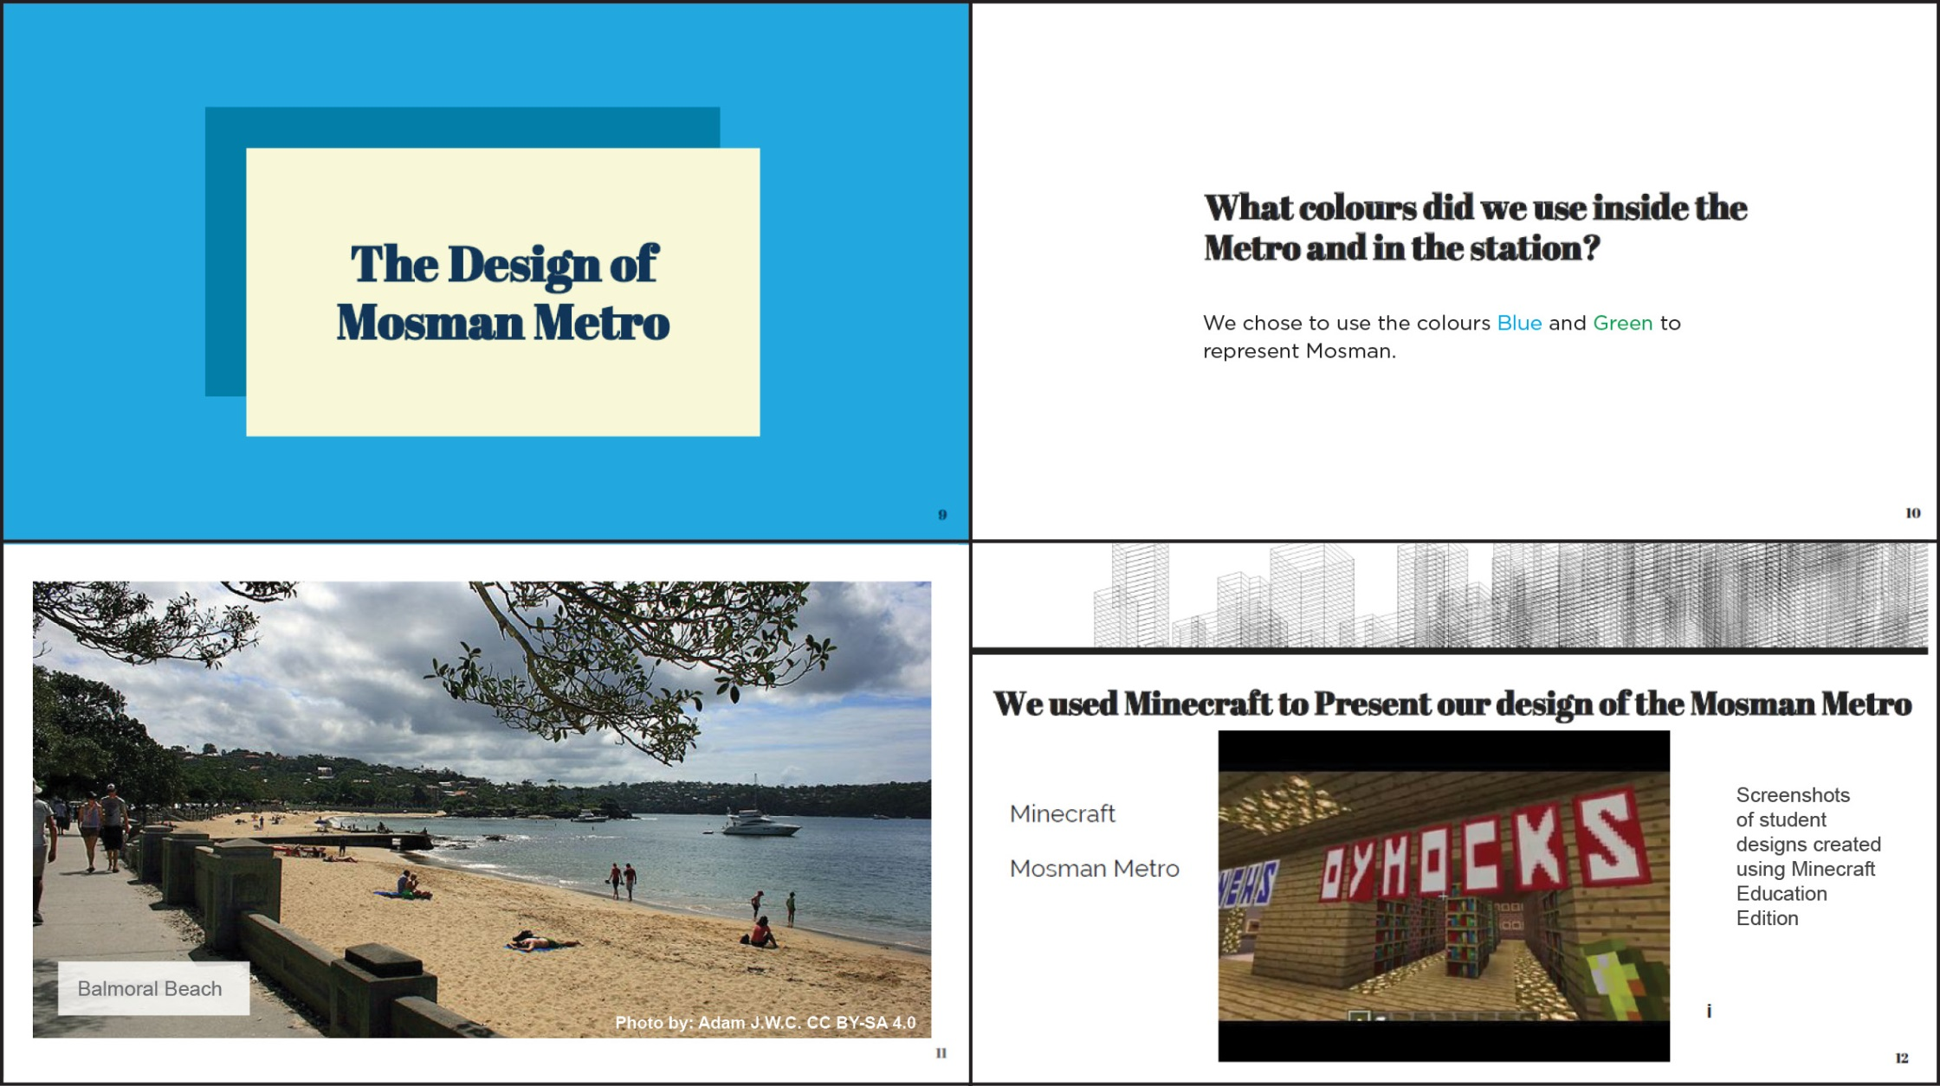

Final design presentation group 2 (continued)
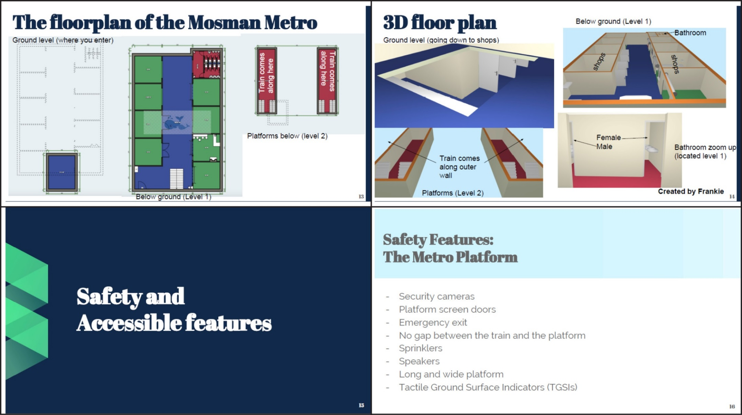
Floorplan of the Mosman Metro Page 13 and 3D floor plan page 14: Designs created using https://floorplancreator.net

Final design presentation group 2 (continued)
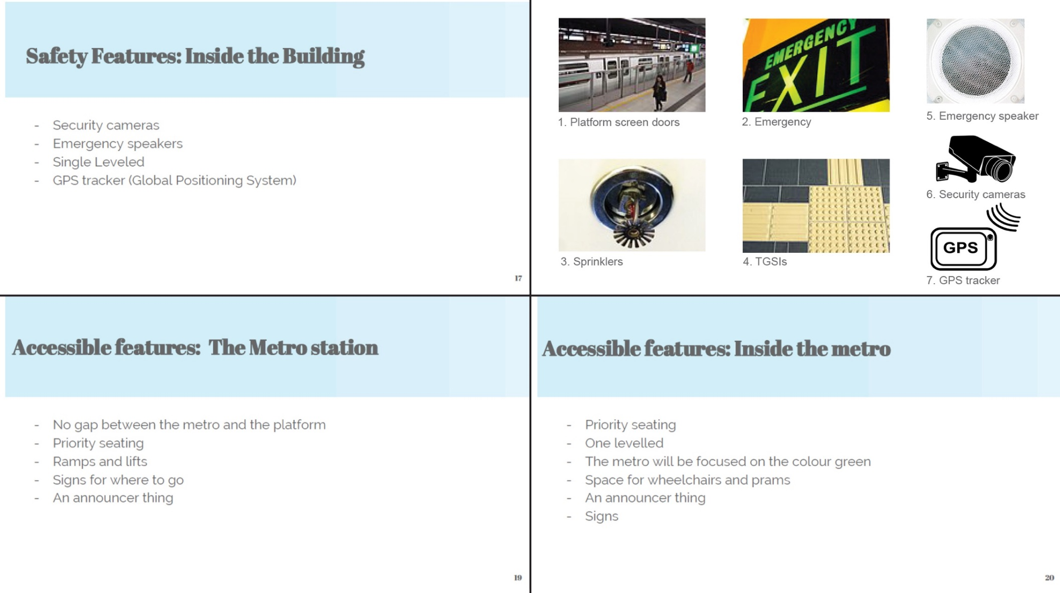
Image accreditation
1 Platform screen doors,.Tongzeit Mihoapci CC BY-SA 4.0
2. Emergency exit, Nicholas Smale CC BY 2.0
3. Fire sprinkler HomeSpot HQ CC BY 2.0]
4. TGSIs, Haragayato CC BY-SA 2.5
5. Emergency speaker, torange.biz CC BY 4.0
6. Security surveillance camera b0red from Pixabay
7. GPS navigation tracker Clker-Free-Vector-Images from Pixabay

Copyright
© State of New South Wales (Department of Education), 2019
The copyright material in this publication is subject to the Copyright Act 1968 (Cth), and is owned by the NSW Department of Education or, where indicated, by a party other than the NSW Department of Education. Copyright material which is owned by the NSW Department of Education is licensed under a Creative Commons Attribution 4.0 International (CC BY 4.0) licence.
This licence allows you to:
- share – copy and redistribute the material in any medium or format
- adapt – remix, transform and build upon the material for any purpose, even commercially.
Attribution should be given to:
© State of New South Wales (Department of Education), 2019.
Material in this publication not available under a Creative Commons licence includes:
- the Department of Education logo, other logos and trademark-protected material
- material owned by a third party that has been reproduced with permission. Permission will need to be obtained from the third party to re-use this material.
If this publication contains your work and you have an objection to such content, please contact legal@det.nsw.edu.au.

Links to third-party websites
If you use the links provided in this publication to access a third party’s website, you acknowledge that the terms of use, including licence terms set out on the third party’s website apply to the use which may be made of the materials on that third party’s website or where permitted by the Copyright Act 1968 (Cth).
The department accepts no responsibility for content on third-party websites.

https://www.australiancurriculum.edu.au/f-10-curriculum/general-capabilities/critical-and-creative-thinking/
https://www.australiancurriculum.edu.au/media/1072/general-capabilities-creative-and-critical-thinking-learning-continuum.pdf
Contact Sydney Metro at sydneymetroedu@transport.nsw.gov.au to request a copy of ‘World’s Best Metro
https://www.australiancurriculum.edu.au/media/1360/lutheran-education-queensland-inquiry-based-learning.pdf
https://course.ccs.neu.edu/is4800sp12/resources/qualmethods.pdf
https://libguides.usc.edu/writingguide/quantitative
https://www.youtube.com/watch?v=dzyILnGf_bo

