Rubbish Rap (ES1-S1)
Vocal Ease More

Speech and song – what is a rap?
- Watch a short video overview by the composer (0:41)
- Watch a short video overview of the teaching points (0:41)
- Listen to the full performance (2:32)
- Listen to the full backing track (2:32)
- Listen to the shortened performance (1:53)
- Listen to the shortened backing track (1:53)
- Access the lyric sheet (pdf)

Background to Rubbish Rap
The aim of this piece is to explore the first steps to music making using speech. This can be identified as rhythmic speech, chant or rap. Speech is one of the most accessible and engaging ways to explore music and allows for easy integration into other key learning areas.
In this piece, students will be engaged in learning a chant whilst exploring all musical concepts through a variety of learning experiences including performing, organising sound and listening.
Rubbish Rap delves into a relevant topic of reducing, reusing and recycling. It forces children to think about this critical issue in an interesting and exciting way.
Begin by learning the reduced version of the rap, then build up to the full version. Explore with movement and instruments following the lesson ideas and then use the backing tracks and suggestions to make your own chants or raps. This backing track can be used in repeatedly to suit your needs.

Quick start menu
- Listen to Rubbish Rap and keep the beat. Learn the shortened version of the rap. Build up to the full version of the rap. Perform.
- Follow the guidelines for graphic notation.
- Improvise, arrange and then create your own raps.
- Complete some or all the suggested activities including some of the suggestions for integrating into other key learning areas.

Key to icons

Concepts of music
Duration
Pitch
Dynamics
Tone colour
Structure

Learning experiences
Performing
Organising sound/composition
Listen
Outcomes and other elements of the syllabus used in this document are copyright Creative Arts K-6 Syllabus (NESA)

Learning across the curriculum
Cross-curriculum priorities | General capabilities | Other learning across the curriculum areas
Sustainability | Critical and creative thinking  Ethical understanding  Information and communication technology capability  Literacy  Numeracy  Personal and social capability | Civics and citizenship

Get familiar

Outcomes and purpose

MUES1.1
MUES1.2
MUES1.4
MUS1.1
MUS1.2
MUS1.4
To introduce and reinforce the Rubbish Rap.
Keeping the beat.
Exploring the structure.

Learning experiences | Activities ES1-S1 | Concepts of music
 | Context – with words displayed, discuss the meaning of the words and what the rap is about. Focus particularly on the reduced version of the rap.
 | Keep the beat – whilst listening to the recording of the full rap. Try this a few times with a variety of methods for beat keeping including movement (such as stepping), clapping or other body percussion (such as clicking or patsching).
 | Investigate the music – discuss the structure of how the piece has been put together. How many lines are there in each verse? (8) How many beats are there in each line? (4)
 | Move – as a class, model movements to reflect the text in each verse. Reinforce the beat through this movement.
Perform – in groups students create a movement pattern to reflect each line of a verse or chorus. There should be 8 movements to reflect the 8 lines of each.
In the reduced version there is 1 chorus to start then 1 verse then a chorus. Therefore, potentially there will be 3 groups (Chorus, Verse, Chorus – CVC). Swap groups and repeat or dramatise the words (the first and last verses are the same and start after the words ‘Ooo, Ahh, Rubbish Rap’. This will assist students in learning them and will also reinforce the beat.

Spice it up

Outcomes and purpose
MUES1.1
MUES1.2
MUES1.4
MUS1.1
MUS1.2
MUS1.4
To maintain the beat.
Creating and performing accompaniments such as ostinatos.

Learning experiences | Activities ES1-S1 | Concepts of music | Watch the lesson
 | Keep the beat – revise the rap in either full or reduced versions. Add some body percussion to each line. Either keep it consistent or change for each line. Examples of body percussion might include clapping, clicking or patsching. |  | 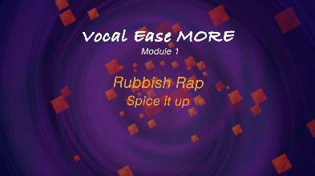  (1:49)
 | Accompaniment – body percussion is one form of accompaniment. Experiment with other forms of accompaniment such as beatboxing or adding an ostinato. An example of an ostinato is taking a phrase or a line and repeating them, such as ‘Ooo, ahhh rubbish rap’. Explore contrasts in dynamics in the accompaniment. One group performs the ostinato whilst the rest of the class performs the rap. |  | (3:08)
Extend – upon this by adding instruments. The instruments can be traditional percussion instruments or self-created (see STEAM link). What is this?
The instruments can replicate the ostinato or body percussion patterns.
 | Experiment – explore recycled materials that can produce a noise, such as scrunch or rip newspaper, tap bottles or twist plastic bags. Use some of the previously learned techniques to create a new accompaniment for the Rubbish Rap either short or full version. |  | 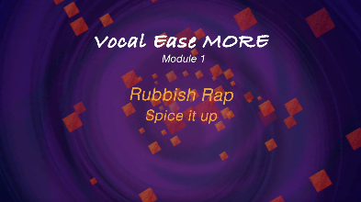  (2:05)
 | Perform – the rap with this new accompaniment.

Notate it

Outcomes and purpose

MUES1.1
MUES1.2
MUES1.4
MUS1.1
MUS1.2
MUS1.3
MUS1.4
To maintain the beat.
Introducing and using graphic notation.
Creating and performing accompaniments such as ostinatos.
Exploring rhythm patterns and rests.

Learning experiences | Activities ES1-S1 | Concepts of music | Watch the lesson
 | Keep the beat – create a grid that has 4 columns and 8 rows. Each square represents a beat in the verse. Pictorially represent the instruments that should play on each beat. This may be as simple as a symbol such as an X or an O to represent two different instrumental groups or may be a picture of the instrument to play on the beat. This is the starting point of graphic notation.  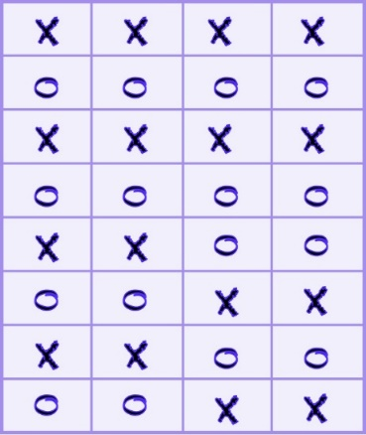 |  | 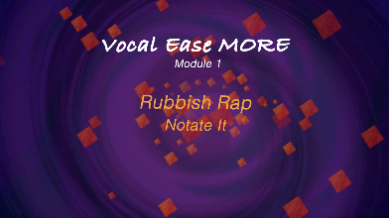  (1:32)
Add some rhythm – try adding in some long notes or short notes to your graphic notation score and perform on available instruments.
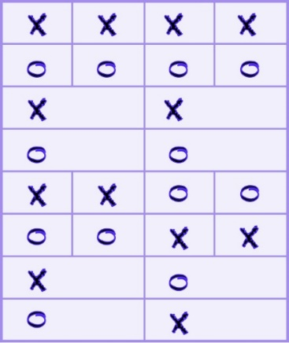
Change the rhythm – you could also try adding in some shorter notes or two sounds (quavers) on the one beat or even rests (no sound on a beat) and perform.
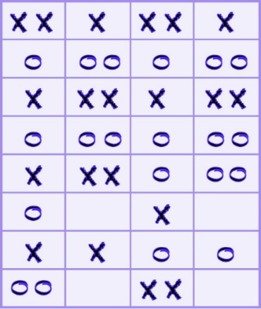
Arrange and notate – experiment with your own arrangements as above. This is also a perfect opportunity to introduce formal stick or rhythmic notation with colour coding for different instruments.
I = one sound on a beat
∏ = two sounds on a beat
Z = no sound on a beat
= two beats, 1 sound
The symbols above could become (X = green, O = red)
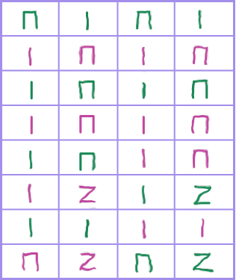

Make it up

Outcomes and purpose

MUES1.1
MUES1.2
MUES1.4
MUS1.1
MUS1.2
MUS1.3
MUS1.4
Counting beats and phrases.
Improvisation through call and response

Learning experiences | Activities ES1-S1 | Concepts of music
Call and response – as a whole class, recite the section of the rap ‘Ooo, ahh, rubbish rap’ (4 beats) whilst keeping a beat underneath. This is referred to as a call. Think of a rhythm pattern response that is also 4 beats long such as:
Practice as a class playing this on an instrument or using body percussion. Make this into a conversation of the call ‘Ooo, ahh, rubbish rap’ followed by the response. Try also using several different response demonstration rhythms until the students are familiar with this call and response technique.
 | Improvise together – as a class, repeat the call ‘Ooo, ahh, rubbish rap’ and then altogether with different improvised response rhythms that last four beats. This is a way for the students to get used to what 4 beats sound like as their response. This will also get the students used to experimenting with rhythm without the pressure of being on their own.
 | Improvise in pairs – with a partner the students can think, pair, share a response to the call ‘Ooo, ahh, rubbish rap’. Sit in a circle. Offer the call for each pair and have them give their response. This may take several turns until the students are able to do this without missing a beat after the call.
 | Improvise alone – repeat the above steps by offering the call but this time the students individually provide their response.

Where to from here?

Purpose
- Exploring rhythm and beat.
- Using speech to explore duration and other musical concepts.

Activities ES1-S1
- Make up your own rap. Use the backing track provided or make your own using ostinatos.
- Explore graphic or stick notation with rhythm charts to reinforce beat, rhythm or to record a rhythmic ostinato to be used with any piece of music. Always check the metre (time signature) first though – remembering for a piece in 3 you will need three beats on your chart, not 4 for example.
- Use call and response as a technique for reinforcing rhythms of new songs.
- Improvise often to increase confidence and skill in this area.

- Create your own instruments using only recycled materials. Watch the Tuneful Trash video as stimulus.
- Explore the rubbish in your school. Using gloves, collate the numbers or types of rubbish left behind. For example, on a bar graph, represent the numbers of types of rubbish like coffee cups, chip packets, bottles and so on.
- Is your school effectively dealing with rubbish and recycling?
- What could you do to support this?
- Repurpose recycled goods or rubbish to suit a need within your school or community. Explore the visual arts project Waste As Art for stimulus.
- Design an advertisement to sell your repurposed rubbish item or to support recycling in your school or community.
- Creative Arts: music – explore the role of music in society for conveying meaning. Explore other examples of songs and their purpose or meaning. Visual Arts: explore the Waste as Art project.
- HSIE: history – explore cause and effect. Look at cause and effect in the past and present with relation to rubbish, environmental change and the effects. Geography - explore place, space and environment. Examine how and why places should be looked after and the problems associated with rubbish. Investigate locations and features such as where to put waste in school, home and the community and places such as the tip and recycling stations.
- English – engage in speaking and listening by replicating rhythms and sound patterns in the rap. Explore writing and representing by manipulating the text to create own lyrics to a rap, as well as reading and viewing to understand and interpret the purpose and meaning of the text.
- Science and Technology – using technologies such as Garage Band to explore accompaniment and to record and manipulate sound.

