When the Clouds Are Sinking Low/A Wonderous Place (S2-S3)
Vocal Ease More

Partner songs – what can music tell us about the past?
- Watch a short video overview by the composer (0:38)
- Watch a short video overview of the teaching points (0:38)
- Listen and follow the score (4:06)
- Listen to the full performance (4:11)
- Listen to the full performance with When the clouds as a feature (4:11)
- Listen to the full performance with A wonderous place as a feature (4:11)
- Listen to the backing track (4:10)
- Access the lyric sheet
- Access the score for When the Clouds Are Sinking Low
- Access the score for A Wonderous Place

Background to When the Clouds are Sinking Low/A Wonderous Place
All the places in this song are in Australia. Many towns have Aboriginal names such as Nar Nar Goo which is the Aboriginal name for koala, Bong Bong meaning blind or a watercourse lost in a swamp and Chinkapook which is thought to have had origins in the Aboriginal words for foot, red pool or red ochre. Research the others mentioned in the song to discover the meanings and their mysteries. The composer did her own research to find these unusual places!
Musically, this song is made up of two songs that can be sung separately or together. It’s a two for one deal! These types of songs are known as partner songs. Whilst this takes time to practice, the beautiful harmonies are worth striving for.
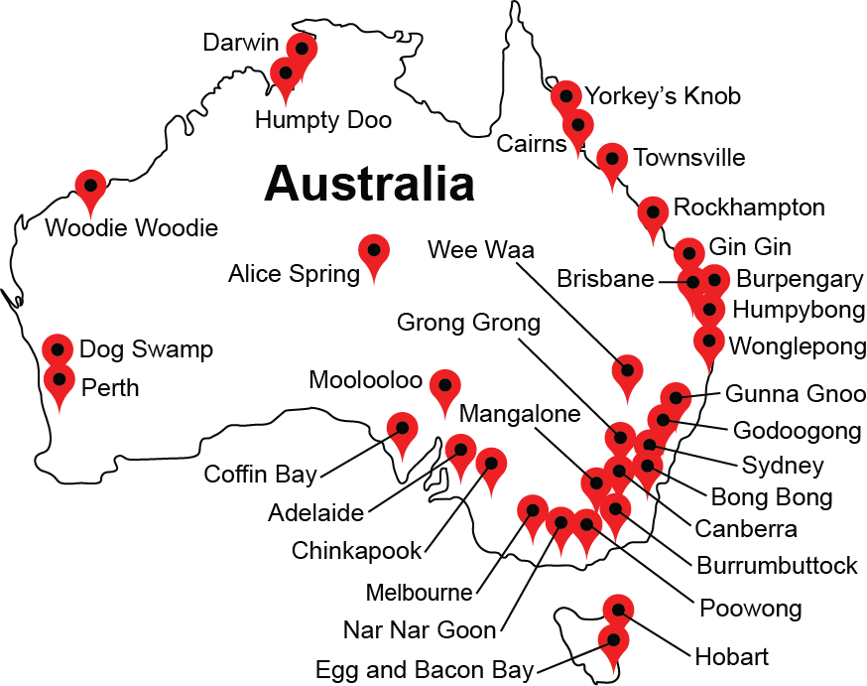

Quick start menu
- Listen to the When the Clouds are Sinking Low/A Wonderous Place and keep the beat. Add movement to help identify the different sections of the music.
- Learn to sing both songs. Put them together as partner songs if you wish.
- Play the stone passing game.
- Explore the phrasing and different feel of each song. Add instruments to represent the different sections.
- Experiment with rhythmic ostinatos and then melodic accompaniments to add to the songs.

Experiment with accompaniments to add to the songs.Key to icons

Concepts of music
Duration
Pitch
Dynamics
Tone colour
Structure

Learning experiences
Performing
Organising sound/composition
Listen
© Outcomes and other elements of the syllabus used in this document are copyright Creative Arts K-6 Syllabus (NESA)

Learning across the curriculum
Cross-curriculum priorities | General capabilities | Other learning across the curriculum areas
Asia and Australia’s engagement with Asia  Aboriginal and Torres Strait Islander histories and cultures | Critical and creative thinking  Ethical understanding  Information and communication technology capability  Intercultural understanding  Literacy  Numeracy  Personal and social capability | Civics and citizenship  Difference and diversity

Get familiar

Outcomes and purpose
MUS2.1
MUS2.2
MUS3.1
MUS3.2
Learn the two songs.
Keep the beat.
Identify the differences in the songs through movement.

Learning experiences | Activities S2-S3 | Concepts of music | Watch the lesson
Context – follow the lyrics and discuss what happens in this song? What do the students notice in the second half of the recording? This is the two songs being sung simultaneously. Discuss the text of both songs. What do they mean? Plot the areas mentioned in the second song on a map. How do the songs relate musically and in terms of the lyrics?
Listen to the recording of the town names. This will help with pronunciation during the singing of the 'faster' feeling second song.
As a class, follow the words and learn to sing the songs separately. It is preferable to wait until the students are very familiar with both songs before attempting to put them together.
What do these songs tell us about Australia and the past? What has happened to the town mentioned now and what was their role in the establishment of our country. Discuss the vastness of our country and the changing ways that we live. Music has played an important role in communicating that social and physical history. Singing songs plays an important part in communicating stories in every culture! How can we identify historical versus contemporary songs? What are some of the clues to recognising these key differences?
 | Keep the beat – with words displayed, keep the beat whilst listening to the recording of the full song. Try this a few times with a variety of methods for beat keeping including movement (such as stepping), clapping or other body percussion (such as clicking or patsching).  Keep the beat at a slow tempo and then at double speed – slow for the first song and fast for the second. During the partner song section swap between the two tempos. Again, explore this using a variety of body percussion. |  | 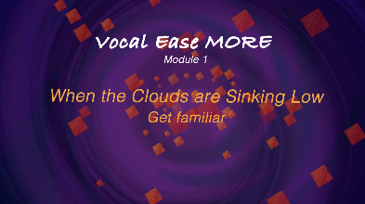  (1:20)
 | Investigate the music – explore the phrasing of the songs. During the slower first song, the students could use a parachute, scarves or Japanese rice balls to show the length of the phrases.  For example, move the parachute up for 4 and down for 4 to show the 8 beats. Alternatively, with right hand starting in front of left shoulder, move it to an outstretched position to the right for the 8 beats of the phrase then swap hands and do to the left for the next 8 with scarves. If using rice paper balls, try to keep them in the air for 8 beats.  During the 'faster' feeling song, explore a different way of showing the phrases. For example, use ribbon sticks, throwing a sandbag or bouncing a ball for these shorter phrases which are generally 4 beats long. |  | 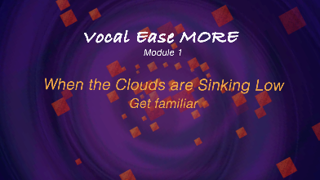  (1:46)
s | Move – during the didgeridoo section of the second song, the students should explore body percussion with a partner. Start with a simple pattern such as facing each other and clapping right hands for 8 beats, then left for 8 and repeating or stepping in one direction for 8 and back for 8.  Once the students are confident with this they should create their own body percussion or movement patterns to match this section of the music. |  | 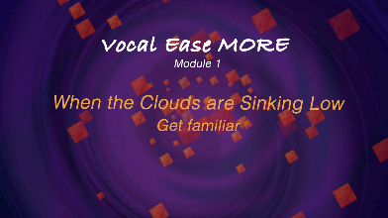  (0:54)
Perform – sing with the complete recording of the song. Add movement as appropriate.
When the song divides into partner songs (the two songs together) either choose one part to sing as a class (with the other being sung on the recording) or divide the students in half and sing both together. This will take some practice and it is important to place a confident student within each group to assist in this process.

Spice it up

Outcomes and purpose

MUS2.1
MUS2.2
MUS3.1
MUS3.2
To further investigate the structure.
To sing both songs together and hear the harmonies.
To accompany the song using ostinatos.

Learning experiences | Activities S2-S3 | Concepts of music | Watch the lesson
 | Keep the beat – revise the song by singing and keeping the beat using some form of body percussion or movement. Repeat one of the activities previously completed.  Do a stone passing game to demonstrate the differences in the feel of the tempo.  The students should be in a circle and then pass a stone or collective of objects to the right on the beat. Start this process slowly by practicing with the words ‘pick up, pass’, whereby they pick up the stone in front of them and then pass it to floor in front of the person next to them.  When the second song is on, repeat this at the faster feeling tempo.  During the partner songs, try either or even both with two different circles. To do this with two circles, divide the students in half with one group taking one song and the other group the remaining song.  Students should keep doing the stone passing game only when their song is being performed. When both are sung together, the stone passing game continues with both circles at the same time. You can even try one circle within the other! |  | 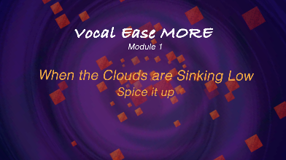  (3:57)
Accompaniment – using available percussion instruments, play on the beat throughout the song, either as a whole class or in the two groups to represent the two songs and only play with one song or the other.
During the didgeridoo section the students could improvise rhythms on their instruments.
If available, play melodic instruments such as xylophones, boomwhackers or ukuleles on the beat or at the start of each bar as indicated on the music and following the notes indicated by the chord symbols.
 | Experiment – create an ostinato pattern to accompany the song throughout. Start with rhythms such as long, long, short, short, short throughout the song. Change this if required to explore different rhythms.  Use the town names included in the faster feeling song as ostinatos. Start this process by dividing the students into groups depending upon how many town names you want to use. Allocate each group a town name. Practice saying it separately as an ostinato then layer them on top of each other. Provide a steady beat throughout this process. Add some or all of the ostinatos to the song.  During all the instrumental sections in the recording, students should use claves or other available classroom or environmental percussion instruments to improvise rhythms. If instruments are unavailable, students could either improvise or create clapping games or patterns with a partner. |  | 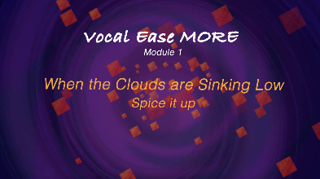
 | Perform – use your ostinato and movement accompaniments to sing one or both songs with the complete recording of the song.

Take it apart

Outcomes and purpose

MUS2.1
MUS2.2
MUS3.1
MUS3.2
Singing the songs separately and confidently.
Singing the songs together in harmony.

Learning experiences | Activities S2-S3 | Concepts of music
 | Sing – revise singing the song. Choose only one song to sing during the combined partner song section. Select one activity already completed to perform with the song, always reinforcing the beat.
Divide – group the students into two groups. Allocate one group to one song and another group to the other. Perform the song with just one group singing their part during the partner song section. The recording will assist with this. The other group could perform one of the previous ostinatos underneath. Swap roles.
Use the track of the complimentary song being sung softly to assist with learning.
- When the clouds as a feature (4:11)
- A wonderous place as a feature (4:11)
Conquer – sing both songs together during the partner song section. This will take some practice and it is important to place a confident student within each group to assist in this process. Use the recording with the complementary song at a soft dynamic level to assist and then without.
A performance of this song could consist of ostinatos, ukuleles or other melodic accompaniment, non-melodic accompaniment singing with the backing track.
Find other partner songs to try this learning structure with. For example, Native Companions Dancing, Pease Pudding Hot and A Ram Sam Sam, Row Row Row Your Boat and Kookaburra Sits in the Old Gum Tree.

Make it up

Outcomes and purpose
MUS2.1
MUS2.2
MUS2.3
MUS2.4
MUS3.1
MUS3.2
MUS3.3
MUS3.4
Organising sound by starting with altering the lyrics.
To learn about the chord structure of a song.
To use this chord structure to assist in organising sound

Learning experiences | Activities S2-S3 | Concepts of music | Watch the lesson
Change the context – revise the song in complete form with the recording by keeping the beat.
Think of local place names that could take the place of the town names in the faster song. Use the backing track to substitute the local names into the song.
 | Learn the chords – this song consists of chords I, IV, V (or 1, 4, 5). (Please note that these have been simplified or substituted from the original). These chords form the basis of the majority of songs, particularly for children. In this piece, that represents a C chord, F chord and a G chord. This can be heard using the recording track. Follow the score along and notice when the chords change. You will notice the symbols change at the top of the music.  Practice playing this pattern by moving between C, F and G. If melodic instruments are not possible, explore alternative options such as iPads or tuned bottles.  Play four beats on each note to represent a full bar of each chord. To finish, return to C (or chord I):  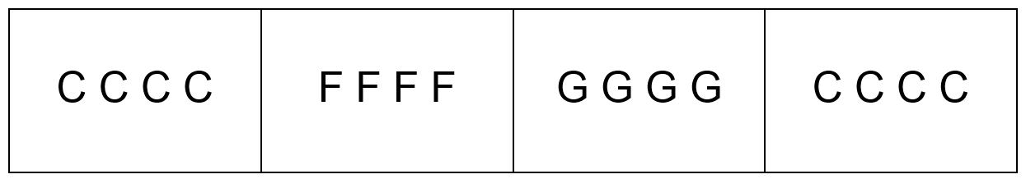 |  | (1:31)
 | Play it – practice playing with the songs by starting with the teacher calling out the chord and the students playing on any available melodic instruments or alternatively singing the chord notes. For example C, C, C, C, F, F, F, F, G, G, G, G, G, G, G, G and so on. Follow the music and play on the beat.
 | Improvise together – return to the pattern of chord I IV V I (C F G C). Practice playing the pattern as an ostinato.  Divide the class in two groups. One group performs the chord pattern as an ostinato and the other improvises over the top of the pattern.  The group who are improvising, could begin by exploring just single notes with a variety of rhythms on C, F and G depending upon which chord is playing. Swap groups. |  | Vc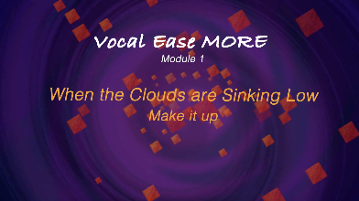  (2:14)
 | Improvise in pairs – with a partner, the students can think, pair, share a melodic improvisation. Sit in a circle. As a whole class, play the chord pattern for each pair and have them play their melodic improvisation on either C, F or G. This may take several turns until the students are able to do this without missing a beat after the call.
 | Improvise alone – repeat the above steps by offering the chord pattern for each student but this time the students individually provide their improvisation.
Extend it – point out to the students that these chords actually contain extra notes – not just the main note. Repeat the above steps but experiment with the extra notes of the chord.
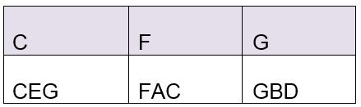

Where to from here?

Purpose
Using partner songs as a way into part singing and exploring pitch and harmony in combination with other musical concepts.

Activities S2-S3
- Explore stone passing games in two groups within other partner songs or rounds.
- Experiment with changing tempo from slow to double tempo.
- Use objects such as scarves or rice paper balls to reinforce the phrasing.
- Find other partner songs and use these techniques to learn to sing them.
- Find, discuss and sing other songs that tell us stories about our country and the past either geographically or socially. For example, Click Go the Shears, We were only Nineteen, The Band Played Waltzing Matilda, Bound for Botany Bay, Waltzing Matilda, Advance Australia Fair.
- Music – explore other Australian songwriters or bands such as Colin Buchanan, John Williamson, Midnight Oil, Yothu Yindi Cold Chisel and so on.

- Design your own town. What does a town need to survive? Describe or create designs to reflect its purpose and features. What will the population do in your town? What will you call it? Where will it be on the map and why? What are the financial implications of establishing your town?
- Create souvenirs what will they features and why? What is the main industry of your town? Design outfits, buildings and historical monuments for your town.
- Create Australian artworks reflecting your town based upon those of the great Australian masters such as Russell Drysdale. Why did they paint the way they did? What do you see in their artworks and what does this tell us about the agriculture, economics and structures around them?
- Explore the economics behind the successful maintenance of townships. Look at business models, profit and lost as to their success.
- Using a map of Australia. Plot the towns mentioned in this song. What is the distance between them and to the nearest large centre? What trends do we notice in their survival as a town to this day? Examine population changes over the years through graphs.
- What is clockwise and anticlockwise? Why do we generally dance in an anti-clockwise direction? Try dancing in a clockwise direction. What do you notice? Can we turn back time?
- Explore the relationship of metre to song. For example, why are most songs in 4 yet dances are generally in 8? What so they sometimes then have a section with 16 beats? Explore movement in 3 what is the difference and why? How would you dance in 5, 7, 9? What are odd numbers more difficult to dance to?
- Examine the seasons and time of year in Australia. People say our seasons are changing. Why?
- Creative Arts - Visual Arts – reflect upon those of the great Australian masters such as Russell Drysdale, Norman Lindsay, Margaret Preston and Margaret Olley. Dance – what is clockwise and anticlockwise? Why do we generally dance in an anti-clockwise direction? Try dancing in a clockwise direction. What do you notice?
- English – find other Australian folksongs, poetry and stories. Examine Australian literature and art. What do you consistently notice? Create your own artworks or literature/stories. Think about representative and adaption rather than copying. Read about Ted Egan. He creates Australian literature and is famous for storytelling through song. Why not make your own Australian books and songs?
- HSIE - History – investigate the names of the towns mentioned in the song. What meaning do they have? What do we know about their names and their significance to Australia history such as Bong Bong have housed important police stations and supposedly hosting many famous Australian ghosts still to this day? Explore colonial Australia, urbanisation and change. Look at Australian history and poetry. Explore Australia as a nation. What role did rural and regional Australia have in the creation of our country? Explore historical monuments in the community. Why do we have them? What makes a community? Geography - investigate the names of the towns mentioned in the song. Plot them on a map. Research other towns in Australia with unusual names (such as those initially used by the composer) to find on a map.
- PDHPE – learn folk or bush dances of Australia and beyond. Discuss what makes a community and strong pillars of our society. What makes a great Australian? What makes you a great Australian and what else could you do to be even greater and make a difference to yourself, your school, your family and your community?

