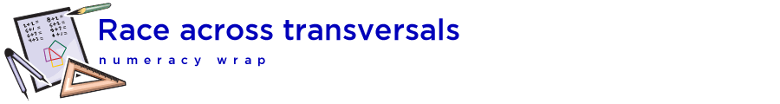

## Teaching notes

This numeracy wrap addresses the following syllabus outcomes from the NSW K-10 Mathematics Syllabus 2012, © NSW Education Standards Authority, NSW:

MA4-1WM communicates and connects mathematical ideas using appropriate terminology, diagrams and symbols

MA4-3WM recognises and explains mathematical relationships using reasoning

MA4-18MG identifies and uses angle relationships, including those related to transversals on sets of parallel lines

Students will:

* Identify corresponding, alternate and co-interior angles when two straight lines are crossed by a transversal
  + identify, name and measure alternate angle pairs, corresponding angle pairs and co-interior angle pairs for two lines cut by a transversal
    - use dynamic geometry software to investigate angle relationships formed by parallel lines and a transversal
* Investigate conditions for two lines to be parallel
  + use angle properties to identify parallel lines
    - explain why two lines are either parallel or not parallel, giving a reason

|  |  |
| --- | --- |
|  | Before and after looking at the interactives, students could suggest methods for checking whether the lines in the optical illusion are actually parallel. You may have to remind students what the converse of a property is. |

|  |  |
| --- | --- |
|  | A class discussion about the quiz could allow students to share different methods of solution. |

|  |  |
| --- | --- |
|  | [The Geometer’s Warehouse](https://app.education.nsw.gov.au/rap/resource/access/cb02edfa-eb1d-43e7-b913-08e55cdb3435/1) comprises 70 dynamic html worksheets, each exploring a different outcome in Stage 4 and Stage 5 geometry. A unique characteristic of the resource is that when screen figures are dragged, angle and length measurements are updated automatically, allowing students to recognise and explore invariant properties. |