Guidelines for some working scientifically skills

A support document for teachers
This document is aimed at supporting science teachers in improving students’ skills in Working Scientifically.
SC4-9WS – presents science ideas, findings and information to a given audience using appropriate scientific language, text types and representations.
SC5-9WS – presents science ideas and evidence for a particular purpose and to a specific audience, using appropriate scientific language, conventions and representations.
Science (incorporating Science and Technology K-6) K-10 Syllabus © NSW Education Standards Authority (NESA) for and on behalf of the Crown in right of the State of New South Wales, 2012
This support document provides guidance for:
- Diagrams
  - Line diagrams
  - Lewis diagrams
  - Pedigrees
  - Microscopy
- Flow charts
- Graphs and charts
  - Divided bar gaphs
  - Column graphs
  - Line graphs
  - Line of best fit
  - Sector graphs
- Tables
These skills are introduced in Stage 4 and 5 within the Working Scientifically Skills of the Science 7-10 Syllabus. The HSC Science courses and exams require a deeper understanding of these skills which are introduced in the Skills outcomes components of the Stage 6 Science syllabuses.

Diagrams
Diagrams in science encompass a wide variety of representations and are used to convey scientific information pictorially. Diagrams range from line drawings, microscopy, Lewis structures and pedigrees.

Line diagrams
A good line diagram:
- Is drawn in black pencil
- Has crisp, sharp lines without shading, feathering or stippling
- Has any straight lines present drawn with a ruler
- Is drawn in two dimensions only
- Has the openings of containers not closed off with a line
- Is large enough to show the important details
- Has each component labelled with a ruled line without arrow heads
- Has label lines that do not cross over.
NB: Arrow heads are used to denote movement or a process only
Example: laboratory equipment set up
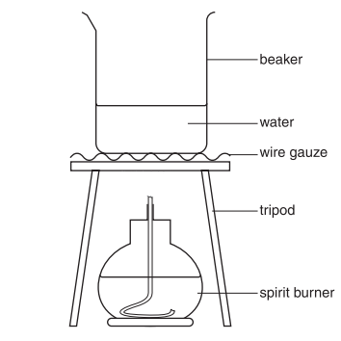

Lewis Diagrams
- Only dots are used (no crosses).
Examples
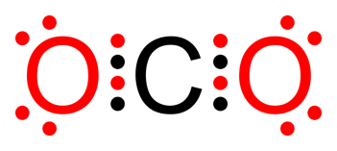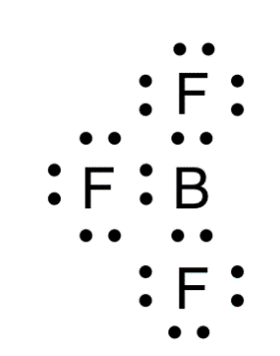

Pedigrees
A good pedigree:
- Has circles to denote females
- Has squares to denote males
- Has triangles to denote unknown gender
- Has affected individuals shaded
- Has carriers unshaded
- May have generations labelled to the left of the diagram with roman numerals
- May have individuals number from left to right for each generation.
Example: Inheritance of Left Handedness in a Family
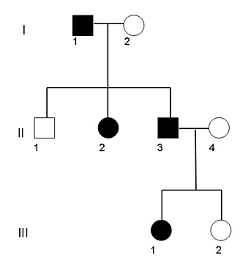

Microscopy
A good diagram:
- Is large enough to show the important details
- Is drawn in black pencil
- Has crisp, sharp lines without shading, feathering or stippling
- Does not contain any open circles, i.e. all lines have a distinct beginning and end
- Has each component labelled with a ruled line without arrow heads
- Has label lines that do not cross over
- Usually contains 3 - 5 representative cells only and does not show the entire field of view, as it is not possible to draw the large number of cells present accurately.
- May consist of a block diagram, that shows zones of tissue types only rather than individual cells
- Has a brief title
- Shows the magnification.
Examples
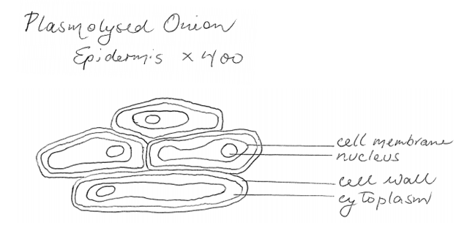
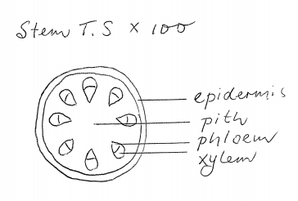

Flow charts
A flowchart is a visual representation of the sequence of steps and decisions needed to perform a process. It is reasonable to expect that by the end of Year 10 students have developed the necessary flow charting skills to be able to demonstrate their ability to sequence the steps in an explanation, correctly organise the steps in a procedure, and extract information from a flow chart.
A good flow chart:
- Encloses each step in an appropriate shape
- Links each step with connecting lines and directional arrows
- Has a logical structure that allows the process to be followed from beginning to end
- Contains a clear sequence of steps through the process
- Often shows inputs shown on the top and left, and outputs shown on the right and bottom
- Usually runs either from left to right or from the top to the bottom of a page.
Most flow charts are built around the use of three main types of symbol that have a special shape and use:
Shape | Use
Action
A rectangle represents an activity or action to be completed
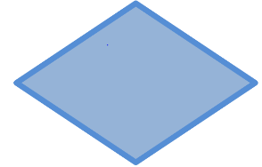 | Decision  A diamond represents a decision to be made
Start/Stop
An elongated circle represents the start or end of a process.
Connector
This allows a jump from one point in the sequence to another point
Direction of flow
Connects symbols and show direction of flow of instructions

Graphs & Charts

Divided bar graphs
A divided bar graph should be selected when displaying proportions, percentages, ratios or fractions of an entity, such as gases, division of money, or percentage of rock content. The data is discrete. A divided bar graph usually runs horizontally. Divided bar graphs allow comparison between different amounts in a group or category.
A good divided bar graph:
- Has the length of the bar proportional to the percentage of each category
- Uses shading or colour to distinguish between each sector
- Either has a legend/key or a label for part of the bar
Composition of the Atmosphere

Column graphs
A column graph should be selected when the data is discrete or non-continuous, ie the data is derived from categories. A column graph may run horizontally or vertically. Column graphs allow comparison between different groups or categories.
A good column graph:
- Is drawn in black pencil
- Has one axis labelled with appropriate headings
- Has numbered graduations shown on the other axis, clearly marked with at least three or more points
- Has an appropriate title
- Contains a legend or key if there is more than one data set.
Example
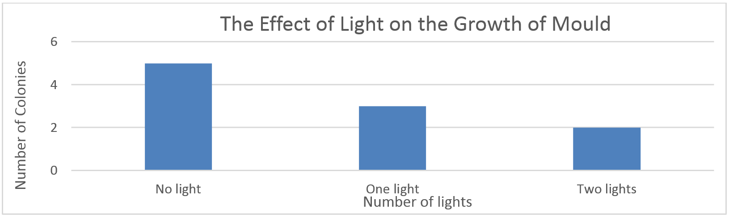

Line Graphs
Line graphs may be used to display the relationship between two variables for which the data is continuous.
A good line graph:
- Is drawn in black pencil
- Has axes labelled with appropriate headings with units
- Usually has the Independent variable on the X axis
- Usually has the dependent variable on the Y axis
- Has numbered graduations shown on each axis, clearly marked with at least three or more points
- Provides a consistent linear or logarithmic scale, which has been selected to allow the range of data displayed to extend over most of the available grid
- Uses a discontinuity marker if necessary
- Has an appropriate title
- Plots points with a sharp cross or circle
- Additional data sets plotted with an alternative shape such as a circle
- Contains a legend or key if there is more than one data set
- Has the first data point plotted close to the origin (not necessarily 0,0)
- Uses a line of best fit where appropriate (ie a straight or a curved line) that does not extend beyond the first and last plotted points
- Has extrapolations shown as a dashed line which is not be joined to the origin or axes unless this is given in the data or can be reasonably assumed
- For interpolation, uses a ruled line drawn from one axis to the line, and another ruled line drawn from the line to the other axis
Example
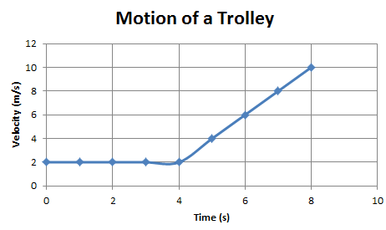
Sometimes it is appropriate to draw a smooth curve that connects the data points, as shown below. This is usually appropriate when displaying reaction rates.
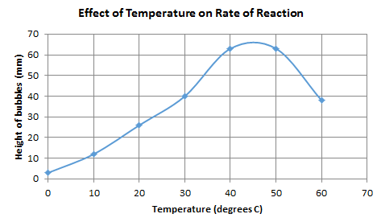
Occasionally, it is appropriate to join points in a line graph, as shown below.
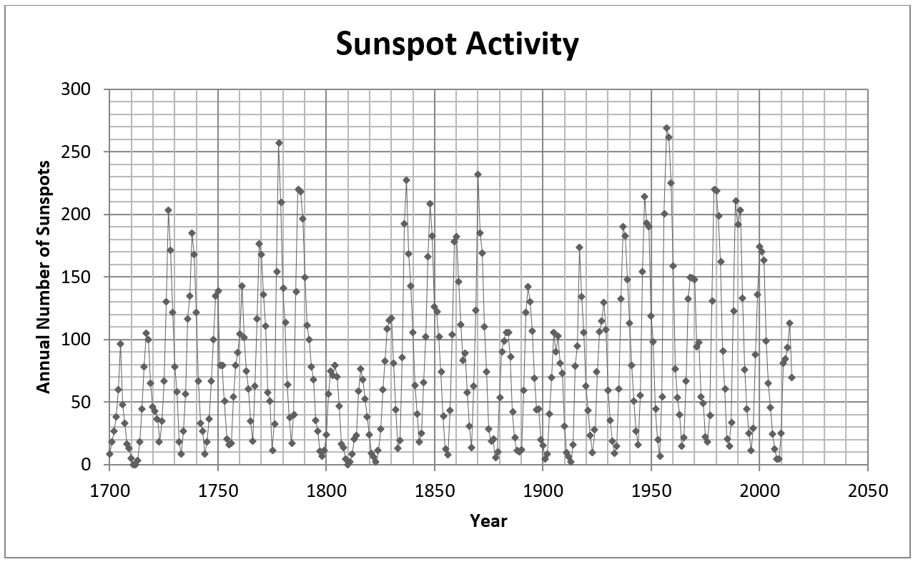
Constructing a best fit line, Math You Need

Line of best fit (trend line)
Note: Drawing a line of best fit is NOT addressed in the Science syllabus until Stage 6. The Science Years 7–10 Syllabus does NOT require this skill for students in Stages 4 or 5.
A line of best fit, or trend line, is a line which indicates the general course or tendency of data. A trend line can be linear, exponential, logarithmic or polynomial. Data that students come across either through first-hand investigations or secondary information usually calls for trend lines of a linear nature; students may be exposed to exponential data in Stage 6 Science courses.
An accurate line of best fit can be worked out mathematically. However, a line of best fit can be worked out manually when trying to ascertain a trend and extrapolate data.
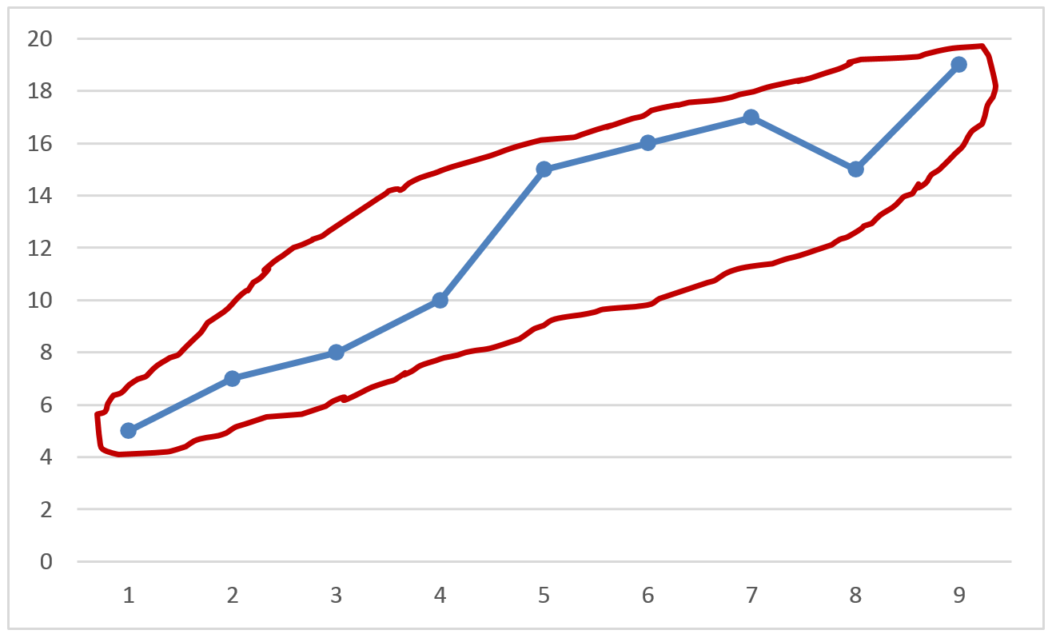
- Draw a circle around the data which encircles all data points.
- Bisect the circle you have drawn
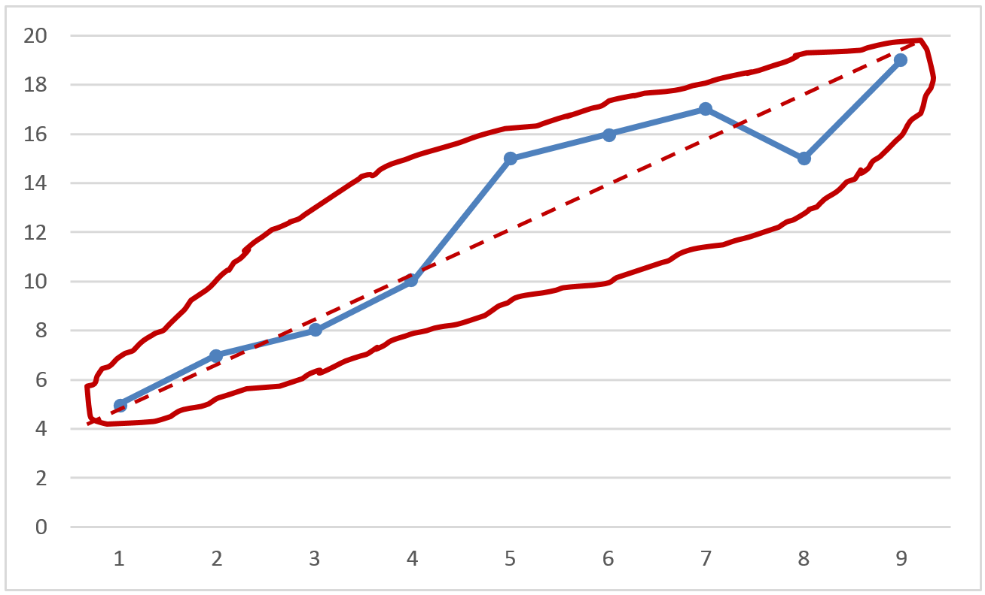
- The line which bisects the circle is a rough line of best fit.
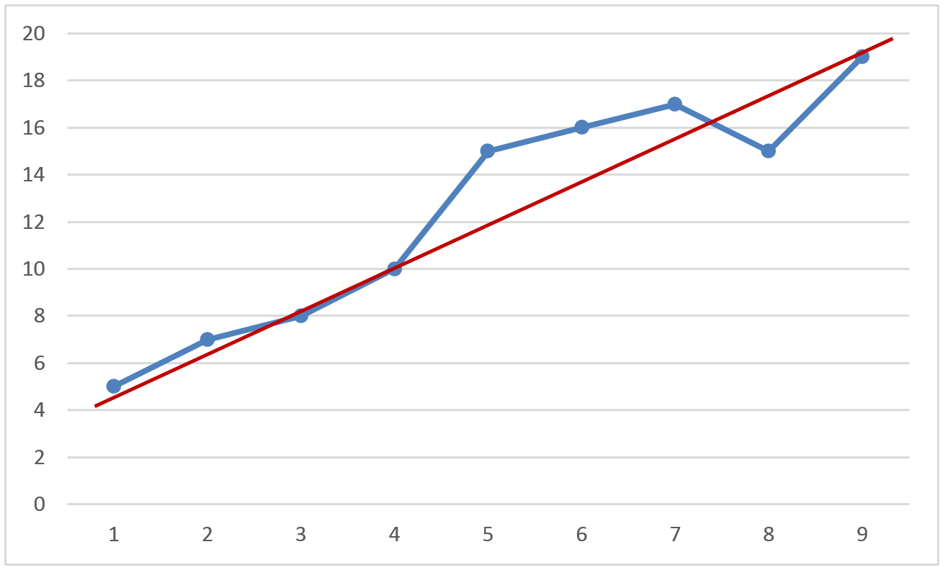

Sector graphs
Each of these graph types are used to show relative proportions. They can be useful for comparing the size of relative parts. Each section of the bar or sector graph represents a percentage of a whole.
A good sector graph:
- Has the angle of each sector proportional to the percentage of each category
- Uses shading or colour to distinguish between each sector
- Either has a legend/key or a label for each sector
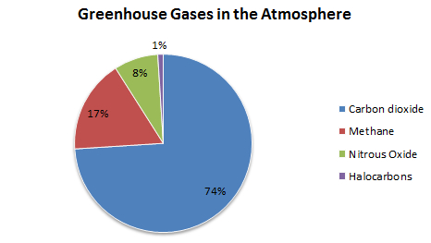

Tables
Tables represent data and allow the organisation of data in rows and columns. Tables can differ in variety, structure, flexibility and representation of data. Tables are valuable as they are used to present results in a readable way.
A good table:
- Contains a descriptive title
- Has rows and columns which have appropriate headings
- Has all data and headings enclosed by ruled lines
- Includes units in the headings, not in the body of the table
- Is drawn to fill at least ¾ of the space provided
- Usually has the independent variable in the left column
- Has figures in each column or row aligned
- Uses a dash when no reading was recorded and a zero when a measurement of zero was obtained
- Shows totals, subtotals, means and/or percentages where relevant.
Table: Effect of light on the growth of mould
Bread Sample | Colonies with no light source | Colonies with one UV light | Colonies with two UV lights
1 | 4 | 4 | 2
2 | 6 | 3 | 1
3 | 7 | 3 | 2
4 | 3 | 2 | 2
5 | 5 | 3 | 3
Mean | 5 | 3 | 2
Range | 3-7 | 2-4 | 1-3

