Early Stage 1 PDHPE, English, Science and Technology – How are you feeling?
Chullora Public School has an enrolment of approximately 300 students and caters to the needs of a low socioeconomic status (SES) and high non-English-speaking-background (NESB) community. There are 12 mainstream classes and a support unit with 3 classes for students with autism and special needs. There are approximately 80 students across stage 3 with a diverse range of abilities as students are meeting Stage 1, Stage 2 and Stage 3 outcomes. In the school community there are also students who are new arrivals to Australia and have limited English skills.

How are you feeling?
Support unit – ongoing depending on student needs

Unit context
This unit was written for students in Early Stage 1 with autism spectrum disorder and/or moderate intellectual disability (IO/AU). Students in our support class are either non-verbal or use echolalia (that is, the repetition of the speech of others) and have various mental health and behaviour conditions and/or receptive and expressive language delays. The developmental age of the students varies from 20-36 months.
This unit was written by Reem El-Haj (Assistant Principal Special Education) of Chullora Public School.
It was created, trialled and peer reviewed as part of a professional development program in inquiry-based learning for primary and secondary school teachers. The professional development courses were part of a pilot partnership between the NSW Government’s Sydney Metro transport agency and Western Sydney University. Facilitated by Western Sydney University’s Education Knowledge Network, the professional development program aimed to develop teacher expertise in inquiry-based learning using a real-life example of a major infrastructure project in delivery stage.
The unit is aligned to © NSW Education Standards Authority (NESA) syllabuses, specifically the English K-10 (2012) Syllabus, the NESA Personal Development, Health and Physical Education K-10 Syllabus (2018) and the Early Years Learning Framework for Australia (2009).
Students in Chullora Public School’s support unit are working towards modified indicators and stage outcomes as compared to their peers in the mainstream who were, at the time of this unit, undertaking an inquiry unit titled “Do we need a Sydney Metro train in Chullora?” This unit was written to support the students in the IO/AU Class to participate with their peers and learning basic communication skills that will allow them to express themselves more appropriately. This unit was undertaken following a spiral of inquiry process (Temperley, Kaser and Halbert, 2014) around expressive language linking to communication and behaviour, emotion and expression.
Chullora Public School’s inquiry journey began with an ‘I wonder’ day. Students in the support unit visited the school hall to explore the different Sydney Metro resources and train artefacts. When they entered the hall, they were completely overwhelmed. They were intrigued by the wooden magnetic train set and began to engage in solitary play. I began to reflect on the skills they needed to express their inquiry and curiosity. I decided to focus on expressive language skills and equip students with the tools to communicate. I ensured that I set up a supportive quality learning environment with hands-on learning and sensory experiences. I explicitly taught students how to use Picture Exchange Communication Systems (PECS®), Key Word Signing and verbal language, depending on the needs and goals based on the students’ personalised learning plans.
Sydney Metro is Australia’s biggest public transport project.

Syllabus links
General capabilities and cross-curriculum priorities | Outcomes | Skills | Concept
ICT  Students have the opportunity to become competent and creative users of ICT as they learn to use ICT effectively when communicating ideas.  Literacy  The knowledge and skills also provides opportunities for personal enrichment through social interaction and engagement.  Personal and social capability  The study of English helps them to identify and express their own opinions, beliefs and responses and to interact confidently and appropriately in a range of social contexts | By end of the unit, students will:  ENe-1A communicates with peers and known adults in informal and guided activities demonstrating emerging skills of group interaction  ENe-6B recognises that there are different kinds of spoken texts with specific language features and shows an emerging awareness of some purposes for spoken language  PDe-10 uses interpersonal skills to effectively interact with others  PDe-3 communicates ways to be caring, inclusive and respectful of others  Early Years Learning Framework Outcomes:  Outcome 1 – Children have a strong sense of identity  - Children learn to interact in relation to others with care and empathy  Outcome 2 – Children are connected with and contribute to their world  - Children become socially responsible  Outcome 4 – Children are confident and involved learners  - Children develop a range of skills and processes such as problem solving, enquiry, experimentation, hypothesising and investigating | Student learn to:  Acquire and use appropriate ways to express and communicate thoughts, feelings and curiosity  Identify and describe different emotions  Regulate their own emotions by utilising expressive language  Identify people that can help in different situations  PDe-10 uses interpersonal skills to effectively interact with others  PDe-3 communicates ways to be caring, inclusive and respectful of others  Inquiry skills found in EYLF:  - Pose questions  - Make observations  - Make connections  - Manipulate objects  - Experiment  - Investigate  - Explore their environment | Student learn about:  Communicate with peers and familiar adults  Respond to simple questions either verbally or non-verbally  Carry out instruction involving one step  Express feelings and thoughts and reasons for their feelings  Understand simple classroom routine  Make simple requests  Communicate feelings, needs, opinions and ideas  Learns to share equipment, material and workspace  Uses self-control to deal with anger or excitement  Works happily with class peers.

Content | Teaching, learning and assessment |  | Resources and technology
English  ENe-1A communicates with peers and known adults in informal and guided activities demonstrating emerging skills of group interaction  Geography  GEe-1 poses questions and makes observation  Science and Technology  STe-4WS explores their immediate surroundings by questioning, observing using their sense and communicating to share their observations and ideas | Learning experience 1  - Attempt to spark curiosity around trains through the 'I wonder' day.  - The school hall is set up with train artefacts, train set and Sydney Metro resources.  - Students visit the hall and explore.  - Observe student interest.  - Record any questions students may have. |  | - Sydney Metro resources set up in the hall  - Train set
Early Years Learning Framework  Outcome 1 – Children have a strong sense of identity  Outcome 2 – Children are connected with and contribute to their world  Geography  GEe-2 Present information/ reflect on their learning  PDHPE  PDe-10 Uses interpersonal skills to effectively interact with others  PDe-3 Communicates ways to be caring, inclusive and respectful of others | Learning experience 2 (embedded into daily programs) —develop language and communication skills through play  What are the building blocks necessary to develop play skills?  - Allow students to explore and engage with their physical environment.  - Provide opportunities for students to engage independently with tasks and play.  - Use play to investigate and explore new ideas.  - Allow opportunities for students to solve problems and contribute to a group.  - Provide opportunities for students to manipulate resources to investigate, take apart, assemble, invent and construct.  - Respond to student emotion to support their understanding of emotional regulation and self-control.  - Join in student's play and model reflecting processes and language.  - Provide sensory and exploratory experiences. |  | - Sharing visual expectations through social stories  - Daily opportunities for structured play  - Responding to their attempt to initiate interactions and conversations  - Be available to support student's expression of their thoughts and feelings  - Spend time daily to interact and converse with each student  - Play resources such as:  - train set  - puzzles  - blocks  - dress ups for pretend play  - LEGO  - sensory tubs
Early Years Learning Framework  Outcome 5 – Children are effective communicators  Science and Technology  Ste1WSS observes, questions and collects data to communicate ideas  Ste1VA explores their immediate surroundings by questioning, observing and using their senses and communicating to share their observations and ideas  English  ENe-1A communicates with peers and known adults in informal and guided activities demonstrating emerging skills of group interaction  ENe-6B recognises that there are different kinds of spoken texts with specific language features and shows an emerging awareness of some purposes for spoken language  PDHPE  PDe-10 uses interpersonal skills to effectively interact with others  PDe-3 communicates ways to be caring, inclusive and respectful of others | Learning experience 3 (embedded into daily programs)  - Provide opportunities for students to engage in a range of texts.  - Model language and encourage students to express themselves through language.  - Share a range of books with students and engage in discussions about books.  - Sing and chant rhymes and songs.  - Buddy classes for opportunities of peer scaffolding, exchanging ideas and feelings.  - Engage in enjoyable interactions using verbal and non- verbal language.  - Use music and art to express to share thoughts.  - When students begin making connections between feelings, words, emotions and ideas introduce ‘The Transporters’ DVD and booklet. ‘The Transporters’ (five minutes per episode) was developed with the Autism Research Centre at Cambridge University, UK. It uses animated vehicles with real human faces to help children transfer learning to real life. At the time of publication of this unit, ‘The Transporters’ DVD and handouts and quizzes and exercises could be purchased at Cambridge Autism Learning |  | - Interactive white board for nursery rhymes and music  - High quality texts  - Levelled readers  - Key word signing  - Visual sentence builder cards (for example, Boardmaker® Picture Communication Symbols)  - Sensory activities  - ‘The Transporters’ program (Catalyst Pictures Ltd)
Early Years Learning Framework  Outcome 5 – Children are effective communicators  Science and Technology  Ste1WSS observes, questions and collects data to communicate ideas  Ste1VA explores their immediate surroundings by questioning, observing and using their senses and communicating to share their observations and ideas  English  ENe-1A communicates with peers and known adults in informal and guided activities demonstrating emerging skills of group interaction  ENe-6B recognises that there are different kinds of spoken texts with specific language features and shows an emerging awareness of some purposes for spoken language  PDHPE  PDe-10 uses interpersonal skills to effectively interact with others  PDe-3 communicates ways to be caring, inclusive and respectful of others | Weeks 1–3  - Introduce the concept 'happy'.  - Read a picture book such as When I'm Feeling Happy  - Discussion and visuals: 'What makes you feel happy?' Show options with PECS (for example, family, playing, going to the park).  - Watch the episode 'The Transporters' happy day' from 'The Transporters' DVD.  - Do the quiz on 'The Transporters' DVD differentiating between a happy face and a sad face.  - Pose the question 'What makes you happy?' using visual sentence builders, for example cards from Boardmaker® visuals.  - Student points or/and circles the appropriate visual.  - Student communicates what makes them happy to a peer by giving the appropriate visual.  - Ask student to draw what makes them happy – model.  - Take a photo of student expressing/demonstrating a happy facial expression.  - Ask how is (student) feeling here?  - Introduce and teach the key word sign for 'happy'. |  | - The Transporters Program  - A picture book such as Moroney T. When I'm Feeling Happy (2019) Australia. Five Mile  - Visual sentence builder cards (for example, Boardmaker® visuals)  - Feelings wall  - Key Word Signing  - Key Word Signing images  - Fine motor pencil grips  - Digital camera, iPad or other ICT for capturing evidence of student work.  - Interactive White Board (IWB)  - ‘Transporters happy day’ video (Autism Transporters Community Interest Company, 2004) (5 minutes)
Early Years Learning Framework  Outcome 5 – Children are effective communicators  Science and Technology  Ste1WSS observes, questions and collects data to communicate ideas  Ste1VA explores their immediate surroundings by questioning, observing and using their senses and communicating to share their observations and ideas  English  ENe-1A communicates with peers and known adults in informal and guided activities demonstrating emerging skills of group interaction  ENe-6B recognises that there are different kinds of spoken texts with specific language features and shows an emerging awareness of some purposes for spoken language  PDHPE  PDe-10 uses interpersonal skills to effectively interact with others  PDe-3 communicates ways to be caring, inclusive and respectful of others | Weeks 4–6  - Introduce the concept 'sad'.  - Read a picture book such as When I'm Feeling Sad  - Discussion and visuals: What makes you feel sad? Show options with PECS (for example, when I have no friends to play with).  - Watch the episode 'Sally's Sad Day' from 'The Transporters' DVD (5 minutes).  - Do the quiz on 'The Transporters' DVD differentiating between a happy face and a sad face.  - Pose the question 'What makes you sad?' using visual sentence builder cards.  - Student points or/and circles the appropriate visual.  - Student communicates this to a peer by using the appropriate visual.  - Ask student to draw what makes them sad and model.  - Take a photo of student demonstrating a sad facial expression.  - Ask 'How is (student) feeling here?'  - Introduce and teach key word sign for 'sad'. | - The Transporters Program  - A picture book such as Moroney T. When I'm Feeling Sad (2019) Australia. Five Mile  - Visual sentence builder cards (for example Boardmaker® visuals)  - Feelings wall  - Key Word Signing  - Fine motor pencil grips  - Digital camera, iPad or other information communication technology (ICT) for capturing evidence of student work.  - Key Word Signing images  - IWB  - 'Sally's Sad Day' video (Autism Transporters Community Interest Company, 2004) (5 minutes)
Early Years Learning Framework  Outcome 5 – Children are effective communicators  Science and Technology  Ste1WSS observes, questions and collects data to communicate ideas  Ste1VA explores their immediate surroundings by questioning, observing and using their senses and communicating to share their observations and ideas  English  ENe-1A communicates with peers and known adults in informal and guided activities demonstrating emerging skills of group interaction  ENe-6B recognises that there are different kinds of spoken texts with specific language features and shows an emerging awareness of some purposes for spoken language  PDHPE  PDe-10 uses interpersonal skills to effectively interact with others  PDe-3 communicates ways to be caring, inclusive and respectful of others | Weeks 7–9  - Introduce the concept 'angry'.  - Read a picture book such as 'I feel angry'  - Discussion and visuals: 'What makes you feel angry?' Show options with PECS (such as when I have no friends to play with).  - Watch the episode 'Barney is mad' from 'The Transporters' DVD (available when the DVD pack is purchased). Alternatively watch the story 'The Red Beast' by K.I. Al-Ghani & Illustrations by Haitham Al-Ghani. (7:52)  - Do the quiz on 'The Transporters' DVD differentiating between a happy face and an angry face.  - Pose the question 'What makes you angry?' using visual sentence builder cards.  - Student points or/and circles visual.  - Student communicates this to a peer by using the appropriate visual.  - Ask student to draw what makes them angry and model.  - Take a photo of student demonstrating an angry facial expression.  - Ask how is (student) feeling here?  - Introduce and teach the key word sign for angry. | - The Transporters Program (Autism Transporters Community Interest Company, 2004)  - A picture book such as ‘I feel angry’ published by Lakeshore Learning Materials or similar  - Visual sentence builder cards (for example Boardmaker® visuals)  - Feelings wall  - Key Word Signing  - Fine motor pencil grips  - Digital camera, iPad or other ICT for capturing evidence of student work.  - Key Word Signing images  - IWB  - Barney is mad’ video (Autism Transporters Community Interest Company, 2004) (5 minutes) or ‘The Red Beast’ by K.I. Al-Ghani & Illustrations by Haitham Al-Ghani. (7:52)

Assessment
In the support classes at Chullora Public School, student assessment is a process of gathering and analysing information. This evidence is used to understand what students know and can do. The majority of evidence come in forms of work samples, baseline videos and observations across various settings (for example, school, home, therapy).
To assess student work, an assessment scale is used to determine the level of prompting the student required to achieve the task.
When assessing a student, it is important to take into account the individual communication strategies used by the student.

Work samples and photos from the unit
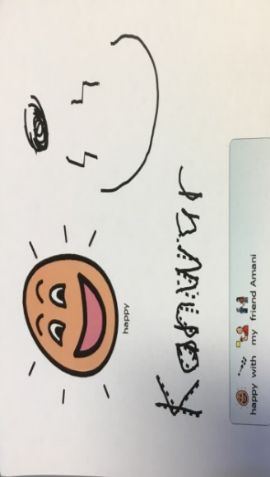
These images were part of an assessment evaluating students’ progress towards the following outcomes:
- COeS1.1 Expresses feelings, needs and wants in appropriate ways
- ENe-1A Communicates with peers and known adults in informal and guided activities demonstrating emerging skills of group interaction

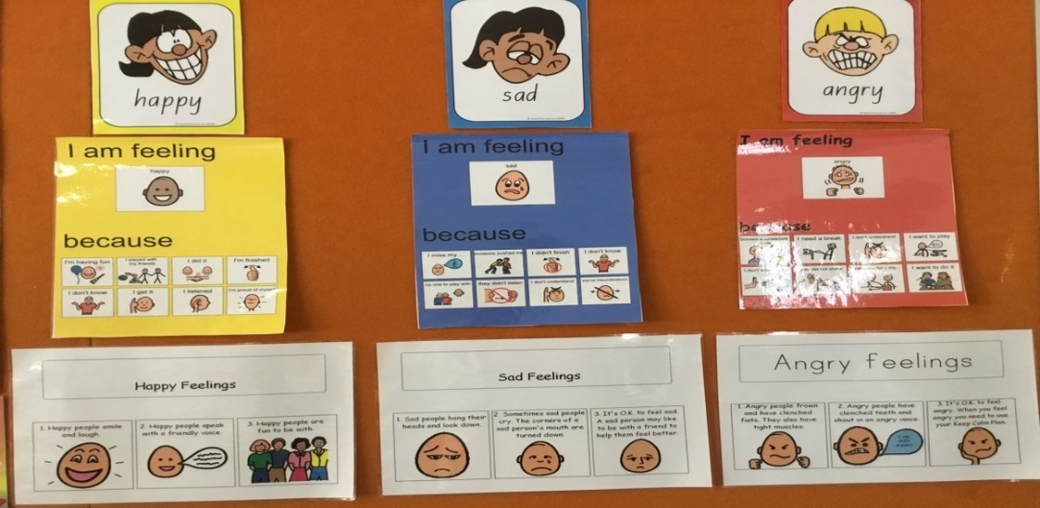
A feeling wall used in the unit to support non-verbal students to recognise and express how they fee

Copyright
© State of New South Wales (Department of Education), 2019
The copyright material in this publication is subject to the Copyright Act 1968 (Cth), and is owned by the NSW Department of Education or, where indicated, by a party other than the NSW Department of Education. Copyright material which is owned by the NSW Department of Education is licensed under a Creative Commons Attribution 4.0 International (CC BY 4.0) licence
This licence allows you to:
- share – copy and redistribute the material in any medium or format
- adapt – remix, transform and build upon the material for any purpose, even commercially.
Attribution should be given to:
© State of New South Wales (Department of Education), 2019.
Material in this publication not available under a Creative Commons licence includes:
- the Department of Education logo, other logos and trademark-protected material
- material owned by a third party that has been reproduced with permission. Permission will need to be obtained from the third party to re-use this material.
If this publication contains your work and you have any objection to such content, please contact legal@det.nsw.edu.au.

Links to third-party websites
If you use the links provided in this publication to access a third party’s website, you acknowledge that the terms of use, including licence terms set out on the third party’s website apply to the use which may be made of the materials on that third party’s website or where permitted by the Copyright Act 1968 (Cth).
The department accepts no responsibility for content on third-party websites.

“Do we need a Sydney Metro train in Chullora?” https://icentral.tdocs.transport.nsw.gov.au/otcsdav/nodes/15991579/INSERT%20LINK_
H temperey, L Kaser, J Halbert, A framework for transforming learning in schools: Innovation and the spiral of inquiry, Centre for Strategic Education, Seminar Series Paper No. 234, April 2014
Our school approached Sydney Metro to assist us with resources for the ‘I wonder’ day. A short video of the day is at youtu.be/ZznfE3po3uE (Transport for NSW, 2019) (2 minutes 37 seconds)
Cambridge Autism Learning https://www.cambridgeautismlearning.com/
At the time of writing this episode could be accessed free of charge from Cambridge Autism Learning at cambridgeautismlearning.com/p/the-transporters1
'Sally's Sad Day' video (Autism Transporters Community Interest Company, 2004) (5 minutes) https://www.cambridgeautismlearning.com/p/the-transporters-uk-all-episode-bundle
'The Red Beast' by K.I. Al-Ghani & Illustrations by Haitham Al-Ghani. (7:52) https://youtu.be/PgrCDqQbgCE

