Stage 4 German

Activity – eating out

Numeracy activity name
Schnitzelhaus

Numeracy Skills Framework Focus Area
1: Mental computation and numerical reasoning

Aspect/s
Understanding mathematical information in texts and tasks
Understanding fractions, decimals, percentages, rates, ratios

Stage
4

Year level
7-8

Language
German

Unit of work
Eating out

How will the numeracy skills be supported by this activity?
Students are required to calculate:
- total costs of items ordered at a restaurant
- the tip as percentage of meal cost
- percentage savings if food is ordered as takeaway instead of table service.

Language structures incorporated

Ich möchte… – I would like…
Wir möchten… – We would like…
einmal/zweimal – one/two (when ordering)
die Rechnung – the bill
die Bedienung – the water/waitress
Zahlen, bitte! – Bill, please!
Stimmt so! – That’s fine! (keep the change)

Menu layout and vocabulary

Schnitzelhaus
View the online menu at the Schnitzelhaus website
Use this menu to answer the questions below.

Question 1
You have offered to take a friend for dinner at the Schnitzelhaus. You have €20 to spend. You would each like to order a main, a dessert and a drink.
What do you order? (Wir möchten einaml/zweimal…)

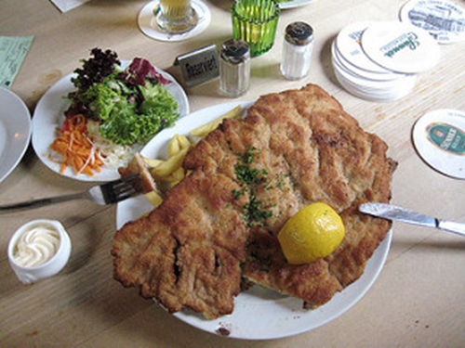
Image: schnitzel, frau-Vogel, CC BY-NC 2.0

Question 2
You are eating on your own tonight. You ordered your food (Ich möchte…) and have now eaten.
You’ve eaten a Wienerschnitzel and a donut, and had a large cola to drink.
What will the total of your bill (die Rechnung) be?

It’s time to pay your bill – Zahlen, bitte!
You’re happy with the service and would like to leave a small tip for die Bedienung.
You give €12,00 and say Stimmt so! (Keep the change)
How much was your tip?

What percentage of your meal cost was your tip?

How much do people usually tip in Austria?

Image: One Euro coins Creative Commons

Question 3
You and your friends are in the mood for some burgers. You want to order three large schnitzel burgers, and some chips.
How much will that cost if you eat in?

How much will that cost if you get takeaway?

What percentage saving will you receive if you order takeaway?

You realise that’s just too much junk food and change your order.
How much for four baked Alaskan salmon fillets, rice and a small green salad? Make sure you get the cheapest option and it’s takeaway!

Is it cheaper to eat more healthily in this instance?

