 United Nations Peacekeeping

This document supports NSW Syllabus for the Australian curriculum history years 7-10 and is developed for year 10 by Woolgoolga high school.

History Stage 5 Depth study 6

NSW Learning and Leadership Directorate have working with a number of schools on a programming project. The purpose of the project has been to explore the principles of curriculum planning and programming and to support teachers in the introduction of the new NSW NESA K-10 History Syllabus.

The programs are not lesson plans but they provide a number of tasks based on syllabus content.

Developing a scope and sequence – the school and learning context

Woolgoolga High School is a comprehensive secondary high school situated in a rural, coastal community in the north of the state. The school caters for a “full range” of students in terms of academic capacity, motivation and confidence. Technology is the most effective motivating or engaging ‘hook’.

Asia, literacy and broadening the horizons of students at Woolgoolga High School is a major focus.

The Stage 5 Depth Study UN Peacekeeping has been drawn from the overviews of ‘The Modern World and Australia’, however, it also has clear links to ‘The Making of the Modern World’ in regard to the formation and activities of the United Nations.

The teaching staff in the Human Society and Its Environment faculty demonstrate a deep commitment to social justice issues and to encouraging students’ understanding of the role of the United Nations in protecting human rights. UN Peacekeeping has been taught as part of Australia’s Role as a Global Citizen in previous years and is, therefore, a modification for the new history Years 7-10 syllabus.

United Nations Peacekeeping is designed to provide a clear insight into the formation and working of the United Nations, and to Australia’s role within that organisation in the Post-War period. Links to YouTube clips and other internet based activities are included in an effort to further engage students in this topic. Additionally, through written work and research tasks, students will apply the historical skills they have been developing throughout Stage 4 and Stage 5 History. This study has provided a strong foundation for students electing to take Stage 6 Modern History.

The unit is comprehensive and allows teachers to select areas they wish to focus on, depending on their programming needs.

Depth study 6: Technology evolution

The Cyberspace Revolution

Suggested teaching time is up to 20-25 hours.

Key inquiry questions

* Examine the role played by the UN and its Peacekeepers in the modern world.
* How has Australia been involved in the UN and Peacekeeping initiatives?

Links to the rest of the syllabus and overview

This unit links clearly to the Core Study: Rights and Freedoms (1945-Present) and to Depth Study 5: The Globalising World. This Depth Study provides the opportunity to direct a focus on Australia’s role in the United Nations or on Australia’s role in UN Peacekeeping.

Aspects of the overview addressed include:

* Continuing efforts post-World War II to achieve lasting peace and security in the world, including Australia’s involvement in UN peacekeeping

Outcomes

A student:

* HT5-1 explains and assesses the historical forces and factors that shaped the modern world and Australia
* HT5-3 explains and analyses the motives and actions of past individuals and groups in the historical context that shaped the modern world and Australia
* HT5-4 explains and analyses the causes and effects of events and developments in the modern world and Australia
* HT5-5 identifies and evaluates the usefulness of sources in the historical inquiry process
* HT5-7 explains different contexts, perspectives and interpretations of the modern world and Australia
* HT5-10 selects and uses appropriate oral, written, visual and digital forms to communicate effectively about the past for different audiences

Historical concepts

* Continuity and change: aspects of a society, event or development change over time or remains the same
* Cause and effect: events, decisions and developments in the past that produce later actions, results or effects
* Perspectives: people from the past may have different views shaped by their different experiences
* Empathetic understanding: the ability to understand another’s point of view, way of life and decisions made in a different period of time or society
* Significance: the importance of an event, development, group or individual and their impact on their times or later periods
* Contestability: how historians may dispute a particular interpretation of an historical source, event or issue.

Assessment

These activities require students to demonstrate assessment for learning. Some activities might be selected and included in a school assessment schedule for assessment of learning.

Task 1: The beginning of the United Nations

Skills Focus: Empathetic understanding; Explanation and communication; Research

Students:

* Outline the reasons for the creation of the United Nations
* Outline Australia’s involvement in the creation of the United Nations

Task:

* **View**: <http://www.youtube.com/watch?v=NvFsb5WHQ1U> ***The Global Village***
* Complete associated **Worksheet *1***, focusing on global inequities. Draw particular attention to global spending on military as opposed to development aid.
* **View**: <http://www.youtube.com/watch?v=3mJU58A9SNc> (Teacher Note: not a United Nations initiative, but still raises awareness of associated issues) *Extension*: Students to find out what has happened to this initiative. Was the campaign successful?
* **Worksheet 2**: Overview of the United Nations
* Find a brief biography of Doc Evatt (e.g. ***Retroactive II***, p.230)
* Complete a mind map or timeline of Australia’s involvement in the creation of the United Nations, incorporating Evatt’s role.

Teacher note: Students are to become aware of the need for solidarity, understanding, patience and education as a starting point for the reasons behind the creation of the United Nations.

Task 2: How does the United Nations work?

Students examine how the United Nations operates, as an entry point into discussion on maintaining peace and security.

Skills Focus: Comprehension: chronology, terms and concepts

Students:

* describe the United Nations’ mechanisms to achieve international peace and security

Focus

* How does the United Nations make a difference?

Task:

* View *The Millennium Declaration* as a link to current goals of the United Nations <http://www.youtube.com/watch?v=QoIafzc0k74> (be aware that there may be some buffering issues on full screen).
* Complete table (Worksheet 3) related to the clip focussing on: composition, purpose, specific focuses, Security Council, General Assembly and goals/outcomes.
* Small groups: identify the United Nations goals and rank them in order of importance. Justify the first three choices. Class discussion and consensus concerning ranking and achievability.
* Seventy ways the United Nations Makes a Difference <http://www.un.org/un70/en/content/70ways>
* Worksheet 4 - In table form select two examples of each issue presented.
* Areas to examine: Peace and Security
  + Poverty (in Economic Development)
  + Education (in Social Development)
  + Human Rights
  + Environment
  + Humanitarian Affairs
  + Health
* Extension: Giving Aid activity – Worksheet 5.

Task 3: The impact of the Cold War on the United Nations

Skill Focus: Explanation and communication

Students:

* describe the impact of the Cold War on the United Nations
* explain how the end of the Cold War led to a renewal of UN Peacekeeping operations.

Task:

Either:

1. Written response

In groups, research and write a 200 word response that explains the relevance of the impact of the Cold War on the renewal of the United Nations in one of the following areas:

* security
* economic
* political

As a whole class, discuss the responses with students individually writing a one-page information report that explains how the end of the Cold War led to a renewal of UN Peacekeeping operations.

OR

2. Literacy task

Read and recall is an activity designed to engage students in listening, recording/summarising pieces of text.

Convert Worksheet 6, The Impact of the Cold War on the United Nations, into a work card and use these in conjunction with the paragraph organisers.

Teachers’ note:

* Students read through the work card and make short, dot-point notes for each of the paragraphs (Students are to leave two lines at the end of each paragraph).
* Students peer mark their work using the marking criteria included.
* Once completed, students are to return to the original work card and add into their notes any significant information that they have missed.

Task 4: Keeping the peace

Skill Focus: Comprehension: chronology, terms and concepts; Analysis and use of sources; Explanation and communication

Students:

* Describe the origin and development of United Nations peacekeeping from 1956 to1988.

Task:

Worksheet 7: *Keeping the Peace –* Teacher Notes

* Complete comprehension and analysis of sources *Worksheet 8*.
* Additional link to interactive map and background information: <http://unama.unmissions.org/>
* <http://www.youtube.com/watch?v=TMX1_Nj-60Q> - Peace Keepers in Solomon Islands and Timor Leste
  + Identify the ways in which Australian peacekeepers offer support to the communities of Solomon Islands and Timor Leste.
  + Consider how the public can identify that they are peacekeepers and not regular military personnel. (Uniform, insignia and colour of helmet/caps etc).
  + Consider the limitations placed on UN peacekeepers.
* Activity: Use *Defence 2020* website. <http://defence2020.gov.au/>
* Click on Interactive Modules. Click on Would You Be a Good Peacekeeper? Complete the online activity.
* Compose a structured paragraph:
  + Outline the main ways United Nations peacekeepers help communities. AND/OR
  + Describe the limitations placed on United Nations peacekeepers.

Task 5: The presence of peacekeeping forces

Skills Focus: Research; Explanation and communication; Analysis and use of sources

Students:

* explain Peacekeeping Operations in the early 1990s – Somalia, Rwanda and Cambodia

Task:

* Introductory activity group work: Produce two A4 posters or a multimedia presentation such as Prezi, Glogster or PowerPoint, selecting one country from each category:
  + Category A: Timor Leste (East Timor), Cambodia, Somalia, Rwanda and
  + Category B: Congo, South Sudan, Haiti, Iran, Afghanistan.
* The presentation must have a balance of written and visual text covering the following:
  + Geographical location
  + Statistical information (population, religious beliefs, language, traditional food, average income in $US)
  + Colonial past
  + History of warfare or conflict
  + Are they considered to be a first, second or third world country?
  + Literacy rates
  + Life expectancy
  + Examples of UN involvement in the country and why.

Task 6: Case studies Rwanda and Somalia

Skills Focus: Analysis and use of sources; Perspectives and interpretations

Students:

* explain the reasons for Australia’s involvement in UN peacekeeping operations in Somalia and Rwanda between 1993-1994
* describe the nature and extent of the peacekeeping operations in Somalia and Rwanda
* evaluate the effectiveness of both the United Nations and the Australians in these peacekeeping operations

Task:

* Resource: Defence 2020 website. <http://defence2020.gov.au/>
* Click on *Links and Resources* tab.
* Scroll to the bottom to downloadable articles. Click on *Studies Magazine Issue 2, 2009*

<http://defence2020.gov.au/pdfs/studies_2_2009_defence2020.pdf>

* + Case Study 1: *Rwanda*, pp.37-39
  + Case Study 2: *Somalia*, pp.40-41
* Read *Case Study 2 Introductory Notes* on p.37. Then, view excerpt from ***Hotel Rwanda*** showing United Nations soldiers. Teachers’ note: This movie is ‘M’ rated. Please preview this as it is quite graphic and may not be suitable for all students.
* View the opening scenes of ***Black Hawk Down***. Teachers to decide how much of the clip to view.

Teacher note: select which source(s) you wish to use for this activity

Comprehension questions are included in these worksheets. There is also a table on *page 32* of the article which may also be completed or adapted. This could be done for both Rwanda and Somalia.

* Answer as a structured paragraph: *Evaluate the effectiveness of the United Nations’ and Australian Peacekeeping operations in Rwanda and Somalia.* For a less capable group they could complete a PMI table (Plus, Minus, Interesting)
* Additional: on Defence 2020 website *Interactive Modules- Acts of Good Citizenship. ­*This focuses on George Gittoes, an Australian War Artist and his experiences with the Peacekeepers.

Teacher note: The work in Somalia continues - <http://www.youtube.com/watch?v=f8wvu5WYV8o> – *Nightline* excerpt on 50 Cent and his role in Somalia as a humanitarian.

Suggested resources

* *The Global Village -* <http://www.youtube.com/watch?v=NvFsb5WHQ1U>
* *Make Poverty History* - <http://www.youtube.com/watch?v=3mJU58A9SNc>
* *How Does the United Nations Work? RMIT -* <http://www.youtube.com/watch?v=QoIafzc0k74>
* *Peace Keepers in Solomon Islands and Timor Leste* - <http://www.youtube.com/watch?v=TMX1_Nj-60Q>
* <http://www.youtube.com/watch?v=oKW7d2-5I28&feature=related> UN Peacekeepers – Be aware that this is a graphic clip – preview before using to determine suitability.
* TaLE website on *Being a Global Citizen* - <http://lrr.dlr.det.nsw.edu.au/Web/east_timor/P1_L3_east_timor_00.htm>
* Film: *Balibo*
* *Documentary: Rosa’s Journey – The Story of a Nation*

Worksheets: United Nations and peacekeeping

Find following a series of worksheets devised to support the unit.

1. The Global Village
2. The United Nations: Guardian of Peace – notes
3. 193 Voices: How Does the UN Work?
4. Sixty Ways the United Nations Makes a Difference – table
5. Australia as a Global Citizen: Giving Aid
6. Read and Recall: The Impact of the Cold War on the United Nations

Paragraph Organiser: The Impact of the Cold War on the United Nations

Marking Criteria: The Impact of the Cold War on the United Nations

1. Keeping the Peace – teacher notes
2. United Nations Peacekeeping Operations – Map
3. United Nations Peacekeeping Operations – Student version. Australia, the UN and East Timor.
4. Rosa’s Journey: The Story of a Nation
5. Report Card: Australia’s Peacekeeping in East Timor
6. Cloze Passage: Australia, Cambodia and the Role of Gareth Evans.

Worksheet 1: The Global village

The following clip operates on the idea of reducing the entire world’s population to a village of only 100 people. The information it contains reflects the issues facing the world today.

* As you watch the *YouTube* clip on the *Global Village* at <http://www.youtube.com/watch?v=NvFsb5WHQ1U>, complete the following questions.
* When you have finished you will need to rank what you believe to be the three most concerning facts raised by the clip. Be prepared to discuss and justify your choices.

Composition of the Village:

1. How many of the 100 villagers are:
   1. Asian:
   2. European:
   3. North American:
   4. South American and Caribbean:
   5. African:
   6. Oceanian:
   7. Male:
   8. Female:
   9. Christian:
   10. Muslim:
   11. Hindu:
   12. Not Religious:
   13. Of another faith:
2. How many people in the village live without basic sanitation or an improved source of water?
3. In a world of 100 people, how many people own 59% of the world’s wealth?
4. How many people in the village are hungry or malnourished?
5. How many villagers can’t read?
6. How many have a Secondary Education?
7. How many own a computer?
8. How many also have internet access?
9. How much money does the village spend on the military?
10. How much is spent on providing aid which will help to develop the village?
11. Complete this sentence.
    * I believe that the three biggest issues with inequality are

Worksheet 2: The United Nations: Guardian of Peace

Near the end of WWII, before the defeat of Japan, representatives of 50 nations met to replace the old League of Nations with a new organisation – the United Nations (UN). Its charter was signed in October 1945.

The aims of the UN are to:

* preserve peace and eliminate war
* remove the causes of conflict by encouraging progress
* safeguard the rights of all individual human beings.

[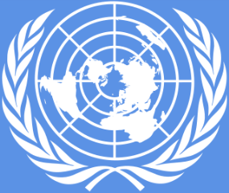](http://upload.wikimedia.org/wikipedia/commons/3/35/Logo_of_the_United_Nations.png)

The UN included members from all countries who won the war or were neutral, including Australia. Members could be called on to deal with aggression if one country attacked another.

The United Nations is a huge organisation. When South Sudan joined the UN on 14th July 2011, it became the 193rd member.

In the year 2011, the UN operated on a budget of over five billion Australian dollars. Most of this money comes from member nations. The amount a country pays depends on its wealth.

* In 2010, the United Nations celebrated its 65th birthday.

Worksheet 3: 193 Voices – How does the UN work?

| Context | How does UN work? |
| --- | --- |
| Composition |  |
| Purpose |  |
| Specific focuses |  |
| Security council   * Members * Role |  |
| General assembly |  |
| Problems dealt with by UN |  |
| Overall goal |  |

Worksheet 4: Sixty ways the UN makes a difference

The table shows seven general issues in which the United Nations is involved. Write two examples of each issue from the website Sixty Ways the United Nations Makes a Difference.

| Issues | Examples |
| --- | --- |
| Peace and security |  |
| Poverty (in Economic development) |  |
| Education (in Social development) |  |
| Human rights |  |
| The environment |  |
| Humanitarian Affairs |  |
| Health |  |

Worksheet 5: Australia as a global citizen - giving aid

In the year 2012-13, the Australian decided to give nearly 5.2 billion dollars in foreign aid. This equals about $228 for every Australian citizen. Most of this money was promised for countries in the Asia-Pacific region. The largest recipient of Australian aid is Papua New Guinea.

Australia offers financial support to developing countries because:

* it provides jobs and experience for Australians who deliver 80% of our aid program
* it improves security in our region. This can be achieved by tackling problems such as disease, crime and illegal drug trafficking. Hopefully this will lead to stronger societies in our neighbouring countries and less chance of conflict within them.

The agency that manages Australia’s funding for developing countries has been called AusAid since 1995. AusAid provides foreign aid in two main forms. The first, economic aid, deals with long-term plans that will help developing nations reach a greater level of independence. Some of these measures include:

* agricultural and rural development
* education
* health
* good government
* infrastructure development, which is basic services like education, transport and sewerage

The other type of foreign aid is humanitarian. This ‘immediate’ aid is in response to emergencies, such as natural disasters and communities recovering from internal conflict. An example of this type of aid was when Australia gave assistance to many Asian countries following the Boxing Day tsunami in 2004.

*Children hunt for clothes in a tsunami affected area of the Solomon Islands. (File photo)
Children rumaging through debris looking for clothes to wear.*

Children hunt for clothes in the wreckage after a tsunami.

Solomon Islands. Photo courtesy of Helen Rook

Imagine this scenario

The emergency session of parliament has put forward 22 suggestions in response to the Asian tsunami. The budget for Australia’s contribution is high but not unlimited. The suggestions are:

* body bags for the deceased
* builders, especially for hospitals, schools and mosques

File:Bodies in Banda Aceh after 2004 tsunami DD-SD-06-07373.JPEG
^ deceased bodies lying in the street with sheets over them. This is in Banda Arch after the 2004 tsunami.

[*Shrouded bodies of the deceased Banda Aceh 2004.*](http://commons.wikimedia.org/wiki/File:Bodies_in_Banda_Aceh_after_2004_tsunami_DD-SD-06-07373.JPEG)

* communication equipment
* electricity generators
* farming equipment, fertilisers and insecticides
* fishing boats and nets
* food packages
* free advertising for Asian tourism interests
* funding for a tsunami warning centre
* a Government-funded concert on New Year’s Eve to raise money for relief efforts
* grief counsellors

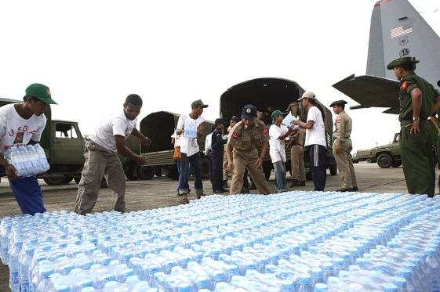

[Burmese service members and civilian aid workers providing bottled water.](http://commons.wikimedia.org/wiki/File:Defense.gov_photo_essay_080512-M-0000R-009.jpg)

* helicopters
* immunisation drugs
* medical teams, including doctors and nurses
* medicines
* military police
* pharmacists to disperse drugs
* road building teams
* tents and blankets
* training for Asian medical students
* transport and accommodation for 5000 refugees
* water purification plants

[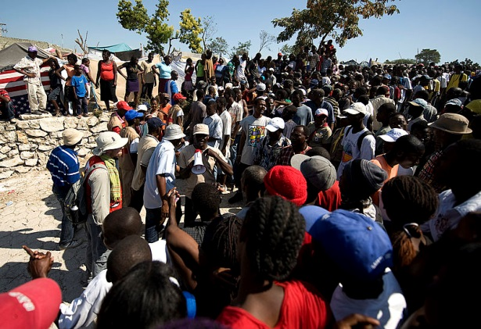](http://upload.wikimedia.org/wikipedia/commons/a/ab/Red_Cross_aid_distribution_in_Port-au-Prince_2010-01-25_2.jpg)

[Haitian earthquake survivors wait to receive non-perishable goods from a Red Cross distribution sire in Port- au-Prince, Haiti, Jan 25. 2010](http://commons.wikimedia.org/wiki/File:Red_Cross_aid_distribution_in_Port-au-Prince_2010-01-25_2.jpg)

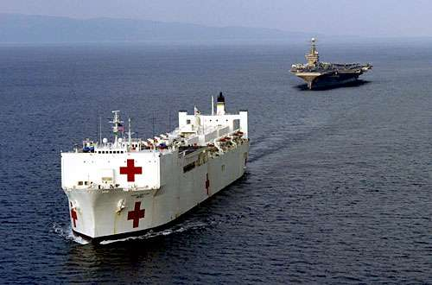

[Red Cross ship bringing aid after the 2004 Boxing Day tsunami](http://commons.wikimedia.org/wiki/File:Humanitarian_aid_Sumatra_Tsunami_2004.jpeg).  [CC BY 2.0)](http://creativecommons.org/licenses/by/2.0/deed.en)

In pairs: your task is to choose the ten most appropriate types of aid for immediate assistance and then justify your choices.

Worksheet 6: The impact of the cold war on the UN

Read and recall work card

Up until the end of the Cold War, the UN only involved itself in conflict if two or more member states were involved. This is known as the principle of non-interference. The enthusiasm for United Nations and world peace was quickly dampened by the Cold War, which had divided the world into East versus West. This conflict made constructive work in the UN Committees very difficult during the first decades of its existence.

[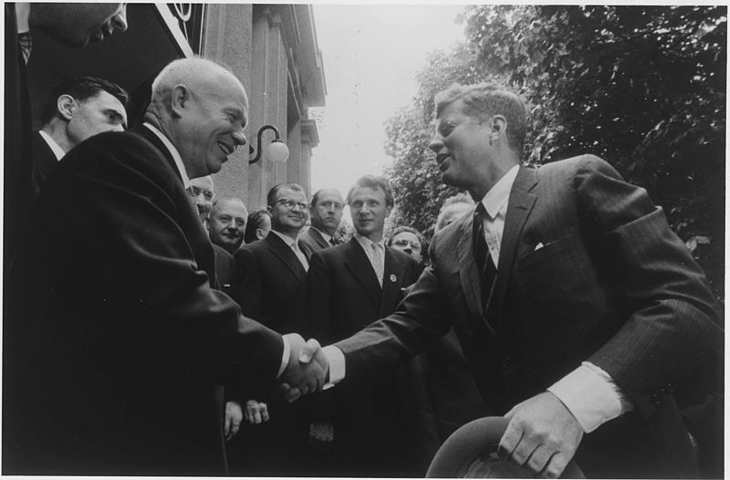](http://upload.wikimedia.org/wikipedia/commons/9/93/Khrushchev_and_Kennedy_Shaking_Hands_-_NARA_-_193204.jpg)

President J. F. Kennedy and Chairman N. Khrushchev

[Stanley Tretick](http://commons.wikimedia.org/wiki/File:Khrushchev_and_Kennedy_Shaking_Hands_-_NARA_-_193204.jpg)

Confrontation dominated debates, especially in the Security Council. The ability of the UN to secure peace practically came to a standstill. However, the blockade of the Security Council helped shape the character of the UN as a forum for global issues. It was during this time that the UN drafted the General Declaration on Human Rights, a significant document in the world’s history.

Since the end of the Cold War in 1989, United Nations Peacekeeping efforts have undergone a notable change. The operations now occur more often within one country, for several reasons. First of all, due to a greater access to information, international public opinion and governments are more aware of what is happening in a foreign country than in the past. Now when images of extraordinary violence reach us, we no longer accept that such horrific conflicts should take place, whether they are religious or ethnic in origin and whether or not they occur within a single country. This was the case for Rwanda, Bosnia, Kosovo and East Timor.

[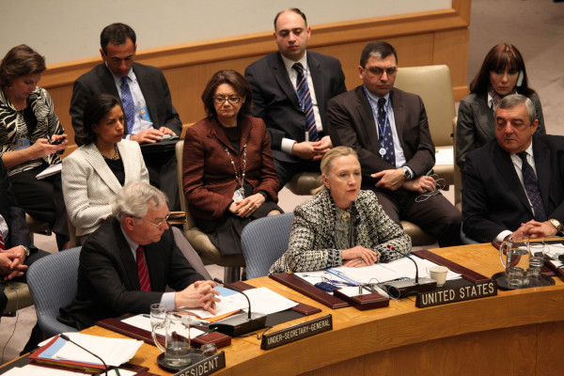](http://upload.wikimedia.org/wikipedia/commons/2/2d/Secretary_Clinton_Participates_in_a_UNSC_Session_on_the_Middle_East_(6976374049).jpg)

[United Nations Security Council in session, 12 March 2012](http://commons.wikimedia.org/wiki/File:Secretary_Clinton_Participates_in_a_UNSC_Session_on_the_Middle_East_(6976374049).jpg)

Paragraph organiser

Paragraph One

* end of the Cold War
* two or more member states
* principle of non-interference
* enthusiasm dampened
* East versus West
* constructive work difficult

Paragraph Two

* Confrontation in the Security Council
* ability to secure peace
* blockade helped
* forum for global issues
* General Declaration on Human Rights

Paragraph Three

* end of Cold War 1989
* Peacekeeping operations
* several reasons – public opinion and awareness of foreign countries
* images of violence
* Rwanda and East Timor

Marking guidelines

8-10

* Has all events in the correct order
* Has written a paragraph with capitals, full stops and sentences

5-7

* Has all of the events but may not have the exact order
* Has written a paragraph with capitals, full stops and sentences

3-4

* Has some of the events listed
* May have some features of punctuation

1-2

* Has only one or two events listed

Worksheet 7: Keeping the Peace

Teacher’s notes

Peacekeepers are soldiers with a difference. Their missions are in response to conflicts. They do not start them.

Being only a defensive force they need to work with, and create a good relationship with the local people, most of whom have already been through terrible trauma.

Peacekeepers are there to help re-build societies that have been damaged by war. Their tasks might include:

* protecting local people from the violence of enemy groups
* keeping law and order between conflicting groups within a community (Dili 2006)
* providing medical care for the sick and wounded
* defusing live landmines.

By the end of the 20th century Australia had provided nearly 15 000 soldiers for United Nations’ peacekeeping missions.

Worksheet 8: United Nations Peacekeeping Operations

Teacher copy

<http://www.un.org/en/peacekeeping/documents/bnote0813.pdf>

Direct the students to open up the documents at the above site and then answer the questions below:

1. How many peacekeeping operations have there been since 1948?
2. What is the current number of UN peacekeeping operations?
3. How many countries contribute personnel to peacekeeping operations?
4. Considering all of the missions, which has run the longest?
5. Considering all of the missions, which has the largest budget?
6. Which one has the greatest number of personnel?
7. In which continent are these two operations taking place? Can you suggest a reason why so many resources are directed here?

Note: the pages at the site are not included, as they are continually updated by the UN. By going directly to the site, students will have access to the most current facts and figures.

Worksheet 9: Australia, the UN and East Timor

East Timor is a small country located only 600 kilometres from Australia’s northwest coast. In recent decades, it has experienced a turbulent history.

For nearly 300 years, East Timor was a colony of the European country of Portugal. In 1975, Portugal effectively abandoned East Timor. Nine days after Portugal’s departure, Indonesia invaded East Timor. In 1976, East Timor was made a province of Indonesia. Over the next 24 years, up to 200 000 East Timorese were killed under the brutal control of Indonesia.

Most East Timorese bitterly resented the presence of Indonesia. Religious difference was a key factor in the desire of the East Timorese people to have their own country. With their Portuguese background, East Timor’s population was 90% Roman Catholic. By contrast, 88% of Indonesian people were Muslims.

The only ray of hope for the people of East Timor came in 1982. In this year the United Nations began negotiations with Indonesia and Portugal over the government of East Timor. Initially, these talks made little progress.

Caving to international pressure, Indonesia allowed limited self-government to East Timor in 1998. In 1999, they agreed to a referendum in East Timor organised by the UN. The people would decide whether they wanted independence, or to remain a part of Indonesia.

For most of the period from 1975 to 1999, Australia did little to condemn Indonesia’s actions in East Timor. This policy was a reversal of its long-standing support of independence over colonialism. Only in the 1990s did Australia join the growing international outrage over the treatment of the East Timorese people.

Locate East Timor on a Google Map to see its location in relation to Australia.

A turbulent history

Re-arrange the events in East Timor’s history into the correct order and write them into your books.

* The UN begins talks to decide East Timor's future
* Indonesia grants East Timor limited independence
* East Timor is made an Indonesian province
* UN-organised referendum in East Timor
* East Timor is a Portuguese colony

East Timor Decides

The referendum to decide East Timor’s political future took place on 30 August 1999. It did not pass without incident. Militia groups who wanted to keep East Timor as part of Indonesia undertook a campaign of violence and harassment in an attempt to put people off voting. They failed.

Ninety-five per cent of East Timor’s voting population took part in the referendum. Nearly eighty per cent chose independence. East Timor was internationally recognised on 20 May, 2000. A new country was born.

1. Explain the purpose of the referendum. Was it successful?

The hope that the election result would be well accepted by the pro-Indonesian militia was immediately shattered. The rebel army thought that East Timor’s independence would be short-lived. They believed that staying loyal to the ‘mother country’ would be the best decision in the long run.

1. Describe the violence that broke out following the referendum.

The capital of East Timor, Dili, was almost destroyed in the violence that followed the referendum. In one incident, twenty worshippers were murdered as they prayed in a church. Many buildings in the city were burnt to the ground. Rural areas were not spared either. Thousands of refugees fled for the hills or crossed the border to West Timor.

1. How did the UN respond?

In response to the violence, the United Nations acted quickly. They called on Indonesia to take action against the groups that were fighting under their name, and quite possibly with some Indonesian military assistance. The Indonesian Government responded by supporting a force of UN peacekeepers. They were called the ‘International Force in East Timor’, or interfet.

1. Outline Australia’s role and responsibilities in East Timor.

Australia was nominated as the country to lead the UN peacekeeping force in East Timor. Significantly, the peacekeeping force included no American troops despite a request for help from Australia to its closest ally.

The aim of the mission was to secure East Timor and make sure they were free from the hostile militia groups. The United Nations added that ‘all necessary means’ would be used to achieve this goal. This would ensure safety for the East Timorese people and allow life to return to normal. It would also pave the way for establishing the new country.

Australian peacekeepers were involved in:

* restoring order in Dili by patrolling streets and guarding important buildings and services
* searching houses for any pro-Indonesia soldiers or their weapons
* guaranteeing the city’s water supply
* camping in small villages in an effort to win the confidence and support of the people. Soldiers often found the most effective way to do this was through the local children who would then convince their parents
* airlifts that dropped troops, supplies and food for the people
* observing the effects of the civil war and collecting information for humanitarian groups like the Red Cross.

1. Identify three ways conditions are improving in East Timor.

The United Nations’ forces had reclaimed East Timor for its people by November 1999. An important reason for the return of peace was the tight control that the UN forces were keeping on the border between East and West Timor (which was still part of Indonesia). This control was helped by the better weapons and technology that UN forces possessed, such as night goggles for fighting in the dark.

From September 1999 to June 2000, nearly 170 000 East Timorese returned from the western half of the island. A growing number of families were being re-united after being split during the worst of the violence. However, a further 100 000 refugees were still not confident enough to follow them.

Worksheet 10: Rosa’s journey

The Story of a Nation (DVD)

Indonesia invaded East Timor in 1975. Over a quarter of the population (200 000) people died in the violence that followed. In 1999’s vote for independence from Indonesia and the elections which occurred in 2006, Indonesia was once more plagued by rioting and violence.

In point form write examples/evidence from the DVD about each of these topics:

* Living Conditions/Quality of Life
* Violence
* Impact on Family Life
* UN Presence

Worksheet 11: Report card

Australia’s Peacekeeping in East Timor

| Topic | General comments | Your comment | A-E |
| --- | --- | --- | --- |
| Restoring the peace |  |  |  |
| Promoting democracy |  |  |  |
| Restoring basic services |  |  |  |
| Cementing the future |  |  |  |

Worksheet 12: Australia and Cambodia

The role of Gareth Evans - Teacher’s copy

Gareth Evans was one of Australia’s longest serving Foreign Ministers, best known internationally for his role in helping to develop the UN peace plan for Cambodia. In fact, Evans won the ANZAC Peace Prize in 1994 for his work on Cambodia. Evans believes that ‘Negotiating and implementing a durable peace in Cambodia remains one of the United Nations’ finest achievements.’

[File:Gareth Evans University of Melbourne.jpg
Gareth Evans
CC BY 1.0
](http://upload.wikimedia.org/wikipedia/commons/b/bf/Gareth_Evans_University_of_Melbourne.jpg)

By the 1970s, Cambodia had been, according to Evans, ‘ravaged by massive US bombing, by civil war, by a genocidal reign of terror exceeded only by the Nazis, by invasion and by civil war again, resulting overall in the deaths of some 2 million Cambodians and the destruction of the lives of many more.’ (Reference: <http://www.g-l-f.org/index.cfm?PAGEPATH=&ID=35990>) Producing a working peace is an incredible achievement in which Australia played a central part.

After summits failed to solve the problems, Evans outlined a peace proposal on 24 November 1989. He suggested that the United Nations be directly involved in the administration of Cambodia until it could govern itself. He suggested that a UN military presence was necessary to ensure that cease-fire was followed and that they help organise and conduct free elections.

From October 1991, Lieutenant General Sanderson became involved in the United Nations process to bring peace to Cambodia. First, he was an adviser to the Secretary General of the United Nations, and then from March 1992, he commanded the 16 000 strong international military component of the United Nations Transitional Authority in Cambodia (UNTAC).

* Central
* Finest
* Free
* 1989
* Prize
* plan
* Million
* 16 000
* Foreign
* Military
* Nazis
* Cambodia
* Nations
* General
* Bombing

Worksheet 12: Australia and Cambodia

The role of Gareth Evans

Gareth Evans was one of Australia’s longest serving _______________ Ministers, best known internationally for his role in helping to develop the UN peace ________________ for Cambodia.

[File:Gareth Evans University of Melbourne.jpg
Gareth Evans
CC BY 1.0
](http://upload.wikimedia.org/wikipedia/commons/b/bf/Gareth_Evans_University_of_Melbourne.jpg)

In fact, Evans won the ANZAC Peace ________________ in 1994 for his work on Cambodia. Evans believes that ‘Negotiating and implementing a durable peace in Cambodia remains one of the United Nations’ _________________ achievements.’

By the 1970s, Cambodia had been, according to Evans, ‘ravaged by massive US _______________, by civil war, by a genocidal reign of ______________ exceeded only by the _________________, by invasion and by civil war again, resulting overall in the deaths of some 2 ___________________ Cambodians and the destruction of the lives of many more.’ Producing a working peace an incredible achievement in which Australia played a __________________ part.

After summits failed to solve the problems, Evans outlined a peace proposal on 24 November ____________. He suggested that the United __________________ be directly involved in the administration of Cambodia until it could ___________________ itself. He suggested that a UN _________________ presence was necessary to ensure that cease-fire was followed and that they help organise and conduct ____________________ elections.

From October 1991, Lieutenant _____________________ Sanderson became involved in the United Nations process to bring peace to ____________________. First, he was an adviser to the Secretary General of the United Nations, and then from March 1992, he commanded the ________________ strong international military component of the United Nations Transitional Authority in Cambodia (UNTAC).

Use the following words to complete the passage above:

* Central
* Finest
* Free
* 1989
* Prize
* Plan
* Million
* 16 000
* Foreign
* Military
* Nazis
* Cambodia
* Nations
* General
* Bombing