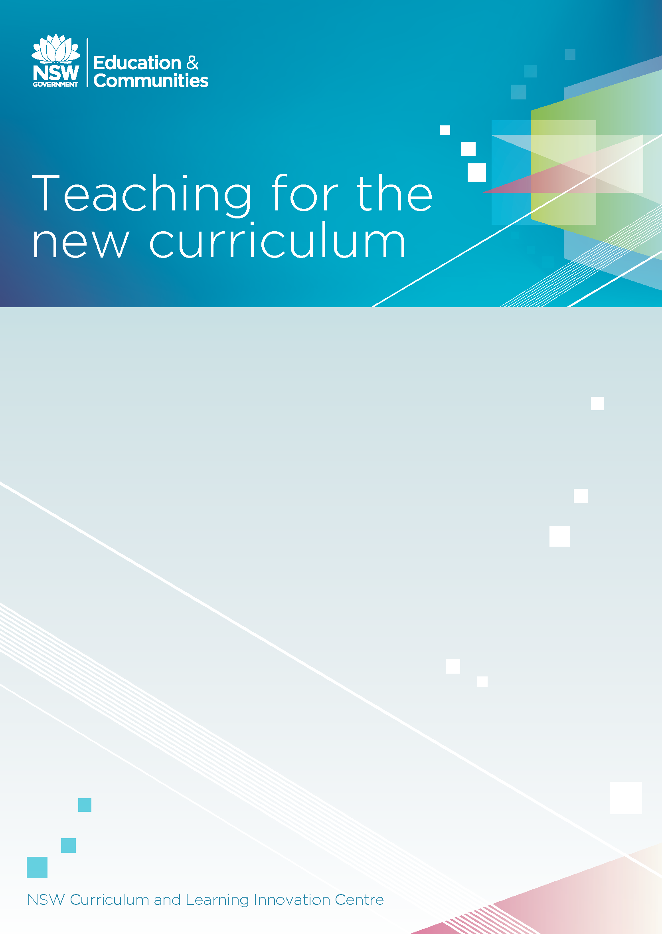

Activity booklet

Contents
About the activities and deliverables 2
Course Completion Checklist 4
Activity 1: My Situation 6
Activity 2: PurposE 7
Activity 3: Principles 8
Principle 1 8
Principle 2 9
Principle 3 9
Principle 4 10
Principle 5 10
Deliverable Part A: Principles 11
Activity 4: Planning 12
Deliverable part B: Planning – whole school, stage and year 13

About the activities and deliverables
Within the activity booklet you will find activities and deliverables.
Activities are designed to focus thinking and stimulate discussion on pragramming, planning, assessing and reporting practices. Completing the activities will guide your thinking in completing the deliverables.
Deliverables are designed to provide evidence for your course supervisor that you have satisfactorily completed the course.
The times suggested to complete the activities are indicative.

Course Completion Checklist

Teacher Name: ______________________________________________________________________
School: ____________________________________________________________________________

Course: Teaching for the new curriculum
To successfully complete this course, ensure you have undertaken the pre-course activities, activities, deliverables and had your supervisor complete the sign-off. If you are seeking accreditation, you must complete the deliverables.

Pre-course checklist
☐ I have registered in the appropriate event for this course on MyPL@Edu
(course code 151CLC027)
☐ I have accessed the Curriculum planning and programming for quality teaching, assessing and reporting document

Post-course checklist

Activities
I have completed the following:
☐ Activity 1: My Situation
☐ Activity 2: Purpose
☐ Activity 3: Principles
☐ Activity 4: Planning

Deliverables
Deliverables are the evidence that you need to provide to your supervisor, along with the checklist and sign-off, in order to certify that you have satisfactorily completed the course.
☐ Deliverable part A: Principles
☐ Deliverable part B: Planning

Evaluation
☐ MyPL@Edu evaluation must be completed for successful accreditation.
☐ Institute of teachers evaluation must be completed for successful accreditation.

Supervisor sign-off

I certify that _______________________________ has completed the above requirements for the course Teaching for the new curriculum.

Signed: ___________________________________ Date: _____________

Position: _________________________________________________________________

Activity 1: My Situation (10 minutes)

Planning and programming for quality teaching
Discuss current planning and programming practices in your school. Consider what is being done well and what could be improved. Reflect on your own practice as part of the wider school community. Share your responses with colleagues.
What works well for you in your teaching, and what could you improve? (At least 3 ideas)
Here are some suggestions to get you started:
- differentiation for diverse learning needs
- clear links to previous learning
- clear links to the NSW quality teaching model
- assessment activities
- analysis of data
What do you do well? | How do you do it?
Consider how effective planning and programming could enhance your teaching practice.
What needs further development? | How could it be developed?

Activity 2: Purpose (20 minutes)

Why plan and program?
Watch the animation and listen to the voice over. How do the following impact on your teaching? If possible, share your thoughts with a colleague.
Local school context

Students’ learning needs and interests

What we want students to learn

How we want students to learn

Activity 3: Principles (60 minutes)

How well does your current curriculum planning and programming practice show evidence of the following principles?

Review the principles on pages 3 to 6 of the document Curriculum planning and programming for quality teaching, assessing and reporting.

Group: Divide into small groups and allocate each group a principle to discuss in depth. Share your responses with the whole group.

Individual: Select at least two of the principles and complete the related activities.

Principle 1: Curriculum planning and programming aims to be responsive to student needs
What do you do well? | How could this be improved?

Principle 2: Curriculum planning and programming aims to provide a seamless progression of learning within and across school years
What do you do well? | How could this be improved?

Principle 3: Curriculum planning and programming aims to focus on learning of high intellectual quality and significance
What do you do well? | How could this be improved?

Principle 4: Curriculum planning and programming aims to make explicit high expectations for learning and achievement
What do you do well? | How could this be improved?

Principle 5: Curriculum planning and programming aims to enhance professional practice through collaborative development and evaluation:
What do you do well? | How could this be improved?

Deliverable Part A: Principles
Curriculum planning and programming aims to:
Principle 1: be responsive to student needs
Principle 2: provide a seamless progression of learning within and across school years
Principle 3: focus on learning of high intellectual quality and significance
Principle 4: make explicit high expectations for learning and achievement
Principle 5: enhance professional practice through collaborative development and evaluation

Based on your responses to Activity 3, complete the following question:

What curriculum planning and programming practices will I put in place to reflect these five principles?

Activity 4: Planning (30 minutes)
This activity will enable you to complete Deliverable part B on the next page.
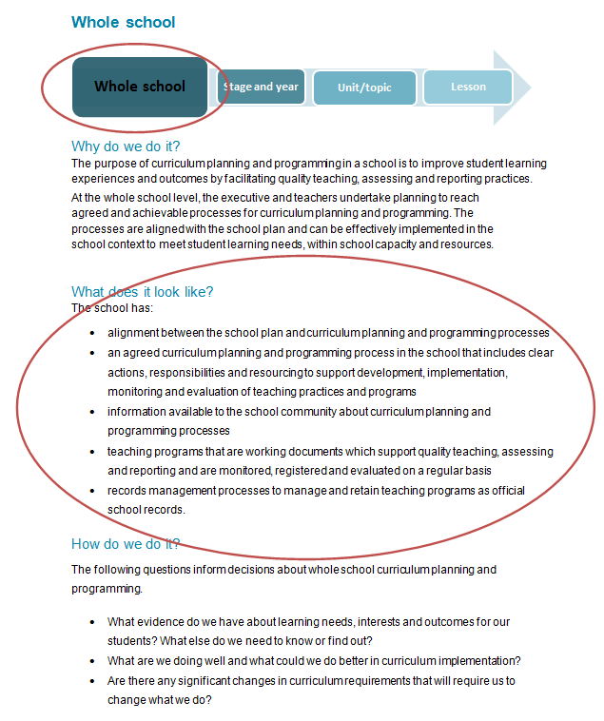
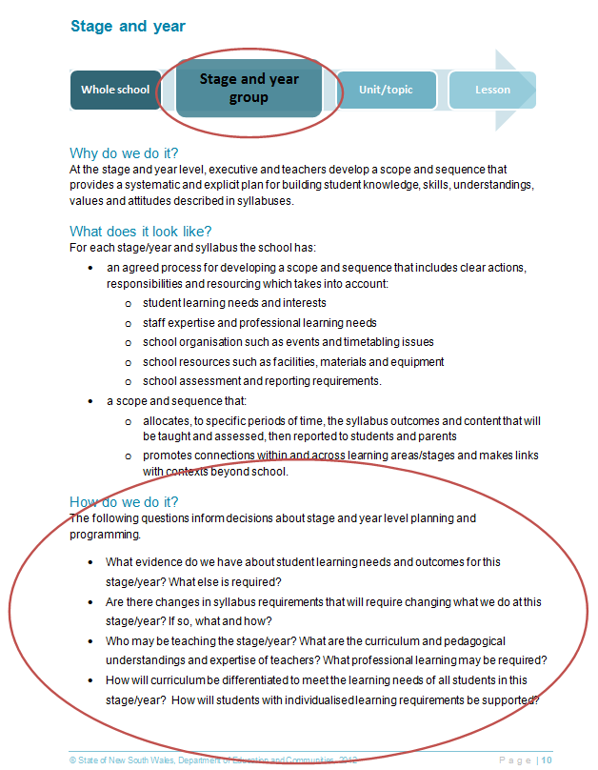
Explore the information under the Planning tab.

Read through What does it look like? at the whole school and stage/year level (pages 8 and 10 in Curriculum planning and programming for quality teaching, assessing and reporting).

For each of these levels, use the questions under How do we do it to stimulate discussion.
Remember, collaboration is an essential part of effective curriculum planning and programming.
If you are working alone select the level most appropriate to your situation. If possible, talk to colleagues at school or use communication channels such as Maang or other social media to share ideas and gain feedback.

Deliverable part B: Planning – whole school, stage and year

Decision making about curriculum planning and programming
In the context of your school, what people, processes, products and practices will enable you to achieve the following?
What | People  Who will be involved? | Process  How will we do it? | Products and practice  What will it look like? | Time  When will we do it?
Is there alignment between of curriculum planning and programming and the school plan?

What level of consistency of planning and programming will we expect aross the whole school in:
- scope and sequence

- units of work?

What quality assurance processes for teaching programs will we have?

What information will be provided to the school community?

What records management processes will we have for teaching programs?

What monitoring and evaluation processes will we use?

