Work Education 7-10

About the syllabus
This syllabus provides students with an opportunity to develop knowledge and understanding of the world of work, (its dynamic nature, how and why it may change and what this means for their future), the diverse groups within the community, and the roles of education, employment and training.
The diverse needs of all students is taken into account. Essential knowledge, understanding, skills, values and attitudes are identified. Clear standards of student expectations of knowledge is outlined and structures and processes by which teachers can provide continuity of study for all students.
Through student study of Work Education, students prepare for the working world by developing understanding of themselves in relation to work, recognising their aspirations, their rights and responsibilities as workers, employer expectations and the diversity of work opportunities.
Developing self-evaluation, goal setting and decision making skills, allows students to develop employability skills and the capacity to prepare and adapt to multiple transitions throughout their lives including post - school pathways.

Key content
Stage 4 | Stage 5
Student outcomes –knowledge and understanding | Student outcomes –knowledge and understanding
The world of work  WE4 -1 describes different types of work and employment options  WE4-2 recognises appropriate behaviours and protocols in diverse work contexts | The world of work  WE5-1 analyses employment trends and changes in the nature of work  WE5-2 analyses current workplace issues and their implications
Roles of individuals and diverse organisations within the local and Australian community  WE4-3 identifies the range of organisations within their local community  WE4-4 describes the roles and responsibilities of individuals within the local community | Roles of individuals and diverse organisations within the local and Australian community  WE5-3 examines the roles of diverse organisations in the Australian community  WE5-4 evaluates the roles and responsibilities of individuals within the Australia community
The role of education, employment and training in planning and managing transactions  WE4-5 describes the purpose of education, employment and training organisations  WE4-6 explains personal goals ,attributes and values too inform choices and career pathways plans | The role of education, employment and training in planning and managing transactions  WE5-5 explains the roles of education, employment and training organisations  WE5-6 assesses personal goals, attributes and values in the context of education, training and employment
Student outcomes - skills related to workplace contexts, entrepreneurship and managing transitions | Student outcomes - skills related to workplace contexts, entrepreneurship and managing transitions
WE4-7 identifies skills, attributes and entrepreneurial behaviours for effective participation in work and society  WE4- 8 identifies skills related to career development and managing transitions | WE5-7 explains skills, attributes and entrepreneurial behaviours in a range of contexts  WE5-8 assess options for career development and managing transitions
Research and communication skills that relate to the world of work  WE4-9 uses relevant information from a variety of sources  WE4-10 selects and users appropriate forms to communicate information about the world of work | Research and communication skills that relate to the world of work  WE5-9 selects and analyses relevant information from a variety of sources  WE5-10 selects and users appropriate forms to communicate information about the world of work for different audiences

Assessment
Assessment in Work Education is of school-based assessment. The school-based assessment requirements are as follows:
STAGE 4 and 5 School developed assessment closely aligned to the outcomes to the stage
Assessment for students with special needs.
Adjustments will be required for some students to assessment practices in order to demonstrate the outcomes and content.

Additional information for teachers
This syllabus has been streamlined to enable program and content designers to develop a scope and sequence/program in line with students needs and projected outcomes.
Outcome coding: Syllabus Outcomes are codes in a consistent way. The code identifies the subject, stage, outcome number and the way the content is organised.

Stage 4, Stage 5 and Life Skills are represented by the following codes:
Stage | Code | Comments
Stage 4 | 4 | In this syllabus ,outcome codes indicate subject , Stage and outcome number/ For exampleWE5-1 :Work Education stage 5 outcome 1
Stage 5 | 5
Life Skills | LS | Life Skills

New to this syllabus
This curriculum includes Australian Curriculum content for Work Studies with Australian Curriculum codes in brackets at the end of each content description e.g. initiatives to build employment and enterprise opportunities in their community/region (ACWSCL015)
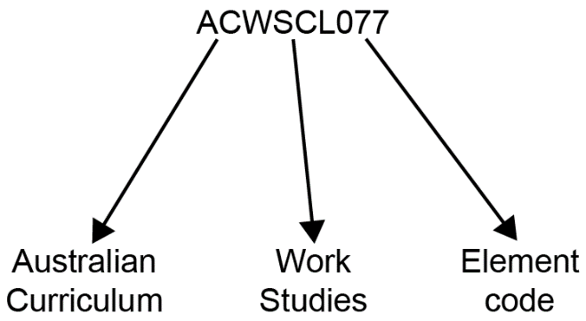
Australian Curriculum - Work Studies - Element Code (ACWSL0077)

