Research an Aboriginal artist
You will be researching a chosen Aboriginal artist. You need to investigate their artmaking practice and their relationships within the art world from both cultural and structural points of view.
Use the resources provided in class and answer the following questions to being your research.

Part A
Answer the following questions in the spaces provided.
In the space below, create a design with the name of your artist, based on their style.

- Describe the world of the artist.
Where are they from? What kind of landscape is it? – City/suburban/urban/rural/outback.

- What parts of the world does the artwork represent? Making a list of what you can see in their art and link these to a common theme.
For example – In my chosen artist’s work they feature plants and animals from the environment including trees, kangaroos, emus, etc.

- Is the artist contemporary (living) or historical (deceased)?
What was happening at the time of their artmaking? How has the artist represented this in their artmaking practice?

- Choose one artwork by your artist. When is the name of the artwork and when was it created? In your own words, describe the artwork.
Include the colours, shapes, patterns and their positions.

- Explain the intention behind the artwork. Read the text to find why the artist created this artwork. In your own words, summarise the story represented in the artwork and why this is important to the artist?

Part B
The conceptual framework provides a model for understanding the agencies of the art world (artist, artwork, world and audience) and their relationships.

The conceptual framework model
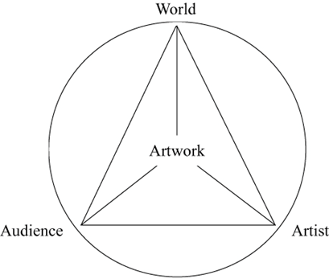
Visual Arts 7-10 Syllabus © NSW Education Standards Authority (NESA) for and on behalf of the Crown in right of the State of New South Wales, 2003.
In the space below, map the conceptual framework for the artist.

