Analysing Art

Part 1 – The Frames
Duration: 3 - 4 weeks

Overview
Students will criticise works by professional artists and engage in the practise and processes of creating their own works.
Stage 4 outcomes | Stage 5 outcomes
A student: | A student:
4.7 explores aspects of practice in critical and historical interpretations of art | 5.7 applies their understanding of aspects of practice to critical and historical interpretations of art
4.9 begins to acknowledge that art can be interpreted from different points of view | 5.9 demonstrates how the frames provide different interpretations of art
Visual Arts 7-10 Syllabus © NSW Education Standards Authority (NESA) for and on behalf of the Crown in right of the State of New South Wales, 2003.

Content
Cross-curriculum content and key competencies
Literacy
Difference and diversity
Information and communication technology
The frames are constructed to give students a means for analysing art from multiple perspectives. When completing this unit, students will explore individual artworks through conceptual practice.

Assessment
All activities require students to demonstrate their learning and are all assessment for learning activities.

Teaching and learning activities
Students will:
- read and complete the activities in the Introduction to The Frames prezi
- complete the slideshow Introduction to VA terminology
- complete the interactive activities on the framed website.

Group work
Required resources
- large butchers paper
- pencils
- charcoal
- pastels
- The Frames infographic
- access to the following artworks (these are suggested artworks and may be substituted for alternatives if required)
  - Edvard Munch, The Scream, 1893
  - Vincent Van Gogh, The Starry Night, 1889
  - Pablo Picasso, Guernica, 1937
  - Salvador Dali, The Persistence of Memory, 1931.
In groups, students will:
- select one of the artworks above
- assign a frame to explore the artwork. For example -
  - The Subjective frame: Edvard Munch, The Scream, 1893,
  - The Cultural frame: Vincent Van Gogh, The Starry Night, 1889,
  - The Structural frame: Pablo Picasso, Guernica, 1937
  - The Post Modern frame: Salvador Dali, The Persistence of Memory, 1931
- use the elements and principles of design to create a frame on the butchers paper that portrays a perspective of looking at that artwork through that view. Repeat this process again on another artwork from the list.
- discuss how each frame changed the perspectives of the artworks around the room The Frames infographic (PDF 5.57MB) provides guided questions to assist with this)
- answer the following questions in their diary/blog
- How are the frames different?
- How do the frames influence your perspective?
- play The Frames and Conceptual Framework Kahoot quiz
- create a wordle linking the metalanguage to each frame.

Critical analysis

The Scream and the subjective frame
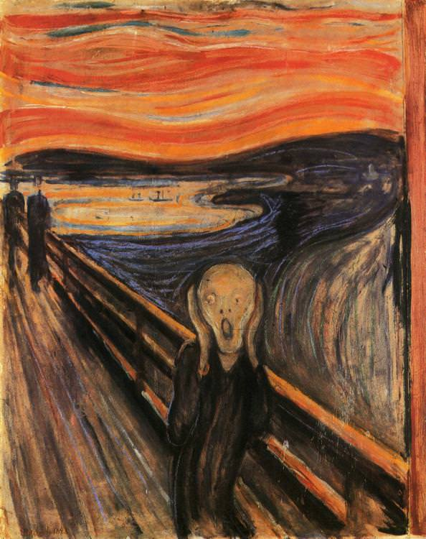
Edvard Munch, The Scream, 1893 date accessed 09/03/18.
Students will:
- read the article What is the meaning of The Scream?
- write a word bank of any terms they are unfamiliar with in the article
- familiarise themselves with the features of a narrative text by reading through the Literacy structures, language forms and features pdf
- write a story using the word bank above as descriptive language to support their view from the subjective frame and describe what is happening to the subject matter within the artwork
- discuss the use of descriptive language and how it influences the perspective of the reader in both the historical and critical text excerpt
- highlight the subjective language examples within historical and critical analysis (an example has been provided below).
Historic text | Critical text
The exhibition at the Neue Galerie explores the relationship between Munch, who was born the second of five children to an impoverished military doctor in 1863, and the avant-garde Expressionist art movement that emerged in Germany and Austria in the early years of the 20th Century. Although the show concentrates on the latter stages of the artist’s career (Munch died in 1944), it still finds room for The Scream of 1895, which he created three years after first arriving in Berlin, where he quickly made a notorious name for himself.  It was in Germany, during several creatively frenzied years, while fraternising with like-minded artists and writers, such as his close friend August Strindberg, at a bar called the Black Piglet, that Munch created the major paintings which remain his best-known works, including The Vampire and Madonna. They were conceived for his epic, semi-autobiographical series The Frieze of Life, which transmuted his own high-keyed emotions concerning love, sexuality and death into universal symbols. The original, 1893 version of The Scream was one of 22 elements in the cycle. | Beneath a boiling sky, aflame with yellow, orange and red, an androgynous figure stands upon a bridge. Wearing a sinuous blue coat, which appears to flow, surreally, into a torrent of aqua, indigo and ultramarine behind him, he holds up two elongated hands on either side of his hairless, skull-like head.  His eyes wide with shock, he unleashes a bloodcurdling shriek. Despite distant vestiges of normality – two figures upon the bridge, a boat on the fjord – everything is suffused with a sense of primal, overwhelming horror.
Text extracts from What is the meaning of The Scream? BBC, date accessed /09/03/18.

The Starry Night and the structural frame
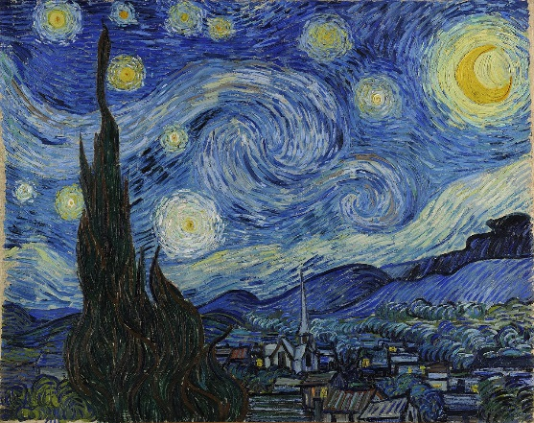
Vincent Van Gogh, The Starry Night, 1889 date accessed 09/03/18.
Students will:
- read through the information on the website Artble Starry Night Analysis
- draw a quick sketch of the work
- identify the picture plane and patterns within the art. The analysis below has an example of this.
- create a Sway presentation outlining their knowledge of the structural facts on the composition of the artwork.

Guernica and the cultural frame
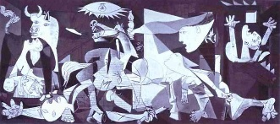
Pablo Picasso, Guernica, 1937 date accessed 09/03/18
Students will:
- watch the following videos as an introduction to the meaning of the artwork
  - clip The weeping woman from 1.10 – 1.50 mins
  - Guernica Subliminal Images
- Use the internet to research and create a newspaper article (referencing the artwork of Guernica) about the events that took place in Spain in 1937
- highlight signs and symbols from within the painting that suggest factual information to the reader.

The Persistence of Memory and the postmodern frame
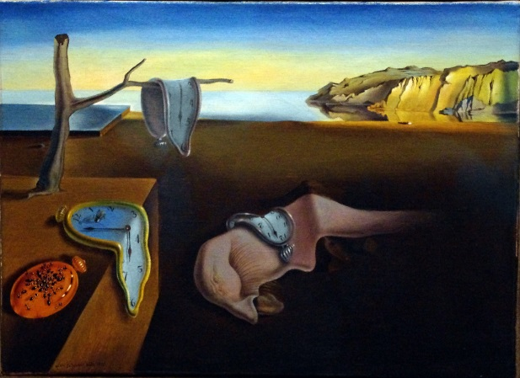
Salvador Dali, The Persistence of Memory, 1931 date accessed 09/03/18.

Students will:
- compare the work of Salvador Dali to an example of a traditional landscape painting such as Claude Lorrain, Ascanius Shooting the Stag of Sylvia, 1682
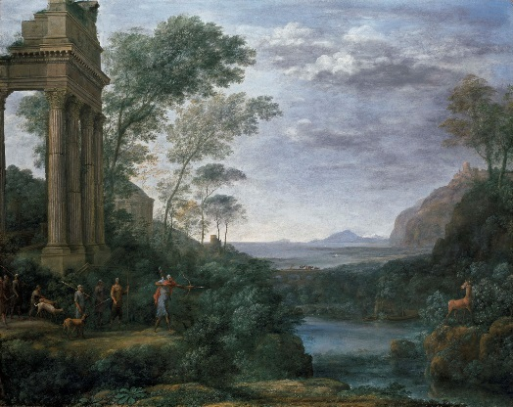
Claude Lorrain, Ascanius Shooting the Stag of Sylvia, 1682, date accessed 09/03/19.
- answer the following questions:
  - What elements of design have been applied to both?
  - How have these been manipulated within Dali’s representation of his world to communicate the ‘surreal’ as opposed to the ‘sublime’? Define these terms in relation to the examples above.
- creating an advertisement campaign for an exhibition of the artwork which justifies its overall meaning.

Communicate
Written responses are documented and shared within collaborative discussion facilitated by the teacher.

Multimedia blog
Students are to:
- document the process of their artmaking within a journal. This can be their visual arts process diary, or an online blog through sites such as Google classroom.
- photograph or sketch the process used
- write a response to the process used following literacy structures, language forms and features, as seen in the DoE text type support document.

Differentiation

Extension
Students could:
- deconstruct and reconstruct The Persistence of Memory by selecting one or two of the elements of design and recreating the artwork (either digitally in a software platform such a photoshop or manually)
  - For example, in selecting shapes and colours, remove the colours from some of the objects within the artwork to make them black and white, move them, rotate them, resize them and even replace them with popular cultured objects to change the meaning in the artwork.
- write an artist statement clarifying the representation that you have created.

Life skills
Life skills outcomes
A student:
LS.5 recognises that various interpretations of artworks are possible
Visual Arts 7-10 Syllabus © NSW Education Standards Authority (NESA) for and on behalf of the Crown in right of the State of New South Wales, 2003.
Students could:
- select one of the artworks from the series of lessons above and find a quote for each of the frames to describe that interpretation
- explain to the class what they think the artwork means and why
- change the frame of an artwork to take on a new meaning
- present their new artwork to the class.

Evaluate
Feedback is formative for the duration of the project.

Reference list and resources
Visual Arts 7-10 Syllabus © NSW Education Standards Authority (NESA) for and on behalf of the Crown in right of the State of New South Wales, 2003.
Scream Article, date accessed 09/03/18.
Frame Image, date accessed 09/03/18.
Guernica YouTube, date accessed 09/03/18.
Interactive activities, date accessed 09/03/18.
Introductory PowerPoint , date accessed 09/03/18.
Introductory Prezi , date accessed 09/03/18.
Literacy structures, language forms and features
The elements of design , date accessed 09/03/18.
The Frames The Frames, date accessed 09/03/18.
Geurnica Image, date accessed 09/03/18.
The persistence of memory image , date accessed 09/03/18.
The scream, date accessed 09/03/18.
The Starry Night image, date accessed 09/03/18.
Traditional landscape image, date accessed 09/03/18.
Wordle.net, date accessed 09/03/18.

