Compositions within landscapes

Part 4 - Ceramics
Duration: 4 weeks

Overview
Students are introduced to ceramics through an exploration of landscapes and sculptural design inspired by the work of Riccardo Biavati.
Stage 4 outcomes | Stage 5 outcomes
A student: | A student:
4.1 uses a range of strategies to explore different artmaking conventions and procedures to make artworks  4.2 explores the function of and relationships between the artist – artwork – world – audience  4.3 makes artworks that involve some understanding of the frames  4.6 selects different materials and techniques to make artworks | 5.1 develops range and autonomy in selecting and applying visual arts conventions and procedures to make artworks  5.2 makes artworks informed by their understanding of the function of and relationships between the artist – artwork – world – audience  5.3 makes artworks informed by an understanding of how the frames affect meaning  5.6 demonstrates developing technical accomplishment and refinement in making artworks
Visual Arts 7-10 Syllabus © NSW Education Standards Authority (NESA) for and on behalf of the Crown in right of the State of New South Wales, 2003.

Content
Students will work as ceramic artists inspired by the world surrounding them. They will refine their practices and techniques when making ceramic pinch pot sculptures.
Cross-curriculum content and key competencies
Environment
Information and communication technology

Assessment
All activities require students to demonstrate their learning and are all assessment for learning activities.

Teaching and learning activities
Students will:
- investigate the practice of Dreamy ceramics by vising their website
- identify and discuss the sculptural landscape designs
- watch the video outlining the process that Riccardo Biavati follows when designing landscapes using the throw wheel (00:02:05)
- discuss how the initial design is sketched before any construction takes place​
- work through the Ceramics – creating pinch pots presentation
- create a glossary of the vocabulary of terms
- watch the video How to make a simple Pinch Pot (00:06:52)
- design a ‘Dreamy landscape’ and constructing it using a pinch pot technique

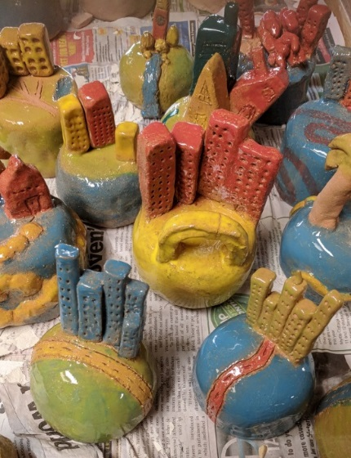
Elizabeth Macarthur High School, Ceramic examples, 2017. Photo C.Redmond
- creating a pinterest, flicker or alternative social media page of images reflecting on the creative process for their ‘Dreamy landscape’.

Making

Pinch pot ceramic sculpture
Students will:
- research and write a report on an iconic landscape in their local area
- sketch a pot sculpture design based on a landscape that they value in their ‘world’
- identify which components of the design are based on their exterior landscape
- discuss the texture of their intended surface treatment
- list the elements of the design from all of the angles, including front and back imagery within the sketches
- present their design to the teacher
- summarise and complete the exercises in the slideshow Origins of Ceramics
- read through the Basics of working with clay handout
- collect allocated clay from the teacher
- watch the video Clay Tools and Rules – Teaching clay to Elementary Students (00:08:07)
- construct their design based on their previous sketch.
Work with the students to complete the firing processes of the materials to complete the process.

Communicate
Written responses are documented and shared within collaborative discussion facilitated by the teacher.

Multimedia blog
Students are to:
- document the process of their artmaking within a journal. This can be their visual arts process diary or an online blog through sites such as Google classroom.
- photograph or sketch the process used
- write a response to the process used following literacy structures, language forms and features, as seen in the DoE text type support document.

Differentiation

Extension
Students could:
- use coil construction or slab construction to extend their design in form or surface treatment
- create a secondary extended sketch that refines their world representation.

Life skills
Life skills outcomes
A student:
LS.9 uses a range of materials, techniques and processes to make artworks
Visual Arts 7-10 Syllabus © NSW Education Standards Authority (NESA) for and on behalf of the Crown in right of the State of New South Wales, 2003.
Students could:
- create a pinch pot following the techniques demonstrated in class
- use PVA glue to seal their sculpture as an alternative to a glaze fire.

Evaluate
Feedback is formative for the duration of the project.

Reference list and resources
Visual Arts 7-10 Syllabus © NSW Education Standards Authority (NESA) for and on behalf of the Crown in right of the State of New South Wales, 2003.
‘Dreamy ceramics’ website, date accessed 08/03/2018.
Riccardo Biavati using the throw wheel, date accessed 08/03/2018.
Clay PowerPoint, date accessed 08/03/2018.
Pintch pot technique date accessed 08/03/2018.
Working with clay and the firing process, date accessed 08/03/2018.
Rules of working with clay worksheet , date accessed 08/03/2018.
How to handle clay YouTube, date accessed 08/03/2018.

