Appropriation worksheet
The Great Wave off Kanagawa is a famous woodblock printing by the Japanese artist Hokusai. It was published in 1832 as the first in Hokusai's series 36 Views of Mount Fuji and is his most famous work. It depicts an enormous wave threatening boats near the Japanese prefecture of Kanagawa; Mount Fuji can be seen in the background. The wave is probably not intended to be a tsunami, but a regular ocean wave created by the wind. Like the other prints in the series, it depicts the area around Mount Fuji under particular conditions.
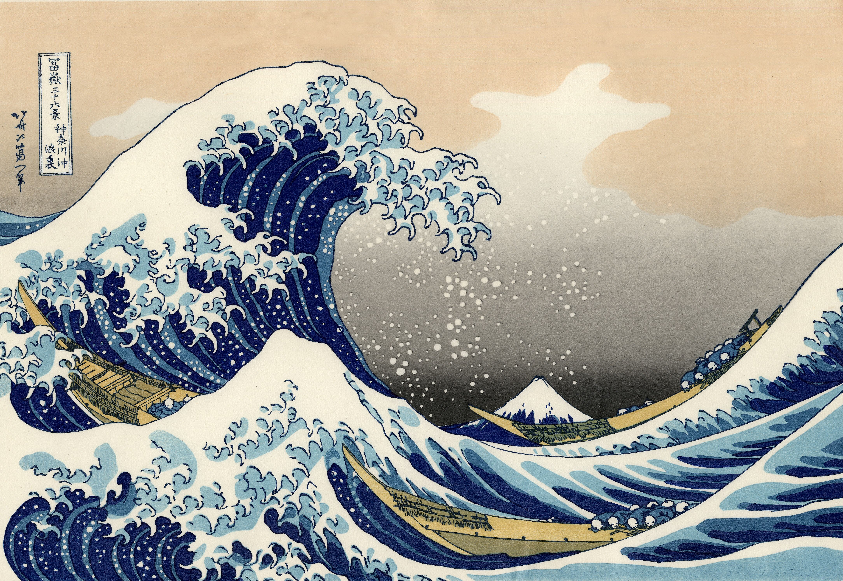
Image: bit.ly/2hV0Duk
Copies of the print hang at the Metropolitan Museum of Art in New York City, the British Museum in London, and in Claude Monet's house in Giverny, France.
The logo for the surf brand Quiksilver is based on this artwork:
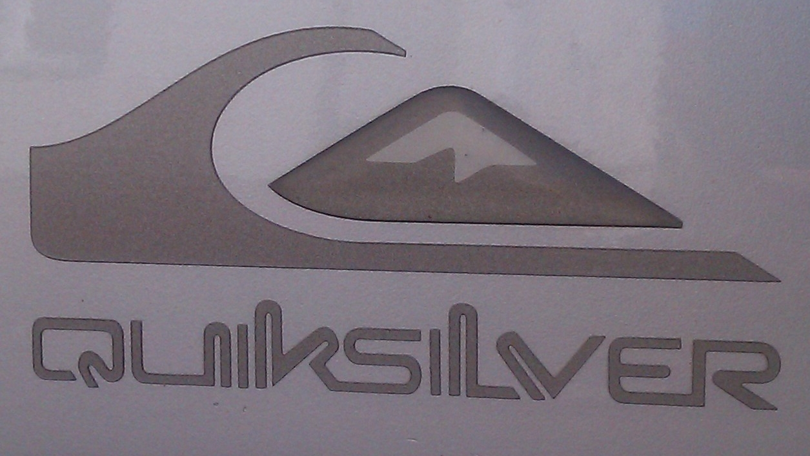
Image: bit.ly/2Af3hmY
Appropriation is the use of an image within another image.
The following images are appropriated forms of Hokusai’s The Great Wave off Kanagawa, 1832.

Activity
Complete the table by listing the similarities and differences in the artworks.

Image | Similarities | Differences
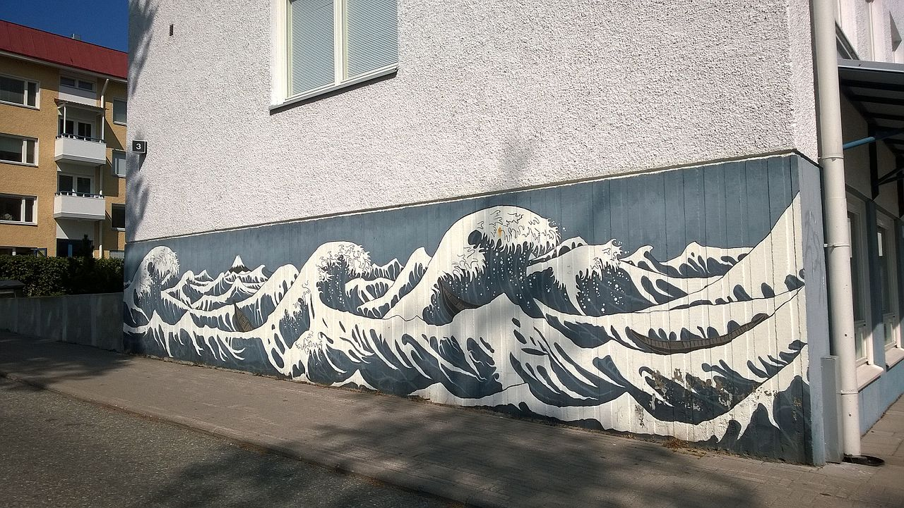  Image bit.ly/2n8p9NW | Write here | Write here
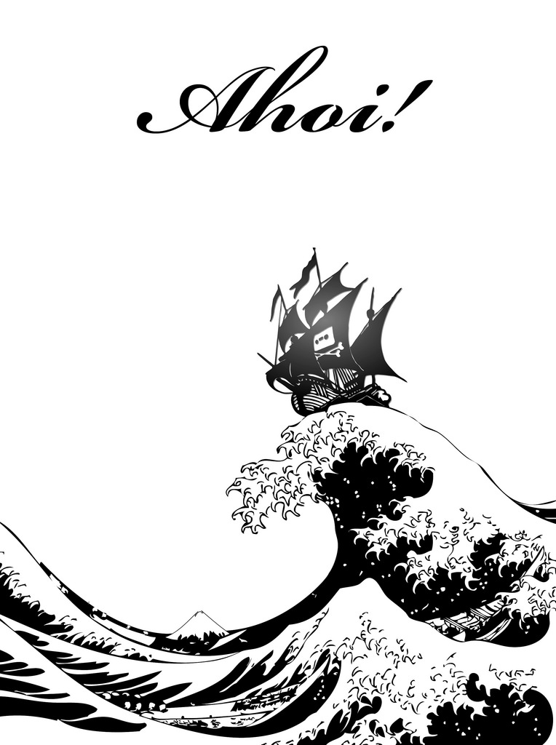  Image bit.ly/2jrUmpY | Write here | Write here
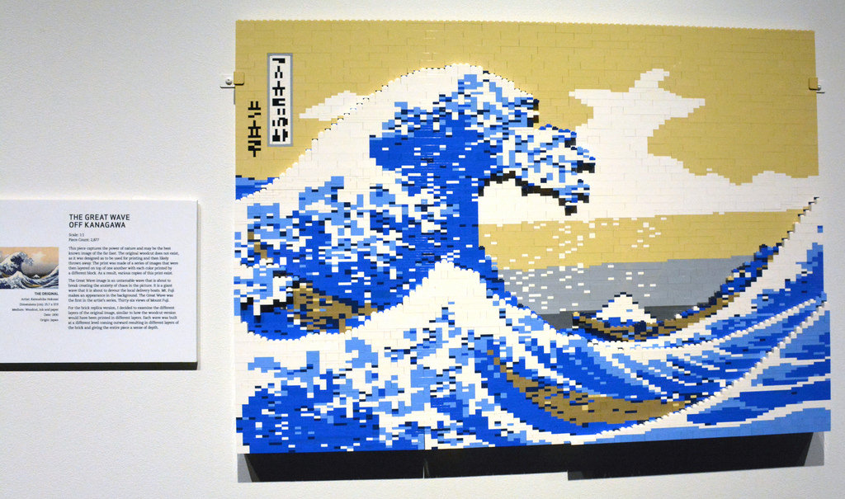  Image bit.ly/2i99Ym1 | Write here | Write here

