Artmaking

Part 2 - Drawing
Duration: 3 weeks

Overview
Students investigate the meaning of public art through a development of artmaking towards a target audience. Students will examine the practice of professional artists by proposing a design for an exhibition within an environment chosen by the teacher, applying the knowledge and skills of the curation process. Students will undergo the development of a body of work and document the process, utilising ICT skills.
Stage 4 outcomes | Stage 5 outcomes
A student: | A student:
4.1 uses a range of strategies to explore different artmaking conventions and procedures to make artworks | 5.1 develops range and autonomy in selecting and applying visual arts conventions and procedures to make artworks
4.2 explores the function of and relationships between the artist – artwork – world – audience | 5.2 makes artworks informed by their understanding of the function of and relationships between the artist – artwork – world – audience
4.3 makes artworks that involve some understanding of the frames | 5.3 makes artworks informed by an understanding of how the frames affect meaning
Visual Arts 7-10 Syllabus © NSW Education Standards Authority (NESA) for and on behalf of the Crown in right of the State of New South Wales, 2003.

Content
Students will explore the Sculpture by the sea exhibition, and the practices of contemporary sculpture artists for their conceptual and material conventions and procedures.
Cross-curriculum content and key competencies
Work, employment and enterprise
Civics and citizenship
Information and communication technology

Assessment
All activities require students to demonstrate their learning and are all assessment for learning activities.

Teaching and learning activities
Students are to work in groups and investigate the driving question using the Sculpture by the sea website.
Suggested student learning activities include:
- write a vocabulary list
- research and investigate the Sculpture by the sea exhibition through ideas such as:
  - What is public art? (define and explain)
  - How does the audience interact with the artworks in person as opposed to online?
  - Select an example artwork (cite the artist, ‘title’, year, medium).
  - Look at the artwork from a structural frame perspective. Use descriptive language, such as elements of design, to describe the work as if the reader has never seen the work before.
  - Use your description above to write about the Artwork from a cultural frame perspective. Can you identify any aspects of the artwork that make connections to meanings in the artwork? Explain
- develop a bank of online websites that they have used to frame their research

- for each group of students (3-4 depending on class size) allocate a location within the school where students could exhibit their work. Create a mind map outlining the connections between the meaning of their artworks and the environmental exhibition space
  - schools may choose to work closely with their local council or community groups to exhibit their works in places such as halls or outdoor parks.

Students are encouraged to experience the exhibition online or in person. The Western Sydney University has virtual gallery tours, as well as an annual sculpture prize for rural and remote schools.

Making skills

Drawing
Students will:
- demonstrate mark-making practices of shading, line, cross-hatch, pointillism, reduction and text
- focus on tone and texture to create a 2-dimensional drawing of a proposed sculpture. Some examples of drawing methods can be found at:
  - How to shade drawings with pencil and pen | 9 methods
  - How to shade with pencil | pencil shading techniques | drawing exercises | basic drawing lessons
- create and design a sculpture based on a given selection of materials. Examples and inspiration can be found by researching current exhibitions in your local area. An environmental example could be:
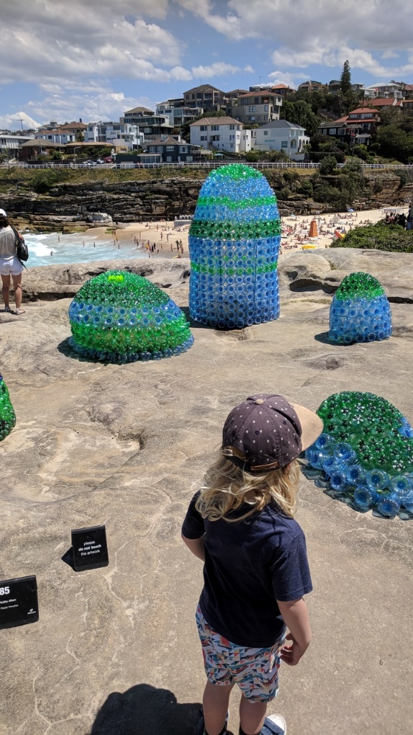
Kathy Allam, ‘Plastic Paradise’, Sculpture by the sea, 2017. Photo: C.Redmond
  - This Artwork explores the issues of recyclable materials through its material and conceptual practice. This could be related to the school playground and discarded rubbish found amongst the grounds.
- exhibit student artwork.

Communicate
Written responses are documented and shared within collaborative discussion facilitated by the teacher.

Multimedia blog
Students will:
- document the process of their artmaking within a journal. This can be their visual arts process diary, or an online blog through sites such as Google classroom.
- photograph or sketch the process used
- write a response to the process used following literacy structures, language forms and features, as seen in the DoE text type support document.

Differentiation

Extension
Students could:
- investigate a local sculptural art prize such as the Wollongong acquisitive sculpture award
- write a report outlining the practice conventions, sculptural terms, conditions and design process
- design a sculpture individually or collaboratively within the restrictions and limitations of the competition and complete an application.

Life skills
Life skills outcomes
A student:
LS.6 makes a variety of artworks that reflect experiences, responses or a point of view.
Visual Arts 7-10 Syllabus © NSW Education Standards Authority (NESA) for and on behalf of the Crown in right of the State of New South Wales, 2003.
Students could:
- select an artwork from the exhibition experienced online and draw a representation of that artwork from different perspectives.

Evaluate
Feedback is formative for the duration of the project.

Reference list and resources
Visual Arts 7-10 Syllabus © NSW Education Standards Authority (NESA) for and on behalf of the Crown in right of the State of New South Wales, 2003.
Sculpture by the sea
Western Sydney sculpture prize
Literacy structures, language forms and features
Acquisitive Sculpture Award.

