Identity

Part 2 - Portraiture
Duration: 1-2 weeks

Driving question
How do the images around us define and shape our identity?

Overview
Students investigate the concept of ‘identity’ through an exploration of portraiture within artmaking practice. Students look at mixed media techniques used by artists to deconstruct and reconstruct meaning shaping their identity to an art audience.
Stage 4 outcomes
A student:
4.1 uses a range of strategies to explore different artmaking conventions and procedures to make artworks
4.2 explores the function of and relationships between the artist – artwork – world – audience
4.3 makes artworks that involve some understanding of the frames
4.5 investigates ways to develop meaning in their artworks
Visual Arts 7-10 Syllabus © NSW Education Standards Authority (NESA) for and on behalf of the Crown in right of the State of New South Wales, 2003.

Content
Students will explore the genre of portraiture within practice. They will investigate conceptual and material conventions and procedures for art making through the creation of a subjective artwork.
Cross-curriculum content and key competencies
Work, employment and enterprise
Civics and citizenship
Information and communication technology

Assessment
All activities require students to demonstrate their learning and are all assessment for learning activities.

Teaching and learning activities
Students will:
- discuss the composition of the artwork Eolo Bottaro on the art gallery of NSW website
- summarise the information and describe the artworks in The Archibald Prize slideshow
- read the information on the following two Art Gallery NSW sites
  - Syllabus connections: the Archibald Prize - Art Gallery NSW
  - Portraiture and the prize education kit - Art Gallery NSW
- answer the questions below using the information on the websites above
  - What is portraiture? Define the concept and provide an example from your investigation into the Archibald prize.
  - What makes this example fit within this genre?

Self Portrait
Materials required
- computer/phones/digital device
- A3 paper (plain or cartridge)
- 6B Progresso pencils (an alternative will be acceptable)
- charcoal
- pastels
- watercolours
- ink.
Students will:
- write a reflection in their books answering the questions below
  - How do others perceive you?
  - How would you like to be perceived?
- create a table of emotions, colours and symbols to assist in the design of a self-portrait using mixed media materials. For example:

Emotion | Colour | Symbol
Happy | Yellow | Google image
Sad | Blue | Google image
Frustrated
Shocked
Scared
Mellow
Anxious

- create a self-portrait based on a photo of themselves
- transfer the outline of your portrait onto an A3 piece of paper
- watch the video How to Draw Faces (00:19:21)
- watch the video Watercolour background wash tutorial (00:05:12)
- select a colour (or two) that represents the emotions in their portrait
- create a watercolour wash background for their A3 portrait
- use charcoal and highlights to add tone, texture and contrast to refine each layers of their image. Examples have been provided below.
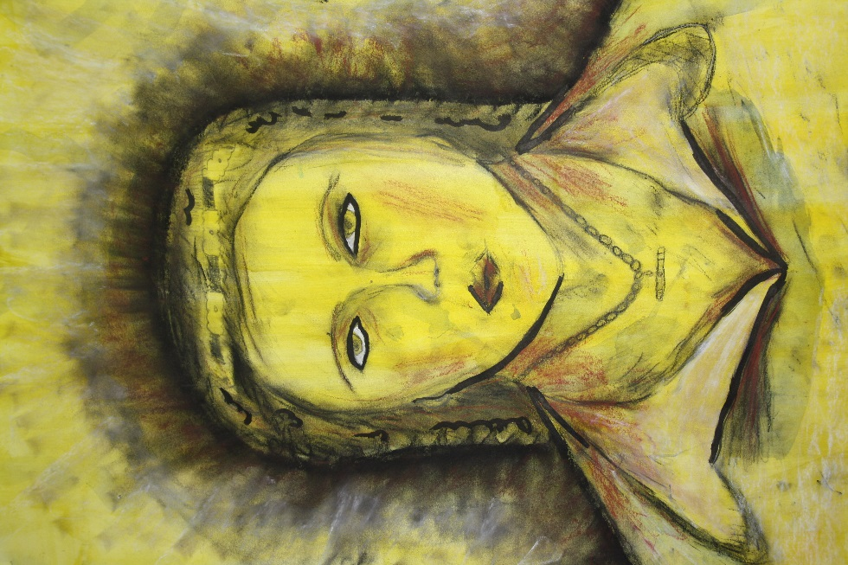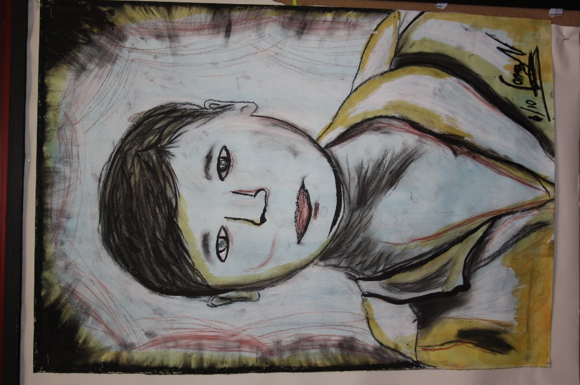
Year 7 sample artworks, Elizabeth Macarthur High School, 2010. Image: C. Redmond.

Communicate
Written responses are documented and shared within collaborative discussion facilitated by the teacher.

Multimedia blog
Students are to:
- document the process of their artmaking within a journal. This can be their visual arts process diary, or an online blog through sites such as Google classroom.
- photograph or sketch the process used
- write a response to the process used following literacy structures, language forms and features, as seen in the DoE text type support document.

Differentiation

Extension
Students could:
- create a portrait that communicates an emotion without clear facial expression
- apply other materials to the artwork (under the discretion of the teacher) to incorporate a symbol of their choice.

Life skills
Life skills outcomes
A student:
LS.6 makes a variety of artworks that reflect experiences, responses or a point of view.
Visual Arts 7-10 Syllabus © NSW Education Standards Authority (NESA) for and on behalf of the Crown in right of the State of New South Wales, 2003.
Students could:
- draw a portrait of themselves
- draw a portrait of their classmate.

Evaluate
Feedback is formative for the duration of the project.

Reference list and resources
Visual Arts 7-10 Syllabus © NSW Education Standards Authority (NESA) for and on behalf of the Crown in right of the State of New South Wales, 2003.
Eolo Bottaro, The Archibald, 2008
The Archibald Prize is - Art Gallery NSW
Portraiture and the prize education kit - Art Gallery NSW
Youtube tutorial scale drawing demonstration

