Identity

Part 1 - Ceramics
Duration: 3 weeks

Driving question
How can a real-world problem influence a person's identity?

Overview
Students use the frames to explore world representation within portraiture. Students look at abstract techniques used by artists to communicate meaning to an art audience and the use of the elements of design.
Stage 4 outcomes
A student:
4.1 uses a range of strategies to explore different artmaking conventions and procedures to make artworks
4.2 explores the function of and relationships between the artist – artwork – world – audience
4.3 makes artworks that involve some understanding of the frames
4.5 investigates ways to develop meaning in their artworks
Visual Arts 7-10 Syllabus © NSW Education Standards Authority (NESA) for and on behalf of the Crown in right of the State of New South Wales, 2003.

Content
Students will explore the work of Pablo Picasso and his representation of portraiture within practice. When creating artwork, students will gain skills in artmaking through the creation of an abstract artwork.
Cross-curriculum content and key competencies
Difference and diversity
Civics and citizenship

Assessment
All activities require students to demonstrate their learning and are all assessment for learning activities.

Teaching and learning activities
Students will:
- research when Pablo Picasso was last exhibited in Australia
- investigate current and previous exhibitions for the work of Pablo Picasso. Some suggested websites could be:
  - Art Gallery of NSW exhibition of 2011-2012
  - National Gallery of Australia in 2018.

“There is no abstract art. You must always start with something. Afterward you can remove all traces of reality.”
By Pablo Picasso.

Using the quote and an image from a website above, students will:
- create a mind map of the representational signs and symbols within the artwork

Weeping woman self-portrait PowerPoint presentation
Using slides 1 to 3, explore the meaning of Picasso’s weeping woman.

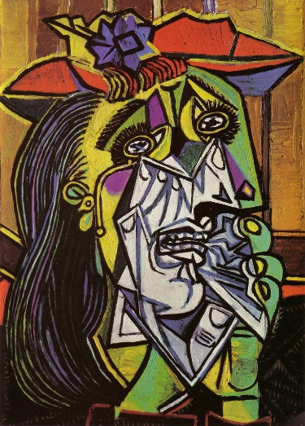 Image: bit.ly/2k2jtUi
In the PowerPoint presentation on slide 3:
- Watch the youtube on the weeping woman while completing a think/ share/ compare table

Think | Share | Compare
List at least five interesting facts that first come to mind when looking at the artwork. | With your partner compare facts and list those they had that you did not. | As a class, what facts were discovered about the cultural context of the artwork that you have not already noted.
Student box | Student box | Student box
Use the think/ share/ compare table above for students to connect facts relating to the cultural and structural frames in learning about this composition.
Stop the powerpoint here with the class and differentiate to use the remainder of the presentation with students aiming to achieve life skills outcomes.

Introducing ceramics
There are plenty of resources online that connect metalanguage with practice, procedures and conventions. Some suggested resources available for printing are available at:
- Ceramics vocabulary worksheets
- Golden rules of ceramics.
Set up the classroom in a ‘u’ shape with a table for instruction in the middle at the front of the room. This will be used as the table for teacher demonstration and make the practical component sequence more accessible for students.
Demonstrate how to handle clay. An example of this is the video Clay tools and rules.
For this sequence, students will be working with a ‘slab construction’. Watch the YouTube Cutting clay slabs to initiate practice in this:
Ask students to write a procedure in their visual arts diaries on the construction of clay, in this case, it will be a slab, for consideration during the process.
Students will:
- sketch their initial designs for an abstract clay mask utilising slab construction techniques
- using the weeping woman for inspiration, design and plan the surface using tone and texture in their drawing
- consider adding colour and glaze for an additional firing and what colours and textures will be applied to the surface.
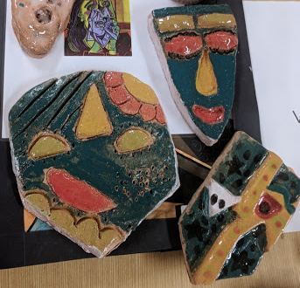
Elizabeth Macarthur High School, Ceramic Mask examples, 2017. Photo C.Redmond

Communicate
Written responses are documented and shared within collaborative discussion facilitated by the teacher.

Multimedia blog
Students are to:
- document the process of their artmaking within a journal. This can be their visual arts process diary, or an online blog through sites such as Google classroom
- photograph or sketch the process used
- write a response to the process used following literacy structures, language forms and features, as seen in the DoE text type support document.

Differentiation

Extension
Students are to:
- write a long-response answer to the driving question, relating to the process of design for their ceramic mask
research the history of masks and collate a list of signs and symbols and their origins.

Life skills
Life skills outcomes
A student:
LS.2 explores a variety of materials, techniques and processes
Visual Arts 7-10 Syllabus © NSW Education Standards Authority (NESA) for and on behalf of the Crown in right of the State of New South Wales, 2003.
Students are to:
- follow the directions for artmaking in the weeping woman self-portrait powerpoint, which directs them step-by-step on the construction of an abstract mixed media design instead of ceramics.

Evaluate
Feedback is formative for the duration of the project.

Reference list and resources
Visual Arts 7-10 Syllabus © NSW Education Standards Authority (NESA) for and on behalf of the Crown in right of the State of New South Wales, 2003.

Art Gallery of NSW exhibition of 2011-2012
National Gallery of Australia in 2018
Weeping woman self-portrait PowerPoint presentation
Weeping woman image
Ceramics worksheets

