Year 12 Mathematics Standard 1
This document references the Mathematics Standard Stage 6 Syllabus © 2017 NSW Education Standards Authority (NESA) for and on behalf of the Crown in right of the State of New South Wales.

Unit title
Networks and Paths (MS-N1)

Duration
3-4 weeks

Rationale
Students develop their appreciation of the applicability of networks throughout their life, for example, social networks, and their ability to use associated techniques to optimise practical problems. Students learn through practical tasks.

Topic focus
The principal focus of this subtopic is to identify and use network terminology and to solve problems involving networks.
Students develop their awareness of the applicability of networks throughout their lives, for example, social media networks, and their ability to use associated techniques to optimise practical problems.

Prior knowledge required
- Addition of two numbers up to 4 digits in length
- Comparison of two numbers

Language considerations
Terminology is introduced as required in each section.

Outcomes
A student:
- MS1-12-8 applies network techniques to solve network problems
- MS1-12-9 chooses and uses appropriate technology effectively and recognises appropriate times for such use
- MS1-12-10 uses mathematical argument and reasoning to evaluate conclusions, communicating a position clearly to others

Assessment (including formative and summative)
Formative examples:
- Card matching activity (number of nodes, minimum spanning trees, and so forth)
- Construction of physical network using paddle pop sticks
Summative assessment:
- Networks and Pathways Assessment Task
Content | Teaching and learning strategies and evidence of learning | Resources
N1.1 Networks | N/A | N/A
Identify and use network terminology, including vertices, edges, paths, the degree of a vertex, directed networks and weighted edges | Key ideas:  - Identify and use network terminology  - Use simple network diagrams  Language:  - Network – a group of objects which can be represented as a diagram of connected lines (called edges) and points (called vertices). For example, a rail network.  - Node/vertex – a point in a network diagram where lines of pathways intersect or branch.  - Arc/edge – refers to a line which joins vertices to each other in a network diagram.  - Path – a walk in which all the edges and all the vertices are different in a network diagram. There may be multiple paths between the same two vertices.  - Open path – a path that starts and finishes at different vertices.  - Weighted edge – the edge of a network diagram that has a number assigned to it which implies some numerical value such as cost, distance or time.  - Closed path – a path that starts and finishes at the same vertex.  Activities:  - 6 degrees of separation:  - Each student is given a sticky note and they are to write down 5 of their favourite things (no prompting). One student is selected to start and their sticky note is stuck on the board. The teacher asks remaining students if any of their favourite things match the first student and the sticky notes are stuck to the board one at a time making connections between each person as they go. The result is a very large network with many connections, with multiple edges coming out of each node. For a large class this could be performed in groups of 5-6 students.  - Konigsberg bridge problem:  - The Konigsberg bridge problem asks if the seven bridges of the city of Konigsberg over the river Preger can all be traversed in a single trip without doubling back, with the additional requirement that the trip ends in the same place it began.  - Students are to make a network diagram representing the Konigsberg bridge problem using pipe cleaners and modelling clay.  - Teacher to play the TED Ed video to unpack the problem in more detail after solutions have been explored hands-on and on the board.  - Way to school:  - Teacher to complete a basic network diagram using a map of the local area projected onto the whiteboard as a sample of their pathway options to school, using home, school and the shops as the nodes, overlaid on a map of the local area. Students could model different ‘way to school’ scenarios by using paddle pop sticks with values written on them. Foam cups could be used as the nodes. Increase complexity as student’s understanding increases, including weighted edges.  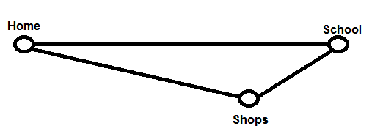  - Students are to complete their own version of a network to represent different pathways to school, starting with three nodes and increasing to up to ten. (Students may require a copy of the local area to overlay their network diagram.)  - Students add weights to their network diagram with travel time estimates. (Help with estimation times may be required). Students highlight the fastest path to school.  - Students calculate the time taken to travel to school for three different paths from their network diagram.  - Hamilton’s puzzle:  - Hamilton’s puzzle asks if there is path along the edges of a regular dodecahedron which visits every vertex exactly once and returns to the start, where each of the vertices represents an important city.  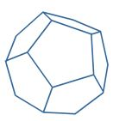  - Students are given a network diagram representing Hamilton’s puzzle and attempt to solve.  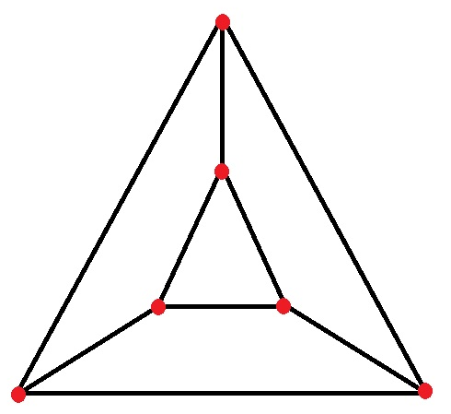  - Students are to create their own simple network diagram using the local area. It is recommended that mini whiteboards and markers are used for ease of swapping network diagram. Another student then has the challenge of visiting each local landmark exactly once, starting and finishing at the same place.  - Social network:  - Class discussion of social networks and Facebook/Instagram influences.  Assessment of learning:  Students have produced a number of networks based on different situations. Teacher can check students’ learning by looking at their individual diagrams.  Optional homework activity:  Star constellations are networks. For example, the Pointers and the Southern Cross. Sketch the network below that represents the Southern Cross. For homework, use the degrees of space to add weight to the edges, or research the distance in kilometres.  - Note – Your pinky finger held out with an extended arm will measure one degree of space, and your middle three fingers when held together will measure 5 degrees.  - For an extension activity, draw a weighted network diagram for the constellation of the month.  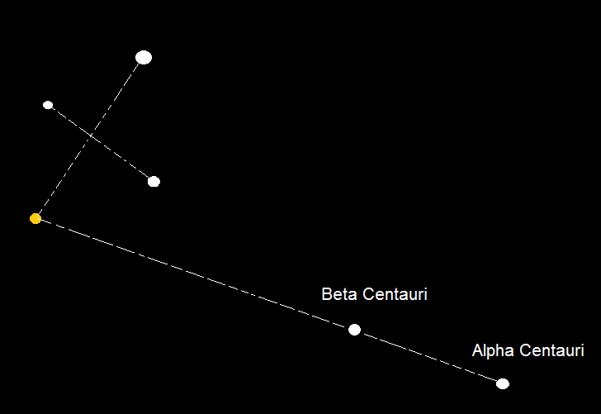 | - Teacher could prepare a card matching activity that matches a diagram, name and description using the definitions listed.  - Teacher could use local public transport maps or airports to represent networks on a larger scale. For example:  - Sydney Trains Network  - Qantas Domestic Routes  - Konigsberg bridge problem (TED Ed video on YouTube)  - Hamilton’s puzzle  - Measuring the sky with your hands (ABC Science)
Solve problems involving network diagrams AAM  - Recognise circumstances in which networks could be used, such as the cost of connecting various locations on a university campus with computer cables  - Given a map, draw a network to represent the map, such as travel times for the stages of a planned journey | Key Ideas:  - Solve simple problems using network diagrams  Language:  - Shortest pathway – a path between nodes that represents the minimum sum of the weights.  - Directed network – when the edges of a network have arrows and travel is only possible in the direction of the arrows.  Activities:  Paw Prints:  - A warm-up activity that introduces the concept of directional edges from NRICH.  Road Tripping 1:  - Students refer to the network diagram of Goulburn to Tamworth.  - Draw arrows on the network to represent direction if each route is to take you closer towards Tamworth.  - List the nodes of this network.  - What do the numbers on the weighted edges represent?  - What is the greatest distance between any two nodes?  - Which two towns are 70 km apart?  - Given that each path taken must bring you closer to Tamworth, list the number of routes from Goulburn to Tamworth.  - Calculate the distance for each route from Goulburn to Tamworth.  - Does the longest route from Goulburn to Tamworth go through Sydney or Bathurst?  - Which route represents the shortest path?  - Is it possible to visit every town or city exactly once when travelling from Goulburn to Tamworth?  - Is it possible to use every road exactly once when travelling from Goulburn to Tamworth?  - Is it quicker to take the coastal road via Sydney/Newcastle, or inland via Bathurst?  - Which route would you prefer to use and why?  - Extension – Students choose two locations of their own and draw a network diagram showing different routes between each. Weighted edges can be travel times using speed distance formula.  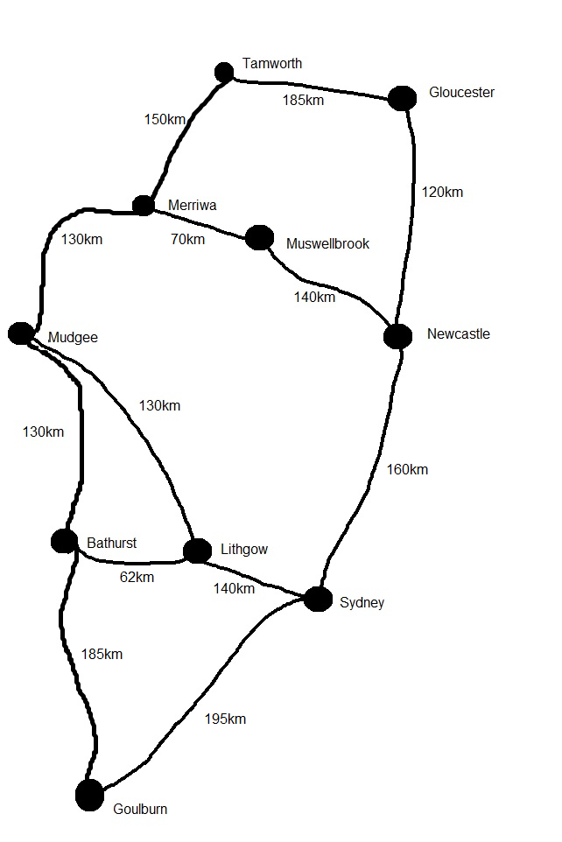  Farmer Brown:  - Farmer Brown has one generator to power four sheds, a barn, an office and two houses. The undirected diagram below shows the distance between each node in metres. Cabling costs $25 per metre.  - How much would it cost the farmer to cable the two houses?  - What is the minimum cost for cabling the two houses?  - Is the 12m cable between the houses necessary? Why/why not?  - What is the cost of cabling just the four sheds?  - The farmer could save money by removing some cables. Which cables do you think should be removed if every building must have power?  - Calculate the minimum cost for the farmer to cable his entire network.  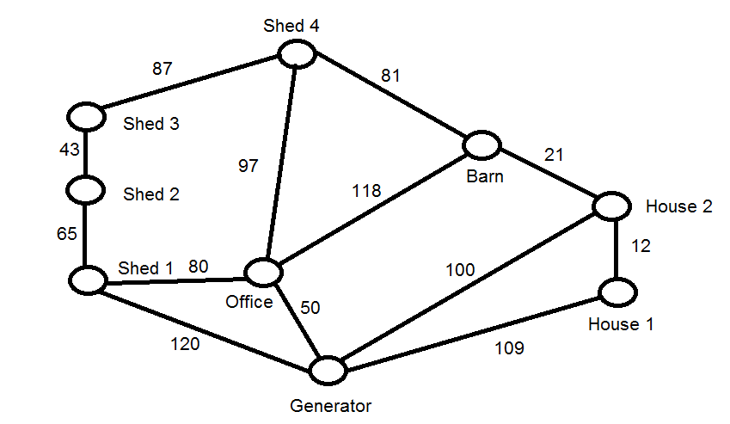  Farmer Brown 2:  - Students are to locate a property on Google Earth or SIX maps that contains different buildings.  - They use the calculator function in the given application to create a weighted network diagram, using distance.  - Calculate the shortest path from the main building to a shed.  Muddy City:  - A 20 minute lesson activity that explores one way to optimise the choice of pathways between nodes.  Assessment of learning:  - Students create an undirected weighted network diagram based on their local area and approximate travel times.  - Students correctly calculate the cost for Farmer Brown and can justify which cables could be removed.  - Students draw a directed network diagram with weighted edges to model a trip from the Central Coast to Sydney, representing the cost of travel. | - Paw Prints (NRICH)  - The Muddy City (CS Unplugged)
- Draw a network diagram to represent information given in a table | Activities:  School Computer Network 1:  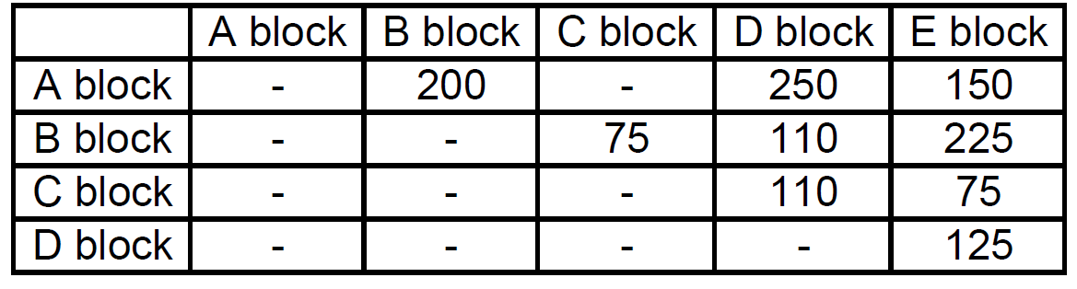  - The cost in dollars of connecting various blocks at a school with network cables are given in the table above. A blank space indicates no direct connection.  - Draw a weighted network diagram to represent this situation.  School Computer Network 2:  - Select five locations from around the school to construct a simple network diagram.  - Students use a stopwatch to time in seconds the distance between each node (students may need help with rounding), recording the information in a table.  - Add weighted edges to the network diagram.  - Compare the table and network diagram. Discuss the advantages and disadvantages of each.  Road Tripping 2:  - Refer to the inland route of the map from Goulburn to Tamworth from Road Tripping’ 1.  - Complete the table below:  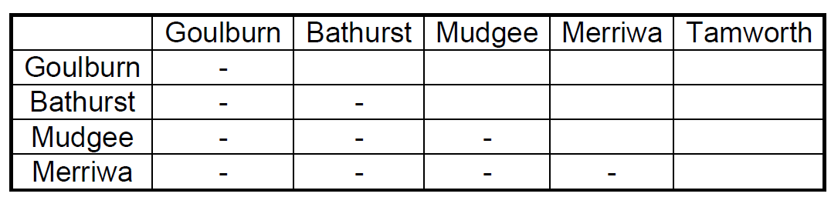  - Solution:  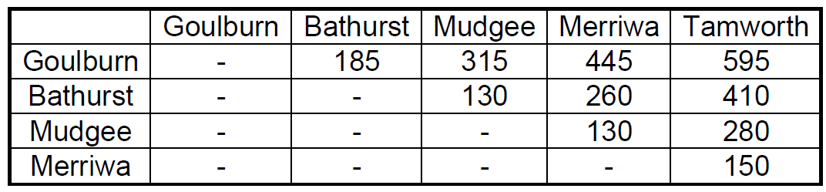  - Create a table using the coastal route.  Road Tripping 3:  - You live in Bathurst, NSW and you are planning a road trip to visit friends in Tumut, Wagga Wagga, Hay and Lake Cargelligo. However, with the price of petrol around $1.40/L and your car uses 13L per 100km, you want to calculate the order to visit the cities to make the round-trip the shortest and save money on petrol.  - Copy the map and find the distance between each of these two points.  - Find the distance between each point from the given table.  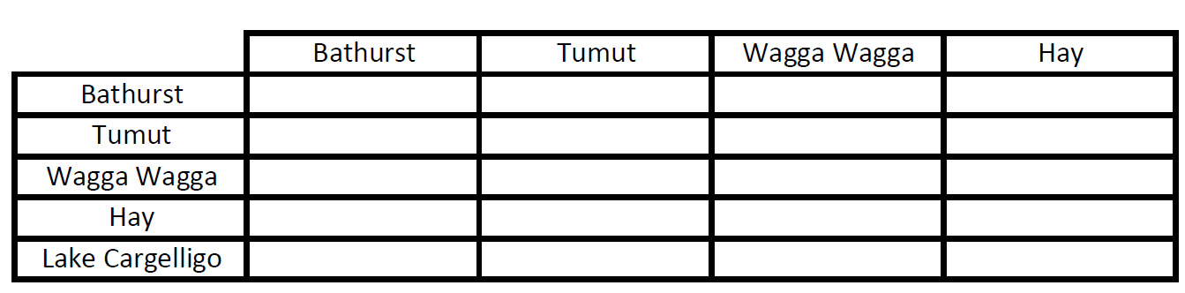  - Extension – Have students work out the distances between each town.  Assessment of learning:  - In pairs, students are to create a network diagram using published distance tables. | - Australian driving distances
N1.2 Shortest paths | N/A | N/A
Determine the minimum spanning tree of a given network with weighted edges AAM  - Determine the minimum spanning tree by using Kruskal’s or Prim’s algorithms or by inspection  - Determine the definition of a tree and a minimum spanning tree for a given network | Key ideas:  - Understand and use the terminology ‘shortest path’ and ‘spanning tree’  Language:  - Degree of a node – is the number of edges connected to the node.  - Minimum spanning tree – is a subgraph which connects all nodes together with a minimum possible edge sum.  Activities:  Introduction to Kruskal’s Algorithm:  - Using the sample network of a school, implement Kruskal’s algorithm to find the minimum spanning tree.  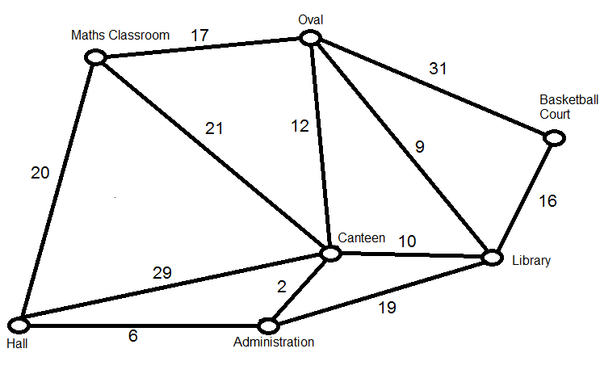  - Solution:  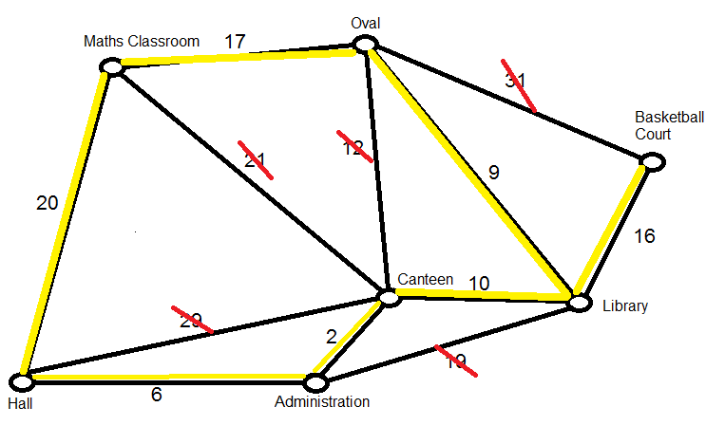  - Select 8-10 locations around the school and construct a simple network diagram with nodes of various degrees. Students pace out the step distance (or time in seconds) between each node.  - Students are to construct a weighted network of their own school and use Kruskal’s algorithm to find the minimum spanning tree.  - Students research Prim’s algorithm.  - Students find the minimum spanning tree of the school network using Prim’s algorithm.  - Class discussion on the advantages and disadvantages of each algorithm. | - Minimum Spanning Trees  - Kruskal’s algorithm in 2 minutes  - Prim’s algorithm in 2 minutes
Find the shortest path from one place to another in a network with no more than 10 vertices AAM  - Identify a shortest path on a network diagram  - Recognise a circumstance in which a shortest path is not necessarily the best path or contained in any minimum spanning tree | Key ideas:  - Find the shortest path given different options.  Language:  - Shortest path – can refer to the shortest distance from A to B. It does not necessarily imply that all nodes are visited. It does not always refer to the shortest distance in length, it could also refer to the cheapest route/path or quickest route.  Activities:  Introduction to Shortest Path:  - To find the shortest path between A and B in a network:  - Step 1 – For all nodes one step away from A, write down the smallest number. If two nodes are equidistant from A, then follow both pathways.  - Step 2 – For all nodes two steps away from A, write down the smallest number and continue on that pathway.  - Step 3 – Repeat until B is reached and then add up the numbers.  - In this 2x2cm grid, find the number of shortest paths that exist.  Shortest Path at School:  - By inspection, using the diagram created earlier in the unit, find the shortest path from the hall to the basketball court.  - Class discussion – Students are to identify circumstances for the school network example where the shortest path is not necessarily the best path. For example, the oval in wet weather could be too wet, some of the pathways could not be undercover and wouldn’t be suitable in rain, and so forth. | N/A

Reflection and evaluation

