Rubbish Rap (S2-S3)
Vocal Ease More

Speech and song – what is a rap?
- Watch a short video overview by the composer (0:41)
- Watch a short video overview of the teaching points (0:41)
- Listen to the full performance (2:32)
- Listen to the full backing track (2:32)
- Listen to the shortened performance (1:53)
- Listen to the shortened backing track (1:53)
- Access the lyric sheet (pdf)

Background to Rubbish Rap
The aim of this piece is to explore the first steps to music making using speech. This can be identified as rhythmic speech, chant or rap. Speech is one of the most accessible and engaging ways to explore music and allows for easy integration into other key learning areas.
In this piece, students will be engaged in learning a chant whilst exploring all musical concepts through a variety of learning experiences including performing, organising sound and listening.
Rubbish Rap delves into a relevant topic of reducing, reusing and recycling. It forces children to think about this critical issue in an interesting and exciting way.
Begin by learning the reduced version of the rap, then build up to the full version. Explore with movement and instruments following the lesson ideas and then use the backing tracks and suggestions to make your own chants or raps. This backing track can be used in repeatedly to suit your needs.

Quick start menu
- Listen to Rubbish Rap and keep the beat. Learn the shortened version of the rap. Build up to the full version of the rap. Perform.
- Follow the guidelines for graphic notation.
- Improvise, arrange and then create your own raps.
- Complete some or all the suggested activities including some of the suggestions for integrating into other key learning areas.

Key to icons

Concepts of music
Duration
Pitch
Dynamics
Tone colour
Structure

Learning experiences
Performing
Organising sound/composition
Listen
Outcomes and other elements of the syllabus used in this document are copyright Creative Arts K-6 Syllabus (NESA)

Learning across the curriculum
Cross-curriculum priorities | General capabilities | Other learning across the curriculum areas
Sustainability | Critical and creative thinking  Ethical understanding  Information and communication technology capability  Literacy  Numeracy  Personal and social capability | Civics and citizenship

Get familiar

Outcomes and purpose
MUS2.1
MUS2.2
MUS3.1
MUS3.2
To introduce and reinforce the Rubbish Rap.
Keeping the beat.
Exploring the structure.

Learning experiences | Activities S2-S3 | Concepts of music
 | Context – reflect upon the text and the meaning of the lyrics in the full version
 | Keep the beat – with words displayed, keep the beat whilst listening to the recording of the full rap. Try this a few times with a variety of methods for beat keeping including movement (such as stepping), clapping or other body percussion (such as clicking or patsching). You will notice that sometimes the words are not on the beat ‘Rubbish Rap’ and ‘Flip that lid right on the bin’. This is called syncopation.
 | Investigate the music – discuss the structure of how the piece has been put together. How many lines are there in each verse? (8) How many beats are there in each line? (4)
 | Move – as a class, model movements to reflect the text in each verse. This many initially take the form of hand gestures then expand to the other movements. Reinforce the beat through this movement.
 | Perform – in groups students create a movement pattern to reflect each line of a verse. There should be 8 movements to reflect the 8 lines of each verse (the first and last verses start after the words ‘Ooo, Ahh Rubbish Rap’). There are 3 verses and 2 choruses in total, therefore 5 groups. Swap groups and repeat or dramatise the words and perform for each other. This will assist students in learning the words.

Spice it up

Outcomes and purpose

MUS2.1
MUS2.2
MUS3.1
MUS3.2
To maintain the beat.
Creating and performing accompaniments such as ostinatos.

Learning experiences | Activities S2-S3 | Concepts of music | Watch the lesson
 | Keep the beat – revise the rap in either full or reduced versions. Add some body percussion to each line. Either keep it consistent or change for each line. Examples of body percussion might include clapping, clicking or patsching. |  | 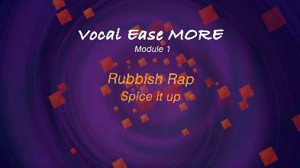  (1:49)
 | Accompaniment – body percussion is one form of accompaniment. Experiment with other forms of accompaniment such as beatboxing or adding an ostinato. An example of an ostinato is taking a phrase or a line and repeating them, such as ‘Ooo, ahhh rubbish rap’. You will hear this on the Ooo, Ahh audio track. One group performs the ostinato whilst the rest of the class performs the rap.  Student will then be able to create their own ostinatos to accompany the rap. Discuss the requirements of this including the number of beats (such as beats 2 or 4).  Watch this video to see this activity being taught. Extend upon this by adding instruments. The instruments can be traditional percussion instruments or self-created (see STEAM link). What is this? The instruments can replicate the ostinato or body percussion patterns. |  | 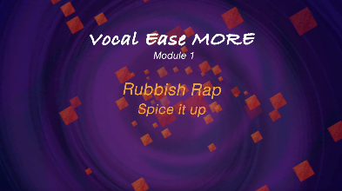  (3:07)  (2:05)
 | Experiment – explore recycled materials that can produce a noise, such as scrunch or rip newspaper, tap bottles or twist plastic bags. Look at an example of the unusual use of newspapers of Stomp – Newspapers (8:21). Experiment with using these as an ostinato accompaniment.
 | Perform – use some of the previously learned techniques to create a new accompaniment for the Rubbish Rap full version. Perform with this new accompaniment and the rap.
 | Extend it – take this further with the use of bins, buckets and other environmental percussion such as using chairs, tables or walls to accompany the rap exploring different tone colours to accompany the rap.

Notate it

Outcomes and purpose
MUS2.1
MUS2.2
MUS2.3
MUS2.4
MUS3.1
MUS3.2
MUS3.3
MUS3.4
To maintain the beat.
Introducing and using graphic notation.
Creating and performing accompaniments such as ostinatos.
Exploring rhythm patterns and rests

Learning experiences | Activities S2-S3 | Concepts of music | Watch the lesson
 | Keep the beat – create a grid that has 4 columns and 8 rows. Each square represents a beat in the verse. Pictorially represent the instruments that should play on each beat. This may be as simple as a symbol such as an X or an O to represent two different instrumental groups or may be a picture of the instrument to play on the beat. This is the starting point of graphic notation.  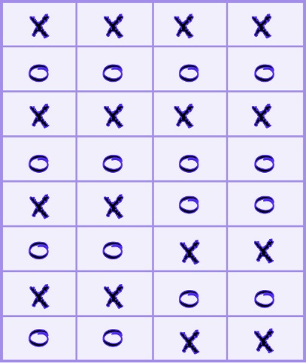 |  | 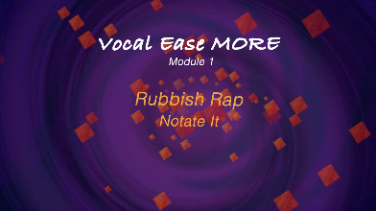  (1:31)
Add some rhythm – try adding in some long notes or short notes to your graphic notation score.
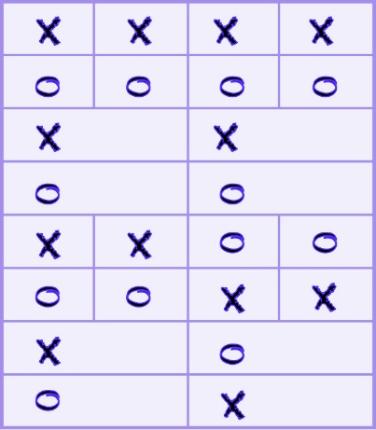
Change the rhythm – you could also try adding in some shorter notes or two sounds (quavers) on the one beat or even rests (no sound on a beat).
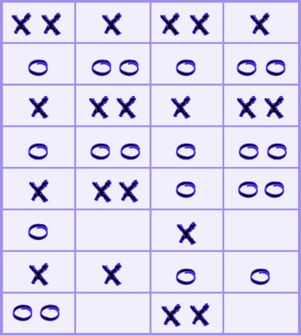
Arrange and notate – experiment with your own arrangements as above. This is also a perfect opportunity to introduce formal stick notation with colour coding for different instruments.
I = one sound on a beat
∏ = two sounds on a beat
Z = no sound on a beat
= two beats, 1 sound
The symbols above could become (X = green, O = red).
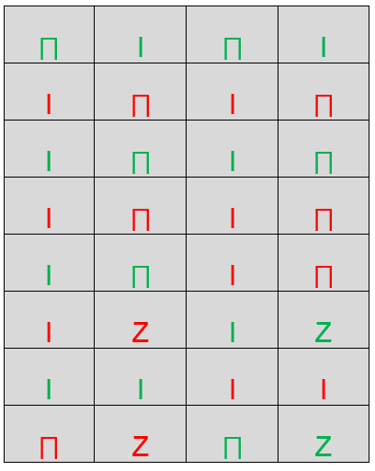

Arrange it

Outcomes and purpose

MUS2.1
MUS2.2
MUS2.3
MUS2.4
MUS3.1
MUS3.2
MUS3.3
MUS3.4
To explore the musical concepts through organising sound.
Using visual imagery as a stimulus for musical composition.
Creating a soundscape to represent visual images through sound.
Using graphic notation as a medium for symbolic representation of sound.

Learning experiences | Activities S2-S3 | Concepts of music | Watch the lesson
Explore timbre – use the instruments explored as accompaniments to create a soundscape. Set a theme in this case a rubbish theme or recycling as the basis of the composition. Tying this in with visual literacy is a natural link. There are numerous images available that could be used as stimulus. For example,
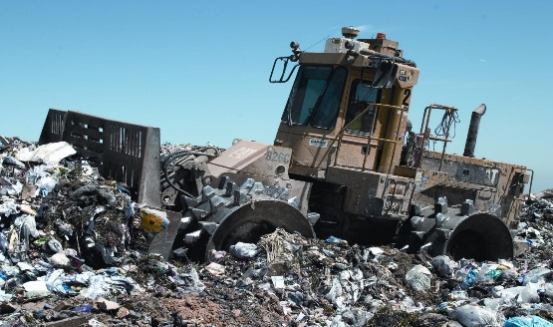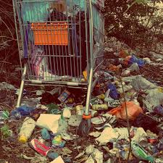
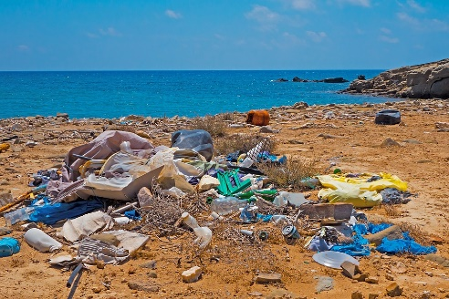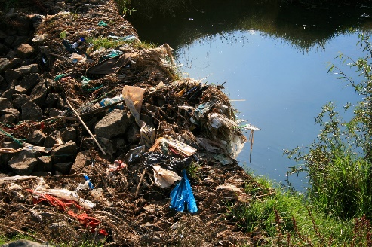
 | Create a soundscape – in groups student create soundscapes based upon the image they have examined. Explore the important aspects of the images then discuss in terms of musical concepts:  - Duration – how will you create a beat, what tempo, will there be an ostinato?  - Dynamics – will the dynamics be constant or change and what effect will this have?  - Pitch – will there be a melody and will there be a variety of pitches of instruments  - Timbre – which instruments will be used when and why?  - Structure – how will the soundscape be constructed? Will the parts enter together or layer in and out? Will everyone play the same thing? Refer to the Tuneful Trash video as a guide for using recycled materials.  Perform – record and/or perform for each other. Comment on the use of musical concepts in each group. Students can take on the role of a critic to discuss and analyse each group. |  | 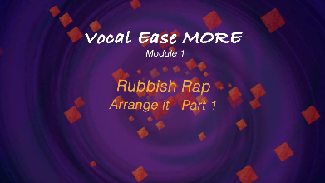  (2:51)  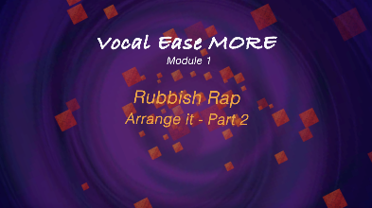  (3:26)  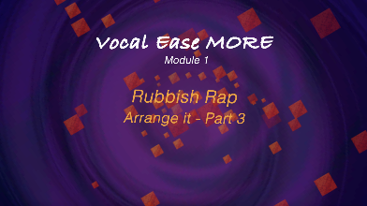  (1:50)
 | Notate – using graphic notation, each group can write down their soundscape using symbols. Students can explore their own ways of recording their soundscapes. As an experiment exchange instruments and graphic notation scores. How easily can they be replicated? Why?

Make it up

Outcomes and purpose

MUS2.1
MUS2.2
MUS3.1
MUS3.2
Counting beats and phrases.
Improvisation through call and response

Learning experiences | Activities S2-S3 | Concepts of music
Investigate – view and discuss the musical concepts explored by Australian percussion group Tetrafide. Particularly look and listen to their composition Stinkin’ Garbage (3:43). Repeat with that of Stomp London – Dustbin Lids (2:10).
Discuss the use of layers within these compositions. How are they constructed? How are they performed and what is the role of each musician? How are the different instrumental timbres put together?
 | Experiment – use beatboxing and layers of sound exploring apps such as Incredibox, Loopy HD or Mad Pad. Become familiar with these programs and the concepts they involve. Videos by groups such as Tempo also show this concept well. They demonstrate the role of the beat and accompaniment.
 | Create – choose a theme for the students to make their own raps. Decide on a number of beats per line (such as 4 as in the Rubbish Rap). Then discuss how many lines per verse (possibly 8), and how many verses? Will any verses be repeated? Create own raps either as a class or in separate groups.
 | Accompany – students can either use the accompaniment track or they can create their own using some of the techniques or technologies explored earlier. Experiment with preferred options.
 | Movement – add some form of movement or dance to the student arrangements such as hip-hop dance moves or simple hand gestures. Record or perform.

Where to from here?

Purpose
Using raps in a variety of situations to reinforce duration and other musical concepts.

Activities S2-S3
- Make up your own rap. Use the backing track provided or make your own using ostinatos.
- Explore graphic or stick notation with rhythm charts to reinforce beat, rhythm or to record a rhythmic ostinato to be used with any piece of music. Always check the metre (time signature) first though - remembering for a piece in 3 you will need three beats on your chart, not 4 for example.
- Use call and response as a technique for reinforcing rhythms of new songs.
- Improvise often to increase confidence and skill in this area.
- Create soundscapes based upon class topics. Link to visual literacy and other key learning areas as appropriate.
- Create graphic notation scores.

- What are the components that make up a rap and how do we create our own?
- Create your own instruments using only recycled materials either to help with the rap or for a variety of other purposes. Watch the Tuneful Trash video as stimulus.
- Explore the rubbish in your school. Using gloves, collate the numbers of types of rubbish left behind. For example, on a bar graph, represent the numbers of types of rubbish such as coffee cups, chip packets, bottles and so on.
- Is your school effectively dealing with rubbish and recycling? What could you do to support this?
- Repurpose recycled goods or rubbish to suit a need within your school or community. Explore the visual arts project Waste as Art for stimulus.
- Design an advertisement to sell your repurposed rubbish item or to support recycling in your school or community.
- Creative Arts: music – explore the role of music in society for conveying meaning. Explore other examples of songs and their purpose or meaning. Visual Arts - explore the Waste as Art project.
- HSIE: history – explore cause and effect. Look at cause and effect in the past and present with relation to rubbish, environmental change and the effects. Geography – explore place, space and environment. Examine how and why places should be looked after and the problems associated with rubbish. Investigate locations and features such as where to put waste in school, home and the community and places such as the tip and recycling stations.
- English - engage in speaking and listening by replicating rhythms and sound patterns in the rap. Explore writing and representing by manipulating the text to create own lyrics to a rap, as well as reading and viewing to understand and interpret the purpose and meaning of the text.
- Science and Technology – using technologies such as Garage Band to explore accompaniment and to record and manipulate sound.

