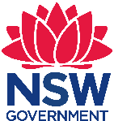 Stage 2 Geography, History, English –
Sydney Metro – Creating a website
Chullora Public School has approximately 300 students and caters to the needs of a low socioeconomic status and high non-English speaking background community. The school is organised into stage-based learning teams led by a dedicated and skilled executive team. Our students have diverse learning needs. As well as providing enrichment activities, the school has a comprehensive learning support program for students in need of additional assistance.

Sydney Metro – Creating a Website
Stage 2 – duration 8–10 weeks

Unit context
This unit was written by Joanna Huynh (Assistant Principal) of Chullora Public School.
It was created, trialled and peer reviewed as part of a professional development program in inquiry based learning for primary and secondary school teachers. The professional development courses were part of a pilot partnership between the NSW Government’s Sydney Metro transport agency and Western Sydney University. Facilitated by Western Sydney University’s Education Knowledge Network, the professional development program aimed to develop teacher expertise in inquiry based learning using a real-life example of a major infrastructure project in delivery stage.
The unit is aligned to © NSW Education Standards Authority (NESA) syllabuses specifically the Geography K-10 Syllabus 2015, History K-10 Syllabus 2012 and English K-10 Syllabus 2012. The unit was implemented as an open inquiry using the spiral of inquiry process (Temperley, Kaser and Halbert, 2014).
Sydney Metro is Australia’s biggest public transport project.

Syllabus links
General capabilities and cross-curriculum priorities | Outcomes | Skills | Concept
From the NSW Syllabus for the Australian Curriculum  - Information and communication technology  - Literacy  - Work and enterprise  - Sustainability  - Asia and Australia’s engagement with Asia  - Numeracy | By end of the unit, student/s will:  HT2-2 describes and explains how significant individuals, groups and events contributed to changes in the local community over time  GE2-1 examines features and characteristics of places and environments  GE2-2 describes the way people, places and environments interact  EN2-1A communicates in a range of informal and formal contexts by adopting a range of roles in group, classroom, school and community contexts (page 80)  - Interact effectively in groups or pairs, adopting a range of roles  EN2-2A plans, composes and reviews a range of texts that are more demanding in terms of topic, audience and language (page 82)  - Discuss aspects of planning prior to writing for example knowledge of topic, specific vocabulary and language features  - Plans and organise ideas using headings, graphic organisers, questions and mind maps  EN2-10C thinks imaginatively, creatively and interpretively about information, ideas and texts when responding to and composing texts  - Use visual representations, including those digitally produced, to represent ideas experience and information for different purposes and audiences  EN2-12E Recognises and uses an increasing range of strategies to reflect on their own and others' learning  - Discuss the roles and responsibilities when working as a member of a group and understand the benefits of working collaboratively with peers to achieve a goal  - Develop criteria for the successful completion of tasks | Student learn to:  HT2-5 applies skills of historical inquiry and communication.  Analysis and use of sources  - Locate relevant information from sources provided  Research  - Pose a range of questions about the past  - Plan an historical inquiry  Explanation and communication  - Develop texts, particularly narratives  - Use a range of communication forms (oral, written and digit)  GE2-4 acquires and communicates geographical information using geographical tools for inquiry  - examine and determine functional requirements to define a problem | Student learn about:  One important example of change and one important example of continuity over time in the local community, region or state/territory.  Students using a range of sources, describe and explain how and why one area, e.g. transport, work, education, entertainment and daily life, has changed or one that has remained the same in the local area, region or state/territory since colonial times.  Students investigate Australia’s neighbouring countries and their diverse characteristics for example comparison of the natural and human features of a city in Australia with a city in a neighbouring country.  Investigate the settlement patterns and demographic characteristics of places and the lives of the people who live there e.g. examination of the varying settlement patterns and demographics of places.
Geographical tools integrated into this unit: Maps (M) pictorial maps, large-scale maps, world map, globe, Fieldwork (F) observing, collecting and recording data, conducting surveys, Graphs and statistics (GS) tally charts, pictographs, data tables, column graphs, weather data, Spatial technologies (ST) virtual maps, satellite images, Visual representations (VR) photographs, illustrations, diagrams, story books, multimedia, web tools

Broad focus
How have trains changed over time and how can we work together to showcase our learning on a website for other students.

Generative questions
- How have trains changed over time?
- When was the first train introduced?
- Where is Bankstown station? Why is the location important?
- Where do trains stop and go?
- What do trains look like in the past and present?
- What types of trains are there overseas?
Teaching, learning and assessment | Resources and technology
Learning experience 1: Tuning in (to students – not just the topic!)  Collect pre-assessment of what students know about Sydney Metro by using a mind map.  Host a Sydney Metro themed ‘I wonder’ day i.e. a room of objects and experiences to prompt interest in the Sydney Metro. For example, organise discovery tables around the room that will stimulate interest. These discovery tables can include past and present photos of Sydney trains, toy figures of trains, maps of Sydney Metro network and/or old and current train tickets.  Have students explore around each discovery table. Whilst students are exploring, tune into what the students are thinking and feeling by asking using both guided and open inquiry questions about the Sydney Metro.  Refer to the tuning in questions on page 10 of this document (Kath Murdoch, 2019). For example,  - What are you noticing?  - What are you curious about?  - How is what you are thinking connected to…..’s thinking?  - Can you make a connection  Students record a question on Sydney Metro they are curious about on a speech bubble template.  Teachers use information from the ‘I wonder’ day to gather prior knowledge and early thinking – What I know, What I wonder?  After the ‘I wonder’ day analyse student responses by asking the following questions in your team.  - What are you curious about?  - Where to now?  - How can we address their needs and interests?  Note to teachers: Inquiry teachers constantly help their students connect the ‘new’ with the ‘known’ throughout the unit. | - Video/s to introduce Sydney Metro such as ‘Sydney Metro: FastTracking the Future education program an introduction for primary school students’ (Transport for NSW, 2019) (4 minutes 1 second)  - Stimulus to create curiosity  - Speech bubbles  - Photos
Learning experience 2: Finding out. Why do we need trains in Australia and Bankstown?  Ask students, ‘Why do we need trains?’  To prepare students to take on the role as researchers, brainstorm what is a fact and what is an opinion? Provide examples for students. A fact is information and an opinion is what you think and feel.  Create an anchor chart on the difference between fact and opinion with the class. Then look at useful websites and ask students, ‘What is a useful website and what is not a useful website?’  In pairs, students to research the topic and record their findings on an A3 paper.  Reflect back to the questions created during the ‘I wonder’ day. Students should use the Reflection, Engagement and Authentic | - Anchor chart  - A3 paper  - Laptops, iPads or other ICT  - Optional: A digital classroom tool like, Seesaw or Google Classroom

Teaching, learning and assessment | Resources and technology
Learning REAL Dimensions of Student Self-Assessment (Munns et al 2006 Munns & Martin 2005) to ask questions in order to stimulate deeper thinking and reflection questions.
Students can record their reflections using a digital classroom tool, like Seesaw or Google Classroom, and share their reflections with their peers.
Note to teachers: During an inquiry, students should experience the work of a researcher. Look back into syllabus documents to identify inquiry tools that relate to your KLAs, for example the Geographical Tools Continuum (Geography Syllabus, page 34) and History Skills Continuum (History Syllabus, page 21)
Learning experience 3: What is the need? (primary school student-friendly websites about Sydney Metro) and planning to resolve the need  Brainstorm ideas on how we can showcase our information and learning as a class.  Discuss the audience (other students, parents and the community), purpose (to give other students information) and the problem faced in previous learning experience (i.e. There are no primary school student-friendly websites about Sydney Metro).  Lead the conversation and develop the idea that the class is to design and create a website for other students, parents and the community.  Brainstorm and create roles that will assist in building a website. Students to form their groups based on student interest.  Roles  - Mapping crew  - Journalists  - Website builders  - Videographer  - Photographers  - Editor.  Students create and record their group rules and responsibilities on the website creation project on a poster. Students to present their roles and responsibilities of each group. As a class, provide two stars and a wish for their group rules.  Students reflect on this activity, using REAL questions to stimulate deeper thinking and reflection questions.  Students can record their reflections in a medium such as a book or using a digital classroom tool, like Seesaw or Google Classroom and share their reflections with their peers. | - Anchor chart  - A3 paper  - Optional: Laptops, iPads or other ICT  - Optional: A digital classroom tool, like Seesaw or Google Classroom

Teaching, learning and assessment | Resources and technology
Learning experience 4: Team logo creation  Recap on group roles and responsibilities.  Brainstorm what is a logo and the purpose of a logo?  Show examples of the variety of logos.  Each group to create a logo and create a draft copy on paper.  The final logo could be represented on paper, however if possible we encourage teachers using a digital art app like Pic.EDU or a site like Google My Drawings to create a digital version of their logo.  Present logo to the whole class.  Students reflect on this activity, using REAL questions to stimulate deeper thinking and reflection questions.  Students can record their reflections in a medium such as a book or using a digital classroom tool, like Seesaw or Google Classroom and share their reflections with their peers. | - Reflection questions  - Laptops, iPads or other ICT  - Optional: A digital classroom tool, like Seesaw or Google Classroom
Learning experience 5: Class working bee  Teacher to create a scaffold of the website for students who are curious to know this information. Prior to this lesson, students to brainstorm questions they are still wondering about  Create an anchor chart, ‘How to locate relevant information?’ (See student work samples on page 12 of this unit)  Teacher to set up classroom as a ‘working bee’ environment. Display questions of the students created during learning experience 1, allow students to add onto the questions.  Mapping crew  Students to navigate using digital map tool like Google ‘My Maps’ to explore their areas of interest. Research, ‘Where is Bankstown station?’ and use the different tools to explore the surrounding areas of Bankstown.  Journalists  Research on facts and appropriate information to answer questions created by the students.  For example, ‘What does a driver’s room look like?’  Website builders/designers  Students to create a criteria, ‘What do good websites have in common?’ Survey students around the room.  Videographer  Students to take photos and video recordings of students working using digital cameras, iPads or other ICT tool that can capture photos and videos.  Editor  Students to review work samples and correct grammar and punctuation. Editors give feedback to other peers using 2 stars and a wish.  Photographers  Students to view select and review photos of the past and present that help answer the inquiry question “How have trains changed over time?”  Students reflect on this activity, using REAL questions to stimulate deeper thinking and reflection questions.  Students can record their reflections in a medium such as a book or using a digital classroom tool, like Seesaw or Google Classroom, and share their reflections with their peers.  Note to teachers: This is where students have opportunities to take more personalised learning pathways – the emphasis here is on choice and differentiation. Students might find that their inquiry journey leads them into new and sometimes unexpected territory! | - Laptops, iPads, digital cameras or other ICT  - Prior to lesson, the teacher needs to set up groups in a digital classroom tool, for example Google Classroom, with a work folder created for each group  - Reflection question  - Group rules of each group  - Templates to support each group  - Optional: Seesaw app or other platform for sharing information
Learning experience 6: Making meaning  Create an anchor chart on, ‘How to ask deeper questions?’ using thick and thin questions. Refer back to, ‘How to locate relevant information?’ anchor chart.  As a group, students read and discuss feedback from teacher and decide how to implement the feedback into their inquiry research task.  Students selected to plan and create a script/video with the purpose of informing the audience about Sydney Metro using the green screen (see student work sample of their video they created with the green screen). Students to create an informative text on Sydney Metro.  Students reflect on this activity, using REAL questions to stimulate deeper thinking and reflection questions.  Students can record their reflections in a medium such as a book or using a digital classroom tool, like Seesaw or Google Classroom, and share their reflections with their peers.  Note to teachers: ‘Meaning making’ involves organising, analysing and communicating information gathered using a range of learning areas. You might need to model for students how to ‘loop back’ to things they already know and identify and ask questions about new things they discover. | - Anchor charts  - Optional: Laptops, iPads or other ICT  - Optional: A digital classroom tool, like Seesaw or Google Classroom
Learning experience 7: Inquiry continuation  Students continue their research task.  Website builders/designers to create success criteria of what the website should look like and introduce the idea to the class and add on feedback, before their group starts to construct their website in the next learning experience.  Students reflect on this activity, using REAL questions to stimulate deeper thinking and reflection questions.  Students can record their reflections in a medium such as a book or using a digital classroom tool, like Seesaw or Google Classroom, and share their reflections with their peers. | - Reflection questions  - Optional: Laptops, iPads or other ICT  - Optional: A digital classroom tool, like Seesaw or Google Classroom  - Laptops  - Reflection questions  - Seesaw app or other platform for sharing information
Learning experience 8: Finalising the website  Students collaborate to complete the website. Editors to correct punctuation, grammar, tense etc. There are many websites that allow K-6 students to create their own websites, for example Google Sites or Weebly.  Students reflect on this activity, using REAL questions to stimulate deeper thinking and reflection questions.  Students can record their reflections in a medium such as a book or using a digital classroom tool, like Seesaw or Google Classroom, and share their reflections with their peers.  Student work samples of the website is at Sydney Metro | - Prior to lesson, teacher should ensure that students can access the website creator site, and that any student accounts are already set up  - Reflection questions  - Laptops, iPads or other ICT  - Optional: A digital classroom tool, like Seesaw or Google Classroom  - Laptops  - Reflection questions  - Seesaw app or other platform for sharing information
Learning experience 9: Concluding and acting  Revisit the generative question.  Review the mind maps made at the beginning of the unit.  Reflect: what have we learned? How has our thinking changed? What can we do with this learning? Is there an action that seems important to undertake?  Hold a Sydney Metro showcase to celebrate the learning and have students present their final work to other classes and the principal. | - Reflection questions  - Optional: Laptops, iPads or other ICT  - Optional: A digital classroom tool, like Seesaw or Google Classroom  - Laptops  - Reflection questions  - Seesaw app or other platform for sharing information

Assessment
- Formative pre-assessment – What do you know about Sydney Metro? What are you wondering about?
- Post-assessment – Use or modify the assessment rubric below and prompt students with the questions below:
- How have trains changed over time?
- When was the first train introduced?
- Where is Bankstown station? Why is the location important?
- Where do trains stop and go?
- What do trains look like in the past and present?
- What types of trains are there overseas?

Assessment rubric
Question | Below | At | Above
How have trains changed over time? Give examples. | Student cannot describe how trains have changed overtime. | Student gives a brief description on how trains have changed overtime and gives an example. | Student gives a description and examples.
Describe and compare the trains of a city in Australia with a city in a neighbouring country? | Student cannot describe the trains of a city in Australia with a neighbouring city. | Student identifies a neighbouring country and is able to describe and compare the trains of a city in Australia with a city a neighbouring country. | Student describes and compares a few features of the trains of a city in Australia with a city a neighbouring country.
Describe the lives of the people who live near a station. How does a train station benefit the area? | Student cannot describe the benefits of a train station. | Student describes the benefits of a train station. | Student describes the benefits of a train station and gives examples.

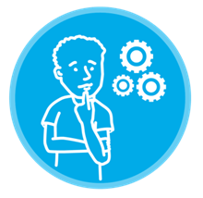

Tuning in
Questions and prompts to help students reveal their thinking
We began by tuning in to our thinking….
We wondered….
We needed to investigate, so we….
That’s interesting, keep going/tell us more
- What are you noticing?
- What makes you say that?
- How is what you are thinking connected to…..’s thinking?
- Can you make a connection?
- What else is like this?
- What puzzles you about this?
- Might there be another way of thinking about this?
- What did you notice about yourself/your thinking when you said/did/heard that?
- So what has helped you decide that? What evidence do you have for that idea?
- Which part is making sense?
- Which part is still confusing?
- What are you wondering?
- What are you planning to do/do next?
- Is there something else you would like to tell us about this?
- Is your thinking changing? How? (I used to think…now I think)
- How could you use this again?
- Where/when have you done this kind of thinking/learning before?
- What’s the most important part of this?

Student work samples and photographs from the unit

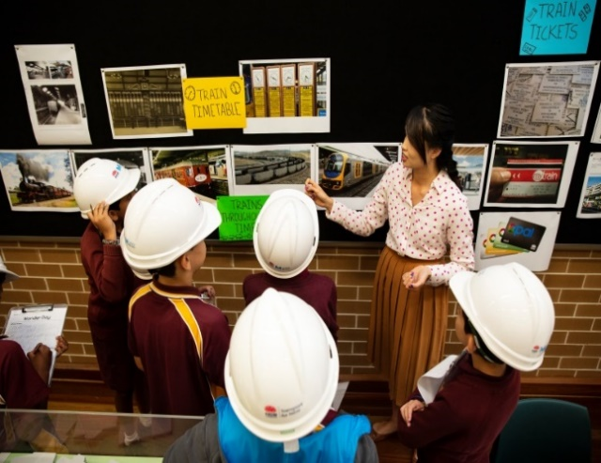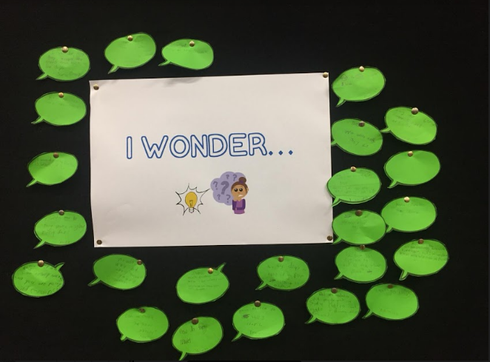
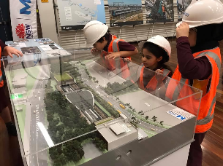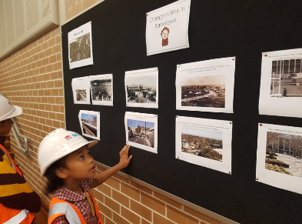
Bottom left and right: Some of the members of the class at the ‘I wonder’ day
Bottom left: An example of the team logo design
Top right: Students recorded their inquiry questions about Sydney Metro and train transport through time on an interactive wall.
Top left: Some of the class members at the ‘I wonder’ day. Copyright of this image is vested in the Crown in right of Transport for NSW, subject to the Copyright Act 1968. This material is protected by copyright but may be reproduced without formal permission or charge for personal, in-house or non-commercial use. No part may be reproduced or reused for any commercial purposes whatsoever without written permission of: Sydney Metro (PO Box 588, North Ryde BC NSW 1670).
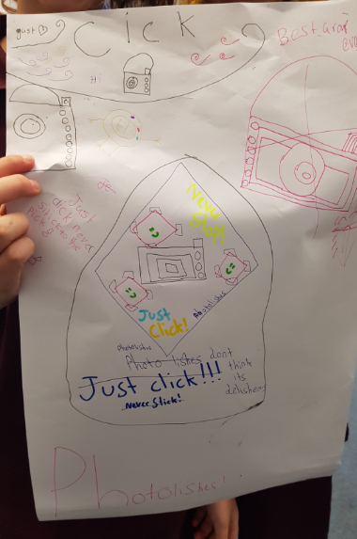
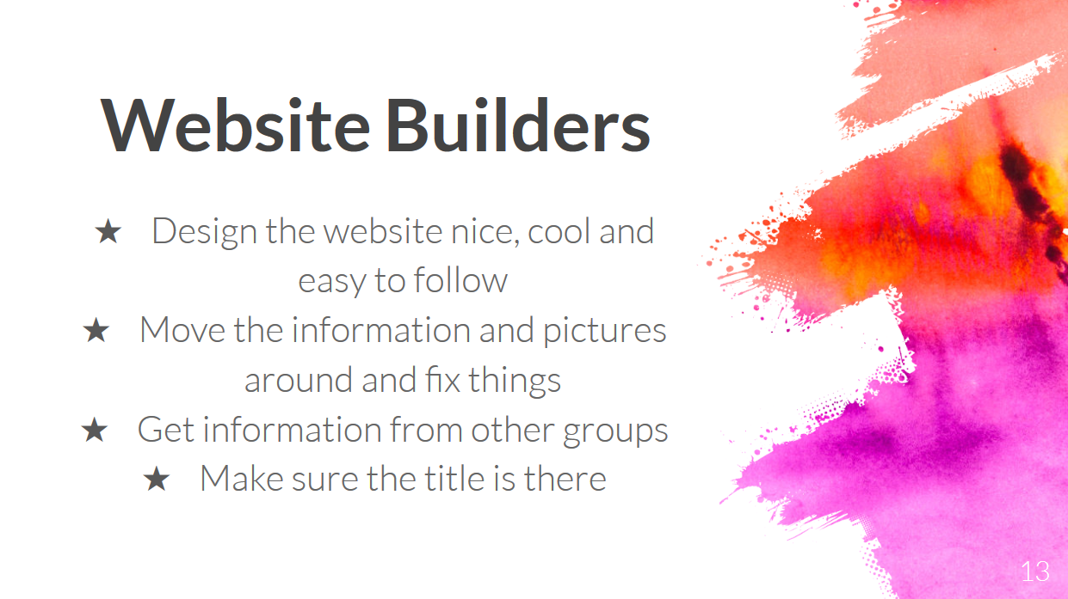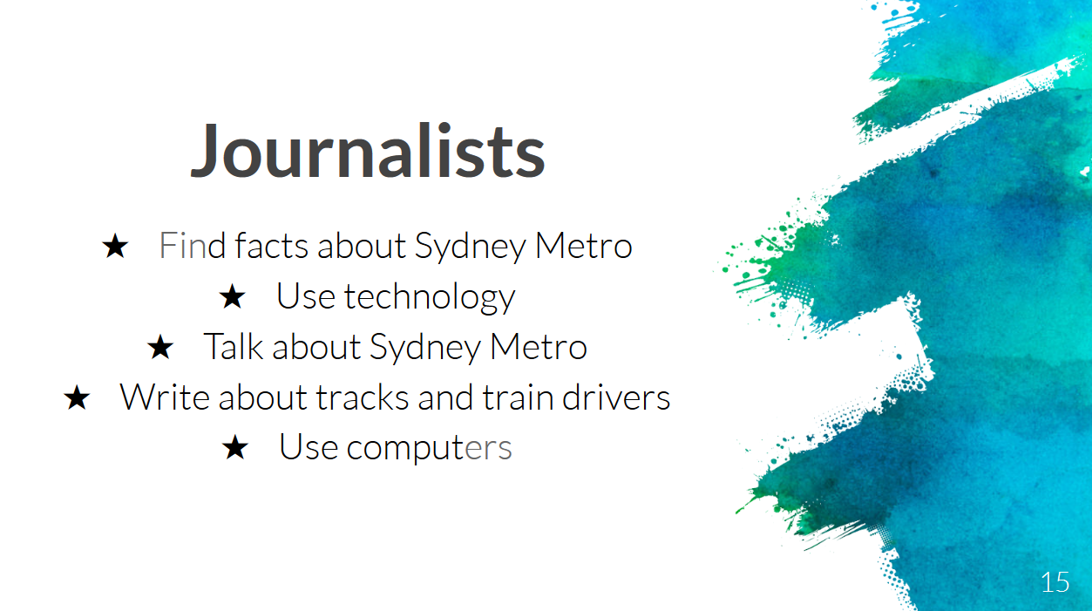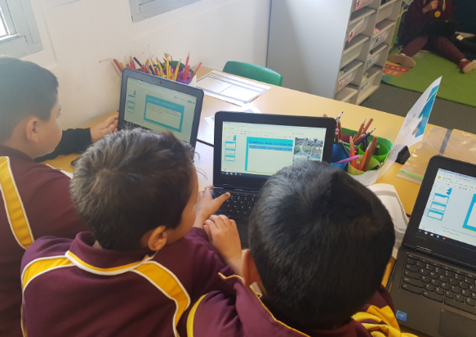
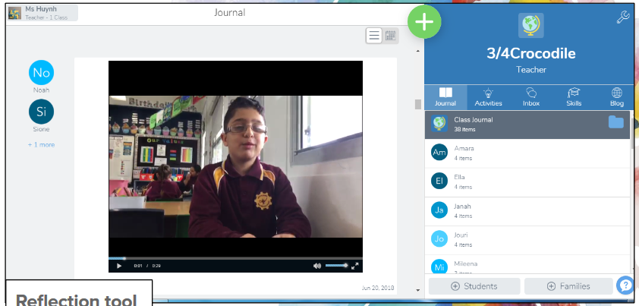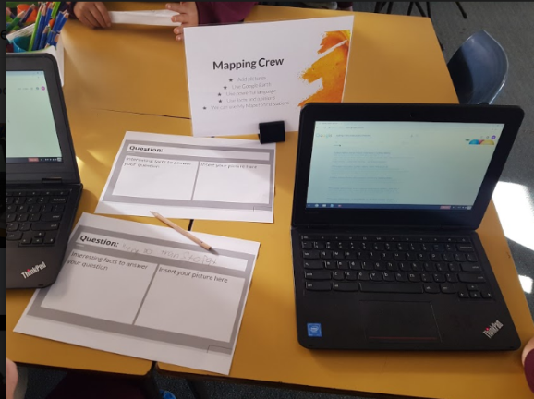
Top left and top centre: Some of the roles and responsibilities that were developed in learning experience 3
Top right: Student teams creating their website
Centre left: Seesaw app used by students to record their learning reflections
Bottom left: Anchor chart created by students in learning experience 2
Bottom right: Mapping crew planning their inquiry

Copyright
© State of New South Wales (Department of Education), 2019
The copyright material in this publication is subject to the Copyright Act 1968 (Cth), and is owned by the NSW Department of Education or, where indicated, by a party other than the NSW Department of Education. Copyright material which is owned by the NSW Department of Education is licensed under a Creative Commons Attribution 4.0 International (CC BY 4.0) licence
This licence allows you to:
- share – copy and redistribute the material in any medium or format
- adapt – remix, transform and build upon the material for any purpose, even commercially
Attribution should be given to:
© State of New South Wales (Department of Education), 2019.
Material in this publication not available under a Creative Commons licence includes:
- the Department of Education logo, other logos and trademark-protected material
- material owned by a third party that has been reproduced with permission. Permission will need to be obtained from the third party to re-use this material.
If this publication contains your work and you have any objection to such content, please contact legal@det.nsw.edu.au.

Links to third-party websites
If you use the links provided in this publication to access a third party’s website, you acknowledge that the terms of use, including licence terms set out on the third party’s website apply to the use which may be made of the materials on that third party’s website or where permitted by the Copyright Act 1968 (Cth).
The department accepts no responsibility for content on third-party websites.

H Temperey, L Kaser, J Halbert, A framework for transforming learning in schools: Innovation and the spiral of inquiry, Centre for Strategic Education, Seminar Series Paper No. 234, April 2014
Our school approached Sydney Metro to assist us with resources for the ‘I wonder’ day. A short video of the day is at youtu.be/ZznfE3po3uE (Transport for NSW, 2019) (2 minutes 37 seconds)
‘Sydney Metro: FastTracking the Future education program an introduction for primary school students’ (Transport for NSW, 2019) (4 minutes 1 second): https://youtu.be/G-nET2o1av4
G Munns, 2006, Student Engagement and Student Self-assessment: The REAL Framework. https://pdfs.semanticscholar.org/b8a5/c8ae1b209875811f77bcedeeed3d4a05d2bb.pdf
Two Stars and a Wish is a formative assessment technique designed to provide student feedback via both peer and self-assessment. Students are allowed two stars to allocate to areas where they have excelled and one wish to apply to an area where they identify that there can be improvement
Thin questions according to Webb’s Depth of Knowledge depend on recall and reproduction typically beginning with who, what, where and when. Thick questions encourage higher order thinking typically beginning with how and why. Thick questions require research and typically have longer answers
Student work sample of their video they created with the green screen https://drive.google.com/a/education.nsw.gov.au/file/d/1sXARTp4n0cTjW30FD12FvoPejttAqXhH/view?usp=sharing
Student work samples of the website is at Sydney Metro https://sites.google.com/education.nsw.gov.au/sydneymetro/home

