Tips for completing the NCCD

Prior to 21 July in ERN Disability Adjustments

In the column “DDA Disability”:
Use the sort arrow to identify all students who have a “no” response to the question: “Does the student have a disability under the DDA?”. A no response in this column will exclude students from the data collection.
For students to be included in the NCCD and the work of the school recognised, the school team must determine that a student meets the broad definition of disability under the DDA. They must be able to answer “yes” to the question in ERN, “Does the student have a disability under the DDA?”. This applies to students included in each of the four levels of adjustment in the NCCD model, including the category “support provided within quality differentiated teaching” (QDTP).
Students with disability, as defined under the DDA and the Standards, are in all school settings, including regular schools, special schools, and specialist support classes located in regular schools. They include:
- students who may not have a formal disability diagnosis but have impairment that requires an adjustment or can be supported through quality differentiated teaching
- students who have formally diagnosed disability by a health or allied health practitioner
- students with intellectual, physical, sensory and social/emotional disability as well as students with difficulties in learning or behaviour due to disability
- students who are gifted and talented and who are impacted by disability.
Having a Disability Confirmation or a clinical disability diagnosis is not a condition or requirement to be included in the national data collection, although many students will have one or both of these. Students with a disability confirmation who are receiving targeted, specialist support (Integration Funding Support or placement in a support class) are only a subset of those students who may be included in the NCCD. For this reason, it is important for schools to have processes in place to identify whether the student who is receiving an adjustment meets the DDA definition of disability and the school’s obligations under the Standards.

In the column “NCCD info provided to parents”:
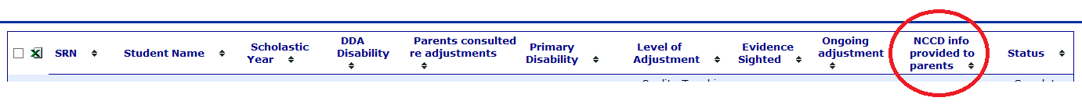
Use the sort arrow to identify any no responses. A no response in this column will exclude students from the NCCD.
While consent arrangements are no longer applicable, parents and students must have information about the national disability data collection made available to them. This may be done through the school newsletter or the school website with links to relevant fact sheets.

In the column “Status”:
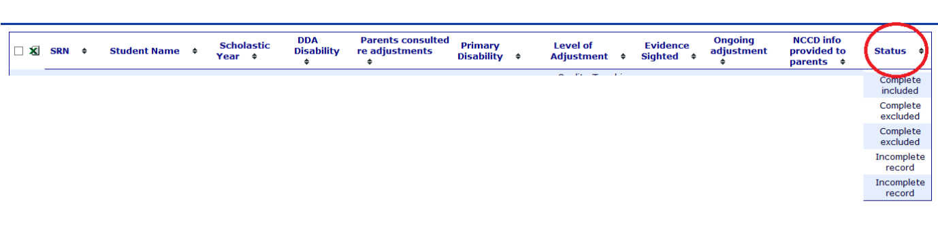
Use the sort arrow to check for any students with incomplete records. Once all student data is complete use the sort arrow to identify students whose data status is complete excluded. Review the data on these students to ensure that this is the intended response.

24 July – 4 August in the online data collection website

Validation stage
In the online data collection website select the link to the nationally consistent collection of data on school students with disability.
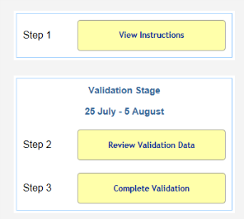
Select Step 2, Review validation data. School NCCD information will be displayed in two tables, students included in the NCCD and students excluded. Schools with large numbers of students identified might need to scroll down the page to reveal the students excluded table.
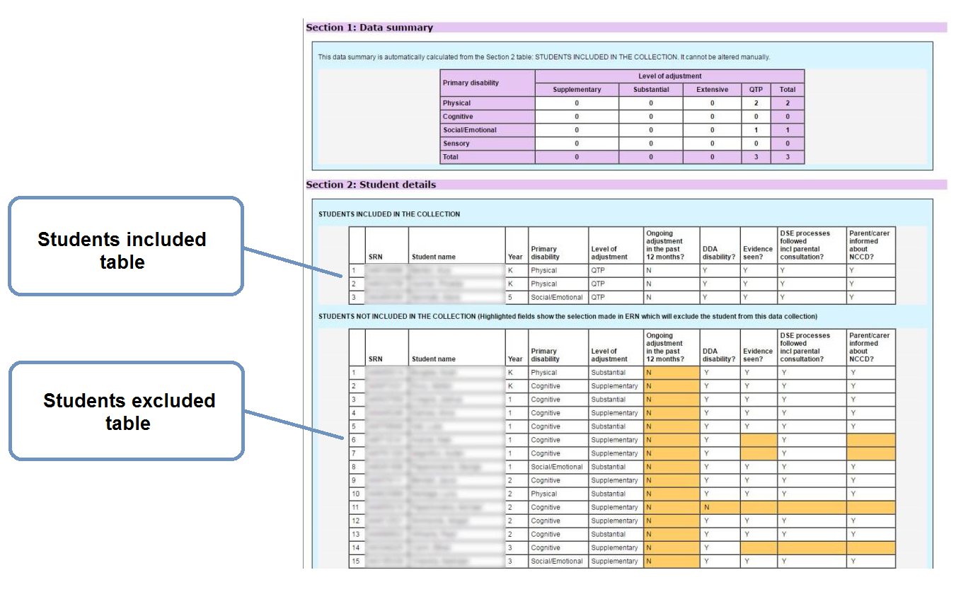
Highlighted cells in the students excluded table specify where the school’s judgements have resulted in a student being excluded. Schools should take note of the exclusions then move to Step 3, Complete validation.

Step 3 indicates to the Statistics Unit that the data has been checked. Schools with a nil return should make a statement in the comment box that the absence of data represents a nil return.
After completion of steps 2 and 3, schools should return to ERN Disability adjustment and make the necessary amendments as specified by the highlighted cells in the online data collection list. This must be done before the census harvest on Friday 4 August.

7 August – 18 August in the online data collections website

Census stage
This important stage produces the school’s official record for the 2017 NCCD.
In the online data collection website select the link to the nationally consistent collection of data on school students with disability.
Select Step 2, Review census data. School NCCD data amended during the validation stage will be displayed in two tables, students included in the NCCD and students excluded. Again the highlighted cells specify where the school’s judgements have resulted in a student being excluded.
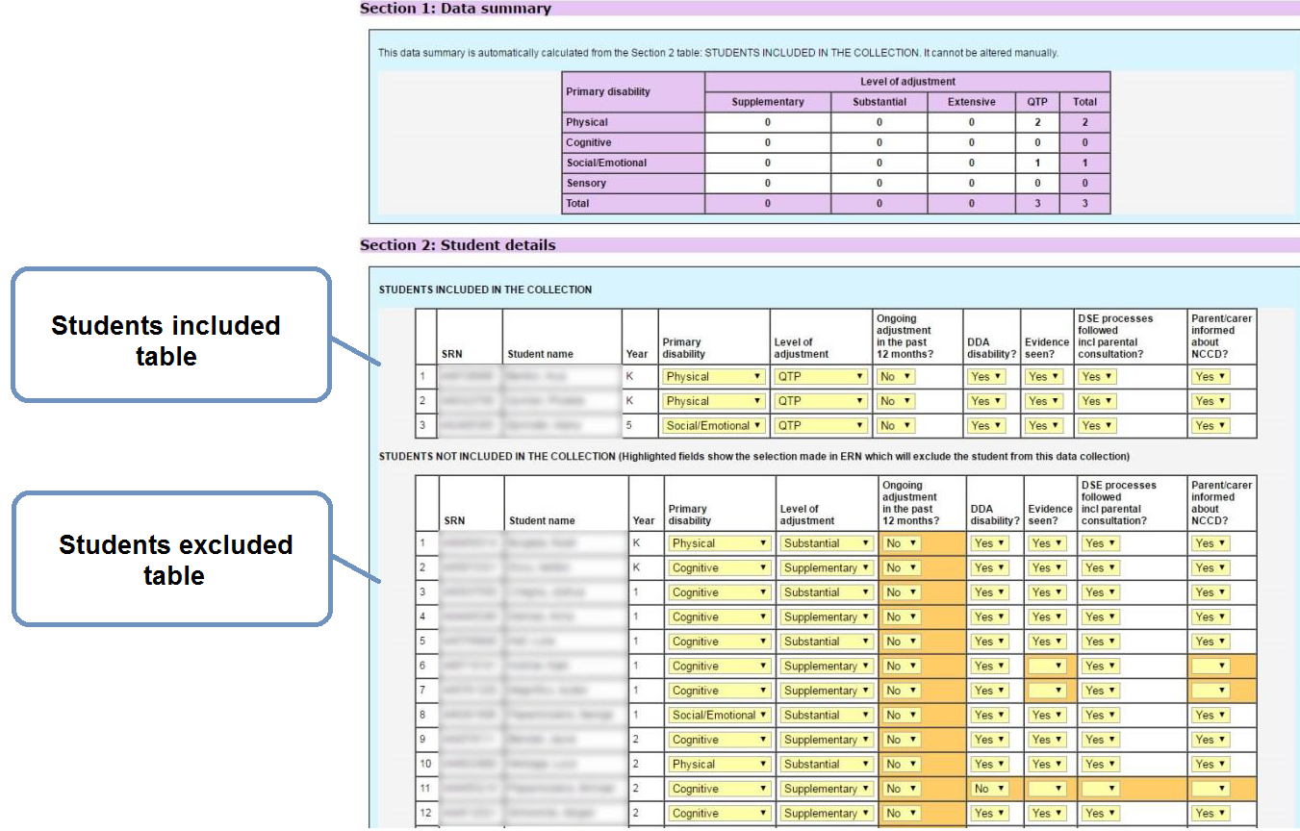
Additional students cannot be added to the list at this stage, however, students can be moved from the excluded table to the included table, and vice versa, by selecting the drop down menu arrows embedded in the table to amend the school’s judgements. Once the judgements satisfy the NCCD criteria and the information is saved the student will automatically move into the desired table.
When the data is accurate, select Step 3, Sign off census. The principal signs off on the data to produce the official 2017 NCCD record. A copy of the data and the sign off should be made for school records.

