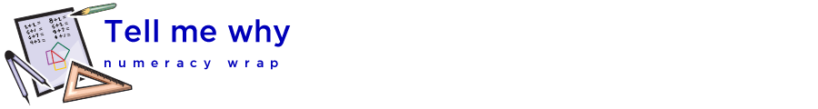

## Teaching notes

This numeracy wrap addresses the following syllabus outcomes from the NSW K-10 Mathematics Syllabus 2012, © NSW Education Standards Authority, NSW:

MA5.2-1WM selects appropriate notations and conventions to communicate mathematical ideas and solutions

MA5.2-3WM constructs arguments to prove and justify results

MA5.2-14MG Uses formulae to calculate the area of quadrilaterals and finds areas and perimeters of simple composite figures

Students will:

* Apply logical reasoning, including the use of congruence and similarity, to proofs and numerical exercises involving plane shapes
  + apply geometrical facts, properties and relationships to find the sizes of unknown sides and angles of plane shapes in diagrams, providing appropriate reasons
  + apply the result for the interior angle sum of a triangle to find, by dissection, the interior angle sum of polygons with more than three sides
    - use dynamic geometry software to investigate the interior angle sum of different polygons

|  |  |
| --- | --- |
|  | The first GeoGebra applet rounds each angle to the nearest whole number. This means that occasionally the numbers appearing in the sum are not correct. |

|  |  |
| --- | --- |
|  | 1. The applet that students create shows the mathematical working for finding a missing angle. This applet could be part of the students’ electronic mathematics notes, as an alternative to copying a static diagram from the blackboard. |

|  |  |
| --- | --- |
|  | [The Geometer’s Warehouse](https://app.education.nsw.gov.au/rap/resource/access/cb02edfa-eb1d-43e7-b913-08e55cdb3435/1) comprises 70 dynamic html worksheets, each exploring a different outcome in Stage 4 and Stage 5 geometry. A unique characteristic of the resource is that when screen figures are dragged, angle and length measurements are updated automatically, allowing students to recognise and explore invariant properties. |