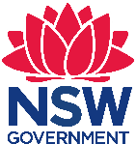 Stage 3 Geography, Science and Technology –
Sydney Metro – A 3D design focused inquiry
Artarmon Public School is situated on the lower North Shore, opened in 1910.There are approximately 1200 students enrolled from Kindergarten to Year 6. Students come from diverse language backgrounds with over 80% from language backgrounds other than English. There are many cultures represented within the school community.
Artarmon Public School has a reputation for excellence in academic achievement and is also a centre for four opportunity classes. It provides a rich educational experience for students K–6, with particular emphasis on curriculum differentiation, effective integration of information communication technologies and a strong creative arts program.

Sydney Metro – A 3D design focused inquiry
Stage 3 – duration 7 weeks (1 hour per week)

Unit context
This unit was written by Sally Lee of Artarmon Public School.
It was created, trialled and peer reviewed as part of professional development in inquiry-based learning for primary and secondary school teachers. The professional development courses were part of a pilot partnership between the NSW Government’s Sydney Metro transport agency and Western Sydney University’s Education Knowledge Network. The professional development program aimed to develop teacher expertise in inquiry-based learning using a real-life example of a major transport infrastructure project in delivery stage.
The unit is aligned to © NSW Education Standards Authority (NESA) syllabuses, specifically the Science and Technology K-6 Syllabus (2017) and the Geography K-10 Syllabus (2015). The unit was implemented primarily as a skills driven program embedded in geographical concepts, in order to develop the skills required for inquiry learning.
The unit was run as part of Artarmon Academy whereby students select specialist subjects for one hour a week over seven weeks.
Sydney Metro is Australia’s biggest public transport project.

Syllabus links
Curriculum links will change according to the direction of the student inquiry and may include the following:
General capabilities and cross-curriculum priorities | Outcomes | Skills | Concept
OI.7 Actions for a more sustainable future reflect values of care, respect and responsibility, and require us to explore and understand environments.  OI.8 Designing action for sustainability requires an evaluation of past practices, the assessment of scientific and technological developments, and balanced judgements based on projected future economic, social and environmental impacts.  OI.9 Sustainable futures result from actions designed to preserve and/or restore the quality and uniqueness of environments.  Reasoning in decision-making and actions discuss actions taken in a range of contexts that include an ethical dimension  Students consider the consequences of and reflect on ethical action. They analyse the reasoning behind stances when making ethical decisions and evaluate the intended and unintended consequences of actions in an increasing range of scenarios. Students articulate understandings of a range of ethical responses in social contexts. In developing and acting with ethical understanding, students: reason and make ethical decisions. | In this unit a student:  Science and Technology  ST3-2DP-T plans and uses materials, tools and equipment to develop solutions for a need or opportunity  Geography  GE3-3 compares and contrasts influences on the management of places and environments | Student learn to:  Identifying and defining  ACTDEO024  - examine and critique needs, opportunities or modifications using a range of criteria to define a project  - define a need or opportunity according to functional and aesthetic criteria  - consider availability and sustainability of resources when defining design needs and opportunities  - investigate materials, components, tools, techniques and processes required to achieve intended design solutions  ACTDIP017  - examine and determine functional requirements to define a problem  Communicating  ACSIS093, ACSIS110  - communicate ideas, explanations and processes, using scientific representations including multimodal forms | Student learn:  Geography  - Geographical inquiry skills  - Humans shape places  Science and technology  - Systems in built environments are designed to meet the needs of people  - Social and environmental factors influence the design of built environments.

Content | Teaching, learning and assessment | Resources and technology
Humans shape places  - Students: investigate how people influence places, for example ACHGK029 identification of ways people influence places and contribute to sustainability, for example, roads and services, building development applications, local sustainability initiatives. | - Orientation: Students will be introduced to the Sydney Metro project by a member of the Sydney Metro education team.  - Clarification: Students will summarise/categorise the information they have gathered.  - Conceptualisation: Students will be encouraged to 'wonder' about different aspects of the project and to become aware of the angle of inquiry that most intrigues them.  - Investigation: Students will research their line of inquiry through use of Internet, materials from the project and their own data collection/interpretation.  - Design/conclusion: Students will design a relevant and curiosity-driven product that addresses their inquiry question. (Possible options for design platform include: Minecraft: Education Edition, Google Sketchup, physical 3D modelling, technical drawing). | Access to an interactive white board for the Sydney Metro education team presentation  (Optional) iPads for research  (Optional) Access to Minecraft: Education Edition for each student to download onto school computers, BYOD computers or iPads. NSW Department of Education can learn more about Minecraft: Education Edition and request free licences for any students from the following link: https://education.nsw.gov.au/itd/guides-and-forms/technology-for-school-users/learning-and-collaboration-tools/minecraft-education-edition  (requires NSW DoE login to access)  Sticky notes for categorising information

Assessment
Success criteria | Novice:  You are just beginning to learn this skill. | Apprentice:  You are starting to get it and can demonstrate skills or behaviours most of the time. | Practitioner:  You’ve got it.  You have demonstrated skills or behaviours and are on track | Expert:  You accomplished more than expected on these skills and behaviours. | How this unit will be assessed
Examine and critique needs, opportunities or modifications using a range of criteria to define a project |  |  |  |  | Observation/questioning during conceptualisation phase  Feedback, together with evidence, to help teachers and students decide whether students are ready for the next phase of learning or whether they need further experiences to consolidate their knowledge, understanding and skills.
Define a need or opportunity according to functional and aesthetic criteria |  |  |  |  | Observation/questioning during conceptualisation phase.
Consider the availability and sustainability of resources when defining design needs and opportunities |  |  |  |  | Observation/questioning during investigation phase.
Investigate materials, components, tools, techniques and processes required to achieve intended design solutions |  |  |  |  | Observation/questioning during investigation phase.
Examine and determine functional requirements to define a problem |  |  |  |  | Observation/questioning during investigation phase.
Students investigate how people influence places, for example: identification of ways people influence places and contribute to sustainability, such as roads and services, building development applications, local sustainability initiatives. |  |  |  |  | Observation/questioning during investigation phase.
Plans and uses materials, tools and equipment to develop solutions for a need or opportunity. |  |  |  |  | Peer review –Two stars and a wish  During final presentation of product, students identify two positive aspects of the work of a peer and then express a wish about what the peer might do next time in order to improve another aspect of the work.  Summative assessment of final presentation of product.
Communicate ideas, explanations and processes, using scientific representations including multimodal forms. |  |  |  |  | Summative assessment of final presentation of product.

Student work samples and photographs from the unit

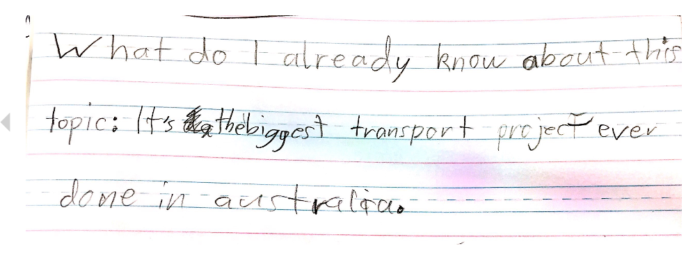
A work sample showing students recalling what they already knew about Sydney Metro at the start of the project.
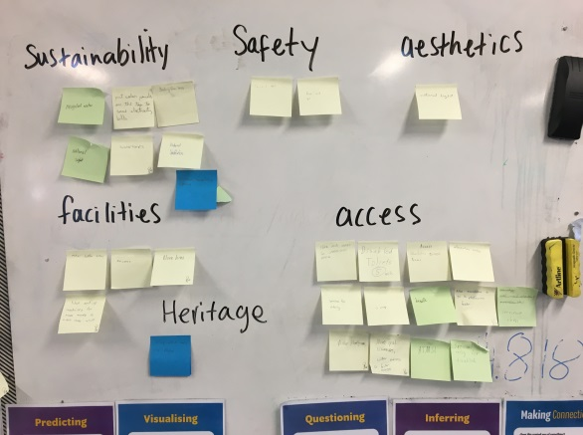
A class brainstorm of considerations when building a station are categorised to come up with some key ideas in order to focus students’ thinking and questioning.
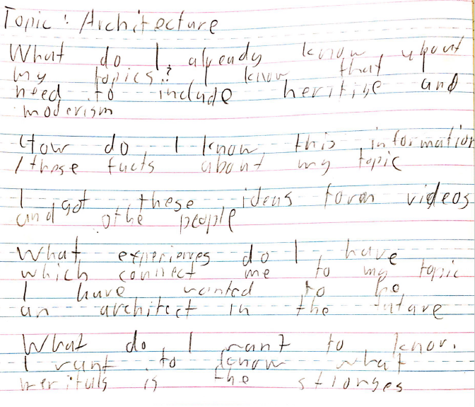 A student ‘wonders’ about his line of inquiry in response to some leading questions.

Student work samples and photographs from the unit
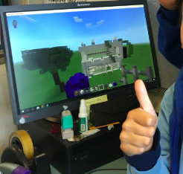
Students applying their research to build their design adhering to their ‘aesthetics’ line of inquiry.
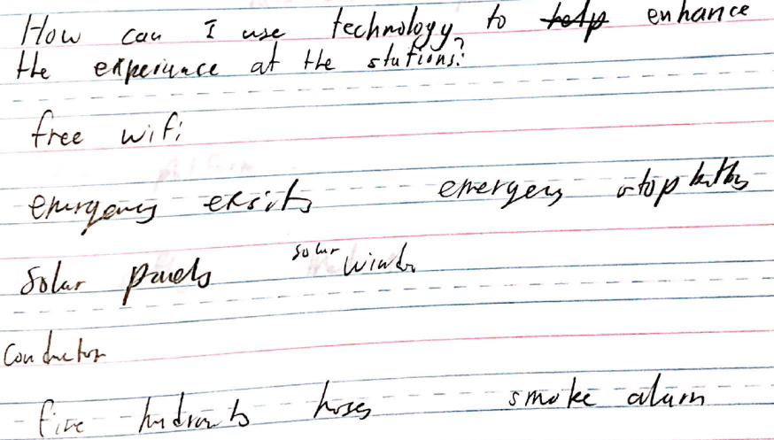
A student investigates some ideas of how technology can enhance his station.

Copyright
© State of New South Wales (Department of Education), 2019
The copyright material in this publication is subject to the Copyright Act 1968 (Cth), and is owned by the NSW Department of Education or, where indicated, by a party other than the NSW Department of Education. Copyright material which is owned by the NSW Department of Education is licensed under a Creative Commons Attribution 4.0 International (CC BY 4.0) licence
This licence allows you to:
- share – copy and redistribute the material in any medium or format
- adapt – remix, transform and build upon the material for any purpose, even commercially.
Attribution should be given to:
© State of New South Wales (Department of Education), 2019.
Material in this publication not available under a Creative Commons licence includes:
- the Department of Education logo, other logos and trademark-protected material
- material owned by a third party that has been reproduced with permission. Permission will need to be obtained from the third party to re-use this material.
If this publication contains your work and you have any objection to such content, please contact legal@det.nsw.edu.au.

Links to third-party websites
If you use the links provided in this publication to access a third party’s website, you acknowledge that the terms of use, including licence terms set out on the third party’s website apply to the use which may be made of the materials on that third party’s website or where permitted by the Copyright Act 1968 (Cth).
The department accepts no responsibility for content on third-party websites.

