Assessment Task – Financial Mathematics

Year 11 Mathematics Standard – Money Matters

Personal Financial Inquiry
This document references the Mathematics Standard Stage 6 Syllabus © 2017 NSW Education Standards Authority (NESA) for and on behalf of the Crown in right of the State of New South Wales.
Assessment type: Assignment or investigation style task
Stage 6
Due Date:

Outcomes
A student:
- MS11-2 Represents information in symbolic, graphical and tabular form
- MS11-5 Models relevant financial situations using appropriate tools
- MS11-6 Makes predictions about everyday situations based on simple mathematical models
- MS11-9 Uses appropriate technology to investigate, organise and interpret information in a range of contexts
- MS11-10 Justifies a response to a given problem using appropriate mathematical terminology and/or calculations
- MSF1.1 Interest and depreciation
- MSF1.2 Earning and managing money
- MSF1.3 Budgeting and household expenses

Learning across the curriculum

Cross-curriculum priorities
☐ Aboriginal and Torres Strait Islander histories and cultures
☐ Asia and Australia's engagement with Asia
☐ Sustainability

General capabilities
✓ Critical and creative thinking
☐ Ethical understanding
✓ Information and communication technology capability
☐ Intercultural understanding
✓ Literacy
✓ Numeracy
✓ Personal and social capability

Other areas of learning
☐ Civics and citizenship
☐ Difference and diversity
✓ Work and enterprise

Task
As part of this activity you will need to choose a full-time occupation. You will need to decide on an appropriate level of income for this occupation and use this information in both Part A and Part B of this assessment.

Part A: Earning and managing money
- Go to the Job Outlook website (http://joboutlook.gov.au/careerquiz.aspx) and complete the questionnaire. Use the results of this questionnaire to help you choose a suitable occupation. At this point you may do further research to assist in your choice.
Write a short paragraph justifying your chosen occupation. You need to include a print screen of the survey results.
- Decide on an appropriate wage or salary for your chosen occupation. You will need to convert this amount to an annual income if it is not already given. Note that your annual income needs to be between $40,000 and $130,000. Your yearly income needs to be based on some provided evidence.
Websites to assist in finding the salary/wage include:
  - Fair Work Ombudsman: https://calculate.fairwork.gov.au/FindYourAward
  - Seek: www.seek.com.au
  - CareerOne: www.careerone.com.au
  - Job Search: www.jobsearch.gov.au
  - I Work For NSW: www.iworkfor.nsw.gov.au
- Does your calculated/provided annual income include compulsory government superannuation? Provide evidence from the source used to ascertain your yearly income.
- Using your yearly income, calculate your fortnightly PAYG, assuming that employer takes out 30% of your gross fortnightly pay (excluding compulsory government superannuation).
- Research the allowable deductions for your chosen occupation. These may include travel expenses, special clothing, tools of trade, books, journals, attendance at conferences, home office expenses and self-education expenses. Choose at least 3 allowable deductions and choose a realistic value for these (convert regular costs to yearly amounts).
The Australian Tax Office (ATO) website can help you find out more information on income and deductions (https://www.ato.gov.au/Individuals/Income-and-deductions).
- Calculate the annual Medicare levy (https://www.ato.gov.au/Individuals/Medicare-levy) based using the taxable income. Note the taxable income needs to exclude allowable deductions.
- Choose an additional form of income that you have received during the year. For example, it could be earnings on a bank account, dividends received through shares, or money received from a part-time job. You need to decide on the amount of this income and provide details supporting this payment.
- Complete the tax return form provided: ATO Tax Return For Individuals (https://drive.google.com/open?id=0Bw3oraSrb8i-c3AzcG9FWENjTUU).
Complete details in all highlighted sections. Income tax payable needs to be calculated using the tax table provided below, and proof of your calculations need to be included.
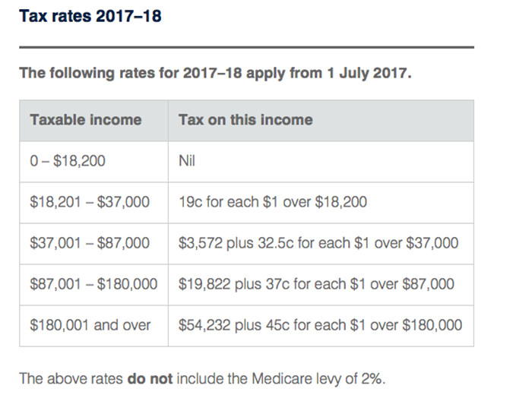
Tax rates 2017-18 table sourced from https://www.ato.gov.au/Rates/Individual-income-tax-rates/.

Part B: Purchasing, running and maintaining a car
- You have decided you need to buy a car and will need to take out a loan to finance this. The finance company is prepared to lend you 80% of the value of the car. Assuming you are able to save 10% of your net income (from above), and based on an interest rate of 2.85% p.a. compounded monthly, use a spreadsheet to calculate your balance of savings after 12 months. Note: your payments into the bank account are monthly in arrears. This means that there is a total of 12 payments with the first payment being in one month’s time.
You will need to use your final balance to work out what funds you have available in purchasing your car.
- For this section you must research two different vehicles, their price and their features. You are going to purchase one of the following cars (used or new) up to the value that you were approved for by the finance company.
Choose any two cars of your choice that suit the budget. (Your choice of car, but one that you can drive on red and green Ps.)
You must include:
  - Price
  - Picture
  - Exactly what model it is
  - Manual or automatic
  - Engine size
  - Capacity of the fuel tank
  - Average fuel consumption
  - Tyres used on the car
  - Safety options/considerations, such as number of airbags, ABS locking, safety rating, and so forth
  - Other car features that are included in the cost of the car
  - Evidence of your research, such as brochures or print outs from the internet
You may wish to do this as a table or factsheets.
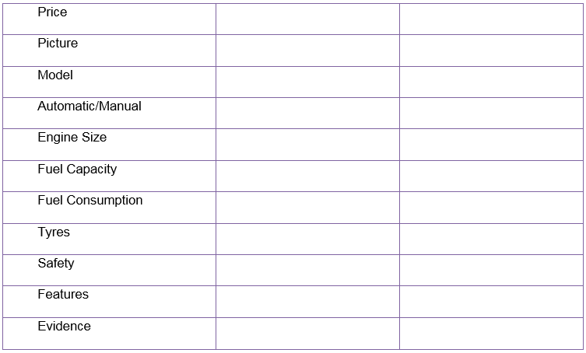
- Explain which car (from the two researched) that you would pick and why.
Include a comparison of the fuel rates for each car. State which car has the best fuel efficiency. Use some of your research to justify your choice.
- In order to buy the vehicle, you will need finance. Use the below loan table to calculate your answer. Note: The table shows the monthly repayment per $1000 borrowed.
Calculate the monthly repayments for a 12% loan. Assume the loan term is 5 years, and you are borrowing the value you are approved for from Question 9. Calculate the total paid for your loan including the following additional fees – Establishment fee $120, Account keeping fees $5 per month.
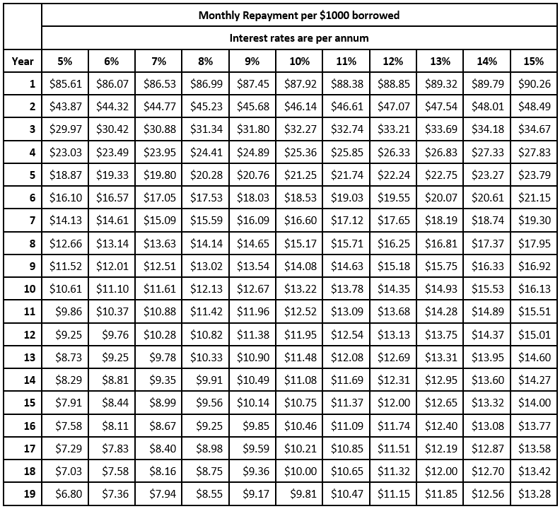
- What will this car cost to own and run for a year?
You need to include:
  - Cost of registration (including CTP green slip)
  - Comprehensive insurance
  - Two services
  - Driver’s licence (you may choose which level of Ps you are on)
  - One new set of tyres
  - Approximate fuel costs for 15,000km (use a fuel price of $1.55/L and assume they will stay at the same rate for the year).
  - Loan repayment
  - Total cost
You may wish to use a spreadsheet /worksheet to show this information clearly
- Construct a straight line depreciation graph and declining balance depreciation graph for the value of your chosen car over 5 years on the same set of axes, given the vehicle depreciates by $3,000 or 20% per annum.
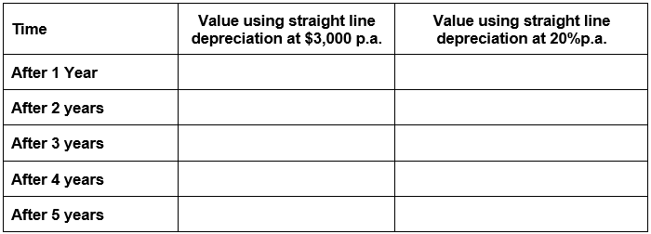

Marking guidelines/rubric
Part A: Earning and managing money
Question | Marking Criteria | Marks
1 | - Justifies choice of occupation with realistic reasons  - Provides screenshot of survey results | 1  1
2 | - Provides a screenshot (or equivalent evidence) of a source used to ascertain employment details and yearly income | 1
3 | - Provides evidence (e.g. screenshot) from a source to prove that their yearly income from Q2 includes/excludes superannuation | 1
4 | - Calculates (approximate) fortnightly PAYG by calculating 30% of their gross fortnightly pay  - Shows full working out or attempts to calculate PAYG | 1  1
5 | - Gives realistic and reasonable values for each allowable deduction  - Or gives three allowable deductions | 1  1
6 | - Calculates taxable income with full working  - Calculates Medicare levy of 2% using taxable income  - Calculates Medicare levy by first removing deductions from the taxable income | 3  1
7 | - Chooses one additional form of income and explicitly explains how it was earned (for example, interest, part-time job, dividends) and gives it a realistic value  - Or chooses one additional form of income and explicitly explains how it was earned (for example, interest, part-time job, dividends) | 2  1
8 | - Correct personal details  - Correct income details provided  - Correct deductions provided  - Calculates taxable income with full working  - Correct tax payable details provided with full working out  - Correctly calculates their tax liability/refund | 1  1  1  1  2  1
Part B: Purchasing, running and maintaining a car
Question | Marking Criteria | Marks
9 | - Calculates 80% of the value of the car  - Calculates 10% of fortnightly income to be saved  - Uses a spreadsheet to calculate the savings total of 10% of fortnightly income compounded monthly at 2.85% for 1 year  - Uses the acquired savings to calculate the maximum value of their car | 1  1  1  1
10 | - Includes each of the following per car:  - Price  - Picture  - Exactly what model it is.  - Manual or automatic.  - Engine size  - Capacity of the fuel tank.  - Average fuel consumption.  - Tyres used on the car.  - Safety options/considerations, such as number of airbags, ABS locking, safety rating  - Other car features that are included in the cost of the car  - Evidence of your research, such as brochures or print outs from the internet | 1  1  1  1  1  1  1  1  1  1  1
11 | - Gives a clear justification of which car they would choose by giving specific reasons for their choice, for example, need for 4WD or safety features  - Compares the fuel efficiencies of both vehicles by:  - Giving a numerical figure of fuel efficiency in L/100km  - Providing full working out of both calculations | 3 (1 mark per reason)  1  1
12 | - Calculates the monthly repayment for a loan with 12% interest on the value of their approved lending amount in Question 9 (80% of the value of their chosen car) using values from the table  - Calculates the total of the loan  - Includes the establishment fee and monthly account keeping fees in the total loan calculation | 1  1  1
13 | - Develops a budget that includes each of the following (with evidence, such as a screenshot of a quote, catalogue or calculations)  - Cost of registration (including CTP green slip)  - Comprehensive insurance  - Two services  - Driver’s licence (you may choose which level of Ps you are on)  - One new set of tyres  - Approximate fuel costs for 15,000km (use a fuel price of $1.55/L and assume they will stay at the same rate for the year).  - Loan repayment  - Calculates total amount of yearly expenses  - Uses spreadsheet formulas to create their budget | 1  1  1  1  1  1  1  1  3
14 | - Accurately calculates the values of straight line depreciation of their car for five years  - Accurately calculates the values of declining balance depreciation of their car for five years  - Plots both depreciation on the same set of axes (with or without technology)  - Correct labels on both axes and accurate units | 1  1  1  1

