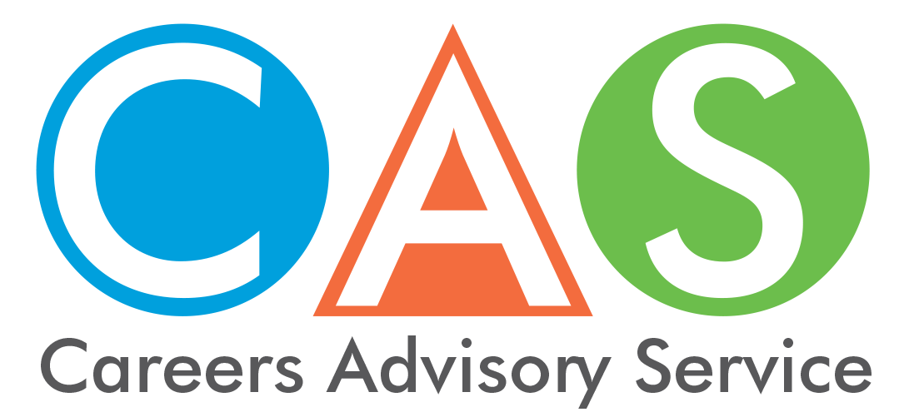

9. Australian Apprenticeships and Traineeships

An apprenticeship or traineeship combines work with training. It can be full-time, part-time or school-based. They can lead to a nationally recognised qualification and are available to anyone of working age. They do not require any entry qualifications.

Australian Apprenticeships
The Australian Government Australian Apprenticeships program covers all apprenticeships and traineeships. The website is designed to provide quick and easy access to information regarding Australian Apprenticeships
To find your nearest Australian Apprenticeship Network Provider Centre phone the Skilling Australia Information Line on 13 38 73 or visit the website.

Training Services NSW
Training Services NSW is responsible for government funded vocational education and training (VET) in NSW. For detailed information on Smart and Skilled, apprenticeships & traineeship regulation, trade skills recognition, dispute resolution, Vocational Training Review Panel or vocational training orders see website or phone 13 28 11 (NSW callers) or 1300 772 104.

How to get an apprenticeship or traineeship
Group Training Organisations (GTOs) are Australia's leading employers of apprentices and trainees. They are dedicated to providing employment and training opportunities for people throughout New South Wales and the Australian Capital Territory.
Your GTO acts as your primary employer. They secure your on-the-job training with businesses known as ‘host employers’, while also organising your off-the-job training with a Registered Training Organisation (RTO). Your GTO also takes responsibility for all paperwork including wages, superannuation and other employee benefits. Most importantly they monitor your progress and offer support throughout the term of your apprenticeship or traineeship.

© 2018 NSW Department of Education

