Teaching notes

How to use this resource
This resource, Laptop wrap: Project projectiles, is designed to support student use of laptops in both online and offline classroom environments.

If you have difficulty viewing this resource on laptop screens you can switch your web browser to full screen mode. With your web browser open press F11 to switch between normal and full screen mode.

Explore
The Shoot the Monkey game is an excellent place to begin student investigation.

This YouTube video (and others with Wile E. Coyote) may be useful for staff explanation. The Khan Academy provide a useful series of tutorials.

Your tasks
- Students should click on the icons or the hyperlinked text to view each particular task in a pop-up window. Links have been provided if additional resources are required for the task.
- Students investigate the concept of projectile motion and the effect of the different variables.

1. Flare launcher/Cannon  Internet | Students investigate the horizontal and vertical forces that might act upon a projectile.
2. Spreadsheet simulation  Internet, Excel. | Students could check the Air Resistance button to investigate the effect of a horizontal force. It may be beneficial to turn the sound off.  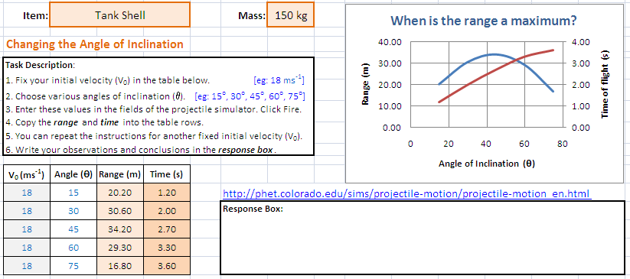
3. Interactive presentation  Powerpoint or other presentation tool. | Students design an interactive seminar that explores the conditions on the motion equations to find height, range and time of flight.
Questions to consider:
- What do the horizontal/vertical equations of motion look like?
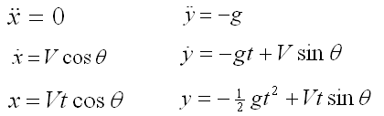
- How do you find the equation of the path of motion?
Solve above equations to eliminate t
- How do you find the maximum height? When does it occur?
Find t, substitute to find y. When
- How do you find the ‘time of flight’?
Find t. Note t ≠ 0. When y = 0.
5) a) How do you find the range of the projectile?
Solve using t from flight time. When y = 0 then x = 0, R
b) When is this at a maximum?
When sin 2θ = 1
- How would you find a particle’s speed or angle of inclination?
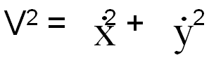 ,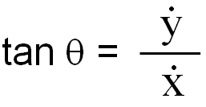
Additional:
- What happens when the particle does not begin at the origin?
Horizontal projection has θ = 0° or change initial conditions y = h
- What happens if the particle is thrown straight up and down?
Motion in a straight line

Quality teaching framework
This resource has been developed to support pedagogy and improve student outcomes based on the NSW Quality Teaching Framework, with particular focus on the following elements.

Intellectual quality |  |  | Quality Learning Environment |  |  | Significance
1.1 | Deep knowledge |  | 2.1 | Explicit quality criteria |  | 3.1 | Background knowledge
1.2 | Deep understanding |  | 2.2 | Engagement |  | 3.2 | Cultural knowledge
1.3 | Problematic knowledge |  | 2.3 | High expectations |  | 3.3 | Knowledge integration
1.4 | Higher-order thinking |  | 2.4 | Social support |  | 3.4 | Inclusivity
1.5 | Metalanguage |  | 2.5 | Students’ self-regulation |  | 3.5 | Connectedness
1.6 | Substantive communication |  | 2.6 | Student direction |  | 3.6 | Narrative

