Online learning courses:
Data summary

August 2017

Contents
Online learning courses: data summary 3
1. Participation since 2009 (at June 2017) 3
Table 1 - Total course participants by course - June 2009 to
June 2017 4
Course participation distribution 4
2. Feedback and evaluation data 4
Table 2 - Participant self-rated knowledge and understanding of the
specific disorders/disability 5
Table 3 - Participant self-rated skills in assessing student needs 5
Table 4 - Participant self-rated skills in planning and implementing
interventions for students 6
Table 5 - Participant self-rated confidence in meeting student’s needs 6
Table 6 - Impact of Online learning courses through pre and post
course evaluations: participants selected their level of knowledge,
understanding, skills and confidence 7
90 day follow up 7
Recommendation of the courses to others 7
3. Qualitative data from participants course contributions 8
Understanding Personalised Learning and Support 8
Understanding Autism Spectrum disorder 8
Understanding and Supporting Behaviour 9
Understanding Dyslexia and Significant Reading Difficulties 9
Inclusion of learners with Speech, Language and Communication
Needs 9
Understanding Hearing Loss 10
Understanding Motor Coordination Difficulties 10

Online learning courses: data summary

1. Participation since 2009 (at June 2017)
Participation | Numbers of participants
Course registrations  Total across the 7 available courses | 32 908
Individual participants  Some staff have taken several courses including classroom teachers, specialist teachers, school principals and other executive staff and school learning support officers | 21 462
Participants in Understanding Autism Spectrum Disorders Since 2009 | 10 543
Participants in Understanding and Supporting Behaviour Since 2010 | 7 607
Participants in Motor Coordination Difficulties Since 2011 | 1 585
Participants in Inclusion for learners with Speech, Language and Communication Needs Since 2011 | 4 199
Participants in Understanding Dyslexia and Significant Reading Difficulties Since 2012 | 5 839
Participants in Understanding Hearing Loss Since 2013 | 945
Participants in Personalised Learning & Support  Since 2015 | 2 183

Table 1 - Total course participants by course - June 2009 to June 2017
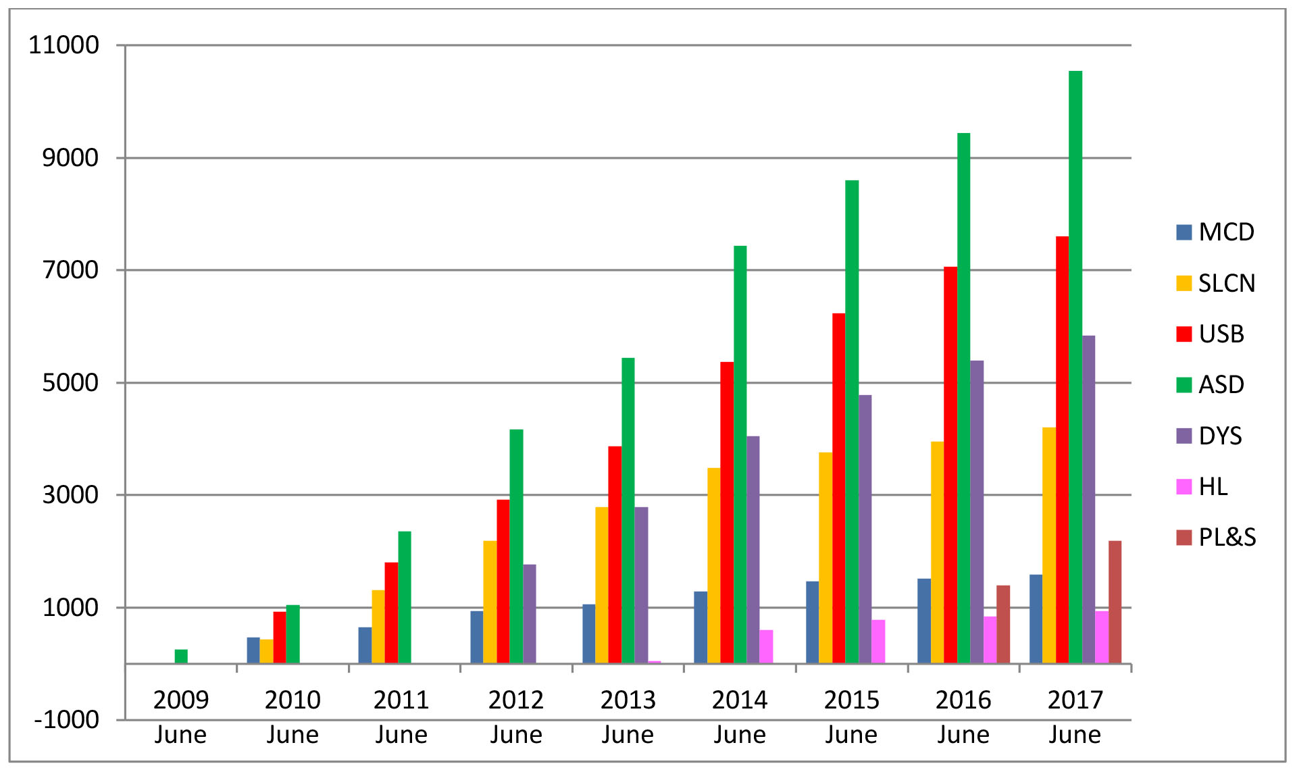

Course participation distribution
Online learning course participation has continued to grow in the first half of 2017 with 1 794 new course registrations. Courses with high take up include Understanding Autism Spectrum Disorder (10 543 registrations since 2009) and Understanding Personalised Learning and Support (2 183 registrations since 2015).

2. Feedback and evaluation data
The department collects and analyses a range of data about the online learning courses to inform planning and support their implementation. This data includes:
- pre and post course surveys of participants about their confidence, knowledge and skills in the topic area
- a voluntary follow up survey 90 days after completion
- post course evaluation of participants’ willingness to recommend the course to others
- qualitative data from participants’ final forum contributions.
The data continues to be highly positive in terms of relevance, participant satisfaction and ongoing use of course materials following course completion. A high completion rate has been sustained across all courses since 2009. Participants are asked, before and after their course, to rate their knowledge and understanding, assessment skills, planning skills and confidence in meeting the needs of students with the particular disability or need on which the course is focused. The data represented below reflects all course evaluations since August 2014.

Table 2 - Participant self-rated knowledge and understanding of the specific disorders/disability
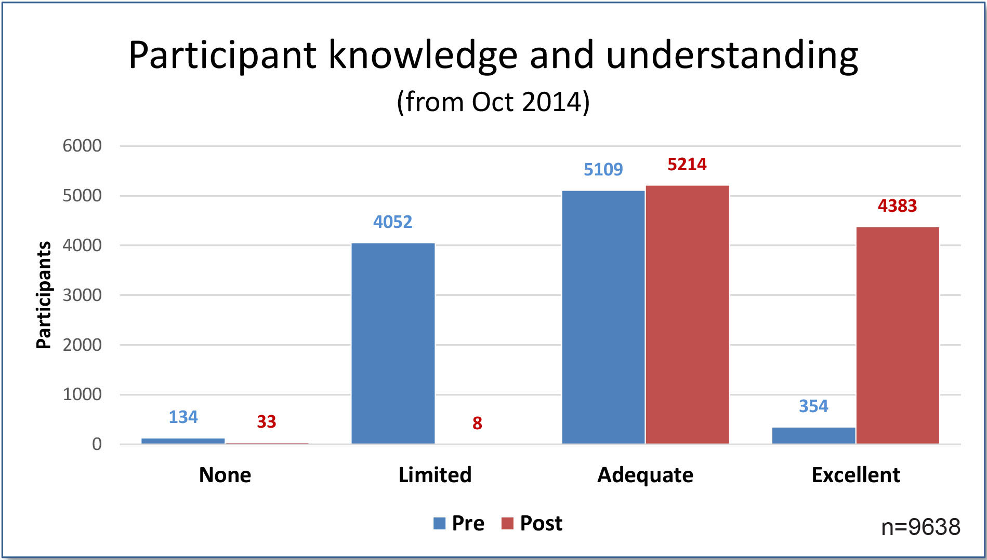
% of participants with no or limited knowledge & understanding reduced from 46% to 0.4%
% of participants with excellent or adequate knowledge & understanding increased from 54% to 99%

Table 3 - Participant self-rated skills in assessing student needs
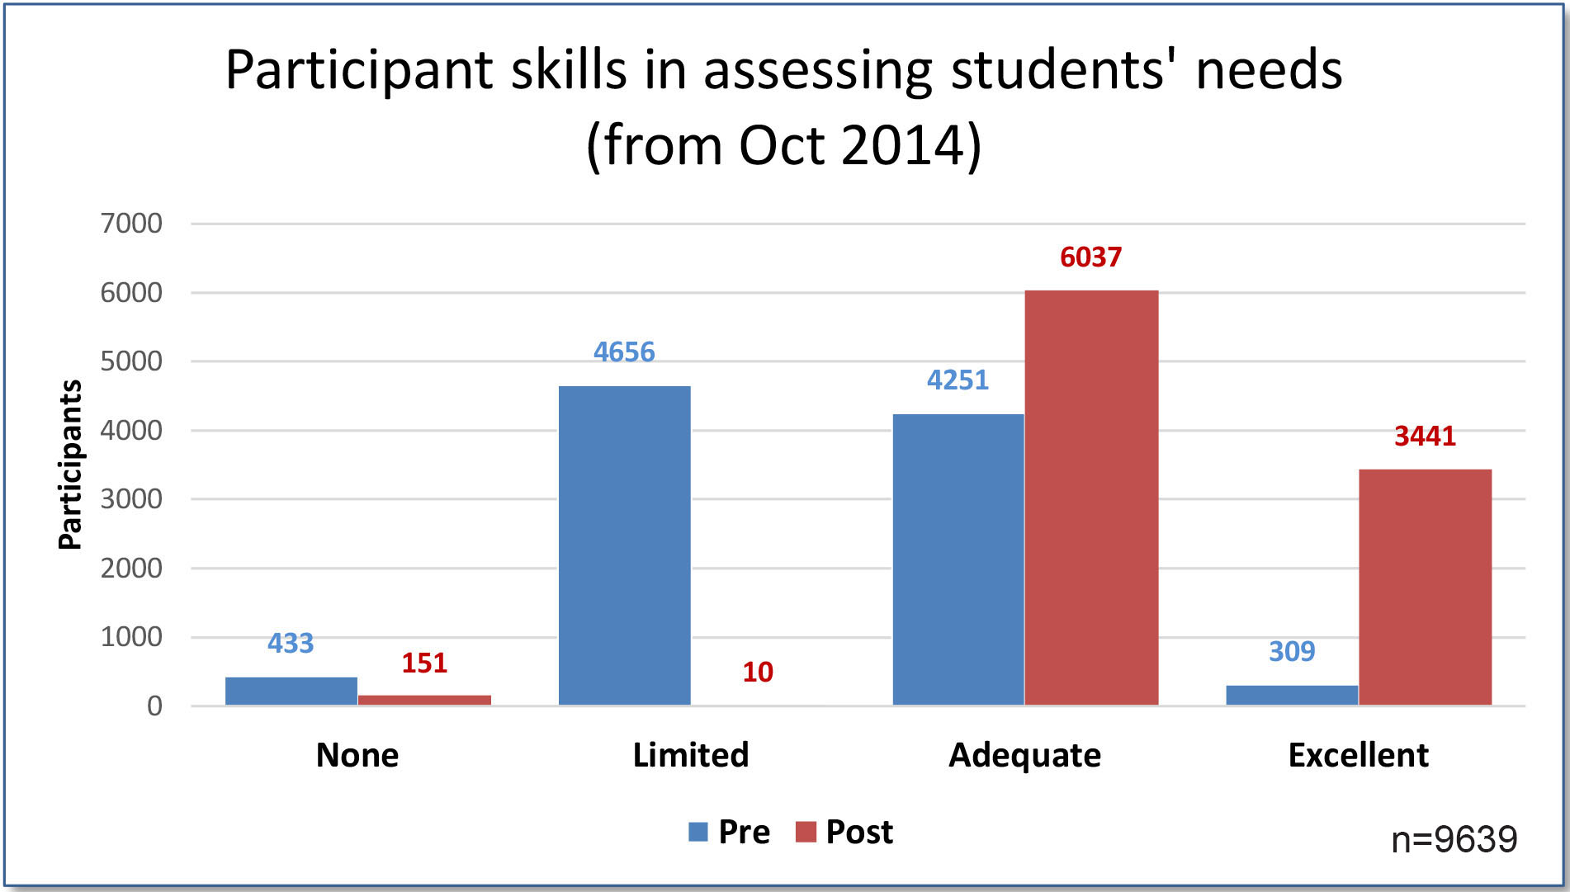
% of participants with no or limited skills in assessing students' needs reduced from 57%
to 1.8%
% of participants with excellent or adequate skills in assessing students' needs increased
from 43% to 98%

Table 4 - Participant self-rated skills in planning and implementing interventions for students
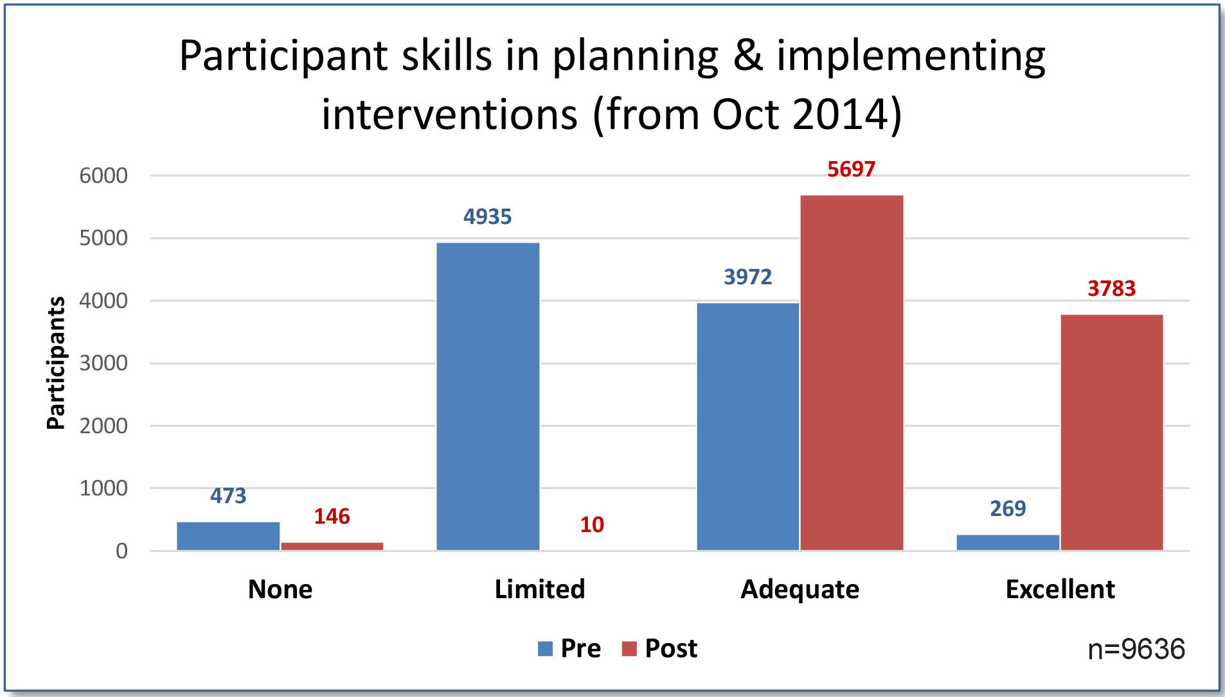
% of participants with no or limited skills in planning & implementing interventions reduced from 60% to 1.8%
% of participants with excellent or adequate skills in planning & implementing interventions increased from 40% to 98%

Table 5 - Participant self-rated confidence in meeting student’s needs
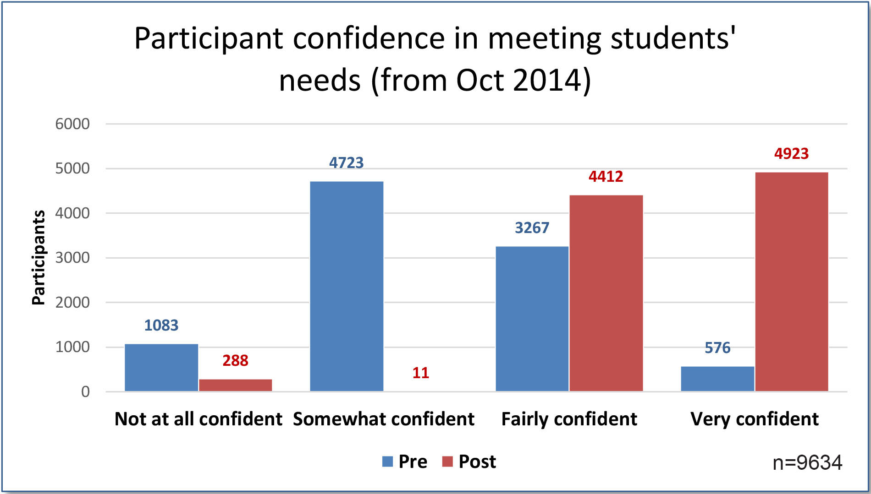
% of participants who are not or are somewhat confident in meeting students' needs reduced from 63% to 3.8%
% of participants who are very or fairly confident in meeting students' needs increased
from 37% to 96%
These results are consistent with the results of the previous reporting period.

Table 6 - Impact of Online learning courses through pre and post course evaluations: participants selected their level of knowledge, understanding,
skills and confidence
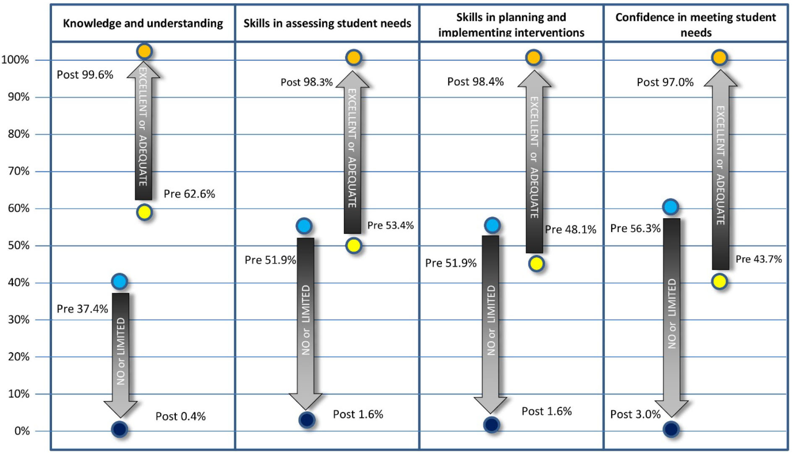
Ratings for each of the 7 courses are based on 8,682 completed post course online surveys since August 2014.

90 day follow up
Course participants receive an email survey 90 days after completion asking if they are still referring back to and/or using the course materials. Their response is voluntary. Feedback data shows that 90% of the 12 433 participants who have responded are still either referring back to the course content or using the course material 90 days after completing a course. This feedback has been collected since 2009 and represents approximately one third of all registrations.
Participants also comment on the extent to which the SMART goals (specific, measurable, agreed, realistic and time-related) they set for their focus student have been achieved and outline their future plans.

Recommendation of the courses to others
The willingness of participants to recommend the course they completed to others has remained consistently high with 98% of respondents indicating that they would recommend the course.

3. Qualitative data from participants course contributions
Each course participant is asked to reflect on their personal learning as they complete the post- course evaluation. A sample of final evaluation comments is provided below. The sample has been selected from a range of people in teaching roles across the department.

Understanding Personalised Learning and Support
“The course has given me a large range of teaching tools and approaches to personalised learning so that I can better meet their needs through modification of my pedagogy. I feel I have a good foundation to begin changing my approach to tasks and incorporating more scaffolding and feedback to support learning.”
“It has enabled me to have a more structured approach to identifying and addressing student’s needs. It has also given a range of options by which to collaborate with colleagues to collect data and create effective learning environments.”
“It has changed my outlook on how I teach and broadened my knowledge of how to incorporate personalised learning. It has also shown me how to adequately make adjustments so that my students who fall under the Disability act can still complete tasks and assessments.”

Understanding Autism Spectrum disorder
“This face to face tutor time was very valuable in giving feedback and reassuring that we were on track. This time also gave us an opportunity to ask questions or further clarify areas of concern. Lastly it gave an opportunity to have time out with other teachers and the tutor to share experiences.”
“The course gave me so much new information and tips on how to assess a student and deal with his/her higher needs. No need to label it. If there is problematic behaviour I need to adjust my teaching, classroom environment and get parents and other teacher to collaborate. I find the whole school approach is the only way ...”
“It gave me the affirmation that what I have been doing so far is the right thing. I have learned that although I am on the right course there are many other things I can try and change to make the learning better for my students. The resources will be invaluable to all staff members.”

Understanding and Supporting Behaviour
“It was great to work on our own, at our own pace, but I also enjoyed talking to teachers from other schools and listening to some of the concerns that they had and strategies that they were using at their schools. Our tutor was fantastic and very helpful in listening to concerns and offering suggestions.”
“The behaviour course has given me the opportunity to refocus on the needs of the students and the individual needs each student has. I believe I can use the knowledge and understanding I have gained when setting individual goals, measuring, and assessing for success.”
“I have particularity enjoyed completing this course with a group of teachers as l found the discussions that have come up very insightful and helpful. Reading the forums was also a great resource as it provided me with new ideas and strategies that l may have not thought of.”

Understanding Dyslexia and Significant Reading Difficulties
“The course has changed the way I support my students by not only now having the tools needed to identify children with severe phonological challenges or reading difficulties but also the ability to devise simple effective achievable SMART goals …”
“I am more understanding of how dyslexia affects a student's learning across all areas not just English. I am also able to be more supportive to my colleagues and provide assistance should they need it.”
“I love the SMART goals framework and I have already begun implementing some of the goals I set. I also have shared the From Assessment to Programming document with several teachers at my school as well as some of the many other excellent resources from the course.”

Inclusion of learners with Speech, Language and Communication Needs
“It reinforced and consolidated my current knowledge based around this topic and I was able to get clarification when I felt unsure about certain topics. I enjoyed how the tutor allowed us to have group discussions and reflect on our own teaching methods.”
“It has directly improved the way I describe the language needs of students - It has increased my confidence in speaking with teachers about student needs - It has increased my knowledge of SLCN when communicating with health professionals.”
“The course has provided a range of additional strategies to implement within my current setting to support students with receptive and expressive language disorders.”

Understanding Hearing Loss
“It has opened my eyes and ears to many factors at school that contribute to a student's educational experience. Things like room acoustics was something I had never considered before, and also realizing how important incidental language is to learning. Linking behaviour issues to hearing was also something I was not really aware of before but now have a better knowledge regarding how hearing loss affects students.”
“This course has shown me that there are a number of support mechanisms within our school and community to support students with hearing loss. I will be able to offer more assistance to my staff when planning and catering to students with hearing loss ensuring that they are able to achieve goals as the rest of the class.”
“During this course I had to work as a part of the hearing team to support the student. I found my support had a more positive outcome as there was a team of professionals all involved on the same goals. I will now be more driven to ensuring learning support teams work together in order to maximise my role for the student.”

Understanding Motor Coordination Difficulties
“It has made me even more aware how important it is that you collaborate with everyone about a student, teaching staff, OT's etc and parents. We need to all work together to get the best outcome.”
“The tutor was able to facilitate contributions from other course members that led to my understanding of MCD. The tutor, also being an experience operator, was able to put the issue of diagnosing, assessing and supporting students with MCD into an appropriate context for the setting in which I work …”
“I have checklists that can be used to assess students who may suffer from MCD. I have resources that I can share with staff to help students who may suffer from MCD. I can plan interventions that can be used to help students who may suffer from MCD.”

