How to select QDTP in ERN

Step 1: Click on the student’s name in the NCCD student list in the “Disability Adjustment” section of ERN. This will open the data entry screen.
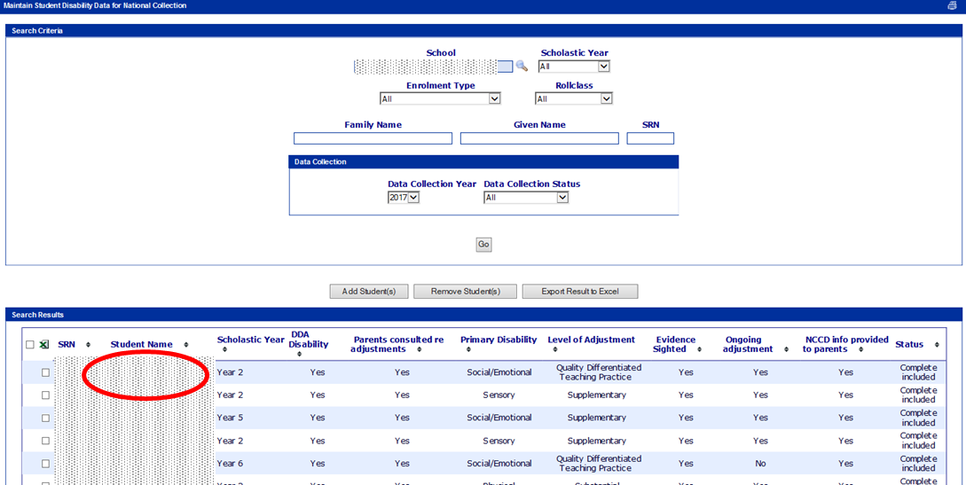

Step 2: In the data entry screen select “No” to the question “Is the student provided with an adjustment?”
This will automatically select “QDTP – Quality Differentiated Teaching Practice” as the level of adjustment. Note that the QDTP is light grey in colour. This will still show up on the main NCCD list as QDTP.
