Electric and magnetic fields

Exercises
- Use the right hand rule to determine the direction of force exerted on each of the moving positive charges shown below.
  - 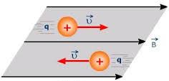
  - 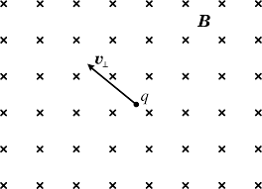
- For an electron (mass $=9.1×{10}^{-31}kg$ and charge $=-1.6×{10}^{-19}C$) placed in an electrical field of strength $50{NC}^{-1}$North, calculate the:
  - force on the electron
  - acceleration of the electron
  - distance the electron would travel before reaching half the speed of light (assume the mass remains constant – i.e. non-relativistic)
- If a proton (charge $+1.6×{10}^{-19}C$ and mass $1.67×{10}^{-27}kg$) travelling at ${4000ms}^{-1}$ enters a uniform magnetic field of strength $0.1$ Tesla at right angles to the field find the:
  - force exerted by the field on the proton
  - radius of curvature of the path taken by the proton in the magnetic field.
- In the experiment below a moving charge enters a region that contains an electric field and a magnetic field. The fields exert forces in opposite directions on the charge. If the charge moves straight through the fields we can deduce that the net force on the charge is zero and hence the force due to the electric field is equal to the force due to the magnetic field.
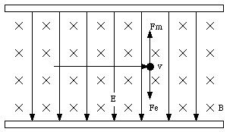
  - Is the charge positive or negative in the diagram above?
  - By equating expressions for the two forces on the charge derive an expression for the velocity ($v$) of the charge.
  - If charges passed straight through when the electric field was set at ${200NC}^{-1}$ and the $B$ field at 0.1 Tesla, calculate the speed of the charge.
- Radioactive decay releases three types of charged particles.
Type of radioactive emission | Mass(kg) | Charge(Coulombs)
Alpha | $$6.64×{10}^{-27}$$ | $$+3.2×{10}^{-19}$$
Beta | $$9.1×{10}^{-31}$$ | $$-1.6×{10}^{-19}$$
Gamma | 0 | 0
  - Sketch the path each type of radiation would take if they entered a magnetic field travelling at high velocity perpendicular to the field.
  - If an alpha and beta particle entered the magnetic field with the same velocity find the ratio of the radius of curvature of the proton’s path to the radius of curvature of the electron’s path.

Answers

  - Force = 0 as the charge has no component of motion perpendicular to the field
  - Force is up the page (in the plane of the page)
  - If we call north up the page the force is directed SW in the plane of the page

  - $F=qE=8×{10}^{-18}N$ in the opposite direction to the field (as the charge is negative)
  - $a=\frac{F}{m}=\frac{qE}{m}=8.79×{10}^{12}{ms}^{-2}$
  - $v^{2}=2as+u^{2}$ and as $u=0$, $s=\frac{v^{2}}{2a}=1.28km$

  - $F=qvB=6.4×{10}^{-17}N$
  - $r=\frac{mv}{qB}=0.42mm$

  - Positive charge
  - $qE=qvB$ and hence $v=\frac{E}{B}$
  - $v=\frac{E}{B}={2000ms}^{-1}$

  - 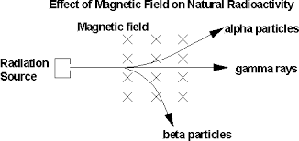
  - $r=\frac{mv}{qB}$ and hence $\frac{r_{p}}{r_{a}}=\frac{m_{p}q_{e}}{m_{e}q_{p}}=3648$

