Nationally Consistent Collection of Data on students with disability (NCCD)
Data Entry Tips for using ERN/ Online Data Collection Website for the Validation Stage (22 July to 2 August)
Refer to the Online Data Collection Website for detailed instructions on completing the NCCD validation stage. Below are quick tips for this stage.

What do I do in the validation stage?
Between 22 July and 2 August 2019, schools will need to:
- review their NCCD data in the Online Data Collection Website (datacollections.det.nsw.edu.au);
- make any necessary changes/additions in the ERN system; and
- confirm in the Online Data Collection Website that the validation phase has been completed before 5pm on census date (2 August 2019).
Note that to be included in the 2019 NCCD, students must be entered into ERN- Disability Adjustments before census date. Past this date, no new students can be added, only existing student details can be edited.

What do I need to look for?
In the Online Data Collection website, under “Step 2: Review Validation Data”, NCCD data will be displayed in two tables (see screenshot below), showing students included in the NCCD and students excluded from the NCCD. Schools with large numbers may need to scroll down the page to reveal the students excluded table.
Orange cells highlight where the schools’ judgements in ERN have resulted in a student being excluded from the NCCD. Schools should make sure that highlighted cells are reviewed and that any required amendments are made in ERN before 5pm on census date
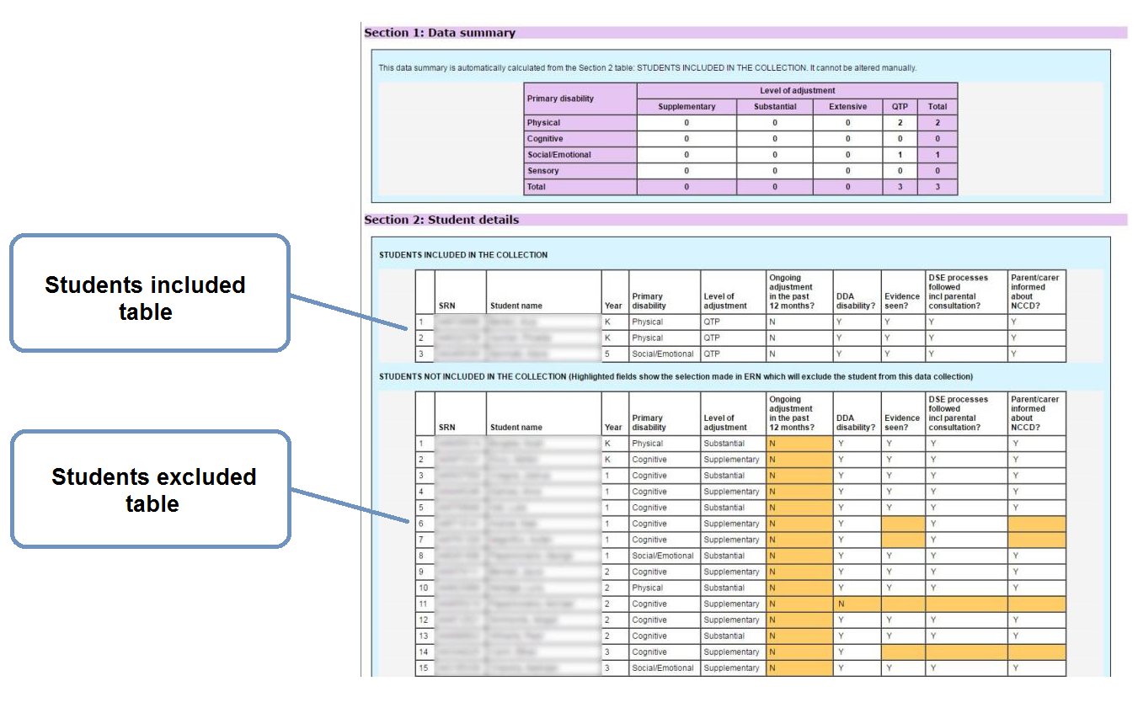
Figure 1 Screenshot from Online Data Collection Website

Why aren’t my ERN changes updating the Online Data Collection Website?
There is no link between ERN and the Online Data Collection Website. Changes made in ERN are not automatically updated on the website.
Changes made to ERN during the Validation phase will not be reflected on the Online Data Collection Website until the second and final data snapshot is taken by the Statistics Unit on census date (2 August 2019) and published on the website on 5 August 2019.

Do I need to sign off?
Schools will need to confirm before census date (2 August 2019, 5pm) in the Online Data Collection Website that the validation stage has been completed (i.e. data has been checked and updated as required in ERN). This indicates to the Statistics Unit that ERN data is up to date and ready for the final data harvest.
What happens next?
The NSW Department of Education Statistics Unit will take a snapshot of data in ERN – Disability Adjustments on census date at 5pm (2 August 2019). This snapshot will be posted on the Online Data Collection Website (datacollections.det.nsw.edu.au) on 5 August 2019.
During the final Census stage, schools will have two weeks to review the data in the Online Data Collection Website, make any changes in Online Data Collection Website and sign off on the census data before the website closes on 16 August 2019 at 5pm. During the final census phase, no further students can be added to the NCCD.
Refer to the Tips for the Census Stage for more information on the final stage of the NCCD.

For more information contact
NCCD Helpdesk
9244 5178 or 9244 5587
nccd@det.nsw.edu.au
education.nsw.gov.au/teaching-and-learning/disability-learning-and-support/personalised-support-for-learning/national-disability-data-collection

