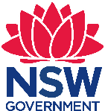 Stage 3 English, Geography, History, Science and Technology –
How does the Sydney Metro meet the needs of society?
Chullora Public School has an enrolment of approximately 300 students and caters to the needs of a low socioeconomic status (SES) and high non-English-speaking-background (NESB) community. There are 12 mainstream classes and a Support Unit with 3 classes for students with Autism and special needs. There are approximately 80 students across Stage 3 with a diverse range of abilities as students are meeting Stage 1, Stage 2 and Stage 3 outcomes. In the school community there are also students who are new arrivals and have limited English skills

How does the Sydney Metro meet the needs of society?
Stage 3 – duration 10 weeks

Unit context
This unit was written by Danielle Hajinakitas (Stage 3 Assistant Principal and L3 Stage 1 Trainer) of Chullora Public School. The unit is aligned to © NSW Education Standards Authority (NESA) syllabuses specifically the Geography K-10 Syllabus (2015), History K-10 Syllabus (2012), the Science and Technology K-6 Syllabus (2017) and English K-10 Syllabus (2012).
It was created, trialled and peer reviewed as part of a professional development program in inquiry based learning for primary and secondary school teachers. The professional development courses were part of a pilot partnership between the NSW Government’s Sydney Metro transport agency and Western Sydney University. Facilitated by Western Sydney University’s Education Knowledge Network, the professional development program aimed to develop teacher expertise in inquiry based learning using a real-life example of a major infrastructure project in delivery stage.
Sydney Metro is Australia’s biggest public transport project.

Syllabus links
General capabilities and cross-curriculum priorities | Outcomes | Skills | Concept
Personal and Social Capability  Critical and creative thinking | By end of the unit student/s will:  HT3-1 describes and explains the significance of people, groups, places and events to the development of Australia.  HT3-2 describes and explains different experiences of people living in Australia over time.  GE3-2 explains interactions and connections between people, places and the environment.  EN3-2A composes edits and presents well-structured and coherent texts.  EN3-3A uses an integrated range of skills, strategies and knowledge to read, view and comprehend a wide range of texts in different media and technologies.  EN3-5B discusses how language is used to achieve a widening range of purposes for a widening range of audiences and contexts.  EN3-7C thinks imaginatively, creatively, interpretively and critically about information and ideas and identifies connections between texts when responding to and composing texts.  EN3-9E recognises, reflects on and assesses their strengths as a learner.  EN3 1A communicates effectively for a variety of audiences and purposes using increasingly challenging topics, ideas, issues and language forms and features..  Students create well-structured and well-presented written and multimodal imaginative, informative and persuasive texts for a wide range of purposes and audiences. They deal with complex topics, issues and language features. | Student learn to:  HT3-5 applies a variety of skills of historical inquiry and communication.  GE3-4 acquires, processes and communicates geographical information using geographical tools for inquiry.  ST3-5LWT plans and implements a design process, selecting a range of tools, equipment, materials and techniques to produce solutions that address the design criteria and identified constraints.  ST3-4LWS investigates by posing questions including testable questions, making predictions and gathering data to draw evidence-based conclusions and develop explanations. | Student learn about:  History  The impact of a significant development or event on a colony; for example, frontier conflict, the gold rushes, the Eureka Stockade, internal exploration, the advent of rail (ACHHK095).  Geography  Humans shape places:  Identifies how people influence places (ACHGK029) and contribute to sustainability for example, roads and services, building development applications.  Examination of a local planning issue; the different views about it and a possible action in response to it.  Science  Systems in built environments are designed to meet the needs of people  Social and environmental factors influence the design of built environments. Students: Generate and develop ideas about how built environments might be designed and constructed in the future to incorporate sustainable environmental practices e.g. the use of recycled materials, natural lighting and solar energy.  Develop designs and solutions to meet specific social or environmental needs of users, e.g. an energy-efficient building or high-traffic airport terminal/train station.
Geographical tools integrated into this unit: Maps (M) pictorial maps, large-scale maps, world map, globe, Fieldwork (F) observing, collecting and recording data, conducting surveys, Graphs and statistics tally charts,(GS) pictographs, data tables, column graphs, weather data. Spatial technologies virtual maps, (ST) satellite images, Visual representations (VR) photographs, illustrations, diagrams, story books, multimedia, web tools
Syllabus main focus (outcome, skill or concept) | Teaching, learning and assessment | Resources and technology
The impact of a significant development or event on a colony; for example, frontier conflict, the gold rushes, the Eureka Stockade, internal exploration, the advent of rail.  Examination of a local planning issue; the different views about it and a possible action in response to it.  Systems in built environments are designed to meet the needs of people.  Develop designs and solutions to meet specific social or environmental needs of users, for example. an energy-efficient building or high-traffic airport terminal/train station  Social and environmental factors influence the design of built environments: generate and develop ideas about how built environments might be designed and constructed in the future to incorporate sustainable environmental practices e.g. the use of recycled materials, natural lighting and solar energy.  EN3-7C thinks imaginatively, creatively, interpretively and critically about information and ideas and identifies connections between texts when responding to and composing texts  EN3-3A uses an integrated range of skills, strategies and knowledge to read, view and comprehend a wide range of texts in different media and technologies. | I wonder’ day  Set up a space such as the school hall or a classroom with artefacts about Sydney Metro such as models, pictures and mapsThere will also be current photographs of Sydney Trains and the congestion that is currently occurring on trains as well as other photos that demonstrate the content listed at the left. Students will watch the video on the Sydenham to Bankstown corridor. The ‘I wonder’ day sheet will include – ‘What I know about trains and what I’m wondering.’ As the students explore the artefacts of Sydney Metro and trains they will record their knowledge and questions on their ‘I wonder’ day sheet. Students will come back to the classroom and share their knowledge and questions with the rest of the class. Questions that are surface level will be explored before developing deeper level knowledge.  Following the ‘I wonder’ day students selected the most commonly asked questions to research. The questions were:  - What are trains and what are they made from?  - How do trains work?  - Why were trains invented?  Assessment 1: This sheet will be used as assessment to gain information on what students already know. | ‘I wonder’ day worksheet (Assessment 1)
Historical Skill: analysis and use of sources - locate information relevant to inquiry questions in a range of sources.  EN3-3A uses an integrated range of skills, strategies and knowledge to read, view and comprehend a wide range of texts in different media and technologies.  EN3-5B discusses how language is used to achieve a widening range of purposes for a widening range of audiences and contexts.  EN3-9E recognises, reflects on and assesses their strengths as a learner. | Experience 1 – What are trains and what are they used for?  Students must work cooperatively in small groups to find relevant information to respond to this question. They can use books, web searches or a digital library like the ‘Epic!’ website to find information on trains.  Students are required to record their research in their books using the inquiry scaffold and share this learning with the class at the end.  Information shared will be written on an A3 piece of paper to journal our inquiry journey.  Students will reflect on their teamwork and research skills. Teacher to ask questions from REAL dimensions of student self-assessment framework such as:  - What did you find easy today?  - What challenged you today?  - How does working with others make you feel? | Epic! website  Optional: Laptops, iPads or other ICT  What I now know about Sydney Metro sheet (Assessment 2)  Inquiry scaffold (on page 12)  REAL dimensions of student self-assessment framework
Historical Skill: analysis and use of sources – locate information relevant to inquiry questions in a range of sources.  EN3-3A uses an integrated range of skills, strategies and knowledge to read, view and comprehend a wide range of texts in different media and technologies.  EN3-5B discusses how language is used to achieve a widening range of purposes for a widening range of audiences and contexts.  EN3-9E recognises, reflects on and assesses their strengths as a learner. | Learning experience 2 – What are the different types of trains and how do they work?  Students must work cooperatively in small groups to find relevant information to respond to this question. They can use books, web searches or a digital library like the ‘Epic!’ website to find information on trains.  Students are required to record their research in their books using the inquiry scaffold and share this learning with the class at the end.  Prior knowledge will be recorded as a class and after research time new knowledge/information will be recorded on the ‘What I now know about Sydney Metro’ sheet.  Students will reflect on their teamwork and research skills. The teacher asks questions from the REAL dimensions of student self-assessment framework such as:  - What did you find easy today?  - What challenged you today?  - How does working with others make you feel? | Epic! Website  Optional: Laptops, iPads or other ICT  Inquiry scaffold  What I now know about Sydney Metro (Assessment 2)
Historical Skill: analysis and use of sources – locate information relevant to inquiry questions in a range of sources.  EN3-3A uses an integrated range of skills, strategies and knowledge to read, view and comprehend a wide range of texts in different media and technologies.  EN3-7C thinks imaginatively, creatively, interpretively and critically about information and ideas and identifies connections between texts when responding to and composing texts.  EN3-5B discusses how language is used to achieve a widening range of purposes for a widening range of audiences and contexts.  EN3-9E recognises, reflects on and assesses their strengths as a learner. | Experience 3 – Where can I get to by train, from my local area?  Students must work cooperatively in small groups to find relevant information to respond to this question. They can use books, web searches or a digital library like the ‘Epic!’ website to find information on trains.  Students are required to record their research in their books using the inquiry scaffold and share this learning with the class at the end.  Prior knowledge will be recorded as class and after research time, new knowledge/information will be recorded on the ‘What I now know about Sydney Metro’ sheet.  Students will reflect on their teamwork and research skills. Teacher to ask questions from the REAL dimensions of student self-assessment framework for students to reflect on such as:  - What would you change about today’s work to help you improve?  - When and where else could you use this information?  - How could you ensure your group has positive feelings about your work together? | Epic! Website Optional: Laptops, iPads or other ICT.  Inquiry scaffold  What I now know about Sydney Metro (Assessment 2)
Geographical tools Continuum: maps – large-scale maps, small-scale maps, maps to identify location, direction, distance  EN3-5B discusses how language is used to achieve a widening range of purposes for a widening range of audiences and contexts.  EN3-9E recognises, reflects on and assesses their strengths as a learner. | Experience 4 – What is the Sydney Metro and how will it help (or hinder) my local area?  Students must work cooperatively in small groups to find relevant information in response to this question.  Students are required to record their research, either on paper or in a digital collaboration space like Seesaw or Google Slides using the inquiry scaffold as a guide. Research will be shared with the class at the end of this session.  Information shared will be written on an A3 piece of paper to journal our inquiry journey.  Students will reflect on their teamwork and research skills. Teacher to ask questions from the REAL dimensions of student self-assessment framework for students to reflect on such as:  - What would you change about today’s work to help you improve?  - When and where else could you use this information?  - How could you ensure your group has positive feelings about your work together?  Assessment 2: What I now know about the Sydney Metro. | Optional: Laptops, iPads or other ICT  Optional: A digital collaboration tool like Seesaw or Google Slides  Paper or digital map of the local area, for example Google Maps  Inquiry scaffold  What I now know about Sydney metro sheet (Assessment 2).
Systems in built environments are designed to meet the needs of people  - Personal and Social Capability  - Critical and Creative Thinking  EN3-7C thinks imaginatively, creatively, interpretively and critically about information and ideas and identifies connections between texts when responding to and composing texts | Experience 5 – Delving deeper  Using your imagination, create a way to express how the Sydney Metro will meet the needs of society.  Justify your thinking.  Brainstorm as a class ways you can answer this inquiry question, such as artwork, diorama or drama.  Go through expectations of working independently and collaboratively within a group. As we were focusing on the personal and social capability we created assessment criteria based on the Tallis Habits of Mind assessment wheel to help the stage 3 team and students assess their collaboration skills.  Ask:  - What does sharing the product look like?  - What does giving and receiving feedback look like?  - What does cooperating appropriately look like?  Have each student sign a contract that they will work with group members for the whole time and will not swap groups and/or change their plan.  Criteria for work – class to create but use this as a guide:  - Select a way to express your understanding.  - Use your time wisely.  - Plan your idea before you start creating.  - Answer the key inquiry question – How will Sydney Metro meet the needs of society?  - Share the workload/make sure everyone is included.  - Journal/reflect your learning.  - If needed, include websites used and write in your own words!  - Seek and give feedback.  - Listen and respond to others.  - Navigate and resolve conflict.  In selected groups have students begin to draft their idea.  Ten minutes before the end of the lesson, have students sit in a reflection circle and reflect on the following questions:  - Who are you working with?  - What is your plan?  - What was enjoyable about your learning today? | A3 paper  The Creative Habits of Mind Assessment Wheel  Personal and social capability success criteria  Group contract
Students evaluate the effectiveness of their writing by drafting, proofreading, editing, reviewing and publishing, focusing on grammatical features and the conventions of writing.  EN3-7C thinks imaginatively, creatively, interpretively and critically about information and ideas and identifies connections between texts when responding to and composing texts. | Experience 6 – Drafting and creating  Pose inquiry question to students again – Using your imagination, create a way to express how Sydney Metro will meet the needs of society. Justify your thinking.  Display personal and social capability success criteria again and go through what this means.  Students are given time during Learning Centres and KLA time to collaborate with their group to create their project that displays their learning
Students create well-structured and well-presented written and multimodal imaginative, informative and persuasive texts for a wide range of purposes and audiences. They deal with complex topics, issues and language features.  EN3-5B discusses how language is used to achieve a widening range of purposes for a widening range of audiences and contexts.  EN3-2A composes, edits and presents well-structured and coherent texts. | Experience 7 – Writing lesson  Students use the writing process (plan, compose, revise, edit and publish) to write a persuasive letter to their local Member of Parliament (MP) − about the Sydney Metro. Their persuasive topic will be around public transport − Is it the way to go?  Teacher will read a letter from Jihad Dib (the local member at the time of this unit’s publication) to the community on the Sydney Metro and ask students whether they agree or disagree with his point of view. Students will watch a news segment on Australia’s population future on Behind the News (ABC, 2018) and will use this information alongside the information that they have gained on Sydney Metro to persuade their local member that public transport is the way to go.  Assessment 3: Persuasive text writing sample. | Link to news segment on Behind the News  Sydney Submission for: Sydney Metro - Sydenham to Bankstown from Jihad Dib  A3 paper  Persuasive plan  Writing folders
EN3-1A communicates effectively for a variety of audiences and purposes using increasingly challenging topics, ideas, issues and language forms and features  EN3-9E recognises, reflects on and assesses their strengths as a learner. | Experience 8 – Showcase of learning  Invite parents to attend this showcase of learning. All students across Stage 3 meet in the hall to showcase their projects. This allows students to see learning and perspectives across the whole stage.  Assessment 4: Have students answered the key inquiry question – How does the Sydney Metro meet the needs of society? Have students reflect on whether they have met the personal and social capability success criteria. | Hall  Note for parents  iPads  Laptops  Hall projector  Personal and social capability success criteria

Assessment

Assessment 1
Students wrote down what they knew about trains before entering the hall as this provided us with data on what prior knowledge the students had. While they were in the hall and exploring the artefacts students wrote I wonder questions. These questions helped shape our inquiry lessons and showed us that the students didn’t have much prior knowledge or experience with trains and the questions they were wondering were very surface level.

Assessment 2
Students were provided with a sheet of paper that said ‘What I now know about the Sydney Metro.’ Students were given time to brainstorm all of the knowledge they had on the Sydney Metro. This was used as a post assessment and compared to Assessment 1, as it provided us with new knowledge that students had gained.

Assessment 3
Writing samples displayed what knowledge students had on the Sydney Metro and how this would be beneficial for the community. A local community letter from local MP Jihad Dib was used as a stimulus for students to write a persuasive letter, and all letters written by students were posted to Jihad Dib.

Assessment 4
This provided us with data on the learning students gained from this project. Students weren't told how they needed to demonstrate their knowledge. They were given examples and ideas of how they could demonstrate this e.g. artwork, PowerPoint presentation, green screen, etc. Students then had the choice of who they would work with and how they would present this knowledge. This allowed student choice concerning the assessment medium. Examples of how students presented their learning can be found on pages 16-17 of this document.

Assessment 5
Students self-assessed their own learning and were assessed by teachers using the personal and social capability success criteria

Teacher reflection on the unit
- Students didn’t have a lot of prior knowledge.
- Students were asking a lot of surface level questions.
- Students felt that they needed to answer every question rather than wondering.
- It would be great to have the artefacts from Sydney Metro for longer to be able to answer the surface level questions and then delve into deeper inquiry faster.
- Less time spent on surface level knowledge would be preferable for the future.
- Weekly collaborative planning worked well and using student questions to drive the learning.
- This was a great opportunity for us to authentically teach teamwork skills such as collaboration.

Inquiry question
Research question:

Important information: | References

Other things I am wondering …

Reflection
What did you find easy today?
What challenged you today?
How does working with others make you feel?

I wonder day
What I know
What I wonder…

Name:
What I now know about trains and the Sydney Metro

Collaborative

Sharing the product
Level 1 | Level 2 | Level 3 | Level 4
not working together  One person hogging the work  Not on task  Bossy | Only sometimes joining in  Not sharing workload | Some people sharing, others not  Being selfish about jobs/roles/tasks | Shared workload  Everyone doing the job they want to

Giving and receiving feedback
Level 1 | Level 2 | Level 3 | Level 4
Disengaged and does not provide or receive feedback  Feedback does not have a ‘where-to-next’ | Listens to feedback but does not provide any feedback  Feedback does not relate to the criteria | Listens to feedback and applies some of it  Gives non-specific feedback | Gives honest opinion  Gives feedback based on criteria with explanation  Gives positive and where to next

Cooperating appropriately
Level 1 | Level 2 | Level 3 | Level 4
Disengaged from task  Peace breaker | Engaging in conflict  Not on track | Talking voices  Most people participating | Peace maker  Leader  On the right track

Contract
I ___________________________________ will be working
with____________________________________________
We will be creating _______________________________
I agree not to make changes to my group and/or my draft.
Signature ______________________________________
Date: _________________________________________

Contract
I _______________________________________ will be working
with__________________________________________________
We will be creating ______________________________________
I agree not to make changes to my group and/or my draft.
Signature ______________________________________
Date: _________________________________________

Student work samples and photos from unit
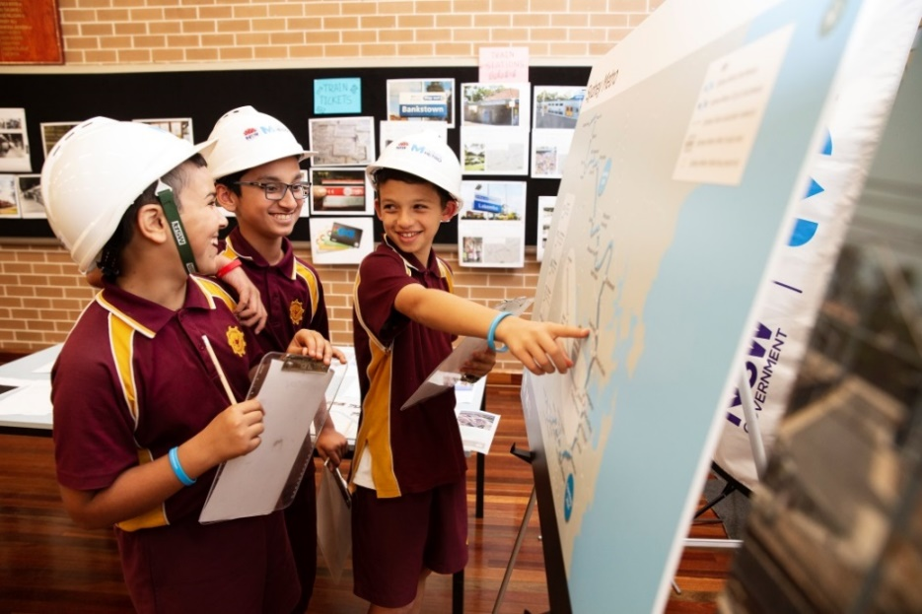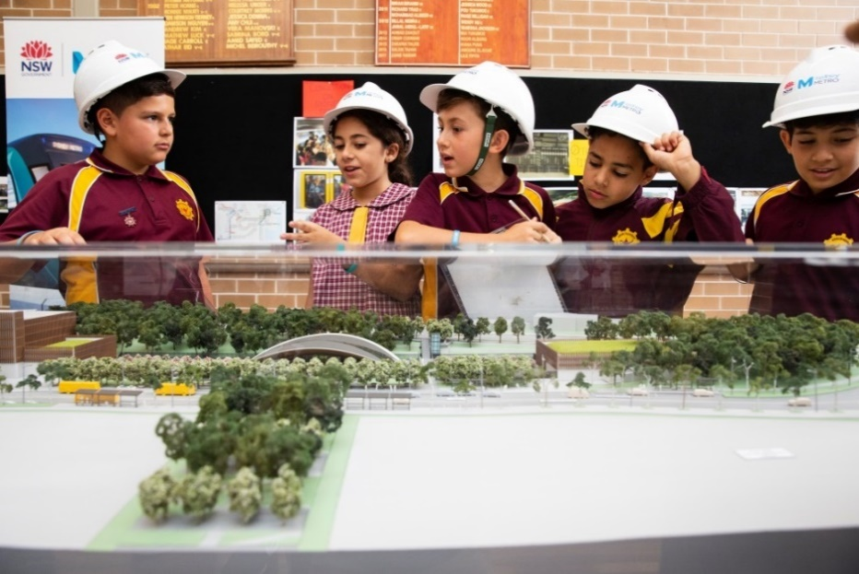
Top and bottom left: Students at the ‘I wonder’ day. Photo courtesy of Sydney Metro. Right: Assessment 1
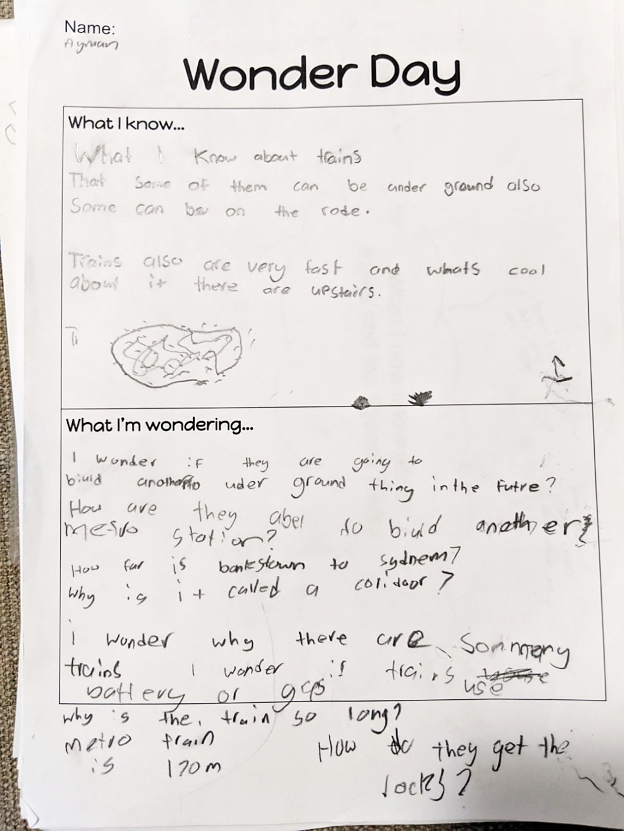

Copyright
© State of New South Wales (Department of Education), 2019
The copyright material in this publication is subject to the Copyright Act 1968 (Cth), and is owned by the NSW Department of Education or, where indicated, by a party other than the NSW Department of Education. Copyright material which is owned by the NSW Department of Education is licensed under a Creative Commons Attribution 4.0 International (CC BY 4.0) licence
This licence allows you to:
- share – copy and redistribute the material in any medium or format
- adapt – remix, transform and build upon the material for any purpose, even commercially
Attribution should be given to:
© State of New South Wales (Department of Education), 2019.
Material in this publication not available under a Creative Commons licence includes:
- the Department of Education logo, other logos and trademark-protected material
- material owned by a third party that has been reproduced with permission. Permission will need to be obtained from the third party to re-use this material.
If this publication contains your work and you have any objection to such content, please contact legal@det.nsw.edu.au.

Links to third-party websites
If you use the links provided in this publication to access a third party’s website, you acknowledge that the terms of use, including licence terms set out on the third party’s website apply to the use which may be made of the materials on that third party’s website or where permitted by the Copyright Act 1968 (Cth).
The department accepts no responsibility for content on third-party websites.

Written by Danielle Hajinakitas of Chullora Public School © NSW Department of Education 2019 for and behalf of the Crown in the State of NSW
Our school approached Sydney Metro to assist us with resources for the ‘I wonder’ day. A short video of the day is at youtu.be/ZznfE3po3uE (Transport for NSW, 2019) (2 minutes 37 seconds)
Epic! is a digital library for students 12 years of age and under https://www.getepic.com/
The REAL dimensions of student self-assessment framework was designed by Geoff Munns and Helen Woodward as a way to allow classroom discourse so that students can openly communicate with others about their thinking, their feelings and their development as learners. The intent of this model and the inclusion of the elements of reflection, engagement and authentic learning led to it being named the REAL dimensions of student self-assessment framework. http://electronicportfolios.org/academy/intro/schedule/lesson-4/RESEARCH-StudentEngagementandself-assessmenttheREALframework.pdf#page=9
https://www.thomastallisschool.com/uploads/2/2/8/7/2287089/the_creative_habits_of_mind_assessment_wheel_final_jime_2013_colour.pdf
https://www.abc.net.au/btn/classroom/australias-population-future/10521708

