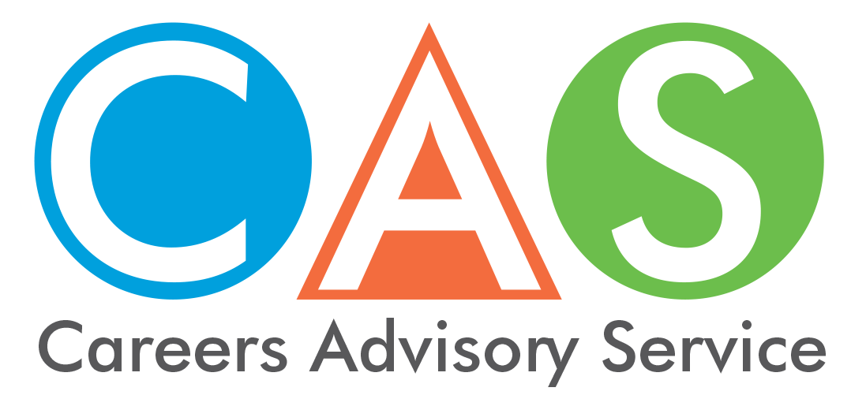

4. Australian Tertiary Admission Rank (ATAR)

ATAR is used to assess and compare the results of school-leaving applicants entry into university
Most university courses in NSW and the ACT attract greater numbers of applicants than available places.
The ATAR is a system that enables universities to rank applicants for university entrance in a fair and equitable way. The University Admissions Centre (UAC) releases your ATAR the day after the NSW Education Standards Authority (NESA) releases your HSC results.
Universities use the ATAR to help them select students for their courses and admission to most tertiary courses is based on your selection rank (your ATAR + any applicable adjustments).
For detailed information see Frequently Asked Questions about the ATAR.
NSW ranks to a common scale and name used by all states. The top rank is 99.95 and the ATAR indicates a NSW student’s position.

Your ATAR is:
- a rank, not a mark
- based on scaled marks (not on actual HSC marks)
- calculated by the universities and released by UAC.

Eligibility for an ATAR
To be eligible for an ATAR you must satisfactorily complete at least 10 units of ATAR courses. Note: only NESA developed courses can count towards an ATAR.
These ATAR courses must include at least:
- eight units from Category A courses
- two units of English
- three Board Developed courses of two units or greater
- four subjects.

Calculating your ATAR - The average ATAR is usually around 70.00
A student’s ATAR is a rank based on an aggregate of scaled marks in 10 units of ATAR courses comprising:
- your best 2 units of English
- your best eight units from the remaining units, which can include up to two units of Category B courses.
It is a number between 0.00 and 99.95 and indicates a student’s position relative to all the students who started high school with them in Year 7. So, an ATAR of 80.00 means that you are 20 per cent from the top of your Year 7 group, not your Year 12 group.
If everyone from Year 7 went on to achieve an ATAR, the average ATAR would be 50.00. But because some students leave early and the ones who stay on to receive an ATAR are a smaller, more academically able group, the average ATAR is higher.
Why do universities use scaled marks?
Scaling is designed to encourage students to take the courses for which they are best suited. It adjusts the students’ raw marks to an estimation of what their marks would have been if all courses had been studied by all students. The underlying principle is that students should neither be advantaged nor disadvantaged by choosing one HSC course over another.

Lost your ATAR Advice Notice?
If you've lost your ATAR Advice Notice you can request, by purchasing, a Printed or Digital ATAR Advice Notice from the UAC Shop. For more information refer to the UAC website ATAR section.

All About Your ATAR and Enquiry Centre
Refer to the All About Your ATAR, where you can download an electronic copy, from the UAC website in December.
Contact the ATAR Enquiry Centre after the release of the ATARs.
Days and hours of operation are:
14th December (8.30am - 6pm)
Monday 17th to Wednesday 19th December (8.30am - 4.30pm)
1300 MY ATAR (1300 692 827) or from
mobiles: (02) 9119 5012
or overseas: +61 2 9119 5012
© 2018 NSW Department of Education

