 Stage 1 History, English and Mathematics – How can transport connect us to places?

Quakers Hill East Public School has approximately 720 students and caters to the needs of a high non-English speaking background community. The school is organised into stage-based learning teams led by a dedicated and skilled executive team. Our students have diverse learning needs. As well as providing enrichment activities, the school has a comprehensive learning support program for students in need of additional assistance.

How can transport connect us to places?

Stage 1 (Year 2) – duration 4 weeks

Unit context

This unit was written by Sarah Reardon of Quakers Hill East Public School.

It was created, trialled and peer reviewed as part of professional development in inquiry-based learning for primary and secondary school teachers. The professional development courses were part of a pilot partnership between the NSW Government’s Sydney Metro transport agency and Western Sydney University. Facilitated by Western Sydney University’s Education Knowledge Network, the professional development program aimed to develop teacher expertise in inquiry-based learning using a real-life example of a major infrastructure project in delivery stage.

Sydney Metro is Australia's biggest public transport project.

The unit is aligned to [© NSW Education Standards Authority (NESA)](https://educationstandards.nsw.edu.au/wps/portal/nesa/mini-footer/copyright) syllabuses, specifically the [Mathematics K-10 Syllabus (2012)](https://educationstandards.nsw.edu.au/wps/portal/nesa/k-10/learning-areas/mathematics/mathematics-k-10), [Geography K-10 Syllabus (2015)](https://educationstandards.nsw.edu.au/wps/portal/nesa/k-10/learning-areas/hsie/geography-k-10), [History K-10 Syllabus (2012)](https://educationstandards.nsw.edu.au/wps/portal/nesa/k-10/learning-areas/hsie/history-k-10) and the [English K-10 Syllabus (2012)](https://educationstandards.nsw.edu.au/wps/portal/nesa/k-10/learning-areas/english-year-10/english-k-10).

Syllabus links

| General capabilities and cross-curriculum priorities | Outcomes | Skills | Concepts |
| --- | --- | --- | --- |
| Literacy literacy icon  Write a persuasive text about why people should use public transport and present this an oral presentation to the class.  Numeracy Numeracy icon  Use directional terms such as north and south to describe locations.  ICT capability Information and communication technology capability icon  Use satellite images to identify the scale of different places  Critical and creative thinking critical and creative thinking icon  Draw conclusions about why connections between places have changed over time.  Personal and social capabilityPersonal and social capability icon  Interview family members about places they visit, whether they use public transport and why/why not.  Sustainability Sustainability icon  Investigate the environmental impact of getting from one place to another and discuss how public transport is a more sustainable option. | By end of the unit a student:  Geography   * GE1-1 describes features of places and the connections people have with places * GE1-3 communicates geographical information and uses geographical tools for inquiry   History  HT2-3 describes the effects of changing technology on people's lives over time  English  EN1-7b identifies how language use in their own writing differs according to their purpose, audience and subject matter  Maths  MA1-17SP gathers and organises data, displays data in lists, tables and picture graphs, and interprets the results | Students learn to:  Geographical inquiry skills   * acquiring * processing * communicating. | In this unit students will learn that:  Key inquiry questions  Geography   * How are people connected to places? * What factors affect people’s connections to places?   History   * How have changes in technology shaped our daily life?   Geographical concepts   * place * space * environment * interconnection * scale. |

Geographical tools integrated into this unit: Maps (M) – Pictorial maps, large-scale maps; Fieldwork (F) –Collecting and recording data, conducting surveys; Graphs and statistics (GS) –Tally charts, pictographs, data tables, column graphs; (VR) – Photographs, illustrations, diagrams, story books, multimedia, web tools.

| **Content** | Teaching, Learning and Assessment | Resources and technology |
| --- | --- | --- |
| Geography  Students investigate people’s connections and access to places, for example: (ACHGK013)   * discussion of why people visit other places Graphs and statistics tool numeracy icon   Mathematics  Students interpret information presented in lists, tables and picture graphs. | * Class discussion: Why do people visit different places? * Have students nominate their favourite place in the local area and graph their responses. * Focusing on the most 'popular' favourite place, brainstorm how students are connected to that place (such as a place to meet friends, a place to go and celebrate, a place to exercise). * Watch 'Heidi's Favourite Place' on the ABC Splash website. Discuss what makes this place important to her and how she is connected to this place. * Talk about places that are special to the students. * Students complete the 'My Favourite Place' resource sheet by drawing a picture of a place that is special to them, writing below it what makes that place special to them and why they like to visit that place. * Read 'Magic Beach' by Alison Lester (Allen and Unwin, 2004) and discuss why the family likes to visit this beach. Why do they call it 'our beach?' How are they connected to this place? * Jointly brainstorm other places people visit (not necessarily their favourite), for example: shops, schools, universities and workplaces. Discuss why people visit these places. | Video: ABC Open, [‘Heidi’s Favourite Place’, (1 minute 15 seconds)](http://education.abc.net.au/home#!/media/2337991/) ABC Education Splash website: abcsplash/m/2337991 (18 February 2019)  Book: Lester, A. (2004), Magic Beach: Allen and Unwin  My favourite place resource sheet: (page 9 of this document) |
| Geography  Students investigate people’s connections and access to places, for example: (ACHGK013)   * identification of factors influencing people’s accessibility to places for example, distance Maps tool Critical and creative thinking icon   Mathematics  Students collect, check and classify data (ACMSP049)   * collect data on familiar topics through questioning literacy icon * use tally marks to assist with data collection. | * Return to the drawings and ask students how they get from their home to their favourite place. * Tally the various methods of transport such as walking, driving in the car, catching public transport, etc. * Pose the question: What is public transport? Students ‘Think, pair, share’. * Demonstrate how to search for a definition. If available, we suggest teachers model the use of online resources, such as web searches or searches through an online encyclopaedia consider using online resources using either online resources or resources from the school Library. Online using World Book Online (or similar). Read out a definition of ‘transport’. Explain that ‘transport’ means to move people from one place to another but ‘public transport’ refers to a system of vehicles (often buses, trains, trams and ferries) that are available to the public (everyone), charge set fares, and run on fixed routes. * Watch 'Public transport in Australia' on the ABC Splash website. * Brainstorm places that the students have travelled to on public transport, for example school, the city, the airport. * Divide students into small groups and give each group a different capital city in Australia to investigate. Students research what public transport is available in their designated capital city using any available digital or physical resources. Groups record their findings in a shared space, either on paper or in a digital collaborative space such as Google Slides, [Padlet](https://padlet.com/) or the Padlet app for iPad. Students compare the various types of public transport in each capital city around Australia and examine accessibility to places. * Do you think people who live in small towns or in the outback have access to public transport? Class discussion about how distance can influence people's accessibility to places as there are not as many transport options away from the capital cities. Examine a railway map of Australia. * Optional: Comparisons could also be made with transport in other countries students are familiar with (have lived in/visited). Watch ['How do people get around?](http://abcspla.sh/m/1661732)' on the ABC Splash website which showcases different forms of transport around the world. | Library books on:   * Transport * capital cities of Australia   (Optional)Access to internet-connected devices for conducting web searches, including laptops, desktops or iPads.  (Optional) Access to an online encyclopaedia, for example World Book Online or [Encyclopedia.com](https://www.encyclopedia.com/).  (Optional)Collaborative Pin board tool for students to save their research to, for example Google Slides, [Padlet](https://padlet.com/)[1] or Padlet app for iPad.  Video: [ABC Australia, ‘Bike use in Europe is streets ahead’, (2 minutes 57 seconds)](http://education.abc.net.au/home#!/media/526985/bike-use-in-europe-is-streets-ahead) comparing bicycle transport in European cities with Australian cities: <http://education.abc.net.au/home#!/media/526985/bike-use-in-europe-is-streets-ahead> (Accessed 27 November 2019)  Video: [YouTube, ‘Cycling Copenhagen with Children, Canines & Couples as Cargo’, (2 minutes 55 seconds)](https://www.youtube.com/watch?v=rycu9iESYCM&list=PLVFfomNEY9YldEFZOaPgJlJ9Cce7yhoyS&index=2) (Accessed 27 November 2019)  Digital image: Map of passenger railway services in Australia State Government owned rail services by Lencer (CC BY-SA 3.0) [2] |
| Geography  Students investigate people’s connections and access to places, for example: (ACHGK013)   * examine how technology has improved people’s access to places Literacy wok and enterprise   History  The impact of changing technology on people's lives (ACHHK046)  Students use a range of communication forms to explain how one example of changing technology affected people's lives critical and creative thinking icon Information and communication technology capability icon Literacy icon | * Read ‘Are We There Yet?’ by Alison Lester. Pose the following questions to the class: How did the family get to the places? Why did they drive? * Class discussion: How can we communicate with people from far away without visiting them in person? * Does this type of technology make access easier or faster than in the past? How? * How has technology changed our ability to communicate with people from far away? * Using the State Library of NSW website, as a class complete the following activities.[3]   + Activity 1: Observe photographs of [past and present transport such as sources 1 and 2](https://www.sl.nsw.gov.au/learning/people-and-places-connections-access-transport/accessing-places-past-and-present). Discuss the differences and similarities between how people access different places now and in the past.   + Activity 2: Observe photographs of [how people travelled in the past such as sources 3 to 10](https://www.sl.nsw.gov.au/learning/people-and-places-connections-access-transport/how-did-people-travel-past) from the State Library of NSW. Discuss how people accessed places in the past.   + Activity 3: Print the [photo by Sam Hood](https://www.sl.nsw.gov.au/learning/people-and-places-connections-access-transport/accessing-places-past-and-present) on page 9 of this document and have students draw and label past transport modes and the built features (infrastructure) onto the photograph.   + Activity 4: observe photos of [transport modes today such as sources 11 to 18](https://www.sl.nsw.gov.au/learning/people-and-places-connections-access-transport/accessing-places-today) from the State Library of NSW. Discuss how people access places today. Students talk with older family members about changing modes of transport. Optional: complete the resource sheet ['Processing information - Past and present access to places'](https://www.sl.nsw.gov.au/sites/default/files/activity_5_0.pdf) with their grandparents or older family member. Print the [photo by Sam Hood](https://www.sl.nsw.gov.au/learning/people-and-places-connections-access-transport/accessing-places-past-and-present) on page 9 of this document and have students draw and label past transport modes and the built features (infrastructure) onto the photograph. | Book: Lester A. Are We There Yet? (2004) Australia. Penguin Australia Pty Ltd  State Library of NSW website [People and Places- Connections Access Transport](https://www.sl.nsw.gov.au/learning/people-and-places-connections-access-transport) [4] |
| English  Respond to and compose texts   * compose and review written and visual texts for different purposes and audiences | * Revise persuasive texts: Scaffold students to undertake the persuasive writing assessment using the prompt ‘Why you should use the new Sydney Metro’. Students are encouraged to consider a range of tools and media in which to create their persuasive argument, including written, in-class presentation or multimedia video. * If available, encourage students to choose from apps and other presentation software in order to help design, develop and present their argument. Some suggested ICT tools include Microsoft PowerPoint, Google Slides, Keynote, iMovie, Shadow Puppets, Clips, Edu Creations and so on. Consider whether students might be able to access an in-class IWB for their presentation. | Online pdf: examples of Stage 1 level persuasive texts   * [Australian Curriculum Assessment and Reporting Authority: Persuasive Text (Pigs) pdf work sample 4](https://docs.acara.edu.au/curriculum/worksamples/AC_Worksample_English_1.pdf)[5] |

Assessment

In groups of three students, create and deliver a presentation ‘Why you should use the new Sydney Metro’. Use the Quakers Hill East Stage 1 persuasive writing rubric.

Quakers Hill East Stage 1 Persuasive Writing Rubric[6]

|  | **Limited** (below expectation)  **Level 1** | **Basic** (working towards)  **Level 2** | **Achieved/Sound** (at expectation)  **Level 3** | **High** (above expectation) **Level 4** | **Outstanding** (well above expectation)  **Level 5** |
| --- | --- | --- | --- | --- | --- |
| Purpose and Audience  EN1-10C  Composition of text to engage and affect the reader. | * Does not express an opinion * Does not attempt to persuade audience * Text is very short | * Expresses a simple opinion on the topic * Attempts to persuade audience * Text is short | * Expresses clear opinion backed up with 3 reasons * Text includes persuasive elements * Audience can easily follow text * Draws on personal experience and topic knowledge to express an opinion | * Expresses clear opinion backed up with 3 or more reasons * Expresses own thoughts and feelings * Text is persuasive and expresses a clear point of view * Text is consistent and effective | * Text is persuasive/expresses a point of view * Reader can easily follow the text * Text is consistent and effective * Content and topic is linked to personal and/or shared experiences |
| Text Structure and Ideas  EN1-2A  Organisation of text features appropriate and effective text structure. Skilful crafting of ideas for a persuasive text | * One or more ideas which are not necessarily related * May use a simple title * No opening and/or closing statement Does not have a position statement Ideas not related to topic * Mostly copies modelled text * Little (weak) or no evidence | * Writes two or three related ideas which may include other unrelated ideas * Uses a title * Uses a simple opening statement with an opinion * Uses a simple closing statement * (These statements may be in the body of the text – for example a single paragraph) | * Writes 3 related ideas which express a range of feelings in response to a topic or text * Either the introduction or conclusion is separate to the body of the text * There are statements of opinion followed directly by statements of some evidence or reason * Ideas are connected and relevant | * Writes 3 or more sequenced and clearly connected ideas that are appropriate to the topic * Organises text logically (ideas in time sequence) * Includes a clear orientation and conclusion * Body has different arguments with solid supporting evidence * Sections are paragraphed * Uses interesting and relevant ideas | * Text features a clear orientation and separate conclusion * Body has different arguments with supporting evidence for each * Body contains key relevant information * At least one piece of supporting evidence to justify it * Uses ideas drawn from their own world * Ideas are based on personal and shared experiences |
| Vocabulary  EN1-9B  Use of variety of precise words e.g. nouns, adjectives, verbs or adverbs | * Very simple words used only * No subject specific vocabulary * Repetitive language (and…then) Only one persuasive language device | * Uses some words to describe emotions * Uses some simple adjectives and adverbs * Uses at least two examples of specific topic related vocabulary * Uses some simple modality * Uses a rhetorical question | * Uses words and links arguments in a text * Uses some persuasive language (3 or more examples) * Uses adjectives to add meaning by describing qualities or features (red, small, long) * Uses appropriate key words to represent an idea (aunty, sister, cousin in a text about family). Uses modifying words (very) | * Uses 3 or more different examples of persuasive language * Uses high modality and effective adverbs * Word choice is effective, engaging, evaluative and persuasive * Uses words to indicate quantity (every, some, a few) * Uses specific learning area topic vocabulary * Uses common homophones correctly | * Uses 4 or more examples * of different examples of persuasive language * Uses highly effective noun groups and some verb modality * Always uses correct and varied conjunctions, connectives and pronoun references to link ideas * Uses some figurative language for example. similes |



My favourite place

Student resource: Accessing places in the past

Draw and label past transport modes and the built features (infrastructure) onto the photograph by Sam Hood.

Image of Hood Collection Part II ca.1935–ca.1955 

Source: State Library New South Wales [Hood Collection Part II ca.1935des](http://www.acmssearch.sl.nsw.gov.au/search/itemDetailPaged.cgi?itemID=153521) and [http://www.acmssearch.sl.nsw.gov.au/search/itemDetailPaged.cgi?itemID=153521](http://www.acmssearch.sl.nsw.gov.au/search/itemDetailPaged.cgi?itemID=153521%20)Free for reuse.  
This image is licensed under Creative Commons Attribution 4.0

Student work sample

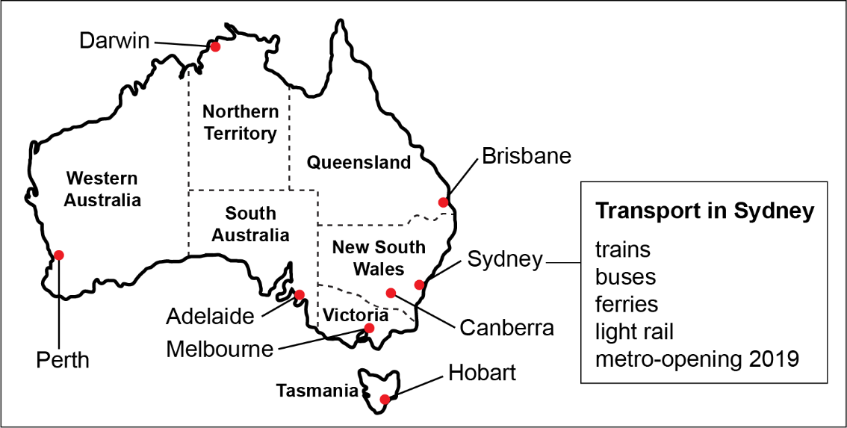

Above: A screen shot of student group work on the Padlet App reporting on their investigation into public transport in capital cities of their designated State or Territory.

Persuasive text student work sample

Screen shot of persuasive videos. 
Argument 3 The Sydney metro is very safe.

Above: Screen shot of persuasive videos.

Screenshot of student work sample containing the image of inside of a Sydney Metro train is reproduced here with the permission of Sydney Metro.

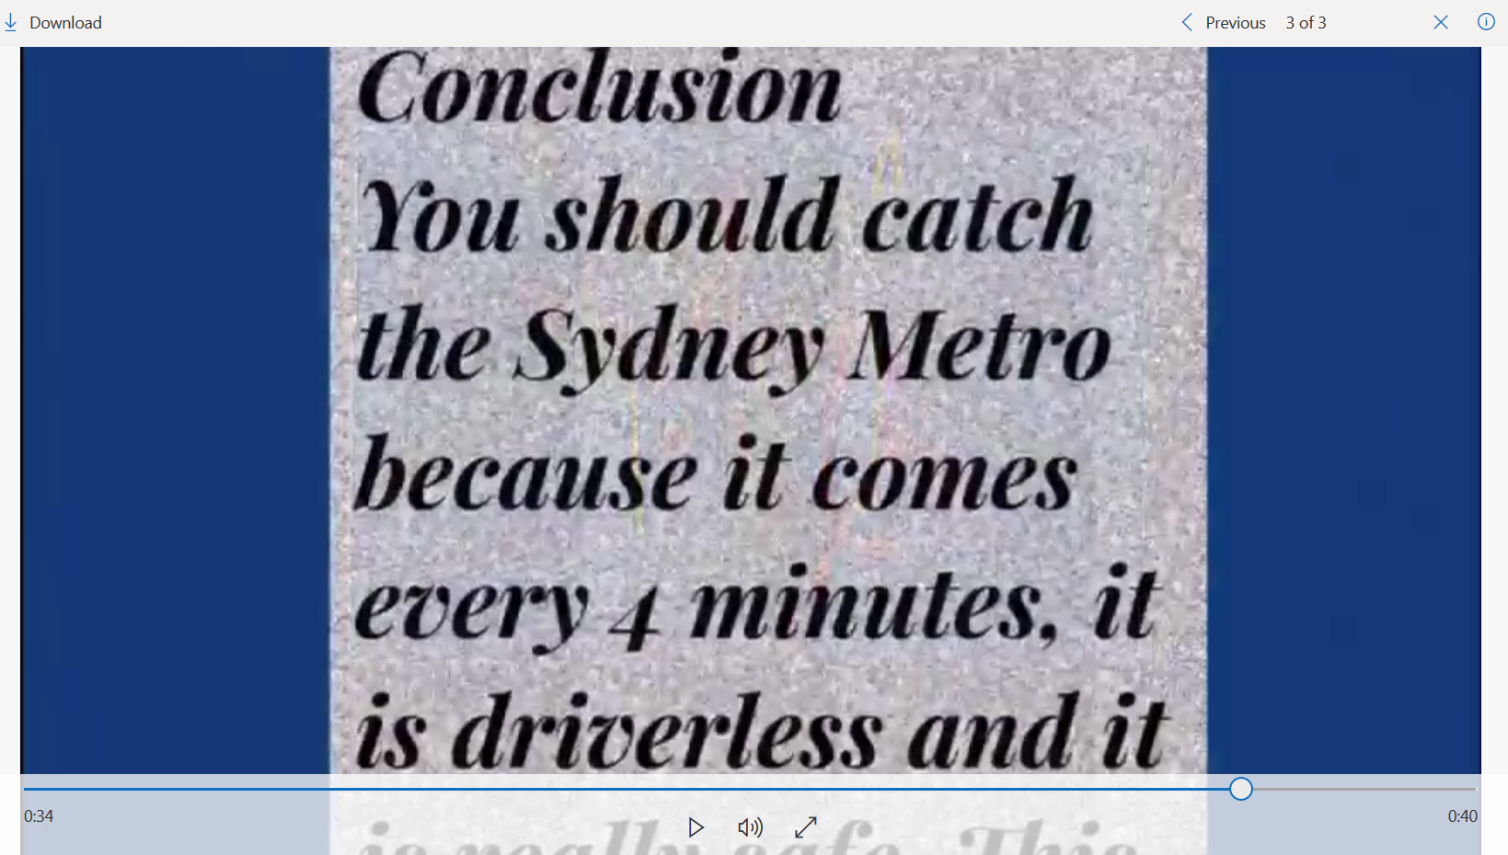

Copyright

© State of New South Wales (Department of Education), 2019

The copyright material in this publication is subject to the Copyright Act 1968 (Cth), and is owned by the NSW Department of Education or, where indicated, by a party other than the NSW Department of Education. Copyright material which is owned by the NSW Department of Education is licensed under a [Creative Commons Attribution 4.0 International (CC BY 4.0) licence](https://creativecommons.org/licenses/by/4.0/)

Creative commons CC BY 

This licence allows you to:

* share – copy and redistribute the material in any medium or format
* adapt – remix, transform and build upon the material for any purpose, even commercially.

Attribution should be given to:

© State of New South Wales (Department of Education), 2019.

Material in this publication not available under a Creative Commons licence includes:

* the Department of Education logo, other logos and trademark-protected material
* material owned by a third party that has been reproduced with permission. Permission will need to be obtained from the third party to re-use this material.

If this publication contains your work and you have any objection to such content, please contact [legal@det.nsw.edu.au](../02-Docs%20to%20be%20reviewed/legal@det.nsw.edu.au).

Links to third-party websites

If you use the links provided in this publication to access a third party’s website, you acknowledge that the terms of use, including licence terms set out on the third party’s website apply to the use which may be made of the materials on that third party’s website or where permitted by the Copyright Act 1968 (Cth).

**The department accepts no responsibility for content on third-party websites.**

1. https://padlet.com/
2. https://en.wikipedia.org/wiki/Rail_transport_in_Australia#/media/File:Passenger_rail_services_in_Australia_en.png
3. Activities adapted from the State Library of NSW Peoples connections to places – accessing places activities. The activities are licensed under Creative Commons Attribution 4.0. You are free to copy, distribute, remix and build upon this content as long as you credit the State Library of NSW as the source
4. State Library of NSW website People and Places- Connections Access Transport https://www.sl.nsw.gov.au/learning/people-and-places-connections-access-transport (Accessed 3 June 2019)
5. https://docs.acara.edu.au/curriculum/worksamples/AC_Worksample_English_1.pdf
6. This was modified from the [Shell Cove Public School Persuasive Writing rubrics (Year 1 and 2)](https://shellcove-p.schools.nsw.gov.au/programming/stage-1/english/writing.html): https://shellcove-p.schools.nsw.gov.au/programming/stage-1/english/writing.html