Project planning template 3 – sample
ES1 (Kindergarten), Term 4, 2015
Big idea/s and why does this learning matter? | Significance/Importance - inclusivity, differences, similarities, acceptance of others, sense of belonging
Driving question: | How can we welcome next year’s Kindergarten to school so that they feel included and part of our school community?
Central syllabus ideas/concept: | History – Continuity and change, Significance, Empathetic understanding  Geography - Place
Hook/entry event: | ‘Who are we?’ day – students bring in artefacts that represent themselves and go on a ‘scavenger hunt’ to find people who have similar and different artefacts. Students share what they learnt about each other.
Possible experts: | Preschool students, teachers and their families.  Community members from different cultural backgrounds or with different abilities and experiences.
Audience: | Preschool students and their families.
Culminating event: | Invite local preschool students and their families to participate in different events run by the Kindergarten students to make them feel welcome at school. These events will run over a period of time towards the end of term rather than on one day with everyone attending.
Possible outcomes that could be covered:
English | History | Geography
Students:  - understand that English is one of many languages spoken in Australia and that different languages may be spoken by family, classmates and community (ACELA1426)  - understand how to communicate effectively in pairs and groups using agreed interpersonal conventions, active listening, appropriate language and taking turns  - replicate the rhythms and sound patterns in stories, rhymes, songs and poems from a range of cultures (ACELT1579)  - deliver short oral presentations to peers (ACELY1647)  - communicate with peers and familiar adults about personal experience  - retell familiar stories, including in home language  - use interaction skills including listening while others speak, using appropriate voice levels, articulation and body language, gestures and eye contact (ACELY1784)  - listen to and respond orally to texts and to the communication of others in informal and structured classroom situations(ACELY1646)  Students:  - create short texts to explore, record and report ideas and events using familiar words and beginning writing knowledge(ACELY1651)  - experiment with basic visual, multimodal and digital processes to represent some simple ideas expressed in texts and to convey experiences  - use opportunities to write in their home language and dialect and make basic connections with English, including Aboriginal languages and Aboriginal English  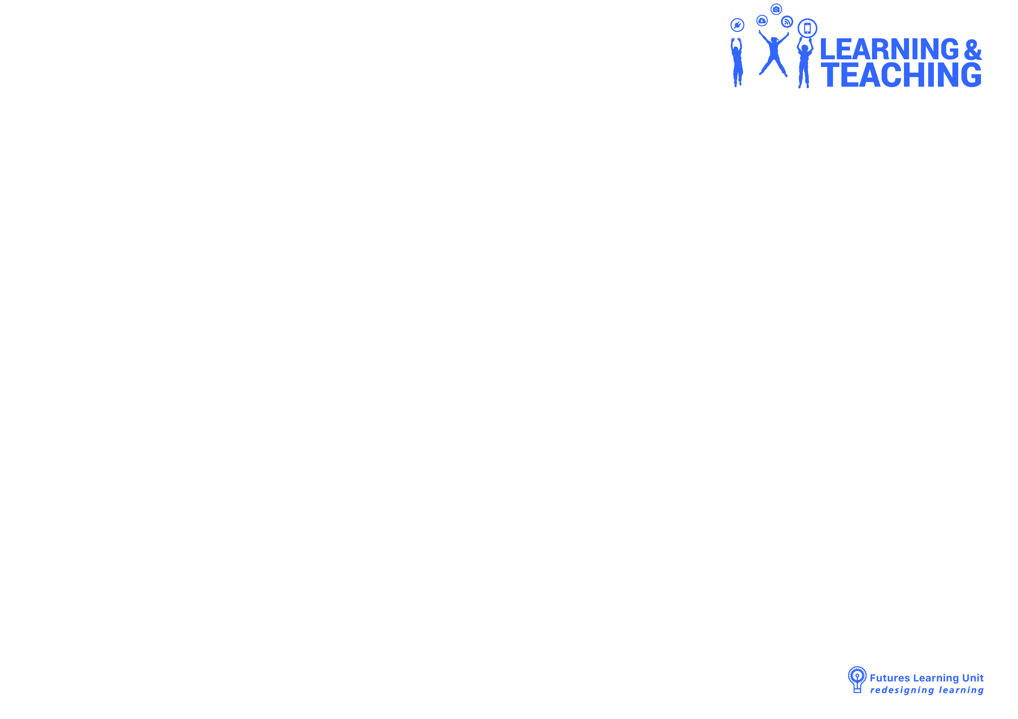  - drawing on their experience of language and texts, begin to understand that writing and representing can be used to convey an idea or message  - share writing with others for enjoyment  - develop an awareness of issues relating to the responsible use of digital communication  Students:  - demonstrate a growing understanding that handwriting and presentation of work needs to reflect audience and purpose in order to communicate effectively  - experiment using digital technologies, eg produce own name, commonly used words and simple sentences  - construct texts using software including word processing programs (ACELY1654)  Students:  - recognise that there are different ways of using spoken language to communicate  - demonstrate a developing understanding of language used at school and expectations for using spoken language according to audience and purpose  - recognise different methods of communication, eg Standard Australian English, Aboriginal English, home language, sign language and body language  - explore how language is used differently at home and school depending on the relationships between people(ACELA1428)  - understand that language can be used to explore ways of expressing needs, likes and dislikes (ACELA1429)  - understand the use of vocabulary in familiar contexts related to everyday experiences, personal interests and topics taught at school (ACELA1437)  - greet people differently according to the relationship  - compose texts to communicate feelings, needs, opinions and ideas  Students:  - compose texts for known audience, eg self, class, other classes, parents  - compose texts using drawings and other visual media to create meaning  Students:  - explore sequencing of a story, focusing on the beginning, middle and end and recognise cultural patterns of storytelling, eg 'Once upon a time', the Dreaming  - interpret pictures with labels, environmental print logos and other visual images  Students:  - share responses to aspects of a text that relate to their own life  - recognise that texts are created by authors who tell stories and share experiences that may be similar or different to students' own experiences (ACELT1575)  - understand that different languages and dialects may be spoken by family, classmates and community  - understand that language can be used to describe likes and dislikes  - explore how language is used differently at home and school  - compare and connect own experiences to those depicted in stories  - compose simple written and visual texts that include aspects of home, personal and local community life  - use visual, multimodal and digital processes to represent simple aspects of home and community life  - respond to texts that depict aspects of home and community life, eg short films and digital texts  - respond to Dreaming stories, eg stories from local Aboriginal and Torres Strait Islander communities  - respond to literature and a variety of other texts from a range of storytellers and cultures, using picture books and online sources  - read and discuss stories that reflect students' social and cultural groups  Students:  - begin to recognise that there are different ways of learning in English  - demonstrate an emerging awareness of criteria to enable the successful completion of tasks  - discuss what it means to be an active listener  - discuss what it means to be a cooperative group member | Who the people in their family are, where they were born and raised and how they are related to each other (ACHHK001)  How the stories of families and the past can be communicated, for example through photographs, artefacts, books, oral histories, digital media and museums (ACHHK004)  Students:  - identify people in their immediate families and show relationships between family members  - discuss where members of their families were born and locate countries of origin of students' families in the class  - use a variety of sources including photographs or a treasured object from their homes, to recount stories about their families and discuss how sources are used to answer the question 'How do we know?'  - discuss the significance of the chosen treasured object or photograph (it may be important or significant to themselves but not to others)  - pose questions about another's object or photograph  - identify and sequence stages in their lifetime.  The different structures of families and family groups today, and what they have in common (ACHHK002)  Students:  - identify and record similarities and differences between families, eg the number of children in the family, family languages spoken at home, number of adults in the immediate family  - compare and contrast various family groups through photographs and stories and identify differences between past and present  - engage in and respond to stories about families in other places, including those of Aboriginal and Torres Strait Islander groups  How they, their family and friends commemorate past events that are important to them (ACHHK003)  Students:  - share experiences of family, school and local events that are celebrated or observed  - identify and record a variety of holidays and special events observed in Australia and other countries, eg birthdays, anniversaries and festivals. Consider the significance of these dates | Important places  Students:  - investigate the importance of places they live in and belong to, for example: (ACHGK002, ACHGK004)  - identification of places they live in and belong to  Locating places  Students:  - investigate how the location of places can be represented, for example: (ACHGK001)  - location of familiar and local places on maps  - description of the location of places.

Additional programs/events to be aware of for the term: (e.g. athletics carnival, Book Week, swim school etc).
End of year assembly, end of year picnic.
Open-ended assessment opportunities
(To capture conceptual understanding around the Big ideas and key/driving syllabus content).
Week | Task | Evidence to collect
Week 1  Purpose: To identify what students know about the differences and similarities between people and how to make everyone feel included. | Provide students with A3 sheets of paper to draw differences and similarities between themselves and other students in the class and how they make people feel welcome and happy at school.  Ask to students to label drawings and write sentences if they can. | Drawings/labels/sentences
Week 5  Purpose: To identify what students know about the differences and similarities between people and how to make everyone feel included. | Provide students with A3 sheets of paper to draw differences and similarities between people in their community and how people are made to feel part of a community.  (Do this after expert visitors)  Ask to students to label drawings and write sentences if they can. | Drawings/labels/sentences
Week 9  Purpose: To identify what students know about the differences and similarities between people and how to make everyone feel included | Provide students with A3 sheets of paper to draw and write about how they made the pre-schoolers feel welcome. If possible get them to video each other to explain why they chose to organise particular activities and how they thought the preschool students and their families felt about the activities.  Ask to students to label drawings and write sentences if they can. | Drawings with written descriptions, video explanations

