Cybermarvels are good digital citizens!

What you can expect to learn
This week we will learn how things online that you see or hear can make you feel, how to be kind online and giving credit to others.

Instructions
The activities below can be completed in any order and you can do all or some of them during the week. At the end of each day, fill in your journal with what you learnt that day and how you will use this learning in the future. You will then be able to use this to create:
- a poster (PDF/word)
- a script for a play (PDF/word)
- an MP4 video
- an MP3 audio
- a website (Google site or similar)
- or write a fictional story to showcase your learning for the whole month (PDF/word).

You can access help for video, audio recording and to write a journal or a story.

Once your teacher has reviewed your work, they can select and submit them to the judge’s panel as an entry to the Be Cybermarvellous Challenge and the best productions will be published on our website.

Week 2: 25 Oct - 29 Oct
Things you need:
- Tablet/ laptop/ PC/phone with internet access
- Headphone (optional)
- Paper and pencils/colour pencils

MONDAY - How do you feel? (adapted from Cyber Aces)
You or your family members would have used emojis to express their emotions when talking online.

- Cut out the emoji cards.
- Tell an adult the name of each emotion
- Make a face to show this emotion
- For each of the situations below, select the emoji card to show how you would feel.
  - Your birthday is tomorrow.
  - You find out one of your friends is moving away.
  - You get lost in your neighbourhood on your way home from school.
  - Your friend tells you a funny joke.
  - You’re going to the park and plan to play on the swings, but when you get there, all the swings are being used.
  - Your teacher sends your parents an email saying how well you did at school today.
  - You’re going to visit your grandparents while your parents go out of town.
  - You don’t know how to do your homework.
  - Your sibling breaks a toy that belongs to you.
  - A package with your name on it is delivered to your house.
  - You can’t find the correct website on your device.
  - You’re playing your favorite game with your friend.
  - A thunderstorm makes the lights go out.
  - You’ve just gotten to the next level in a game.
  - You fall into a swimming pool.
  - You’re making cookies with your family.
  - Your friends tell you they don’t want to eat lunch with you.

- What are some things that make you feel good?
- Why do you think it is important to be respectful online?

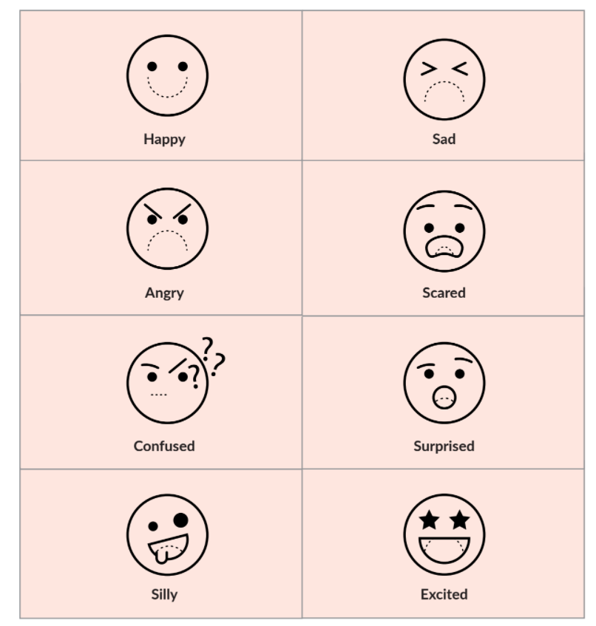

TUESDAY - Be kind online.

When you are talking to someone or playing a game online, you might not be able to see them.

Watch the video - https://www.youtube.com/watch?v=0u6-2aCea-M&ab_channel=PlanetNutshell

Answer the questions below:
- Why is it important to be kind online?
- Talk about what are some ways you can be kind to others online? For example, give some a compliment, only say nice things about people, apologise if you make a mistake.
- Use the card template below to create a thank you card for someone you know.
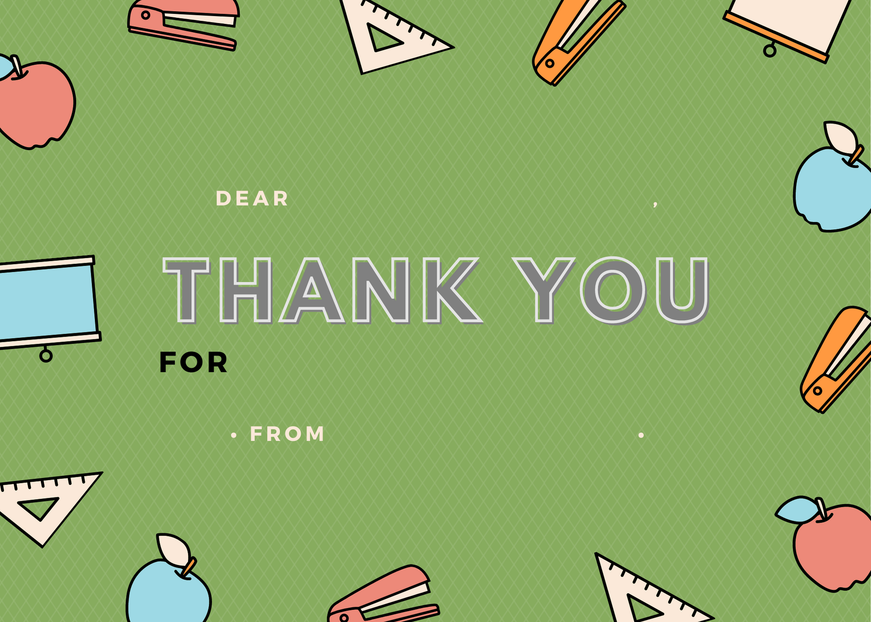
WEDNESDAY - My work is mine! (adapted from Common Sense Education)

Billy entered an artwork competition at school, and his drawing won first place! Billy’s artwork was hung up at school for everyone to see, but Simon’s name was on the art instead of his.
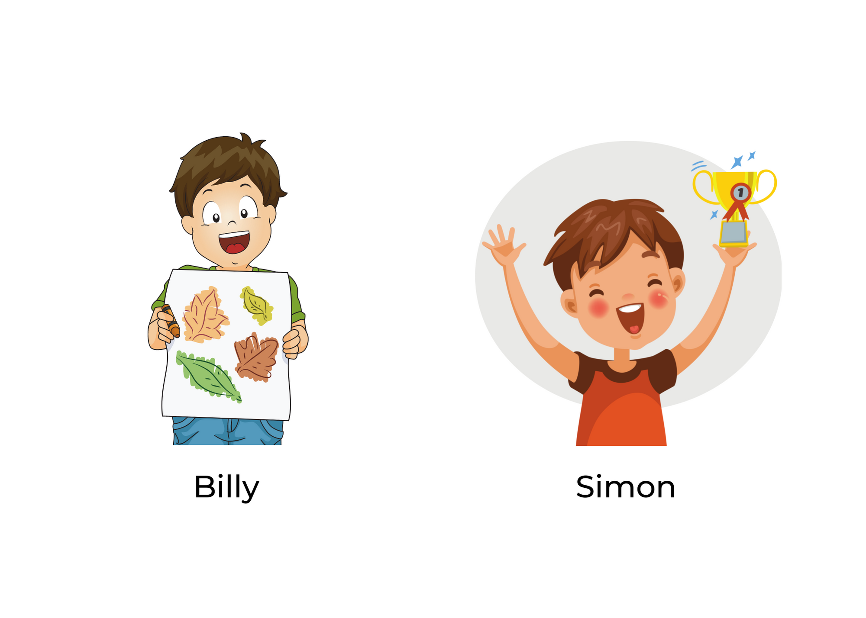
Answer the following question:
- How would that make Billy feel?
- Draw an emoji to show Billy’s emotions.
- What should Simon have done to show respect?

It's a sign of respect to give credit, and it is the right thing to do. This is how you can respect others and their work online.

THURSDAY - Give credit where it is due. (adapted from Common Sense Education)

You are working on an assignment and doing research on the Olympics. You have found this website and want to use some information from it.
It is important to show respect to the author of the website when you use their information. This is called giving credit or referencing.

Answer the following question:
- How will you give credit to information you find online?
- The correct format to give credit is [Author], [Title], [Website]. Use this format to give credit to the sports website above.

FRIDAY - The Digital Citizens Report. (adapted from Common Sense Education)

You are doing a school report on a musical group called The Digital Citizens. You have gathered all of your information from 3 different websites.

Review the websites and complete the report. Be sure to give credit for the information you used!

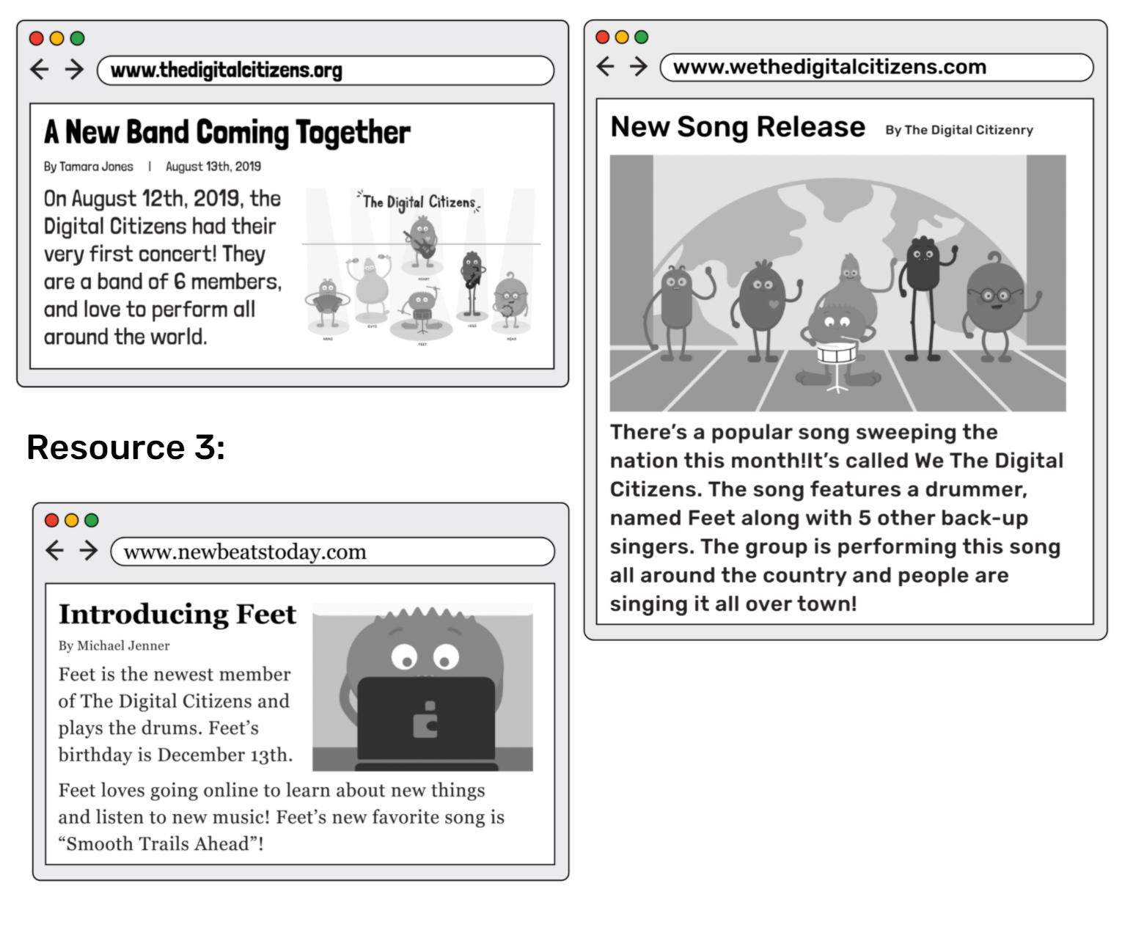
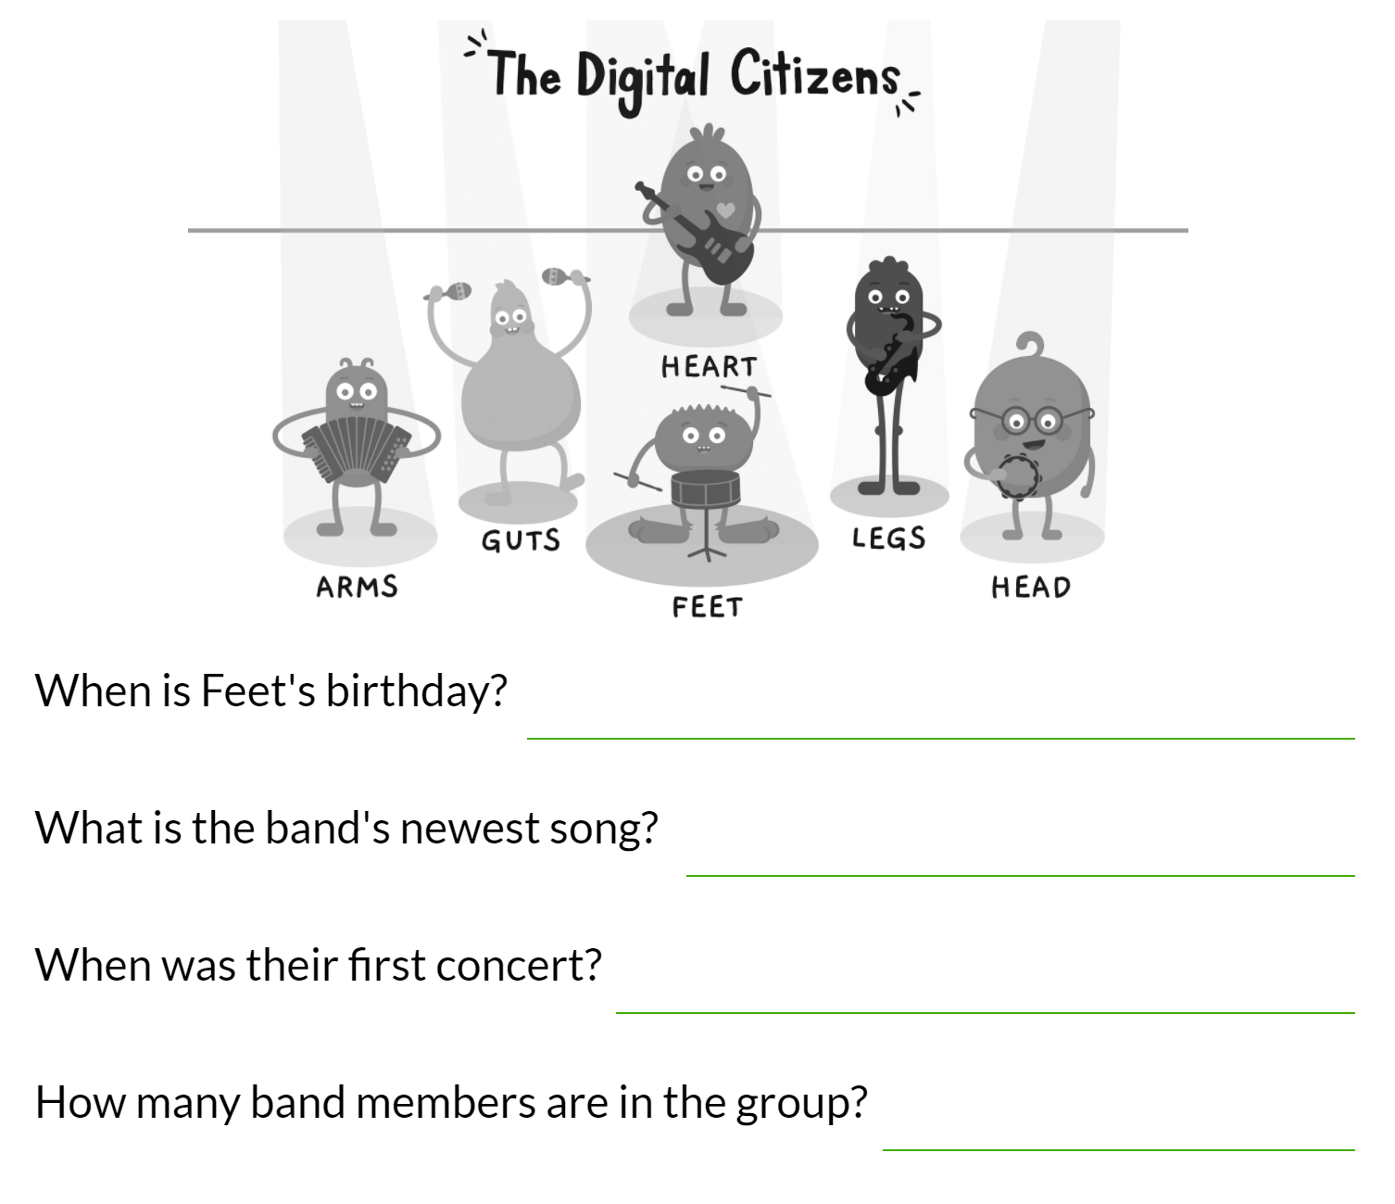
Give credit:
- _________________________________________________________________________________
- _________________________________________________________________________________
- _________________________________________________________________________________

