Cybermarvels are good digital citizens!

What you can expect to learn
This week we will learn why it is not safe to talk to people online that you do not know, what the rules are for safe sharing online and managing your device time.

Instructions
The activities below can be completed in any order and you can do all or some of them during the week. At the end of each day, fill in your journal with what you learnt that day and how you will use this learning in the future. You will then be able to use this to create:
- a poster (PDF/word)
- a script for a play (PDF/word)
- an MP4 video
- an MP3 audio
- a website (Google site or similar)
- or write a fictional story to showcase your learning for the whole month (PDF/word).

You can access help for video, audio recording and to write a journal or a story.

Once your teacher has reviewed your work, they can select and submit them to the judge’s panel as an entry to the Be Cybermarvellous Challenge 2021 and the best productions will be published on our website.

Week 2: 18 Oct - 22 Oct
Things you need:
- Tablet/ laptop/ PC/phone with internet access
- Headphone (optional)
- Paper and pencils/colour pencils
- Scissors and yarn or thread

MONDAY - Who is hiding behind a mask?

Colour in and/or decorate your mask. Cut it out and punch holes in the corners to thread yarn through it. Put it on your eyes and tie it in the back.

Now answer the questions below:
- Why would someone wear a mask?
- Could you pretend to be someone else when you have a mask on?
- Do you know not everyone you talk to online is who they say they are? Is this like wearing a mask?
- How do you think ‘stranger-danger’ applies to the online world?
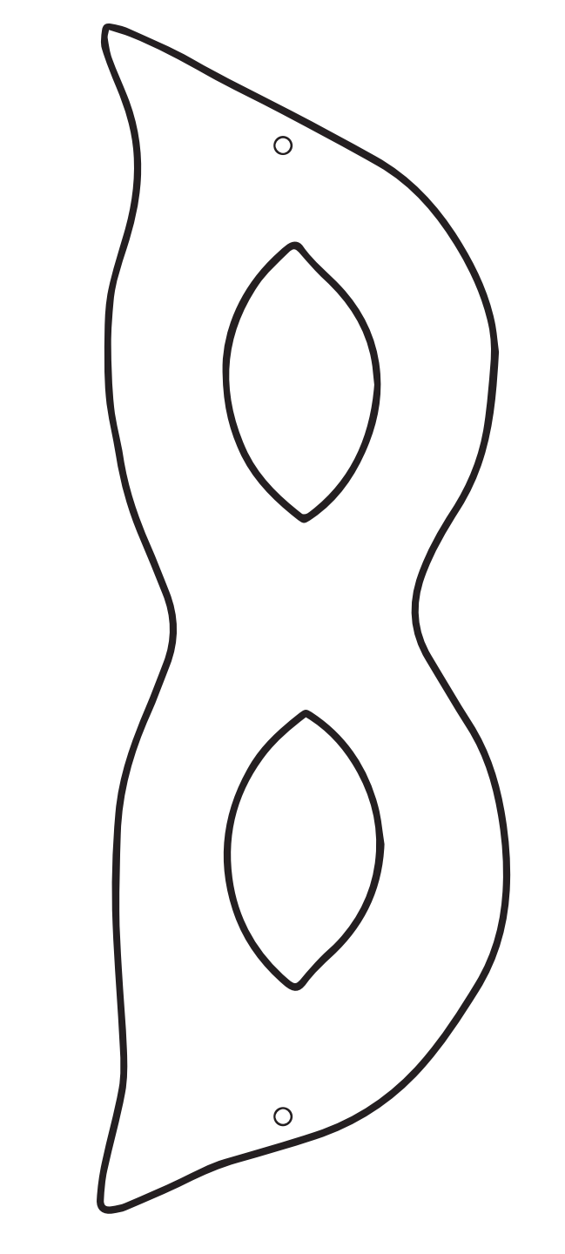
Image courtesy of Cyber Aces | Palo Alto Networks
TUESDAY - Be safe sharing online. (adapted from Common Sense Education)

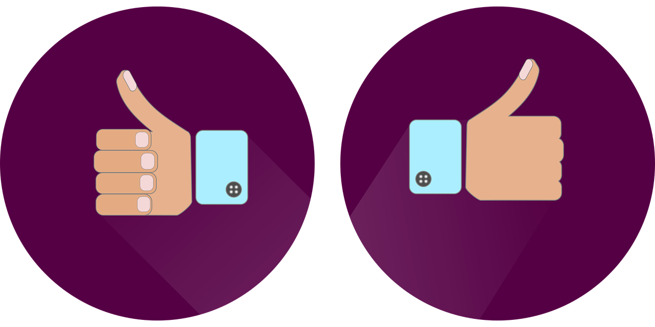

Your private information is what you are -such as your name, date of birth, home address etc.

Play a quick game of thumbs up, thumbs down to make sure you know what is considered private information and what isn't.

For each example below, think about if it is OK to share (thumbs up) or if it is something private that you shouldn't share (thumbs down) with a stranger.

- Your favourite ice cream flavour
- What you ate for dinner last night
- Your home addresses
- Your best friend's favourite movie
- Your mom's phone number
- Your password

Answer the questions below:
- Which ones you felt were not OK to share?
- Why do you think so?
- What is another example of something you can safely share online? Draw it below.
WEDNESDAY - What not to share? (adapted from Common Sense Education)

There's a new app called SongTube that allows you to create your own music. Billy, has permission to use the app, but is being asked to fill out a form first. He needs your help in figuring out what's OK to share.

As you read the form, fill in the sections that don't ask for private information and draw an X through the sections that do ask for private information.

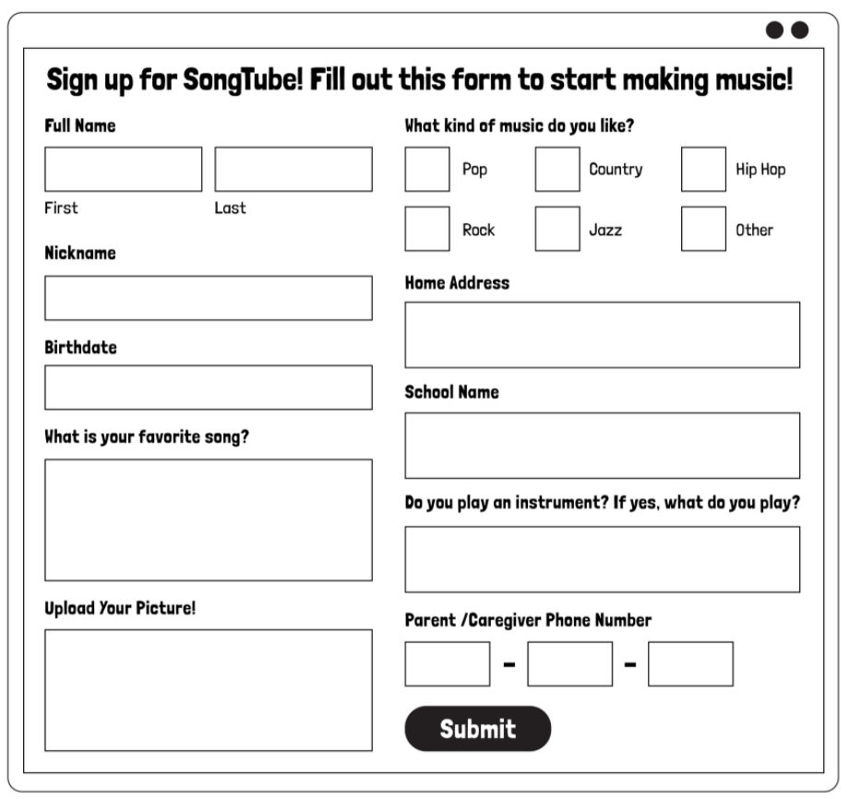

Answer the questions below:
- Which ones you felt were not OK to share?
- Why do you think so?
- Have you seen a form like this when visiting a website or app?
- Why do you think websites and apps ask for this type of information?

THURSDAY - Device free time. (adapted from Common Sense Education)

Watch this video -https://www.youtube.com/watch?v=xwi4E6XAktk&ab_channel=ArthurRead

Answer the questions below:
- What do you think happened?
- Talk about:
  - why it is important to have device free moments everyday
  - are there times when it is better not to use devices?

FRIDAY - Device free rules. (adapted from Common Sense Education)

Today you're going to get to be in charge. That means you have the responsibility to make sure your family is safe and respectful especially when they are online.

You're going to create a list of family rules to have device-free moments!

This list of rules is not just for you, but also for your parents and family. You can write special rules for certain people.
