Cybermarvels are good digital citizens!

What you can expect to learn
This week you will learn what a network is, how you can keep safe online and what things you should not share online by making drawings and creating a storyboard.

Instructions
The activities below can be completed in any order and you can do all or some of them during the week. At the end of each day, fill in your journal with what you learnt that day and how you will use this learning in the future. You will then be able to use this to create:
- a poster (PDF/word)
- a script for a play (PDF/word)
- an MP4 video
- an MP3 audio
- a website (Google site or similar)
- or write a fictional story to showcase your learning for the whole month (PDF/word).

You can access help for video, audio recording and to write a journal or a story.

Once your teacher has reviewed your work, they can select and submit them to the judge’s panel as an entry to the Be Cybermarvellous Challenge 2021 and the best productions will be published on our website.

Week 2: 11 Oct - 15 Oct
Things you need:
- Tablet/ laptop/ PC/phone with internet access
- Headphone (optional)
- Paper and pencils/colour pencils
- Yarn or thread (2 different colours) and scissors

MONDAY - What is a network? (adapted from Cyber Aces)

Prepare:
- Cut out the digital devices to separate them as cards. Cut some small lengths of yarn too.
- In each card, write the name of a person you know who has one of these devices.

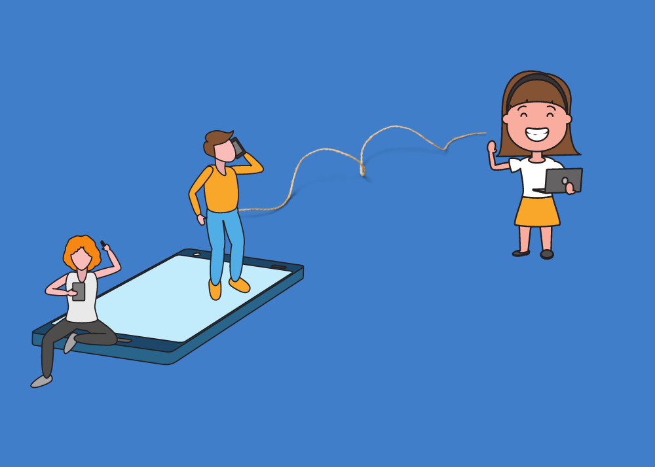
- Sit on the floor and spread the cards on the floor next to you
- Now think about the when you or your parents send or receive messages from these people
- Stretch the yarn between yourself and the card to depict the message you or your parents have sent and a different colour for messages received from each of these people
- The person who sends the message is the sender and one who receives it is the receiver.
- You have made a simple network.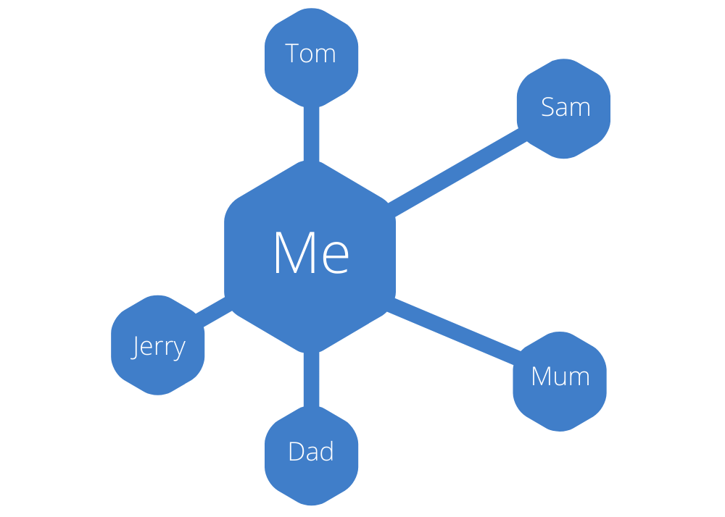

Now answer the following questions:
- Do you know if the people in your network send messages to each other too? Use string to build these network links. You now have a more complex network.
- Talk about the type of things you or your parents’ message about in your network.
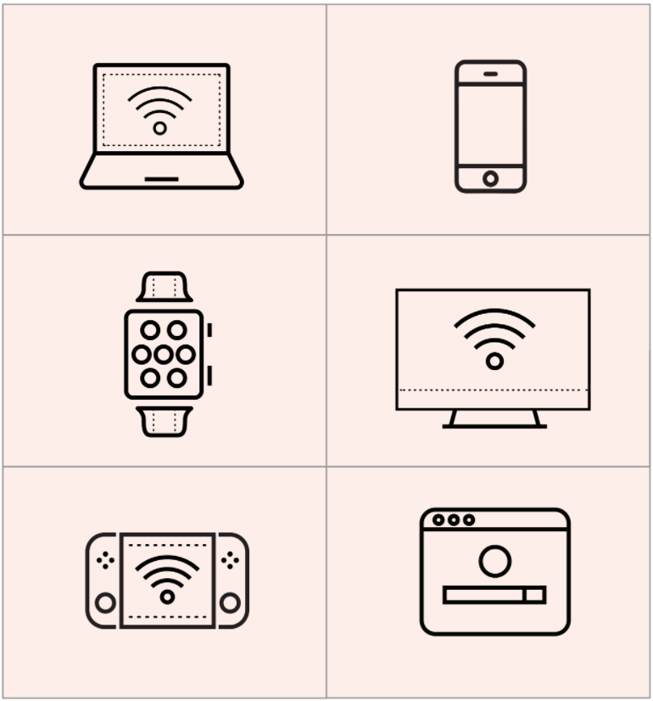
TUESDAY - Online safety rules.

When you or your parents are online and messaging others, there are rules you should follow to be respectful and responsible. For example,
- Ask a parent before using a device or going to a website
- Keep your passwords and personal information secure and private
- Tell a trusted adult if you see or hear anything that makes you feel unsafe.

In the space below draw a picture to show one of these rules.
WEDNESDAY - Your family rules. (adapted from eSafety)

Read the book or watch the video about a family of small sugar glider possums -

https://www.esafety.gov.au/parents/children-under-5/picture-book-and-song/swoosh-glide-and-rule-number-5

- Talk about why the family needed the five rules with devices such as -
  - Be kind, take turns
  - At dinner time, no screens
  - Use it only in shared spaces
  - Ask before you use it
  - No taking screens to bed.

- Does your family have another rule to add to the list above?
- Why do you think we need rules with devices?

THURSDAY - What’s the rule?

You or your parents would have taken a selfie. A selfie is when you take a photo of yourself!

- Do you take photos of your friends or family sometimes, or even a selfie?
- Do you ask for permission before you do this?
- Why do you think we should ask them for permission?
- Draw a picture of a friend who has said OK to having a selfie taken into the box below.

FRIDAY - Tell a story.
Families use devices and the internet all the time. But to use them safely is important.
Think about how your family does this.
- Look at the picture below and tell a story about this family.
- Use your imagination.
- You can also draw in the storyboard below to tell your story with pictures.

