Cybermarvels are good digital citizens

What you can expect to learn
This week we will learn how you can be safe online, how to balance what you see or hear and when to ask for help. You can watch a video, play a game and do some activities.

Instructions
The activities below can be completed in any order and you can do all or some of them during the week. At the end of each day, fill in your journal with what you learnt that day and how you will use this learning in the future. You will then be able to use this to create:
- a poster (PDF/word)
- a script for a play (PDF/word)
- an MP4 video
- an MP3 audio
- a website (Google site or similar)
- or write a fictional story to showcase your learning for the whole month (PDF/word).

You can access help for video, audio recording and to write a journal or a story.

Once your teacher has reviewed your work, they can select and submit them to the judge’s panel as an entry to the Be Cybermarvellous Challenge 2021 and the best productions will be published on our website.

Week 1: 4 Oct - 8 Oct
Things you need:
- Tablet/ laptop/ PC
- Internet access
- Headphone (optional)
- Paper and pencils/colour pencils
- Scissors

MONDAY - Be an eSafe kid

Go to eSafety website- https://www.esafety.gov.au/kids/be-an-esafe-kid
- Complete the activities:
  - Be safe
  - Be curious
  - Be kind
  - Be secure

TUESDAY - Match the correct pairs (adapted from Cyber Aces)

- Draw a line to match the objects on the left to the ones on the right that would keep it safe. For example, you keep money in a wallet to keep it safe.

Object | What keeps it safe?
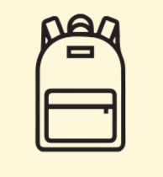 | 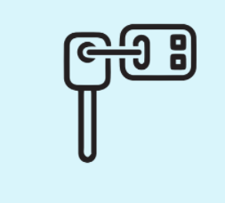
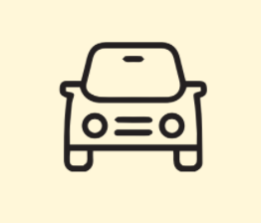
 | 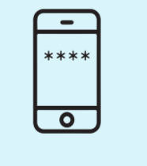
 | 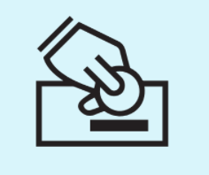
Images courtesy of Cyber Aces | Palo Alto Networks

- Talk about how you or your parents keep the devices at home protected so others cannot use them
- Are there any rules for using devices safely at your home?
WEDNESDAY - Technology scavenger hunt (adapted from Cyber Aces)

Go around the classroom or at home to find all digital devices including those that connect to the internet.
If none are available, use the images below: of a gaming device, a PC, a smart watch, a smart phone, a laptop and an ordinary watch.

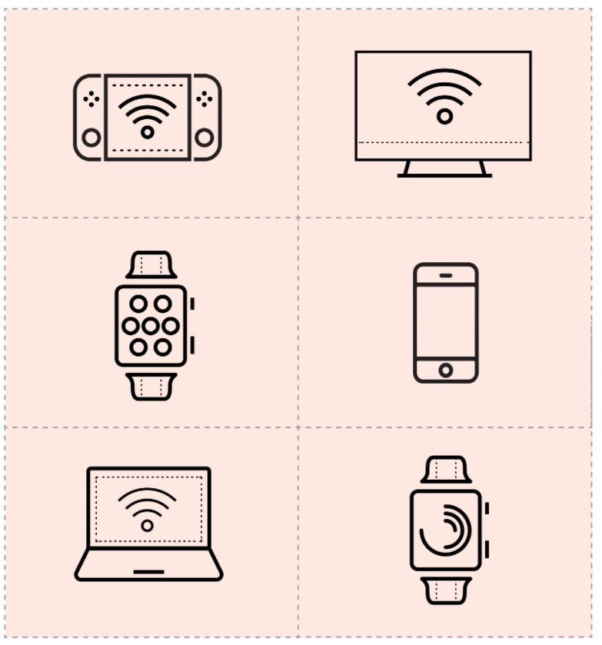
Image courtesy of Cyber Aces from Palo Alto Networks

For each device answer the following:
- How is this device used? Is it connected to other devices?
- What kind of security does it have? Is it protected by a password?
- If you found an unlocked device that was not yours, what would you do?

THURSDAY - Balance is important (adapted from Common Sense Education)

Kindergarten: Stand on one foot on the ground.

- Time yourself. How long can you stand on one foot for?
- Why do you think we need two feet to stand on?
- When you use a device at home or school do you need to balance how long you use them with other activities?
- What are these other activities that you do?

Years 1-2: Good media balance means when you:
- "Pause for people" and stop using devices when someone wants to talk
- Know when it's time to go outside to play
- Turn off your screens before bedtime
- Ask before they use a device, and stay on trusted sites and apps.
- Tell an adult if something makes you uncomfortable.

Watch this video- https://www.commonsense.org/education/videos/media-balance-is-important (you might need to login)

Talk about:
- How can we work together to have media balance as a family?
- What would that look like? You can even draw a picture that shows your whole family practicing media balance!

FRIDAY - Pause and think online (adapted from Common Sense Education)
When you pause and think online, you:
- Pause and think before searching, clicking, or sharing.
- Use your arms – take a break and balance time online
- Use your gut - know when it is safe and make good choices
- Stand up on your legs - stand up to bullies online and help friends
- Use your feet – think about the tracks you leave online
- Think with your heart – you are nice and kind to others online

Watch this video - https://www.commonsense.org/education/videos/pause-think-online (you might need to login)

Talk about:
- What are some things you do when you are online?
- Talk about when you have:
  - Taken a break from being online
  - Listened to your gut feeling
  - Stood up to wrong online behaviour
  - Left good footprints online
  - Been kind online
- What do you think you should do if you need help when online?

