Cybermarvels are good digital citizens!

What you can expect to learn
This week we will learn - what media balance is, how you can make good choices about what to watch, read or listen to and how you can get the whole family involved.

Instructions
The activities below can be completed in any order and you can do all or some of them during the week. At the end of each day, fill in your journal with what you learnt that day and how you will use this learning in the future. You will then be able to use this to create:
- a poster (PDF/word)
- a script for a play (PDF/word)
- an MP4 video
- an MP3 audio
- a website (Google site or similar)
- or write a fictional story to showcase your learning for the whole month (PDF/word).

You can access help for video, audio recording and to write a journal or a story.

Once your teacher has reviewed your work, they can select and submit them to the judge’s panel as an entry to the Be Cybermarvellous Challenge 2021 and the best productions will be published on our website.

Week 1 -4:
Things you need:
- Tablet/ laptop/ PC
- Internet access
- Headphone (optional)
- Paper and pens/pencils/colour pencils
WEEK 1 - My digital footprint (provided by Grok Academy)
Access the Privacy and Sharing online module below to complete the interactive activities.
Explore your digital footprint, and the different ways that private information is shared.

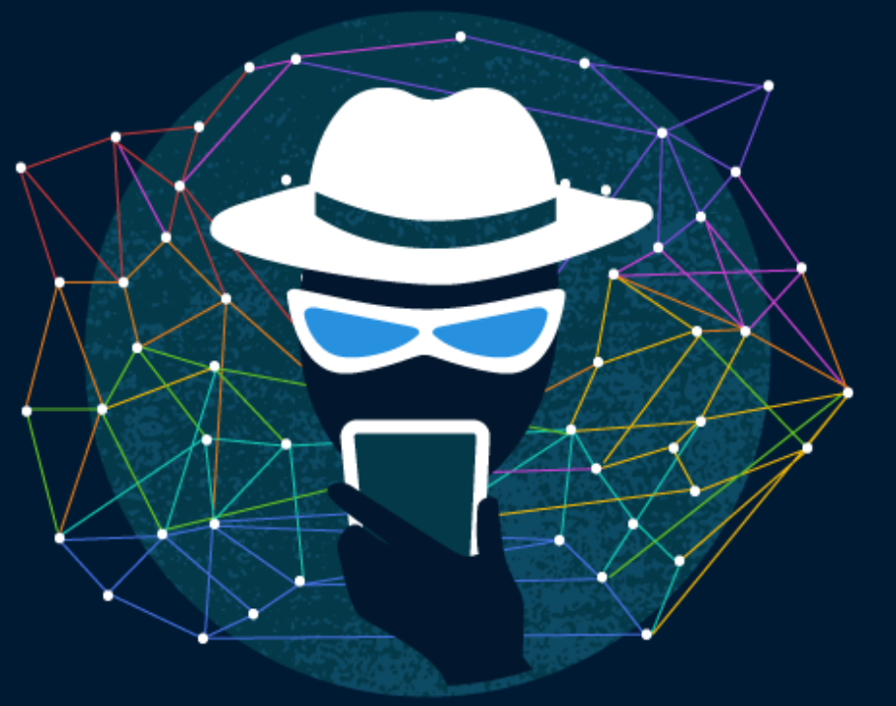
Image from Grok Academy
https://groklearning.com/course/cybermarvel/?utm_campaign=cyber-marvel&utm_source=cyber-marvel&utm_medium=online-ad&short_url=grok.ac%2Fmarvel-course-1

Now complete the table and profile check-up sheet below:
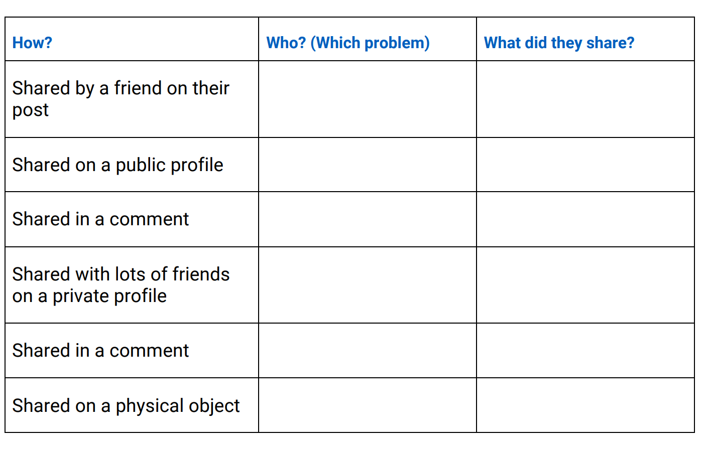
Sharing, sharing everywhere - There are lots of ways private information is shared on social media. Write down examples from Fistbump and Flashtag of private information being shared in these places.

Profile check-up
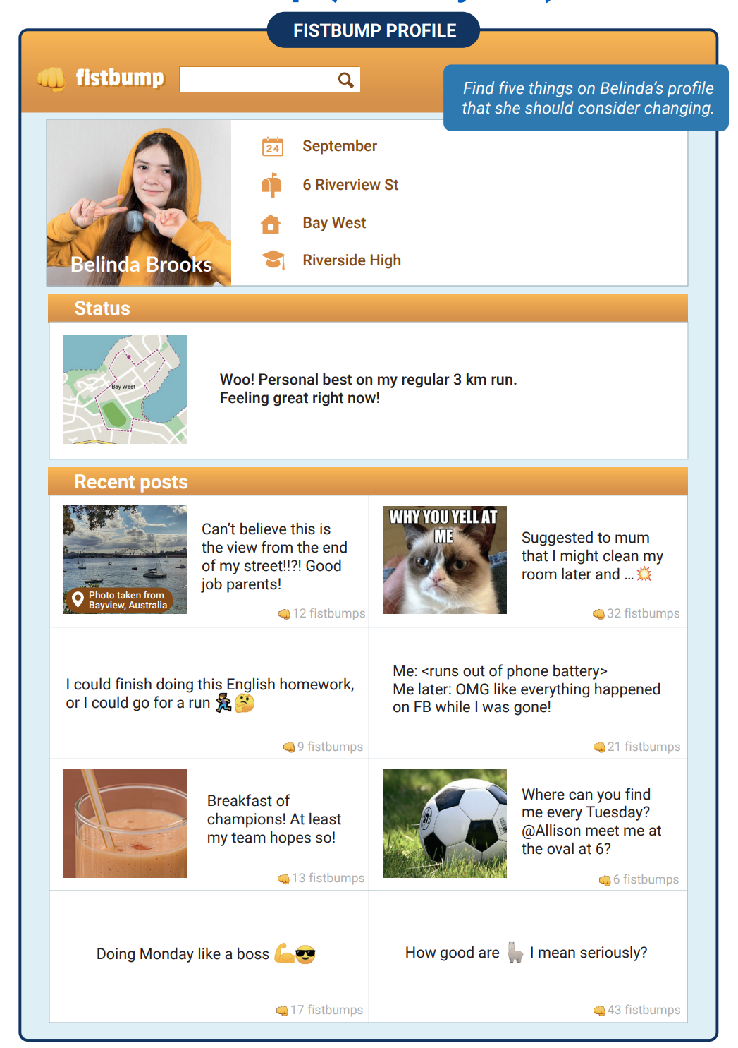
Image from Grok Academy

WEEK 2 - Secure passwords (provided by Grok Academy)
Learn about the need for passwords, and how to create a strong password. Access the Secure Passwords activity online at - https://groklearning.com/course/cybermarvel/?utm_campaign=cyber-marvel&utm_source=cyber-marvel&utm_medium=online-ad&short_url=grok.ac%2Fmarvel-course-2
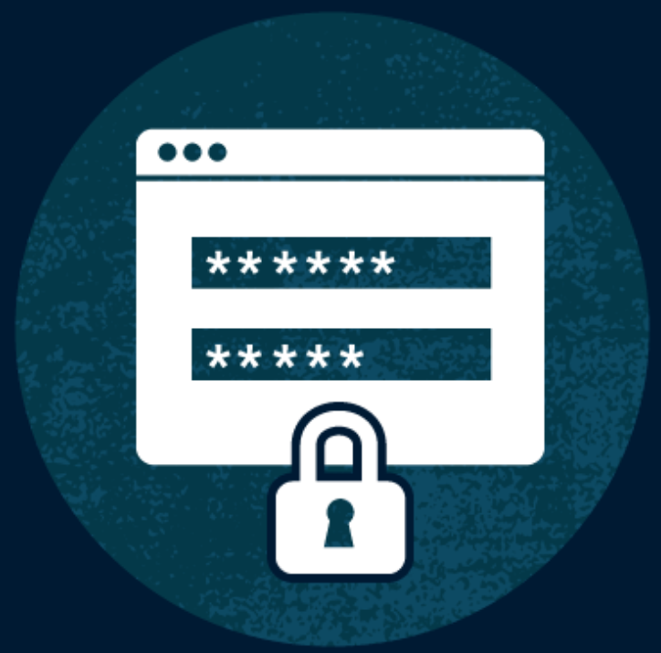
Image from Grok Academy

Work through five interactive problems where you will see examples of insecure passwords and password reuse. Answer the questions below:

- Check how secure your passwords are at- https://www.security.org/how-secure-is-my-password/
- Why are passwords important?
- What makes a good password?
- Why is it important to use different passwords for each app / website?
- Check how secure your and your parents emails are - https://haveibeenpwned.com/

Remember to make a strong password, make it:
- Long
- Unusual
- Memorable
- Secret
- Unique
- Include symbols and numbers.
Image from Grok Academy

WEEK 3 - Avoiding scams (provided by Grok Academy)

Learn about scams and phishing messages: how to spot them and what action they should take if they receive them. Access the Avoiding Scams activity at-

https://aca.edu.au/projects/cyber-challenges/marvel/?utm_campaign=cyber-marvel&utm_source=cyber-marvel&utm_medium=online-ad&short_url=grok.ac%2Fmarvel-infosec#activity-infosec

Complete the questions below:

Scam Detective: How many red flags can you spot in each message?
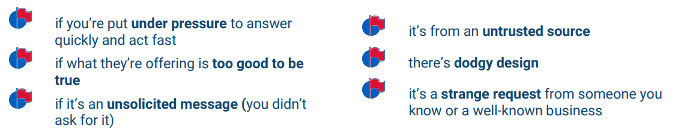
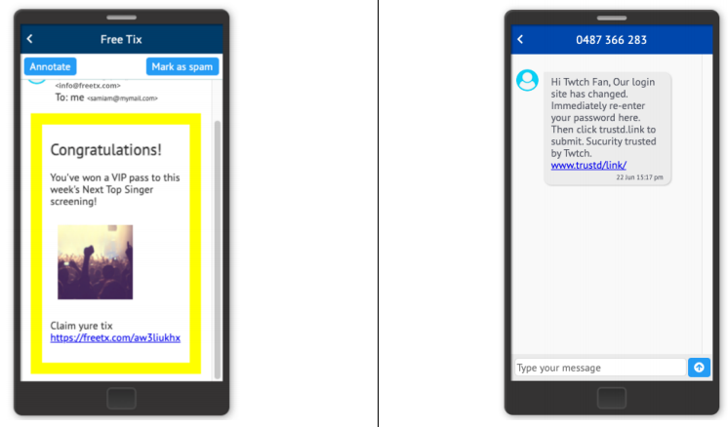
Image from Grok Academy

Red flags: | Red flags:
How many red flags can you see in each message?

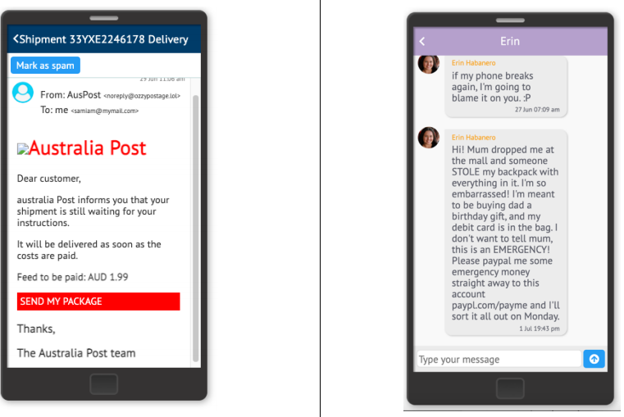
Image from Grok Academy

Red flags: | Red flags:

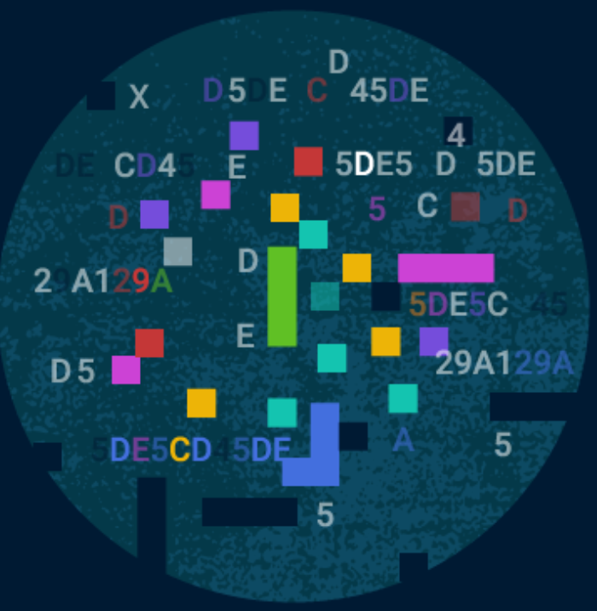
Image from Grok Academy

WEEK 4 - Cryptography (provided by Grok Academy)

Learn how to encrypt and decrypt messages using ciphers. The activity uses ciphers to encode and decode secret messages By following a simple sequence of steps (an algorithm) students can encode and decode different texts.

Cryptography is derived from the Greek words kryptos which means “hidden” or “secret” and graph meaning “writing”. So cryptography is all about hiding messages in an effort to create secure communication.

Cryptography is about creating rules (protocols) and instructions (algorithms) for encoding and decoding messages so that third parties cannot read your communications.
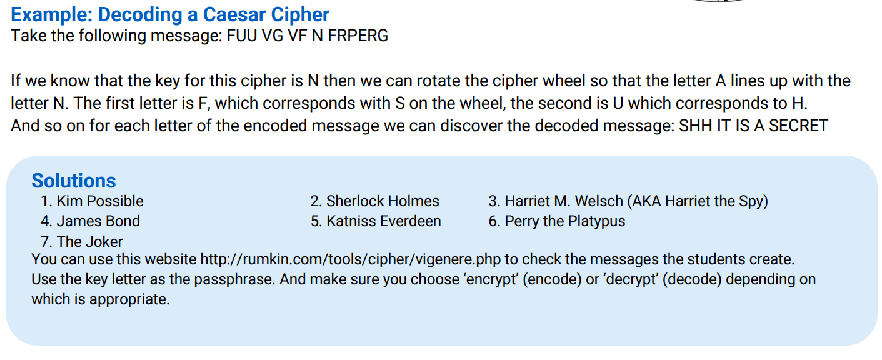

Access the Crytography activity at-

https://aca.edu.au/projects/cyber-challenges/marvel/?utm_campaign=cyber-marvel&utm_source=cyber-marvel&utm_medium=online-ad&short_url=grok.ac%2Fmarvel-infosec#activity-infosec

Complete the questions below:

- Send and Receive Secret Messages- The following messages have been intercepted but they look like nonsense! We know that there are code names of secret agents hidden in them. Help us decode these messages and figure out those code names!
- Cut out and make your cipher wheel using the pattern on the back page. You can use a butterfly clip or paper clip to hold the two wheels together.
- Then for each encoded message use the key and your cipher wheel to decode the secret messages.
- Once you’ve uncovered all the secret identities you’ll be able to use them to find the mastermind behind it all!
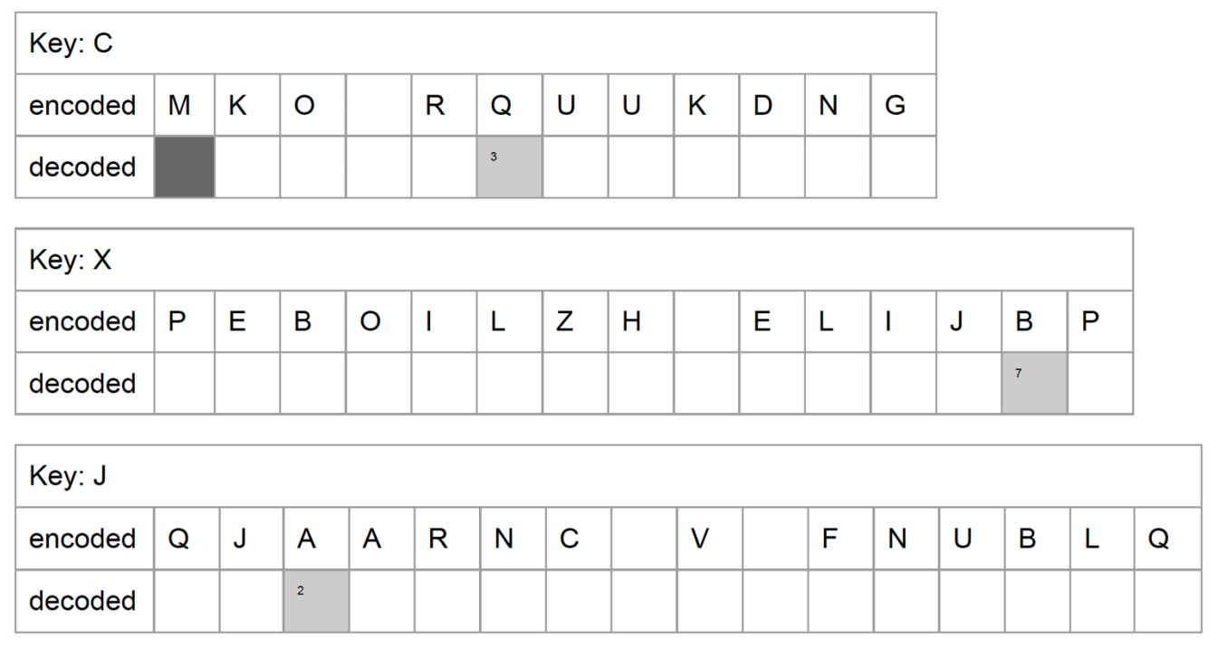
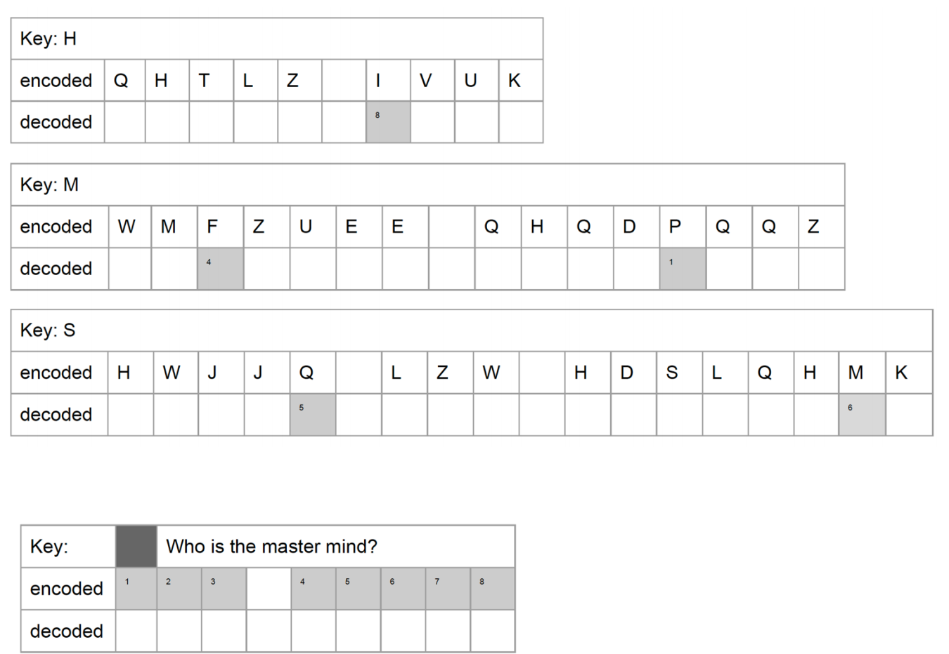
Image from Grok Academy

- Your mission now is to send and receive secret messages.
- Pair up with another secret agent (parent/family member) and encode a secret message for them to read. Make sure you write down the key you used so your partner can decode your message!
- Swap your message with your partner. Once you have their encoded message start decoding the message and see what they have to tell you.
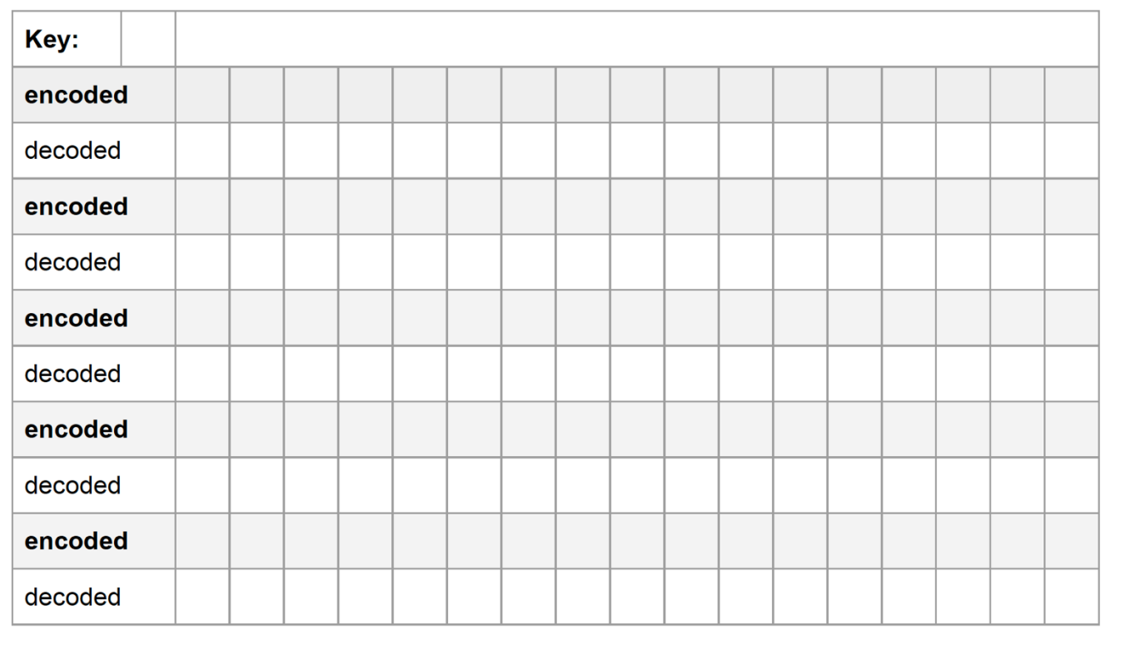
Image from Grok Academy

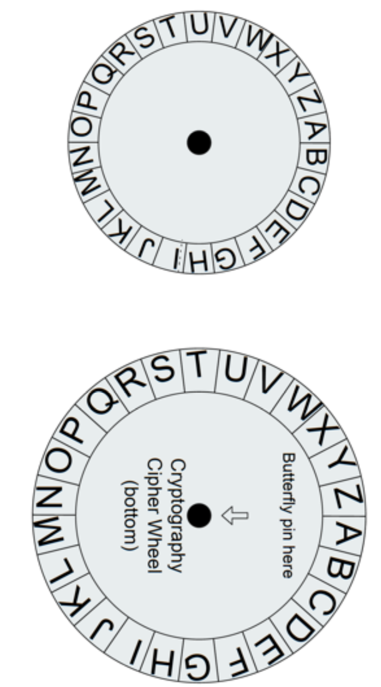

Image from Grok Academy

EXTENSION ACTIVITIES:

- #SocialMedia challenge (adapted from Cyber Aces)

What social media platforms do you, your friends, or your parents use?
Social media platforms allow users to create and share content. Social media has the power to connect us, inform us, and shape our perceptions.

In this activity, we’ll take a close look at how we use social media and how it affects us.
As you read each social media statement, colour in green the ones you agree with, yellow if you are indifferent (that is, you neither agree or disagree), and red if you disagree with the statement.

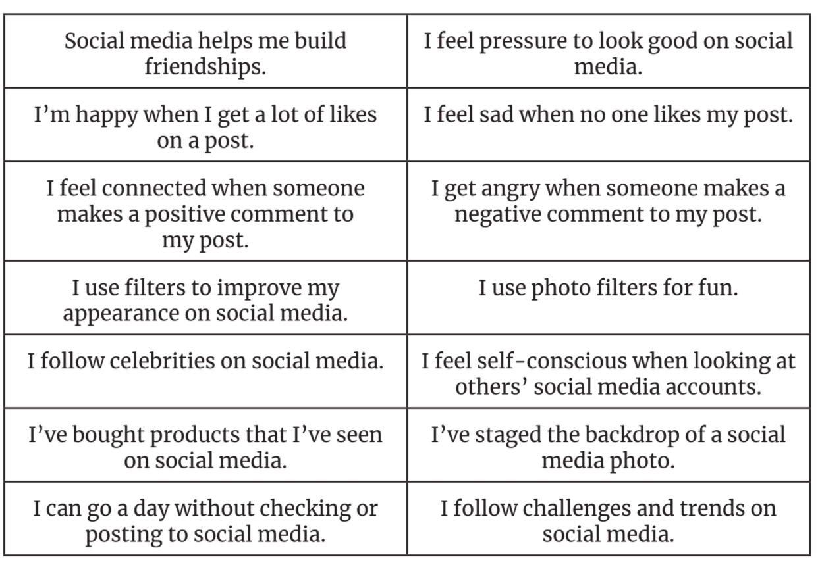
Image from Grok Academy
2. Play the Google’s Interland game - https://beinternetawesome.withgoogle.com/en_us/interland
- Learn to not fall for fake, share with care, secure your secrets and be kind.
- Talk about five things you learnt after playing the game. Read the pledge and sign and date it.
- Get your parent to co-sign-

https://storage.googleapis.com/gweb-interland.appspot.com/en-us/hub/pdfs/Google_BeInternetAwesome_Pledge.pdf

