Cybermarvels are good digital citizens!

What you can expect to learn
This week we will learn - what media balance is, how you can make good choices about what to watch, read or listen to and how you can get the whole family involved.

Instructions
The activities below can be completed in any order and you can do all or some of them during the week. At the end of each day, fill in your journal with what you learnt that day and how you will use this learning in the future. You will then be able to use this to create:
- a poster (PDF/word)
- a script for a play (PDF/word)
- an MP4 video
- an MP3 audio
- a website (Google site or similar)
- or write a fictional story to showcase your learning for the whole month (PDF/word).

You can access help for video, audio recording and to write a journal or a story.

Once your teacher has reviewed your work, they can select and submit them to the judge’s panel as an entry to the Be Cybermarvellous Challenge 2021 and the best productions will be published on our website.

Week 4: 25 Oct - 29 Oct
Things you need:
- Tablet/ laptop/ PC
- Internet access
- Headphone (optional)
- Paper and pencils/colour pencils
- Marker pen
- Scissors

MONDAY - Nothing is free! (adapted from Cyber Aces)

You are using a device and one of these messages below pops-up on the screen.

- Would you provide the details they ask for?
- Does anything seem strange about the pop-ups?

There are many different types of scams. Remember, a scam is a trick or misleading message. Spam emails are emails that are sent to lots of people, often asking recipients to follow a link or do something.
Sometimes, these emails look like they come from a popular company. It can be hard to determine if an email is spam. Before going to a website that does not look familiar or clicking on a link that came from an email, be sure to ask an adult.
Remember nothing is free!
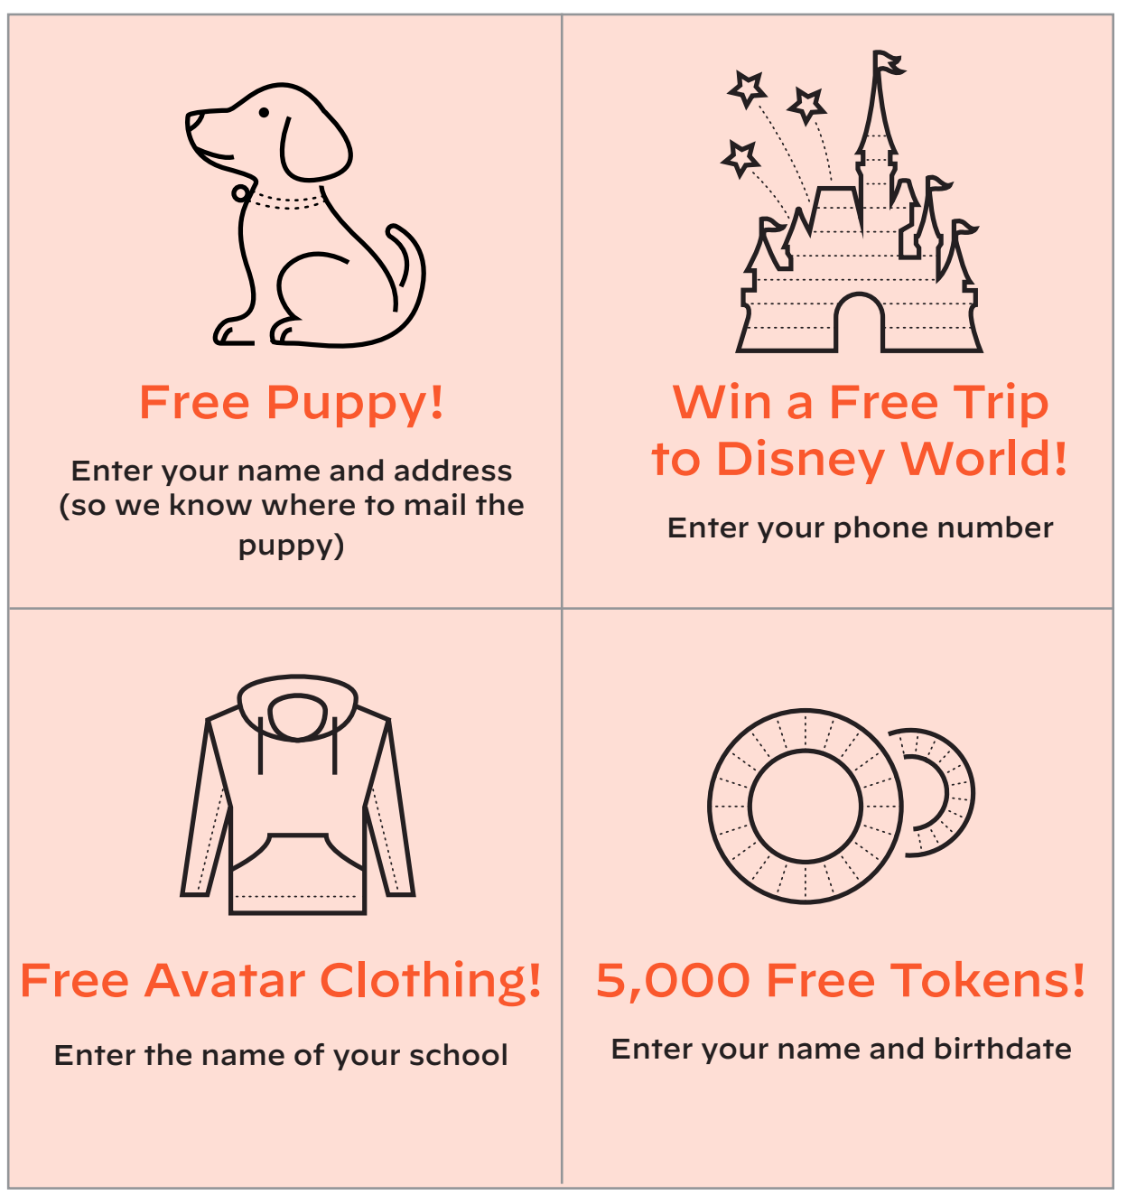
TUESDAY - Cyber says (adapted from Cyber Aces)

Play ‘Cyber says’ with your family members or friends. One person is the leader and they say “Cyber says” before a command. Others act out that command. If the leader does not say “Cyber says” but you act out the command by mistake, then you’re out.

The leader is going to go quickly. Try to keep up!

Commands (leader):

• Cyber says touch your head.
• Cyber says put your hands over your eyes.
• Cyber says pretend to shoot a basketball 5 times.
• Raise your hand. (If anyone does this, they’re out.) I didn’t say “Cyber says.”

• Cyber says pinch your nose.
• Cyber says run in place.
• Cyber says stop. (If anyone keeps running, they’re out.)
• Cyber says touch your elbow.
• Touch your mouth. (If anyone does this, they’re out.) I didn’t say “Cyber says.”
• Cyber says play an air guitar.
• Stop. (If anyone stops, they’re out.) I didn’t say “Cyber says.”
• Cyber says stop.
• Cyber says wave to a friend.
• Cyber says do the strangest dance you can think of.
• Hop like a frog. (If anyone does this, they’re out.) I didn’t say “Cyber says.”

Talk about:

- Did you find that you made more mistakes if the commands came out quickly?
- How can this be relevant to the online space? Do you need to take a pause and think before you post or comment online?

WEDNESDAY - Your responsibility (adapted from Common Sense Education)

Watch the video - https://www.youtube.com/watch?v=fQSnzrB5bso&t=59s

- How could throwing a bottle out of your window be similar to something you do online?
It is about being responsible and behaving correctly, right? Similar principles apply to the online world too.

- Choose three colours and use them to colour in the key below.
- Use the key colours to colour in the correct ring(s) for each statement. Think about whose responsibility it is - yours, your community or the world.

Yourself: The centre ring represents responsibilities you have to yourself, such as keeping yourself safe and healthy.

Community: The middle ring stands for responsibilities you have to your community, including the people you know and interact with on a regular basis. This can include both friends and family. But it can also include people you don't know well, but with whom you interact with (e.g., grocery store clerks, a friend in an online gaming community, etc.).

World: The outer ring stands for your responsibilities to the larger world. This would include people you don't know but whom your actions might affect.
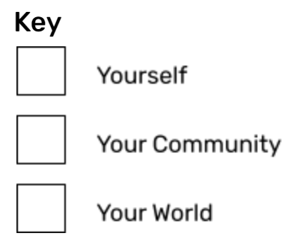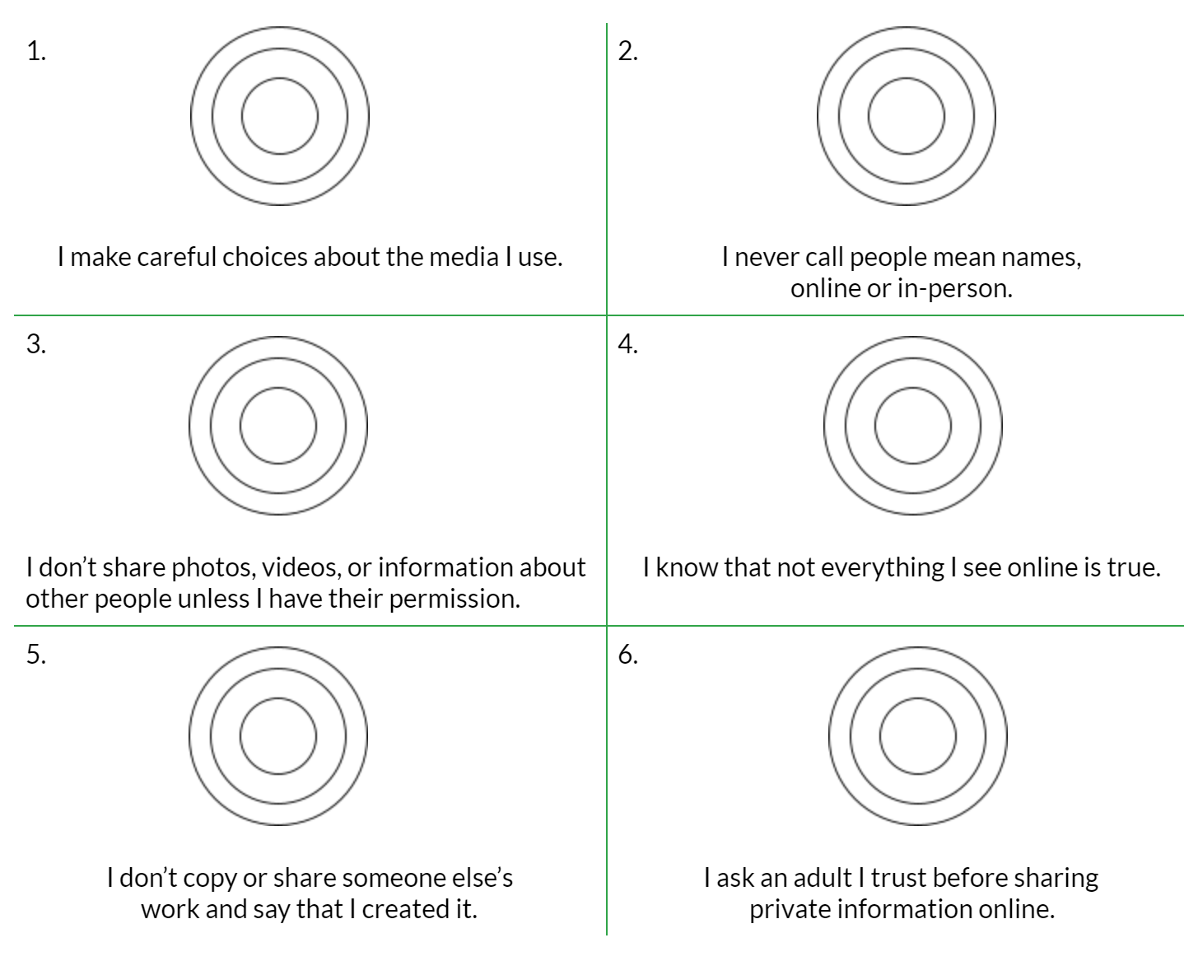

THURSDAY - QUIZ on Rings of responsibility (adapted from Common Sense Education)
QUESTION 1. What are the three rings of responsibility?

- Me, self, family
- Self, community, world
- World, Earth, space
- School, home, neighbourhood

QUESTION 2. Select one answer from the list below.
True or false? When we use the internet or devices, we should think only of how our actions affect ourselves.

- True
- False

QUESTION 3. Select one answer from the list below.
When you go online, what is an example of a responsibility you have to yourself?

- Share pictures that have my friends in them without asking permission.
- Make funny comments to make others laugh.
- Go on a website that is OK for kids my age.
- Download an app my older cousin shared.

QUESTION 4. Select one answer from the list below.
You and your best friend spent the afternoon playing at the park. You took a few photos of you both together and want to share them with your friends online. What should you do?

- Post them online without asking your friend.
- Ask your friend if you can share the photos of you together.
- Wait a couple days, then share them online without asking your friend.

QUESTION 5. Select one answer from the list below.
How confident are you about knowing what your responsibilities are when you go online?

- I feel very confident.
- I feel somewhat confident.
- I do not feel confident.
FRIDAY - Cyberlite activity book (provided by Cyber Aces)

Read and complete puzzles and challenges in the Cyberlite book -

https://www.cyberlitebooks.com/book-preview

(password to access book is Mncyb2021)

